

THE REPUBLIC OF ICENIA

Coat of Arms

This document, last compiled by CreepilyCreep,
includes all legislation enacted and amended
up to and including the Coat of Arms Act passed on
9th September 2025.

Coat of Arms
- The Coat of Arms of the Third Republic of Icenia shall be as follows:
"Argent, a hurt. For the crest, on a wreath Argent and Azure, an isopod statant Argent. For the supporters, dark oak branches Proper, fructed Or. For the motto, "SNEED!" The date of the Declaration of Independence of the First Republic of Icenia "VII•VIII", on the dexter, and "MMXV", on the sinister."
- The Coat of Arms of the Third Republic of Icenia shall be considered an official National Symbol –alongside the Icenian Flag. As such, the emblazonment of the Coat of Arms annexed to this bill must be stamped at the top or middle of the first page on all official documents.
  - The stamping of past archived documents shall not be obligatory, with the exception of the present constitution.
  - From hereafter, new documents without the Coat of Arms of the Third Republic of Icenia shall not be considered official.
  - Draft documents are not required to bear the Coat of Arms.
- The implementation of a State (Governmental) Flag bearing the Coat of Arms should be considered in the future and shall be implemented with a separate bill that modifies the current Icenian Flag Act.
- All shields provided to the military of Icenia shall be crafted as to bear the official shield of Icenia, as described by §1: "Argent, a hurt" and by the annexed construction sheet.

Appendix
Appendix 1: Coat of Arms


Appendix 2: Coat of Arms Construction Sheet
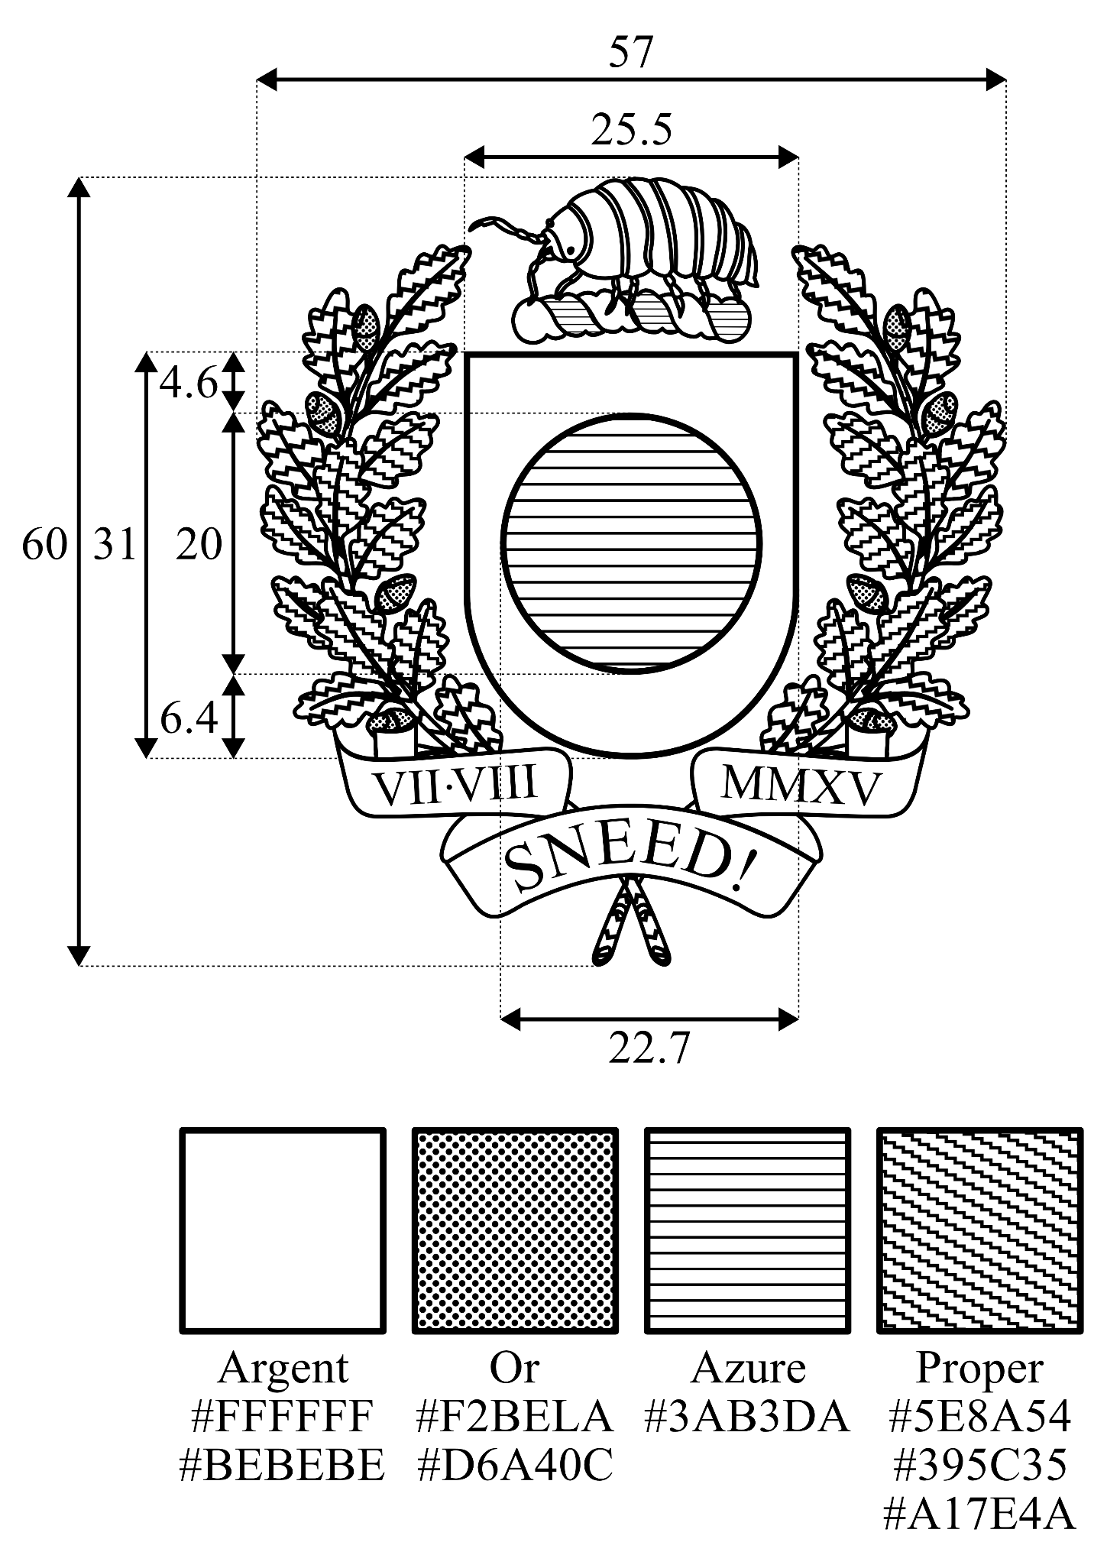

Appendix 3: White Institutional Version of the Coat of Arms for Github
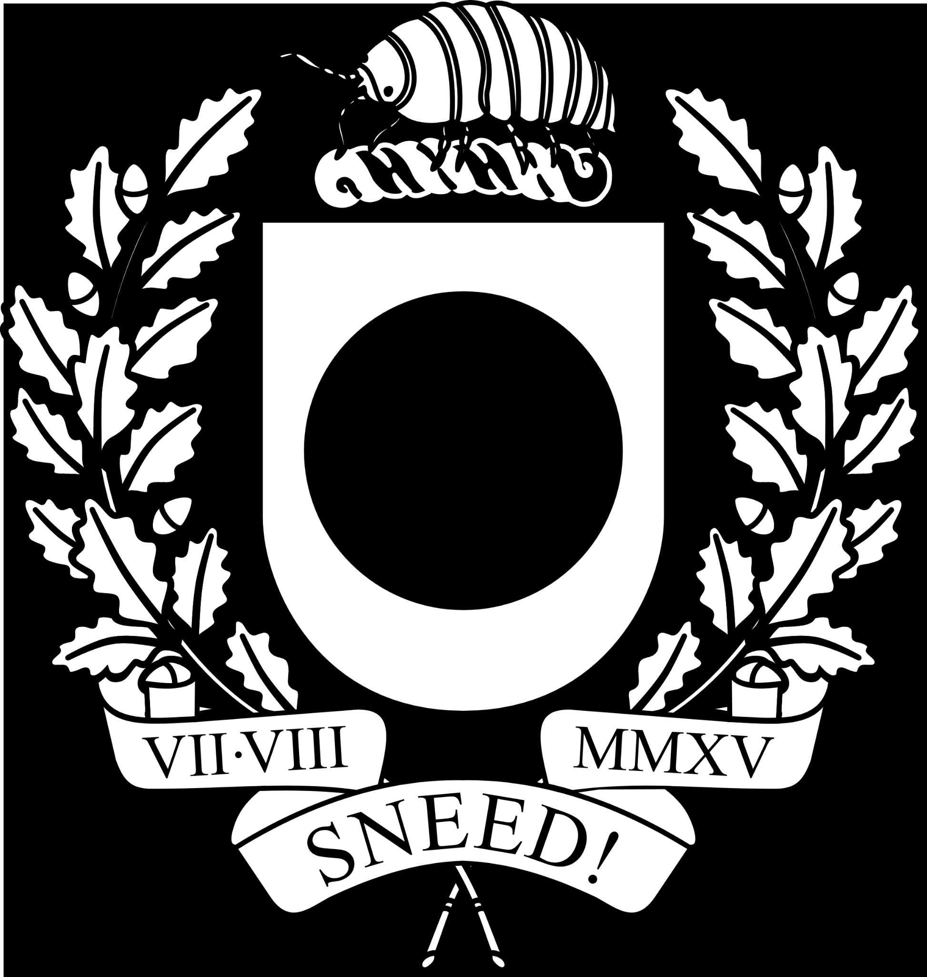

Appendix 4: Construction Sheet for Icenian Shields
