# http://icf-edx-pilot.cloudapp.net/static/themes/ionisx/images/sunrise.98dd28f2df8a.jpg

**Digital Services Contracting Professional Development Program Orientation**

Orientation Participant Materials

August 2016

**Digital Services Contracting Professional Development Program**

**Orientation**

Orientation Participant Materials

August 2016

Contents

[Digital Services Contracting Professional Development Program Orientation 1](#_Toc457838402)

[Overview 1](#_Toc457838403)

[Day 1 Agenda 1](#_Toc457838404)

[Day 2 Agenda 1](#_Toc457838405)

[Day 3 Agenda 1](#_Toc457838406)

[Digital Services Contracting Professional Development Program Participant List 2](#_Toc457838407)

[Program Overview 3](#_Toc457838408)

[Completing Your Individual Development Plan 5](#_Toc457838409)

[Program Deep Dive & Release Rhythm 7](#_Toc457838410)

[Guest Speakers 9](#_Toc457838411)

[Getting started with edX & Completing the Pre-Assessment 10](#_Toc457838412)

[Action Shadowing - Expectations, Roles, and Benefits 11](#_Toc457838413)

[Activity – Plan a Meeting 13](#_Toc457838414)

[Reflection – What Does This Mean for You? 14](#_Toc457838415)

[Live Digital Assignment - Expectations, Roles, and Benefits 15](#_Toc457838416)

[Live Digital Assignment Plan 16](#_Toc457838417)

[Agile at ICF 18](#_Toc457838418)

[Agile at ICF 19](#_Toc457838419)

[Program Expectations 22](#_Toc457838420)

# Digital Services Contracting Professional Development Program Orientation

## Overview

The Digital Services Contracting Professional Development Program Orientation introduces you to the program you will engage in over the next four months. Over the course of these three days, you will participate in discussions that support your understanding of the need for new approaches to digital acquisition in government, explore your role in developing your skills and behaviors to support digital acquisition, and introduce you to the basic concepts of the agile methodology. You will listen to guest speakers in government on their vision for the program, begin work on your team-based live digital assignment, and begin to reflect on what it means to be a digital services acquisition ambassador. It will be a busy three days, and we will look to you to ask questions and interact with your colleagues to get the most out of the experience.

**Location:** ICF International Office; 1725 Eye Street, NW; Concourse Level (Farragut North or Farragut West metro station)

## Day 1 Agenda

|  |
| --- |
| Tuesday, August 2, 2016 |
| * Program Overview and Introductions * Guest Speakers * Lunch * Design Overview * DiSC Assessment Debrief/Activity * Live Digital Assignment Overview * Networking Event |

## Day 2 Agenda

|  |
| --- |
| Wednesday, August 3, 2016 |
| * Digital Services Playbook * Digital Services Overview * Lunch * Agile Overview |

## Day 3 Agenda

|  |
| --- |
| Thursday, August 4, 2016 |
| * Day 2 Review/Pre-Program Survey Results * Implementing Agile in Government * Digital Services Acquisition Case Study: Small Business Administration (SBA) ONE Contracting Systems Modernization Procurement * Lunch * SBA Panel Discussion * TechFAR Hub * Live Digital Assignment Group Work * Orientation Review and Assessment |

# Digital Services Contracting Professional Development Program Participant List

|  |  |  |  |  |  |  |  |
| --- | --- | --- | --- | --- | --- | --- | --- |
| |  |  |  |  | | --- | --- | --- | --- | | Last Name | First Name | Agency | Contact Information | | | | |
|  |  |  |  |
|  |  |  |  |
|  |  |  |  |
|  |  |  |  |
|  |  |  |  |
|  |  |  |  |
|  |  |  |  |
|  |  |  |  |
|  |  |  |  |
|  |  |  |  |
|  |  |  |  |
|  |  |  |  |
|  |  |  |  |
|  |  |  |  |
|  |  |  |  |
|  |  |  |  |
|  |  |  |  |
|  |  |  |  |
|  |  |  |  |
|  |  |  |  |
|  |  |  |  |
|  |  |  |  |
|  |  |  |  |
|  |  |  |  |
|  |  |  |  |
|  |  |  |  |
|  |  |  |  |
|  |  |  |  |
|  |  |  |  |
|  |  |  |  |

# Program Overview

The program has four monthly releases and two iterations within each release focused on the knowledge and skills needed to become a digital acquisition expert. By the end of this program, you will be able to:

* Effectively procure digital services and supplies utilizing concepts such as those described in the Digital Services Playbook and TechFAR; appropriately measure the success of these contracts; accurately describe and define the value received, encourage the use of commercial practices and innovative, flexible approaches; and describe how to effectively make contributions to digital services procurement processes.
* Serve as a business advisor within agency Digital Service teams, providing strategic support to the team, its customers, and its stakeholders.
* Lead agency training, workshops, and consultations in order to expand digital service procurement expertise within your agency and the government.

See below for a high-level summary of the program and the schedule.

See below for a high-level summary of each release.

| Release | Description |
| --- | --- |
| Release 1: Digital Services in 21st Century Government | Release 1 will build your knowledge of who a digital services professional is, which professionals you should be watching, and key digital services, such as Cloud, Big Data, XaaS, Open Source Software, and more. |
| Release 2: What You Are Buying? | Release 2 gets you thinking about what you need to buy and how ready your agency is for change. It also looks at how to communicate with potential vendors, what the difference is between buying compliance and buying outcomes, and how to conduct market research. |
| Release 3: How Do You Buy? | Release 3 delves into the creation of your acquisition – what will your strategy look like and how you will build in things like communication, costs, and evaluation. This release also gives you more opportunities to explore how you can be a change agent in your agency. You will also study how security relates to digital services contracts and how to define your evaluation criteria, as well as look at examples of acquisition innovation. |
| Release 4: Awarding & Administering Digital Service Contracts | Release 4 prepares you to implement your evaluation methods and criteria and determine the appropriate actions to take upon award. You will also learn about how digital services are delivered, looking at topics like version control, continuous delivery, evaluation metrics, and what to do when failure actually occurs.  The final capstone classroom session will involve completing a skills test and then presenting on your live digital assignment. |

# Completing Your Individual Development Plan

To become a digital services acquisition expert, you will need to think about the knowledge, skills, and specific behaviors it requires and what it will take to get you there. Development planning is a way to organize and prioritize what you want to learn and practice in more detail over the next six months of this course. More specifically, development planning:

* Assesses your strengths and areas of opportunity from different angles – knowledge, skills, and behaviors.
* Targets and prioritizes your areas of development based on a combination of what the organization needs and your perspective.
* Keeps you going – development planning helps you to get organized and execute!

The pre-assessment that you will begin working on today and the individual development plan (IDP) that you will receive can help you to do that. The three-step development planning process for this course is outlined below:

|  |  |  |
| --- | --- | --- |
| **Step 1: Complete the Pre-Program Assessment** |  | All participants will take a pre-assessment that presents a series of video-based scenarios and asks you to respond to questions on them. The purpose of the pre-assessment is to assess each participant’s knowledge and behaviors in digital acquisition going into the program. It is not designed to be graded or evaluative, but as a means to see where you’re at. It will also help our facilitators to customize the content to your needs. The pre-assessment will be available to you at the end of today and will need to be completed before **Monday, August 8th** – the start of the first iteration. |
| **Step 2: Receive Your IDP** |  | Based on your pre-program assessment results, you will receive an IDP. The IDP provides you with a list of the program performance objectives, rank ordered from your highest performing objectives to your lowest performing objectives based on your pre-assessment results. The performance objectives are labeled according to the various releases. For example, the first performance objective for Release 2 is labeled 2.1 and the third performance objective for Release 3 is labeled 3.3. As the program progresses, we will be adding suggested learning activities and tips for you to assist you in your development. |
| **Step 3: Participate in Sessions and Activities** |  | Participate in the sessions and activities, as shown in edX and listed in the course calendar. You may want to revisit the IDP on a monthly basis to see if there is anything to refine on it or other activities to engage in. It’s normal for IDPs to adjust as you begin to learn and practice. Finally, we’ll also be asking for feedback on your learning and what would be most helpful as we move forward – this is the responsive part of our curriculum. |
| **Step 4: Practice and Contribute** |  | Make sure you are identifying opportunities to practice and contribute, such as your Live Digital Assignment, posting to the blog and discussion board, and other opportunities to increase your individual development, the evolution of the program, and your profession as a whole. |

# Program Deep Dive & Release Rhythm

The program is organized into four releases. Each release has two iterations that further divide each topic into areas of focus. This summary describes the sessions and activities that compose the releases.

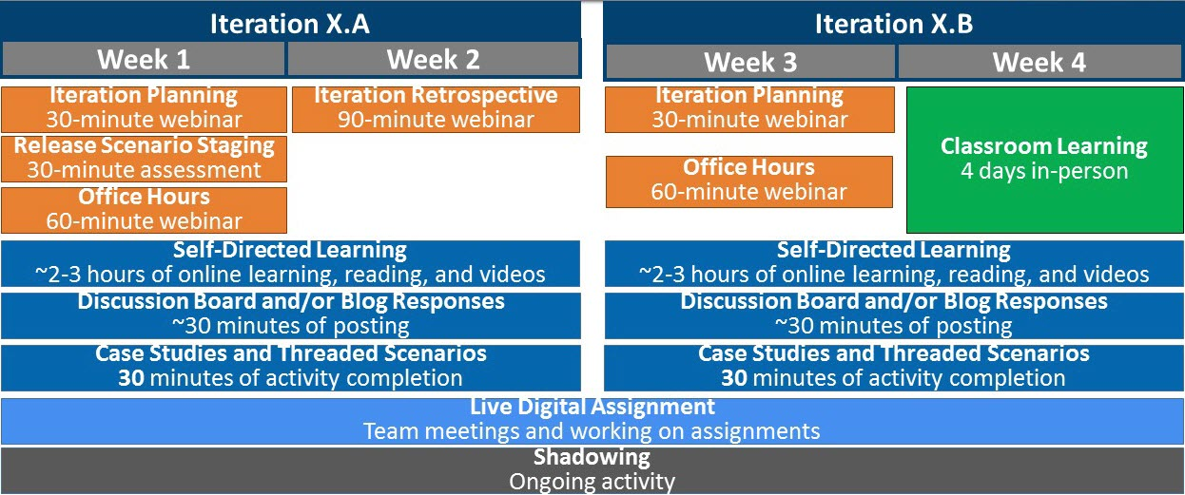

| Session/Activity | Description |
| --- | --- |
| Iteration Planning Meeting | The iteration planning meeting is an introduction to the content, sessions, activities and timing in each two-week iteration. Plan on about 30-minutes every other Monday to attend this session in Adobe Connect so you know what’s going on in the program. |
| Release Scenario Staging | Release scenario staging is a case study scenario that you review and answer questions about. It introduces you to the content and helps you to target your development during the release. It is located in the edX platform and should take 30 minutes to complete. You should complete this activity first when you begin a new iteration. |
| Web Conferences | Web conferences are an opportunity to address course content, function as an office hours session to answer questions or discuss additional information, function as a retrospective of what you learned, or hold a Demo Day for the Live Digital Assignments. These web conferences will range from 60 to 90 minutes and will be hosted on Adobe Connect. |
| Self-Directed Learning | Self-directed learning includes online learning and readings that can be completed on your own time. Both are located in the edX platform. Use your IDP to guide what you should engage in or review those activities that are interesting to you. |
| Discussion Board Responses | Posting on discussion boards gives you the opportunity to start conversations, ask questions, and participate in the course community. You should post discussion board responses in each iteration. |
| Applied Learning | These activities, including the SBA Case Study, Threaded Scenario, and Acqu-a-thons encourage you to demonstrate what you’ve learned in a safe space while contributing to the field. |
| Collaborative Classroom Session | Collaborative classroom sessions are an opportunity for you to come together with your cohort and dive into topics that you haven’t tackled yet, practice what you’ve learned in a safe space, and reflect on the habits you’re developing. Sessions are typically four days in length and will be conducted face-to-face. |
| Live Digital Assignment | The live digital assignment is a group project throughout the program that helps you to take what you’ve learned and apply it to a digital acquisition challenge. Additional information about the live digital assignment appears later in this packet. |
| Shadowing | During the program, you will be required to shadow a digital services implementation/delivery team, i.e., a team that is “on the ground” developing digital services. Additional information about this assignment appears later in this packet. |

Other opportunities for participation and engagement will also occur in the program. These opportunities will be added to the Course Info tab. Examples might include speaking engagements like panels and remarks, opportunities to do a short mini-rotation in a digital office, creating blogs or writing social media posts, and other external contributions including consulting.

# Guest Speakers

**Instructions:** Take notes on the guest speakers in the space provided below.

|  |
| --- |
| Notes |
|  |

# Getting started with edX & Completing the Pre-Assessment

**Step 1:** To participate in the course, you must first register with edX and enroll in the course. You will receive an invite to enroll in the course via email. Follow the instructions in the email to access the portal and register for the course. You will be prompted to enter your email address, full name, a username, and a password.

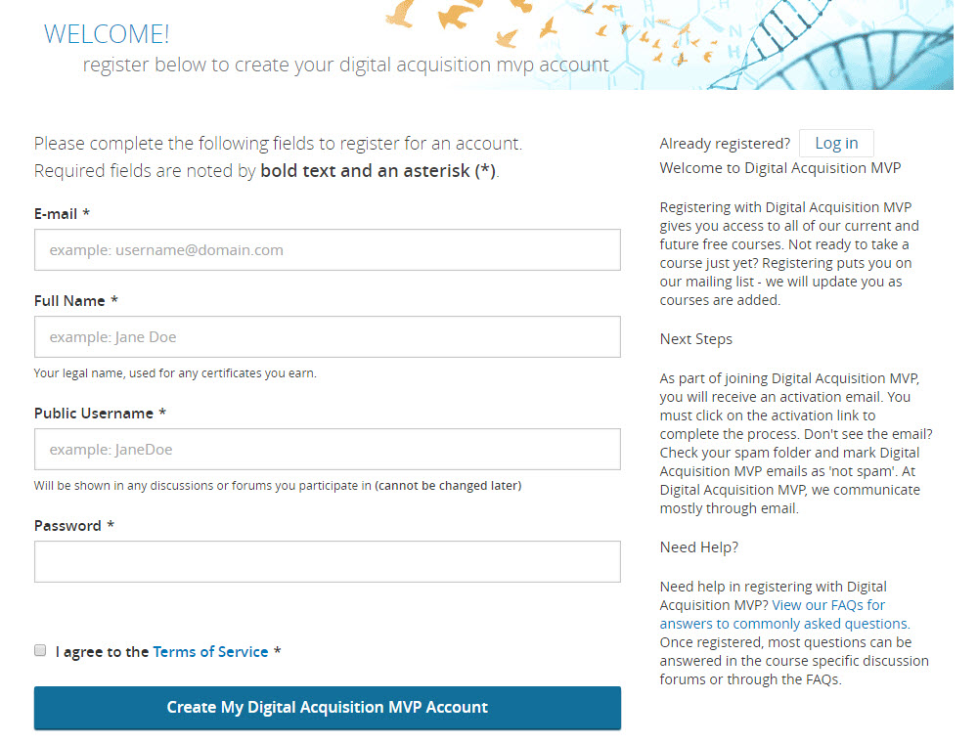

**Step 2:** Once you register, you will be able to login and view course content.

**Step 3:** To access the **Pre-Assessment**, select the **Course** tab along the top navigation bar. C:\Users\36823\Desktop\MVP_Course.jpg

Then, using the side navigation bar, select **Individual Development Plan**, as shown below**.** Instructions for completing the pre-assessment should appear.

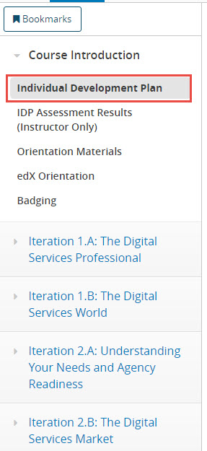

# Action Shadowing - Expectations, Roles, and Benefits

During the program, you will be required to shadow a digital services implementation/delivery team, i.e., a team that is “on the ground” developing digital services.

Action shadowing will provide you with the opportunity to observe and interact with a digital services team in action as a “day in the life” experience. The action shadowing experience will:

* Build your familiarity with modern design and development approaches.
* Engage directly with digital services teams to learn about their work.
* Build a network with digital services experts that you can leverage in your home agency.

Other shadowing basics include:

|  |  |
| --- | --- |
| **What is it?** | An activity where you find an opportunity to shadow a digital services implementation/delivery team |

|  |  |
| --- | --- |
| **What’s the format?** | **Shadowing Opportunity Selection Criteria:** You may choose to shadow a product manager, developer, designer, or anyone on a digital services delivery team within or outside of government. Examples of shadowing opportunities you might select include shadowing an agile team at GSA’s 18F, USDS, or within an agency and attending backlog grooming and sprint planning sessions with the team.    During Release 1, you will be given additional guidance to support you in ensuring an effective shadowing experience and to help the individual you select for shadowing support you effectively. Note that you are responsible for identifying an appropriate shadowing assignment that aligns with the above criteria. The program faculty will support you, as needed. |

|  |  |
| --- | --- |
| **How long will it take?** | **Requirements**: You will need to complete two days (16 hours) of observation and participation with the team you select to shadow. These shadowing segments can either occur in one-day segments or in two consecutive days. Since the goal is to provide you with a feel for digital services implementation/delivery in action, attending “one-off” meetings that add up to 16 hours are not allowed. This is an opportunity for more substantive involvement.  **Completion Timeframe:** You can complete the shadowing assignment at any time during the program, but the opportunity must be identified by the end of Release 2. When identified, share it with the program faculty at our program email address. The actual shadowing experience must be completed by Dec. 31, 2016.  **Deliverable:** A shadowing completion form will be required which will capture the experience and the outcomes learned and must also be completed for course participation credit by Dec. 31. |

**Extra Participation Badge:** Participation badges will be provided to any student who completes more than the two required shadowing assignments or additional days. An additional shadow completion form shall be completed for any additional assignment. If additional days are added, please include that in the required submission form for credit.

# Activity – Plan a Meeting

**Instructions:** In this activity, you will have 15 minutes to plan an all-hands meeting based on the following scenario:

Your manager is out and has asked you to plan an all-hands meeting including determining the agenda and who will lead the meeting. Read through the instructions and plan for the meeting in your group. Be prepared to share your results with the full group during the debrief – aka you will be presenting your proposal to your boss.

As you work through this activity, feel free to jot down notes in the space provided below:

|  |
| --- |
| Notes |
|  |

# Reflection – What Does This Mean for You?

**Instructions:** Take about 10-15 minutes to respond to the following three reflection questions on your DiSC assessment results. Share your reflections with a partner in the classroom.

***What did you learn about your style?***

***What did you learn about how you best interact with others? What are some situations where you would thrive vs. struggle?***

***What are some situations where your style and that of another individual’s may be in conflict (in general)?***

# Live Digital Assignment - Expectations, Roles, and Benefits

During the program, you will work with an assigned team to complete a live digital assignment.

The live digital assignment is an opportunity for participants to practice and experiment with what they are learning in the class. By the completing the live digital assignment, you will:

* Hone your teamwork skills by working in groups
* Practice consultative, critical thinking, and problem solving skills in alignment with the overall program goals
* Identify a relevant digital services acquisition challenge that could benefit from a study, tool, guide, or solution

Other points of consideration for the live digital assignment are as follows:

|  |  |
| --- | --- |
| **What is it?** | A group project throughout the program to take what you’ve learned and apply it to a real digital challenge faced by an agency. |
|  | | |
| **What do I have to do?** | * Put in the time and take it seriously * Push your limits by thinking outside the box * Connect with your group regularly |

|  |  |
| --- | --- |
| **What are the outcomes of the Live Digital Assignment?** | The outcome of the live digital assignment will be a **final briefing**, **case study**, and **artifact/deliverable** that will be presented to a panel of judges during the capstone classroom session. |

|  |  |
| --- | --- |
| **Evaluation Criteria** | Each participant will be evaluated on four dimensions – two dimensions that are evaluated by the peers in their group and two dimensions evaluated on by faculty and other program leadership team members:  **Peer Rating**   * Engaged Contribution * Collaborative Action   **Program Leadership Rating**   * Technical Communication * Analytical Ability |

# Live Digital Assignment Plan

| **Section of Program** | **Task Overview** | **Deliverables** | **Deadline** | **Time Commitment** |
| --- | --- | --- | --- | --- |
| Orientation | * Select a “real life” digital services acquisition challenge. * Use the Design process to draft a hypothesis to solve the challenge. * Submit proposed project & hypothesis to your assigned USDS coach. You will collaborate with them to ensure it is achievable. | * Submit project idea and draft hypothesis by the end of Day 3. * Your USDS assignment guide will provide feedback. | * Draft hypothesis: Aug. 4 * Final hypothesis: Aug. 12 | 3-4 hours |
| Iteration 1.A | * Create a plan for how your team plans to execute and test your approved hypothesis. Describe how you plan to use agile principles to execute your plan. * Work with your USDS guide and program faculty during office hours to refine your plan. | * Create a draft plan for submission. * Your USDS assignment guide will provide feedback. * Finalize your plan. | * Draft plan: Thursday, Aug. 18 * Final plan: Thursday, Sept. 1 | 4-6 hours |
| Iteration 1.B | * Create a product vision * Set up systems or other collaboration tools that will allow you to execute your plan. * Share your hypothesis and product vision as part of a Demo Day. | * Create a draft product vision for submission. * Your USDS assignment guide will provide feedback. * Finalize your product vision. | * Draft product vision: Sept. 9 * Final product vision: Oct. 6 | 4 hours |
| **Release 2** | * Execute your experiment according to your plan. | * Schedule regular meetings with your USDS guide. | * N/A | 6- 8 hours |
| **Release 3** | * Continue execution of your experiment. * Present on assignment progress during guided learning session Demo Days. | * Develop 5-minute presentations of iterative deliverables (mockups/prototypes, etc.) to deliver during Demo Day | * Demo Day 1: Thursday, Nov. 3 * Demo Day 2: Tuesday, Nov. 22 | 8 hours |
| **Release 4/Capstone** | * Develop a final briefing, case study, and artifact/deliverable for presentation | * Submit a final briefing, case study, and artifact. * Present your final briefing to an evaluation panel. | * Submit materials by Friday, Jan. 6 * Present during the capstone classroom session on Monday, Jan. 9-Wednesday, Jan. 11 | 8-10 hours |

# Agile at ICF

**Roles and Responsibilities – by PMBOK Practice**

|  |  |  |
| --- | --- | --- |
| PMBOK Practices | Scrum Team Responsibilities | Project Manager Responsibilities |
| Scope Management | * Team prioritizes Product Backlog throughout the life of the project per Product Owner guidance | * Manages per the contract * Requests Mods for significant scope changes * Works with COR |
| Procurement Management | * Scrum Master communicates needs to PM | * Follows ICF’s Procurement Department policies and processes to establish and maintain the appropriate agreement(s) |
| Time Management | * Team creates and maintains Release Strategy and Road Map; based on key milestones per the contract | * Reviews and approves Release Planning outputs * Monitors Agile Management Tool / receives updates from Scrum Master |
| Communication Management | * Participates in all Scrum Meetings * Continuously collaborates * Updates Agile Management Tool with progress | * Reports project status to Senior Management, Customer, and any other non-Scrum Team stakeholders * Receives updates from Scrum Master |
| Cost Management | * Not involved in Cost Management activities | * Creates, maintains, and reconciles the project budget |
| Quality Management | * Scrum Team agrees on QA/QC processes based on Definition of Done / Acceptance Criteria * Testing, peer reviews, etc. | * Reviews and approves QA/QC procedures defined by the Scrum Team |
| Human Resource Management | * Team communicates upcoming time off * Scrum Master communicates resource needs to PM | * Works with Resource Manager to establish and maintain Project Team * Works with Human Resources department to address performance issues, if any |
| Risk Management | * Team presents impediments daily during stand-ups reducing potential risk impacts * Team continuously collaborates which minimizes risk impact on the project | * Identifies and monitors risks throughout the life of the project in a Risk Register * Reports risk status to Senior Management, Customer, and any other non-Scrum Team stakeholders |

# Agile at ICF

**Roles and Responsibilities – by Scrum Phase**

| ROLE | RELEASE PLANNING | SPRINT PLANNING | SPRINT IMPLEMENTATION | SPRINT REVIEW | SPRINT RETROSPECTIVE |
| --- | --- | --- | --- | --- | --- |
| Product Owner | * Creates and Prioritizes the Product Backlog based on highest business value * Reviews and approves Release Planning outputs * Radiates information to internal stakeholders | * Ensures Product Backlog items are entered and prioritized in an Agile management tool * Conveys why the items are important * Helps to establish/ revise the goal for each Sprint * Answers any clarification questions from the Scrum Team about the items to be completed | * Attendance in the daily stand-up meetings is up to the Scrum Team * Is available to the Scrum Team for clarification/questions | * Observes, asks questions, provides feedback * Approves work completed * Post Review: radiates information to internal stakeholders | * If the Product Owner is the Customer: Informed of the applicable Sprint Retrospective results * If the Product Owner is not the Customer: Attendance in the Sprint Retrospective is up to the Scrum Team |
| Sc Scrum Master | * Works with Product Owner to create user stories * Assists in Product Backlog grooming * Facilitates user story estimation * Conducts Release Planning meeting * Completes the Release Road Map * Reviews the Road Map with Product Owner * Radiates information to the organization, as needed | * Preps meeting materials * Facilitates meeting | * Facilitates daily stand-ups * Removes impediments * Captures metrics (e.g., burn-down) * Communicates with Product Owner (as applicable) | * Facilitates Sprint Review, declares which items are “done” | * Collects and derives Sprint metrics * Communicates metrics to Scrum Team, as applicable, and the Project Manager * Schedules and facilitates Retrospective meeting * Captures and analyzes meeting results to be used during Sprint Planning |
| Development Team | * Adds user stories to Product Backlog * Assists in Product Backlog grooming * Estimates user stories * Identifies and provides feedback for technical priority considerations or impediments | * Creates and/or updates stories/tasks * Estimates stories/tasks * Volunteers to implement tasks | * Participates in daily stand-ups * Implements Sprint Backlog items | * Demos sprint items, answers questions, notes new capabilities discovered | * Provides perspective and input based on their role on the Scrum Team (e.g. tester, developer, etc.) * Identifies potential impediments that may hinder progress * Identifies standard workarounds for impediments encountered, when applicable * Informed of metrics analysis results, as applicable |
| Additional Stakeholders (SMEs, Users, Customers, Internal groups, Owning groups) | * SME(s): provides expert input related to prioritization and needs * User(s): provides user   perspective/priorities   * Internal groups (HR, CIT, Procurement, etc.): provide input on resources and support, as needed * Owning groups (BIS, SAS, TRS, etc. if work is shared across ICF Operating Groups) | * SMEs that will perform work during the Sprint participate in the meeting as members of the Development Team (if applicable) | * SMEs may serve as Development Team Members, as needed | * Observes, asks questions, provides feedback | * Non-Scrum Team members who participated in the sprint may attend |
| Project Manager | * Communicates contract scope constraints * Identifies external impacts to Release Planning * Provides Resources * Reviews and approves plans * Supports Product Owner to manage Product Backlog * Supports Scrum Master, or other lead roles, where applicable | * Communicates scope, schedule, and budget constraints ahead of time or during the meeting * Provides resources * Supports Scrum Master, or other lead roles, where applicable | * ​Reviews Sprint progress * Addresses impediments, where applicable * Manages risks, scope, schedule, and budget based on Sprint progress * Supports Scrum Master, or other lead roles, where applicable | * Participates in the Sprint Review, if applicable | * Project Manager involved in quantitative analysis * Provides perspective and input from a project management view (PM attendance is up to the Scrum Team) * Identifies potential impediments that may hinder progress * Identifies workarounds for impediments encountered, when applicable * Analyzes Sprint Retrospective results to determine corrective actions to project resources, schedule, or budget |

# Program Expectations

Here are some tips on how to get the most out of your participation in the program.

|  |  |
| --- | --- |
|  | **Participate in the sessions and activities**   * Use the edX learning platform to launch sessions and activities associated with the course. * Stay tuned into “Course Info” in edX for other opportunities to support your development as they come up throughout the course. * Share your thoughts and ideas using the discussion boards and Wiki when you’re not in the classroom or webinars. |
|  | **Share what you’ve learned with others at your home agency**   * Update other team members on a periodic basis. * Conduct workshops and training sessions with your colleagues at your home agency. |
|  | **Advocate for and shape your development – agile enables us to shape the course to your needs**   * Complete periodic assessments distributed by the facilitation team throughout the course. * Offer ongoing feedback about what you’re learning and what you would like to learn more about. * Leverage the connections around you – mentors, live digital assignment leads, and your cohort colleagues to further your learning and development. |
|  | **Take calculated risks to experiment with what you learn.**   * Reflect on where you can best apply what you have learned to your daily work and identify “safe spaces” to experiment. * Connect with your manager or other team members who can help you to identify these places to practice. |
|  | **Involve others in your development**   * Engage your manager and team members back at your agency. * Share experiences, observations, and challenges with cohort participants. * Use your facilitator as a resource to ask questions and coach you through content. * Connect with your mentor on your development trajectory and opportunities. |
|  | **Hold yourself accountable for your development with clear timelines.** |