Digital Services Roundtable Activity

Digital Acquisition MVP

Table of Contents

Program Context 1

Activity Summary – What You’ll Be Doing 1

Activity Background – What the Participants Will Have Done Prior to This Activity 3

MAP Case Study Background 3

Developing the Acquisition Strategy 3

Developing the RFQ 4

# Program Context

ICF and USDS are currently running a second pilot offering of the Digital Acquisition Program, which is a four-month learning & development program for contracting professionals across the Federal government. To date, participants have completed three months of the program. This classroom session focuses on innovative methods for acquiring digital services. Your role is to provide vendor feedback in order to help contracting professionals better understand the vendor perspective and to push them to think “outside the box” about how to approach digital acquisition challenges.

As a secondary part of this activity, we would like you to share any examples you have of digital service acquisitions that you have responded to that have been effective in encouraging innovation and delivering value for the government.

# Activity Summary – What You’ll Be Doing

**Attendees:** Rohan Bhobe, David Yang, Mary Schwarz, Steve Ziegler, Jared Elling, & Rami Aboushakra

**Timing:** 1:00-4:00 pm, Nov. 17

**Activity Duration:** 3 hours

**Activity Goal:** By the end of this activity, participants will be able to discuss/analyze a draft acquisition package and incorporate feedback from vendors. A secondary goal of this activity is to continue to promote innovative/creative thinking on the part of the participants around how to most effectively procure digital services that deliver outcomes for the government.

**Activity Summary:**

* Prior to this activity, each team will have developed an acquisition strategy for a case study, selected an SOO (among a series of templates provided by USDS that align with the customer’s maturity with respect to agile/modern design and development practices), and developed their evaluation criteria and methods.
* For this activity, participants will take what they have completed to date in drafting their acquisition package, and they will present their ideas to invited vendors for feedback and discussion. One vendor will be assigned to each of the six teams. Vendors provide feedback to the teams on their acquisition packages and how they can continue to improve them so as to encourage innovative vendor responses, etc.
* Next, the invited vendors will share any examples they’ve brought in of digital service acquisitions that they have responded to that have been effective in encouraging innovation and delivering value for the government.

**Activity Instructions:** The activity is broken down as follows:

* **Share Ideas/Tradeoffs/Thought Process with Vendors (15 minutes).** Teams share the story of how they got to this point and the decisions they made along the way. Vendors can ask clarifying questions during this time, but they should hold off on providing feedback.
* **Vendors Provide Initial Feedback/Answer Questions (30 minutes).** Vendors provide feedback based on what they heard.
* **Participants and Vendors Work to Refine Components of Acquisition Package Based on Feedback (30 minutes).** Based on the feedback/discussion, teams select something that they can work on improving over the course of 30 minutes. This may be clarifying components of their evaluation criteria or writing a more compelling call to action in their SOO.
* **Team Report-Outs (1 hour).** Teams select a spokesperson and then share the results of their discussions with the class. Each team will have five minutes to share and then five minutes of questions from the rest of the class.
* **Break –** 15 minutes
* **Future Marketplace Directions/Other Exemplar RFPs (30 minutes).** The invited vendors participate in a brief panel discussion around other exemplar RFPs that they have responded to in the digital services space as well as their thoughts on where the marketplace is going.

# Activity Background – What the Participants Will Have Done Prior to This Activity

The following outlines the steps that the Digital Services Acquisition MVP participants have taken in preparation for this activity.

## MAP Case Study Background

Earlier in the course, participants were given a case study of a mock government agency: The Department of Metaphors, Acronyms, and Passive Writing (MAP). In the scenario, MAP uses a proprietary application that is not user friendly or effective for MAP employees, leadership, and customers.

Given a product vision, participants were to analyze the digital services need of the agency to determine what services or products in the marketplace already exist and may meet the agency’s needs. Groups were assigned to evaluate either open source, proprietary, or commercial off-the-shelf (COTS) options.

***Product Vision:*** *This product will enable government and private sector customers with the ability to create and receive real time feedback on compliant government documentation which adapts to current literary trends and protocols.*

## Developing the Acquisition Strategy

After conducting their initial market research, participants were required to develop an acquisition strategy using a Lean Acquisition Canvas template (pictured below).

**Lean Acquisition Canvas: *Plan of Action***

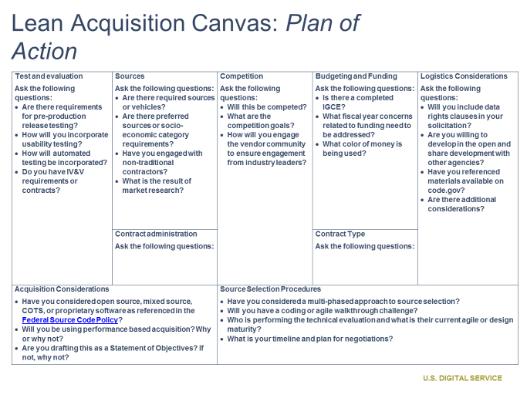

**Lean Acquisition Canvas: *Acquisition Background and Objectives***

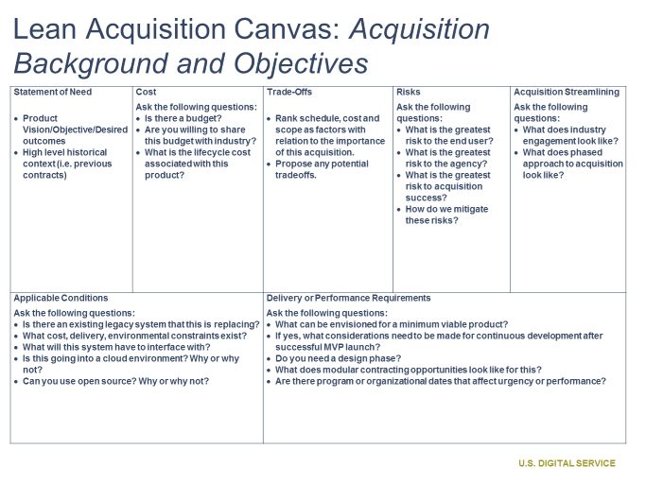

## Developing the RFQ

Following the development of their acquisition strategy, participants were given three templatized SOOs that the U.S. Digital Service has developed. Participants were to select the SOO template that they felt would be the best fit for their acquisition strategy.

* **Digital Minimum Viable Product (MVP):** The objective of this (contract/task order) is to utilize digital service techniques to identify and solve a core user need through the development and release to end users of a Digital Minimum Viable Product (MVP). This SOO is predicated on the fact that (AGENCY) stakeholders have a level of understanding User Experience (UX) design thinking and/or agile software development. For example, job responsibilities within (AGENCY) have been redefined according to agile and/or human-centered design roles, and stakeholders are comfortable enough with modern technology concepts and are ready to start delivery of a digital service product by developing an MVP.
* **Select your Technology:** In light of the release of the Federal Source Code Policy (https://sourcecode.cio.gov/) and the overall desire to update and modernize technology in agencies, the objective of this (contract/task order) is to assist (AGENCY) with the identification and analysis of a modern technology platform that would fit in the (AGENCY) environment for the launch of new digital service products and migration off end of life legacy systems.
* **Learn the Process:** The objective of this (contract/task order) is to assist (AGENCY) with the implementation and adoption of User Experience (UX) design thinking and/or agile software development, which can then be used by the (AGENCY) on future digital service development efforts. These services will be epitomized by driving towards the delivery of quality product within rapid time frames through the utilization of the industry best practices.

Next, participants developed evaluation criteria and methods. In the classroom session, they have broken into groups and continued building out sections of the RFQ.