Scenario 1

Part 1A

Scenario 1

Part 1B

The Department of Digital Services (DS) Program Support Center (PSC) currently maintains a variety of digital assets, including DS.gov, ServicesZone, and service-specific applications. PSC desires to engage with their customers (DS and non-DS employees) by providing a customer-focused experience for a suite of targeted services such as Telecommute Tracking Assignments (TTA) and Digital Services Program Management (DSPM). They use the agile methodology to manage the project.

These are built to be deployed as a service and can be configured with little customization to extend service offerings beyond DS to other departments and agencies with the same business needs. This example is for Digital Service Program Management (DSPM). The Agile team consists of 5 people.

As the CO, you need to compare two burndown charts from the DSPM: Chart 15-5 on the left, which has a three week long sprint and about 400 starting working hours; and Chart 15-8 on the right, which has a two week long sprint and about 180 starting working hours. The vertical axis for both charts indicates the number of hours left in the sprint. The horizontal axis presents each day.

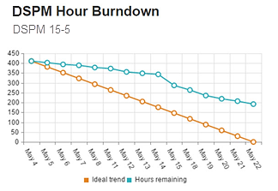 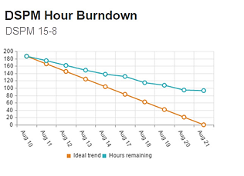

**Discussion Question: What do you observe about these two burndown charts? What are some reasons that 15-5 could be a three week long sprint and 15-8 could be a two week long sprint?**

Scenario 1

Part 2

Scenario 1

Part 3

Sprint 15-5 could be three weeks and Sprint 15-8 could be two weeks because the team began scoping tighter user stories.

Now, think about scope. Examine where the charts in both Sprint 15-5 and 15-8 level off.

**Discussion Question: How could a change in scope cause the chart to level off or show a notable drop? What are some examples that might arise on an agile project?**

Let’s look at these charts from a resourcing perspective.

**Discussion Question: How could changes (good or bad) in resourcing cause the chart to level off or show a notable drop? What effect could staff availability or staff capabilities (expertise) have on resource allocation?**

Scenario 1

Part 4

This scenario was pulled from a real-life agile team. You had discussions about user story scope and resources, but there are other potential reasons why the data leveled off, like recidivism and technical debt. Here are the actual circumstances that occurred within the DSPM team.

In DSPM Sprint 15-5, the following things were factors that affected the burndown chart:

* The DSPM team did have well-defined user stories and the right resources allocated to the tasks.
* The chart leveled off on May 14 due to a change in scope. The product owner changed the scope in mid-Sprint which led to confusion and additional rework. The product owner also requested a pilot to be added in mid-Sprint.

In DSPM Sprint 15-8, the following event had a significant effect on the burndown chart:

* Again, the DSPM team did have well defined user stories and the right resources allocated to the task.
* The Sprint was progressing prior to 8/17 while the product owner was on vacation. Upon the product owner’s return to work, the Sprint levels off due to product owner’s attempt to change the Sprint scope.

Scenario 2

Part 1

Scenario 2

Part 2

An agile team has been tasked to build a system that will provide federal employees with the ability to apply for transit benefits online and the workflow/capability that allows administrators to manage benefits. The team has 10 months to complete the system.

The team created a list of stories to complete. Here is the list they created:

Story 1 – As a Management System (MS) Admin or Assistant Program Manager or MS Program Manager, I would like to be able to Manage Participants - View and Edit Benefits Information - View Submission History. *What the team tells you - the database structure supports these updates.*

Story 2 - As a Benefits Application (BA) end user, I should have the ability to update my benefits, even after the application has been approved. Any changes after approval will initiate a new approval workflow.

* Scenario 1: Benefit in Draft status-New applicant (Application not in Approval Process and no prior active and approved benefit for the Applicant)
* Scenario 2: Benefits in approval workflow- Not fully approved
* Scenario 3: Benefits updated after Final approval (fully approved) (For users with an existing approved benefits).
* Scenario 4: Update on the MS side

*What the team tells you – the database structures does not support these updates.*

**Discussion Question: Looking at the scenario above, can you foresee any problems that might occur?**

Now that you have thought about what could have happened, here are the problems that actually occurred in this scenario:

* The agile team had to get this done within a single sprint (two weeks). Towards the end of the project, the team had switched from three weeks sprint to two weeks. There were too many scenarios associated with Story 2.
* On story 2, there were extra challenges for the developers due to changes needed to be done to the database structure that was already completed.

These problems in Story 2 affected almost all the areas of the project – from the approval workflow to the front end, the Admin Module, and the database itself. It was not possible for the team to complete this story within the sprint.

**Discussion Question: Now that you know what happened, let’s shift gears and talk about user stories. What are criteria that you should use when creating strong user stories?**

Scenario 2

Part 3

Scenario 2

Part 4

The team should have tested the scope of their stories by asking if they were:

* Independent
* Negotiable
* Valuable
* Estimate-able
* Small
* Testable

**Discussion Question: Discuss how these tests could prevent the problems in the scenario.**

In this scenario, the scope of the stories and scenarios was too big. They should have been made into epics with multiple, smaller stories and scenarios below them that could be completed independently.

Let’s return to the second user story presented on Scenario 2, Part 1. What if the agile team determined that the database restructuring should be a priority for the team, given how important it is to users?

**Discussion Question: As a CO, what are the tradeoffs that you should explain to the product owner and team on an agile project?**

Scenario 2

Part 5

In order to keep QUALITY as a constant deliverable:

* **Vary the Scope –** The team could prioritize spending time on the database adjustments, but may need to decrease the focus on lower priority requirements that will remain in the product backlog.
* **Vary the Schedule** – The team can extend the schedule to accommodate other lower priority requirements that will not be gotten to as a result of the database adjustments. This will likely also require an increase in resources if these priorities are important.
* **Vary the Resources –** The team can increase the resources to accommodate other lower priority requirements (which will likely also include an extension to the schedule unless more team members are brought on).

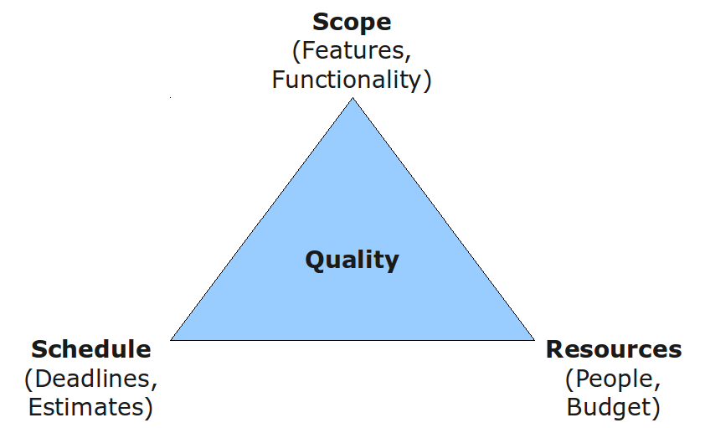

Scenario 4

Part 1a

Scenario 4

Part 1b

You are overseeing two digital services projects. One is going well – the burndown chart is tracking well, and the task is moving forward. The other is not going well – the burndown chart shows a loss of momentum, and the task has reached a bottleneck. Below are the details about each:

**Communication Tracking & Approval (CTA 2.0)** - Government-wide polices have resulted in the need for enhanced controls and processes for requesting, approving and tracking spending on communication. Your team was tasked to develop the Communication Tracking & Approval (CTA 2.0) Orderable Service Module (OSM) within the GovZone system to automate the conference request and approval process, and to prevent underreporting to OMB & OIG on communication expenditures and possible ADA violations.

**Training Systems Program Management (TSPM)** - This project will result in a new application that consists of a Training Management System (TMS) and Training Benefit Application (TBA) integrated into the GovZone site for submitting applications for training benefits and managing approval of these applications, along with administering the payment and billing for these benefits.

Here are the burndown charts for each project:

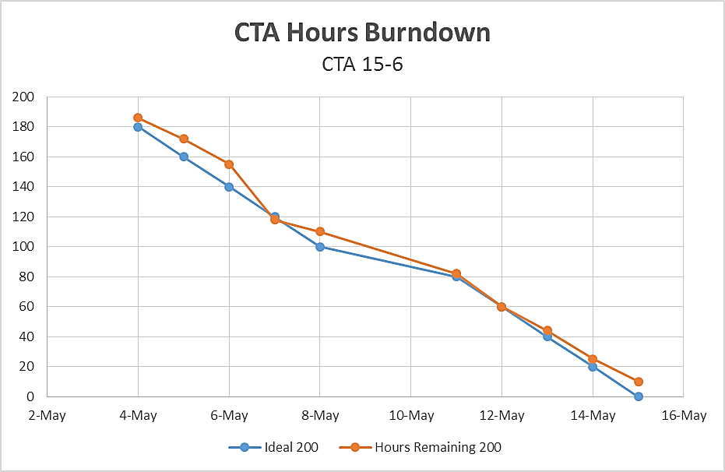 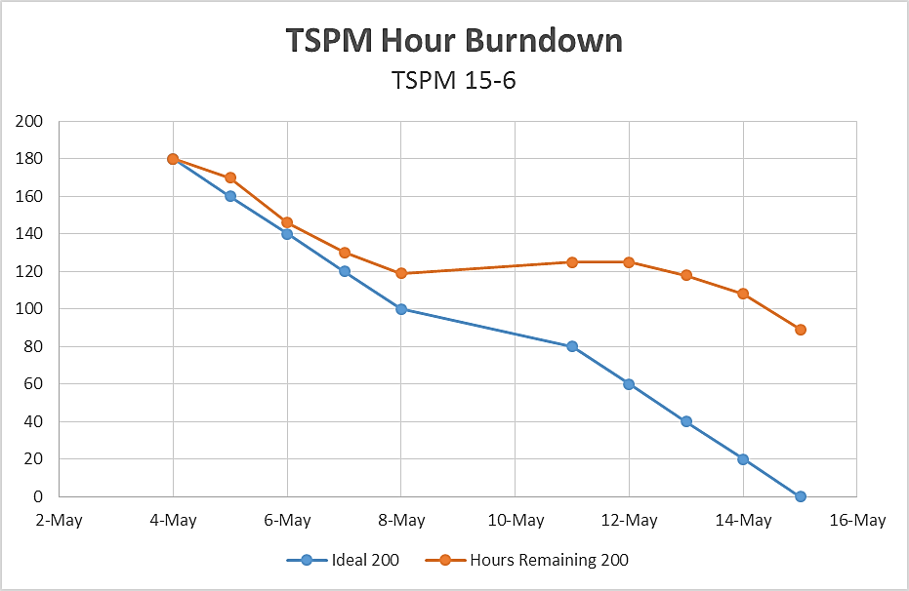

**Discussion Question: Describe what might be happening on each project (remember to reflect on the scope, schedule, and resources).**

Scenario 4

Part 2

Scenario 4

Part 3

Here are the details about what is happening in each project:

Communication Tracking & Approval (CTA 2.0)

* Well-defined user stories.
* Successful product backlog reviews by setting realistic Sprint goals.
* Right resources allocated to the tasks.
* Product owner understood the Agile process, fully participated in meetings/Sprint demo, and did not introduce changes to the scope during Sprint.
* The burndown chart was shared and discussed with the Agile team in daily stand-up and weekly status meetings. Blockers were identified and mitigated in a timely matter. The management team closely encouraged and monitored the burndown chart.

Training Systems Program Management (TSPM)

* Well-defined user stories.
* Successful product backlog reviews by setting realistic Sprint goals.
* Right resources allocated to the tasks.
* Product owner was not always available to participate in meetings/Sprint demo, and continuously introduced changes to the scope during Sprint. The project came to a standstill due to scope changes in the mid-Sprint.
* There’s no designated Scrum Master for the project. The Scrum Master would have the authority to disallow scope changes during mid-Sprint.

**Discussion Question: As a CO, you are going to run the contract administration meeting. What are the types of topics that you might bring up in each meeting?**

The answers will vary for Part 3’s question.

However, now that you have thought about how you would run each meeting, are there things you can share with each team to keep/improve their momentum?

Do you use the same techniques for teams doing poorly as you do for teams doing well?

This answer will also vary, but share ideas as a group and take notes on new tricks that you may not have known.