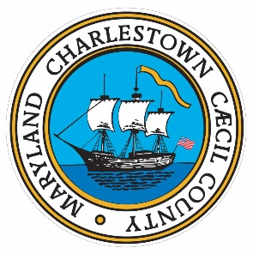

Town of Charlestown
241 Market Street
P.O. Box 154
Charlestown, MD 21914
(410) 287-6173

Charlestown Election Results

Here's the FINAL vote count, in order of votes:

Tom Costanzi- 96
Renee Capano - 88
Felecia Kennedy - 83
Tracey Moore - 82
Dennis Wood - 78
Jack Kroner - 42

Sincerely
Ken Hamilton
Town Administrator
Charlestown Md

