***Robin E. Winston***

***The Winston/Terrell Group***

***1449 North Pennsylvania Street***

***Indianapolis, IN 46202***

***317.917.1953 (W)***

***317.294.9572 (C)***

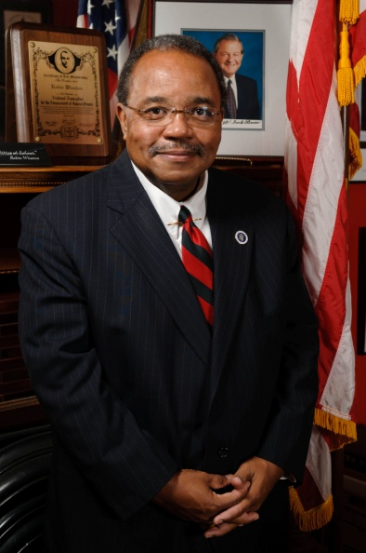An accomplished business leader and a skilled political strategist, Robin Winston has devoted his career to providing timely and savvy strategic, finance, management, marketing, and political advice to the people for whom he has worked. In 1999, he made history when he became the first African-American to chair a major political party in Indiana.

A native of Washington, Pennsylvania, Mr. Winston moved to Kentucky to pursue his education and start a career in business and government. He is a graduate of the University of Louisville, where he was elected president of the student body.

After a brief stint as a lobbyist for higher education in his native Pennsylvania, Winston returned to Louisville and served as assistant director of St. Benedict’s Center for Early Childhood Education, a United Way-funded not-for-profit. Mr. Winston improved service to Louisville’s minority community by more than doubling enrollment and establishing programs to certify all staff in early childhood development. After inheriting a financial deficit, he left the center with a substantial surplus.

Also in Louisville, Mr. Winston served as chief of staff at the city’s legislative body, the Board of Aldermen. He handled constituent requests, assisted with public relations and community outreach for the board, analyzed legislation, and won two national awards for cost-saving innovations. Mr. Winston also operated a political consulting firm and served as general consultant to successful campaigns for city council, county commissioner, county prosecutor, state attorney general, and congress.

Moving to Indianapolis in 1993, Mr. Winston became a community development specialist in the Indiana Department of Commerce. He served as then-Lieutenant Governor Frank O’Bannon’s representative to communities across Indiana. While serving in the Commerce Department, Mr. Winston directed $11 million in grants to communities to improve infrastructure, housing, municipal facilities, and preserve historic buildings.

Mr. Winston then accepted Lieutenant Governor O’Bannon’s invitation to join his personal staff as a special assistant. In that capacity, Mr. Winston served as the lieutenant governor’s liaison to several economic development agencies including the Indiana Housing Finance Authority, the Small Business Development Corp., the Minority Business Development Commission, and the Community Development Division of the state Commerce Department. Mr. Winston focused on enhancing community outreach for the agencies and served as a principal advisor to then-Lieutenant Governor O’Bannon.

Mr. Winston left public employment in 1996 and became deputy director of O’Bannon’s successful campaign to be elected governor. Following the election, Mr. Winston became political director of the Indiana Democratic Party. He became Chairman in 1999 at the request of Governor O’Bannon and United States Senator Evan Bayh.

Indiana Democrats fared well during his term as Chairman. Winston helped direct coordinated campaigns that provided funds and logistical support to Indiana mayoral candidates in 1999, which resulted in a record number of Democratic mayors being elected, including a first-time victory in Indianapolis metro government and the first Democratic mayor in twelve years in Fort Wayne. Scores of Democrats were elected to local municipal offices in 1999. In 2000, the Indiana Democratic Party provided coordinated campaign support for the reelection of Governor Frank O’Bannon and maintaining leadership in the Indiana House of Representatives. In addition, Winston worked with other Democrats to raise a record amount of funds to support party-building and outreach activities across Indiana.

Now a successful businessman in Indianapolis, he runs one the largest minority-owned government affairs, community relations and public outreach firm in Midwest. The Winston/Terrell Group has successfully represented clients in the transportation, human services, homeland security and public utilities fields. With affiliate offices in Chicago; Columbus, Ohio; Louisville and partnerships in Washington, DC, Winston’s firm continues to expand its capabilities to serve diverse clients.

Public outreach, community relations and government affairs reinforce his commitment to diversity. He has led the effort for inclusion of minority-owned firms on federal, state and local projects. Using personal funds, Winston started a scholarship program for inner-city public school students who planned to attend college.

A life member of the NAACP and a member of 100 Black Men, Mr. Winston has served on the Boards of Advisors of the Madame Walker Theatre, the Pike Schools Education Foundation and assists the Association of Retarded Citizens. He formerly was a member of the Eagle Creek Park Foundation, the Help America Vote Act Steering Committee and the Eagle Society of the Eiteljorg Museum. He also served as a member of the board of the Indianapolis Museum of Art, the Indianapolis Urban League and the Indianapolis Cable Franchise Board. In addition, Winston is a political analyst for WTHR, Indiana's most-watched television station and a columnist for *The Indianapolis Business Journal*.

In 2008, he worked with the Obama for President staff on the General Election campaign. His firm provided office space for the GOTV, Field and Legal components of the campaign. He maintained close working relationships with the State Director of the campaign and assisted on logistics for events held in Indiana.

He lives in Indianapolis with his wife, Charlitta Winston, and their daughter, Chloe Margaret Winston.