ENDORSEMENT LETTER

Date: _____________________

To:
The Institutional Review Board (Ethics)
La Consolacion College Bacolod

Through:
The Research and Creative Works Office (RCWO)
Subject: Endorsement of Research Proposal for Ethics Review
Dear Members of the Institutional Review Board,
This is to endorse the research proposal entitled:
“Auditrack: A Compliance and Audit Management System for Accreditation”
authored by:
VJ A. Javellana
BSIT3, School of Business and Information Technology
Having reviewed the attached documents, I confirm that the proposal has undergone initial departmental review and meets the requirements for submission to the Institutional Review Board (IRB) for ethical evaluation.
I respectfully forward this proposal for your consideration and action in accordance with established procedures.
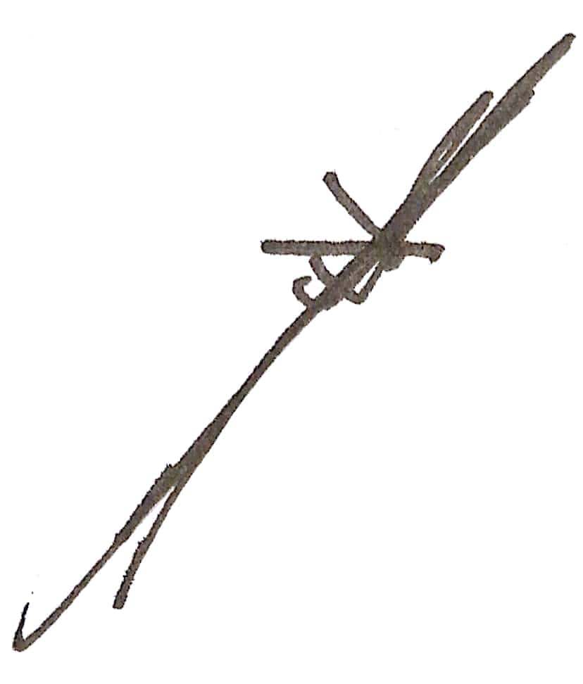
Thank you very much.
Respectfully,
Lenuel S. Betita, MIT
LCCB-RES-FO-11
Issue Date: August 29, 2025
Approved by: President
Issue No: 01 Rev. No. 00
BSIT Program Head
School of Business and Information Technology
La Consolacion College Bacolod

