CivicRecords AI
Unified Design Specification
Version 2.0
April 12, 2026
Draft for Review

Supersedes: Master Design Specification v1 (April 11, 2026)
Incorporates: Master Design Spec, Municipal Open Records UX Style Guide,
Design Critique (April 2026), Context-Mode Architecture Patterns,
Universal Discovery & Connection Architecture

How to Read This Document
This is the single source of truth for CivicRecords AI. Every feature, data model change, design decision, and implementation detail lives here. Each feature is tagged with a phase:

- [BUILT] — Available since v0.1.0; tested through v1.4.1
- [REDESIGN] — Built but needs UI/UX overhaul
- [MVP-NOW] — Must be added before v1.0 release
- [v1.1] — Next release after initial deployment
- [v2.0] — Future capability, architecture should not preclude it

1. Product Summary

What It Is
Open-source, locally-hosted AI system for municipal open records request processing. Runs on commodity hardware via Docker. No cloud, no vendor lock-in, no telemetry.

North-Star Statement
Any resident should be able to search for public records, request what is missing, and understand the status of their request without needing insider knowledge of city government.
Staff corollary: Any records clerk should be able to triage, search, review, redact, and respond to records requests from a single calm interface without falling back to email, spreadsheets, or paper.

What It Is Not
- Not a records management system — it indexes and searches what already exists.
- Not a legal advisor — it surfaces suggestions, staff make all decisions.
- Not a cloud service — every deployment is a sovereign instance owned by the city.
- Not a public-facing portal in v1.0 — internal staff tool first. Public portal in v1.1.

Design Stance
Transparent, calm, accessible, and government-appropriate. Civic and competent: calmer than a startup SaaS product, but cleaner and more modern than a legacy government form portal. The aesthetic target is trust through clarity, not visual excitement.

Core Design Principles
- Clarity over bureaucracy — residents should not need to understand government structure to make a good request.
- Transparency over mystery — statuses, timelines, costs, and next actions should always be visible.
- Consistency over one-off screens — shared patterns reduce confusion and development cost.
- Accessibility over compliance theater — forms and documents must be usable, not merely technically valid.
- Operational calm over case chaos — staff views should help triage and decision-making, not add clutter.
- Human-in-the-loop always — no auto-redaction, no auto-denial, no auto-release. Every AI output is a draft.

2. User Groups

Staff Users (v1.0)
User Group | Primary Need | Design Response
City clerk / records officer | Triage, route, communicate, and complete requests. | Queue views, routing rules, templates, SLA timers, full event history.
Department liaison | Provide documents and answer scoped questions quickly. | Scoped assignment view, internal notes, due dates, one-click return to records team.
Legal / reviewer | Review exemptions, redactions, and sensitive material. | Review queue, exemption tags, redaction ledger, approval state.
City IT administrator | Install, configure, and maintain the system. | Docker Compose, admin panel, model management, audit export.

Public Users (v1.1)
User Group | Primary Need | Design Response
Resident / first-time requester | Submit a request without knowing the exact record title or department. | Guided request flow, plain-language examples, estimated turnaround, visible help.
Journalist / researcher | Search existing records and request additional material efficiently. | Robust search, saved filters, exportable results, request history.

RBAC Roles
Role | Scope | Phase
admin | Full system access, user management, configuration | [BUILT]
staff | Request management, search, ingestion, exemption review | [BUILT]
reviewer | Read-only access plus exemption review approval | [BUILT]
read_only | View dashboards and reports only | [BUILT]
liaison | Scoped to assigned department, can attach documents and add notes | [MVP-NOW]
public | Submit requests, track own requests, search published records | [v1.1]

3. Information Architecture

Staff Workbench (v1.0) — 8 Pages
Page | Purpose | Phase
Dashboard | System health, operational metrics, SLA overview | [REDESIGN]
Search | Hybrid RAG search across ingested documents | [REDESIGN]
Requests | Request queue with triage, routing, SLA timers | [REDESIGN]
Request Detail | Single request: details, workflow, documents, timeline, response letter | [REDESIGN]
Exemptions | Exemption rules management and flag review dashboard | [REDESIGN]
Sources | Data source configuration and file upload | [REDESIGN]
Ingestion | Document processing status and pipeline monitoring | [REDESIGN]
Users | User management and role assignment | [REDESIGN]

Public Portal (v1.1) — 5 Pages
Page | Purpose | Phase
Home | Search bar, common categories, response-time guidance, top tasks | [v1.1]
Search Records | Published records index with filters | [v1.1]
Make a Request | Guided intake wizard with scope helper | [v1.1]
Track a Request | Public timeline, messages, delivered files, fees | [v1.1]
Help & Policy | Open records law summary, fee schedule, exemptions, contact info | [v1.1]

Navigation Rules
- Staff workbench: Sidebar navigation (not top nav). Better for 8+ items, standard for admin panels. Active page highlighted with left border accent.
- Public portal: Top navigation with no more than 6 top-level choices. Complex routing inside guided flows.
- Every page must be identifiable from peripheral vision — unique page icon, header treatment, or accent color.

4. System Architecture

Docker Compose Stack [BUILT]
1. postgres — PostgreSQL 17 + pgvector (data, vectors, audit)
2. redis — Redis 7.2 (BSD license, pinned <8.0)
3. api — FastAPI application server (port 8000)
4. worker — Celery worker(s) for async ingestion/embedding/notifications
5. beat — Celery Beat scheduler for periodic tasks
6. ollama — Local LLM runtime (Gemma 4 + nomic-embed-text)
7. frontend — React/nginx (port 8080)

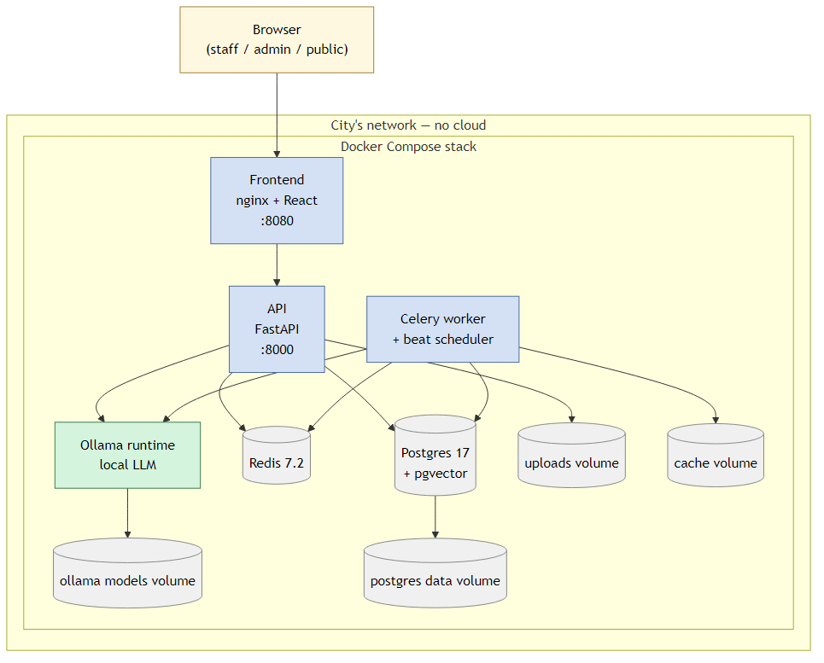
Deployment stack — entire system runs inside Docker Compose on the city's network. No cloud, no outbound by default.
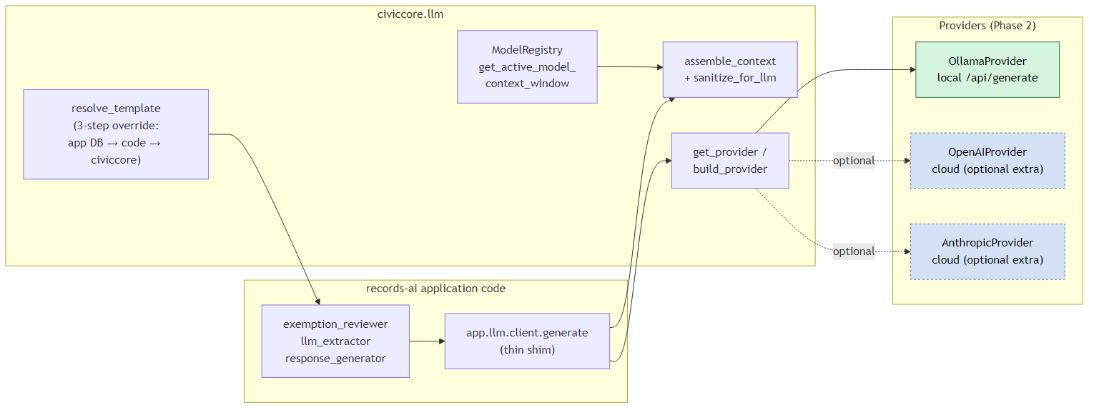
LLM call flow — records-ai routes through civiccore.llm (context assembly, template resolution, model registry, provider factory) to a local Ollama provider.
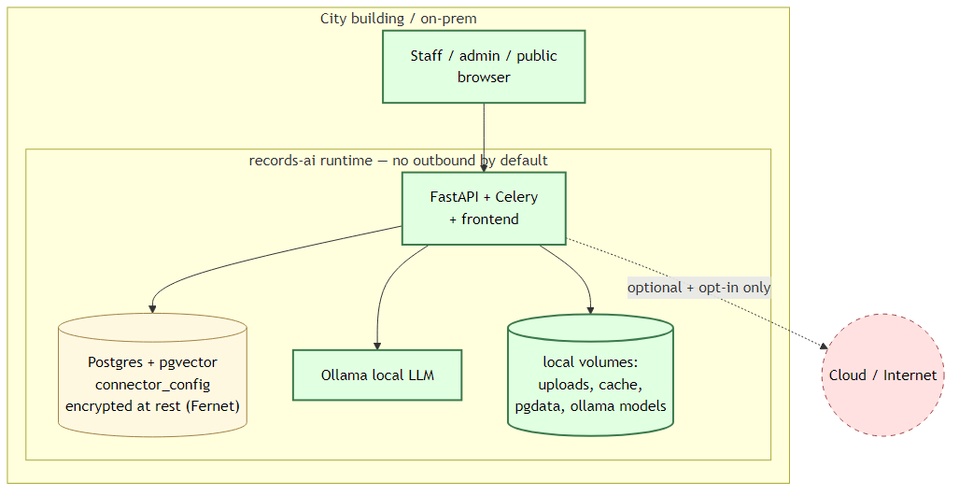
Sovereignty boundary — all runtime components live inside the city's on-prem network. Cloud is opt-in only.

Application Modules
Module | Responsibility | Phase
Auth Module | fastapi-users, JWT, RBAC, service accounts | [BUILT]
Search API | RAG queries, hybrid retrieval, source attribution, session context | [BUILT]
Workflow API | Request CRUD, status transitions, document association, deadline mgmt | [BUILT]
Audit Logger | Hash-chained append-only logging, CSV/JSON export | [BUILT]
LLM Abstraction | Model-agnostic Ollama wrapper, chat + embedding endpoints | [BUILT]
Exemption Engine | Rules engine (regex, keyword, statutory) + LLM suggestions | [BUILT]
Context Manager | Smart prompt assembly with token budgeting for local LLM | [MVP-NOW]
Notification Service | Email templates via Celery tasks, SMTP integration | [MVP-NOW]
Fee Tracking | Fee estimation, payment status, waiver management | [MVP-NOW]
Response Generator | Template-based response letter generation with LLM assist | [MVP-NOW]
Analytics API | Operational metrics, SLA compliance, workload reporting | [MVP-NOW]
Federation API | REST endpoints for inter-instance queries via service accounts | [BUILT]
Public API | Read-only endpoints for public portal with rate limiting | [v1.1]

Context Management for Local LLM [MVP-NOW]
Local LLMs (Ollama) have limited context windows (8K–128K tokens). Municipal documents are large. The system must be deliberate about what enters the LLM prompt.

Token Budget System
Each LLM call has a configurable maximum context budget, partitioned into reserved sections:
System instruction: ~500 tokens (fixed)
Request context: ~500 tokens (requester, deadline, description)
Retrieved chunks: ~5000 tokens (top-k from hybrid search)
Exemption rules: ~500 tokens (applicable state rules)
Output reservation: ~1500 tokens (response generation space)
Safety margin: ~192 tokens

Smart Context Assembly
- Pre-filter with PostgreSQL FTS (tsvector) for keyword relevance.
- Rank with pgvector for semantic relevance.
- Select top-k chunks that fit within budget.
- Include metadata (source filename, page number, date) but not full text of non-relevant sections.

Model-Aware Budgeting
Context budget reads from model_registry table. When the admin switches from Gemma 4 (8K) to Llama 3.3 (128K), budgets auto-adjust via the context_window_size column.

5. Data Model
All tables below are annotated with their implementation phase. New tables and columns added in this spec are marked.

Auth & Administration
users: id, email, hashed_password, display_name, role, department_id [MVP-NOW],
is_active, is_verified, created_at
role ENUM: admin, staff, reviewer, read_only, liaison [MVP-NOW]

departments [MVP-NOW]: id, name, code, contact_email, created_at

audit_log: id, user_id, action, resource_type, resource_id,
details (JSON), ip_address, previous_hash, current_hash, created_at

service_accounts: id, name, api_key_hash (SHA-256), role, scopes (JSON),
created_by, is_active

Documents & Ingestion
data_sources: id, name, type (file_share/database/email/upload/sharepoint/api),
connection_config (encrypted JSON), schedule, status, created_by

documents: id, source_id, source_path, filename, display_name [MVP-NOW],
file_type, file_hash (SHA-256), file_size, ingestion_status,
ingested_at, metadata (JSON), department_id [MVP-NOW]

document_chunks: id, document_id, chunk_index, content_text,
embedding Vector(768), token_count

Search & RAG
search_sessions: id, user_id, created_at
search_queries: id, session_id, query_text, filters (JSON), results_count,
ai_summary, created_at
search_results: id, query_id, chunk_id, similarity_score, rank,
normalized_score [MVP-NOW] (0-100 scale)
saved_searches [v1.1]: id, user_id, name, query_text, filters (JSON), created_at

Request Tracking
records_requests: id, requester_name, requester_email,
requester_phone [MVP-NOW], requester_type [MVP-NOW],
date_received, statutory_deadline, description,
scope_assessment [MVP-NOW] (narrow/moderate/broad),
status, assigned_to, department_id [MVP-NOW],
estimated_fee [MVP-NOW], fee_status [MVP-NOW],
fee_waiver_requested [MVP-NOW], priority [MVP-NOW],
created_by, closed_at [MVP-NOW], closure_reason [MVP-NOW]

Status ENUM (expanded):
received, clarification_needed [MVP-NOW], assigned [MVP-NOW],
searching, in_review, ready_for_release [MVP-NOW],
drafted, approved, fulfilled [MVP-NOW], closed [MVP-NOW]

request_documents: id, request_id, document_id, relevance_note,
exemption_flags (JSON), inclusion_status

request_timeline [MVP-NOW]: id, request_id, event_type, actor_id,
actor_role, description, internal_note, created_at

request_messages [MVP-NOW]: id, request_id, sender_type, sender_id,
message_text, is_internal, created_at

response_letters [MVP-NOW]: id, request_id, template_id, generated_content,
edited_content, status (draft/approved/sent),
generated_by, approved_by, sent_at

Fees [MVP-NOW]
fee_schedules: id, jurisdiction, fee_type, amount, description,
effective_date, created_by
fee_line_items: id, request_id, fee_schedule_id, description,
quantity, unit_price, total, status

Notifications [MVP-NOW]
notification_templates: id, event_type, channel, subject_template,
body_template, is_active, created_by
notification_log: id, template_id, recipient_email, request_id,
channel, status, sent_at, error_message

Exemption Detection
exemption_rules [BUILT]: id, state_code, category, rule_type,
rule_definition, enabled, created_by
exemption_flags [BUILT]: id, chunk_id, rule_id, request_id, category,
confidence, status, reviewed_by, reviewed_at,
review_note [MVP-NOW]
redaction_ledger [v1.1]: id, request_id, document_id, page_number,
redaction_type, exemption_basis, redacted_by, created_at

6. Visual Design System

Design Tokens
Token | Value | Usage
brand.primary | #1F5A84 | Core actions, links, active navigation
brand.primaryDark | #163D59 | Page titles, hover states
brand.primaryLight | #E8F0F7 | Info backgrounds, selected states
text.default | #1F2933 | Body text, headings
text.muted | #5B6975 | Secondary text, labels, metadata
surface.default | #FFFFFF | Page background, card background
surface.subtle | #F6F9FB | Alternate row, section background
surface.border | #C8D3DC | Card borders, dividers
status.success | #2B6E4F | Completed, released, available
status.warning | #8A5A0A | Pending, clarification needed, approaching deadline
status.danger | #8B2E2E | Overdue, denied, failed

Typography Scale
Element | Phase 0 baseline (v0.1.0) | Target (v1.0)
H1 (page title) | Not used | 36px / 700 weight
H2 (section head) | 20px / 600 weight | 28px / 600 weight
H3 (subsection) | 14px / 500 weight | 22px / 600 weight
Body | 16px / 400 weight | 16px / 400 weight (no change)
Labels | 14px / mixed | 13px / 500 weight / uppercase / 0.05em spacing
Stat card numbers | Mixed sizes | 36px / 700 weight for primary metrics

Status Badge Color Mapping
Status | Color Role | Icon
Received | info (blue) | Inbox
Clarification needed | warning (amber) | MessageCircle
Assigned | info (blue) | UserCheck
Searching | info (blue) | Search
In review | warning (amber) | Eye
Ready for release | success (green) | CheckCircle
Drafted | info (blue) | FileText
Approved | success (green) | ShieldCheck
Fulfilled | success (green) | Send
Closed | neutral (gray) | Archive
Every badge includes an icon — never color-only. Accessible for colorblind users.

Button Variants (3 only)
Variant | Use | Style
Primary | Main page action (New Request, Submit for Review) | Filled brand.primary, white text
Secondary | Supporting actions (Search & Attach, Export) | Outlined brand.primary border, transparent bg
Ghost | Tertiary actions (Sign out, Cancel, Back) | Text-only, hover bg surface.subtle

7. Workflow Patterns

7.1 Request Lifecycle
The full request lifecycle from receipt to closure:
[Received] → [Clarification Needed]? → [Assigned] → [Searching]
→ [In Review] → [Ready for Release] → [Drafted]
→ [Approved] → [Fulfilled] → [Closed]

Every status transition:
- Writes to request_timeline
- Writes to audit_log
- Triggers notification (if template exists for that transition)
- Updates records_requests.status

7.2 Response Letter Generation [MVP-NOW]
- Clerk clicks [Generate Response Letter] on Request Detail
- System assembles context within token budget: request, documents, exemptions, templates, fees
- LLM generates draft letter (labeled as AI-generated draft)
- Clerk edits in rich text editor
- Submit for Approval → Supervisor reviews → Approve → Send

7.3 Notification Templates [MVP-NOW]
Event | Recipient | Channel
Request received | Requester | Email
Clarification needed | Requester | Email
Request assigned | Liaison | In-app
Deadline approaching (3 days) | Assigned staff | In-app + Email
Deadline overdue | Assigned staff + Admin | In-app + Email
Records ready | Requester | Email
Request closed | Requester | Email
Tone: reassuring, plain language, explain process. Never defensive or legalistic.

8. Accessibility Standards
Target: WCAG 2.2 AA from day one.
Requirement | Current State | Target
Color contrast | Passes (text ~15:1, muted ~5.7:1) | Maintain
Touch targets | FAIL (nav links 20px, no padding) | 44x44px minimum on all interactive elements
Focus visibility | No visible focus styles | focus:ring-2 focus:ring-primary on all focusables
Skip navigation | Missing | Add skip-to-content link
ARIA landmarks | Good (nav role, table aria-labels) | Maintain + add to new components
Color-only indicators | Status badges use color only | Add icons to every badge
Keyboard navigation | Untested | Full keyboard completion for all workflows
Form error handling | Not tested | Preserve data on validation error, focus first error
Screen reader | Untested | Test with NVDA/VoiceOver before v1.0

Content Design Rules
- Lead with action: "Tell us what records you need" not "Records Request Submission Form"
- Explain why data is requested when the reason is not obvious.
- Never hide important policy terms only in tooltips.
- Every closed/denied request shows reason in human language plus formal basis.
- Replace jargon: "responsive documents" becomes "records found for release"
- Every error state explains: what happened, how to fix it, how to get help.

9. Compliance Architecture [BUILT]
Based on the 50-state regulatory analysis. These are hard requirements enforced at the API layer.

Human-in-the-Loop
- No auto-redaction. Every exemption flag requires affirmative human action.
- No auto-denial. No denial or partial-denial response generated without human decision.
- No auto-release. No document transmitted to requester without explicit human authorization.
- All AI content labeled as "AI-generated draft requiring human review" at the API layer.

Audit Logging
- Hash-chained, append-only audit log.
- Every API call logged with user, action, resource, timestamp, IP.
- Exportable as CSV/JSON for compliance audits.
- Retention policy configurable (cleanup job [MVP-NOW]).

Data Sovereignty
- No outbound network connections (verification scripts provided).
- No telemetry, analytics beacons, or external API calls.
- All processing local. LLM runs on-premises via Ollama.
- All dependencies permissive or weak-copyleft licensed.

10. Technical Implementation Plan

Build Order

Phase 0: Design Foundation [MVP-NOW — do first]
- Install shadcn/ui
- Map design tokens to CSS variables
- Build sidebar layout shell
- Create component variants (buttons, badges, cards, tables)
- Typography scale implementation

Phase 1: Staff Workbench Redesign [MVP-NOW — 8 pages]
- Dashboard with operational metrics
- Search with normalized scores and empty states
- Requests with filtering, priority, SLA indicators
- Request Detail with timeline, messages, fees
- Exemptions with flag review workflow
- Sources with guided setup and integration cards
- Ingestion with clean filenames and progress
- Users with department assignment

Phase 2: New Backend Features [MVP-NOW]
- Database migrations (departments, fees, timeline, messages, notifications, prompts)
- Notification service (Celery + SMTP)
- Response letter generation (LLM + templates)
- Context manager (token budgeting for Ollama)
- Fee tracking API
- Request scope assessment API
- Operational analytics API
- Liaison role + department scoping
- Audit retention cleanup task

Phase 3: Public Portal [v1.1]
- Public API with rate limiting
- Public homepage and search
- Guided request wizard
- Public request tracker
- Published records index and saved searches

Phase 4: Transparency Layer [v2.0]
- Open records library with curated collections
- Reporting dashboards and trend analytics
- Public request archive (closed requests, opt-in)
- Federation between CivicRecords AI instances

12. Universal Discovery & Connection Architecture

12.0 Why This Section Matters
Open records requests can touch any system a city operates. Clerks often spend more time finding records than reviewing them. This section defines how CivicRecords AI finds, connects to, and monitors data sources automatically.
Instead of you tracking down every system that might have responsive records, CivicRecords AI learns what systems your city uses and goes looking for you. You still decide what gets released.

12.1 Municipal Knowledge Graph
The system ships with a curated Municipal Systems Catalog — a structured graph mapping functional domains to systems, data shapes, access protocols, and discovery hints. Organized by 12 functional domains.

Domain | Typical Systems | Sensitivity
Finance & Budgeting | Tyler Munis, Caselle, OpenGov, SAP | Tax IDs, bank accounts, SSNs
Public Safety | Mark43, Spillman, Axon, Genetec | CJIS-protected, juvenile records
Land Use & Permitting | Accela, CityWorks, EnerGov | Homeowner PII, contractor data
Human Resources | NEOGOV, Workday, ADP, Paylocity | HIPAA, background checks, SSNs
Document Management | Laserfiche, OnBase, SharePoint | Varies
Email & Communication | Microsoft 365, Google Workspace | Personal emails, deliberations
Utilities & Public Works | CIS Infinity, Cartegraph, Lucity | Account numbers, payment info
Courts & Legal | Tyler Odyssey, Journal Technologies | Sealed records, juvenile cases
Parks & Recreation | RecTrac, CivicRec, ActiveNet | Minor personal info, payment data
Asset & Fleet Mgmt | Samsara, Asset Panda, FleetWave | Driver IDs, GPS patrol patterns
Legacy & Custom | AS/400, Access DBs, FoxPro, flat files | Often unknown
The catalog is community-maintained and versioned. Cities contribute updates. Local config is never overwritten.

12.2 Guided Onboarding Interview
An LLM-guided adaptive interview that starts broad and gets specific based on answers. Three phases:
- Phase 1: City Profile (5–10 min) — state, population, email platform, IT staffing, request volume.
- Phase 2: System Identification (10–20 min) — walks through each domain, asks targeted questions based on city profile.
- Phase 3: Gap Map (5 min) — identifies domains where the city should have data but hasn't identified a source.
Output: a City Profile with confirmed systems, gap map, IT environment notes, and priority ranking.

12.3 Active Discovery Engine [v1.1]
With explicit IT permission, scans the local network and cross-references findings against the Systems Catalog.
After setup, the system looks around your network and says: 'I found a database that looks like your parks reservation system. Want me to connect to it?' It never connects without your approval.
- Method 1: Network Service Scanning — fingerprints on common ports (SQL 1433, PostgreSQL 5432, SMB, HTTP).
- Method 2: Directory Enumeration — Active Directory service accounts and security groups.
- Method 3: API Endpoint Probing [v2.0] — standard vendor API paths. Probe only, no auth.

Confidence Scoring
Score | Meaning | Admin Action
90–100% | High confidence — vendor API confirmed | One-click confirm and connect
60–89% | Probable match — DB name or service account pattern | Review details, confirm, authorize
30–59% | Possible match — type unclear | Investigate with IT, classify manually
Below 30% | Unknown — unidentifiable | Flag for IT review or ignore

12.4 Universal Connector Protocol
Every connector implements four standard operations:
- authenticate() — secure connection via OAuth2, DB credentials, API key, or service account.
- discover() — enumerate available records in the source system.
- fetch() — pull records and convert to standard document format.
- health_check() — verify connection alive, credentials valid, schema unchanged.

Protocol | Best For | Phase
File System / SMB | Shared drives, document repos, scanned archives | [MVP-NOW]
SMTP / IMAP Journal | Email archives (#1 source for records requests) | [MVP-NOW]
REST API (Modern SaaS) | Tyler, Accela, NEOGOV, cloud platforms | [v1.1]
ODBC / JDBC Bridge | On-prem databases, legacy SQL, AS/400 | [v1.1]
GIS REST API | Esri ArcGIS, spatial data, property records | [v2.0]
Vendor SDK | Evidence management (Axon), CAD systems | [v2.0]
Manual / Export Drop | Systems with no API — clerk uploads | [MVP-NOW]

12.5 Continuous Discovery & Self-Healing
Weekly scheduled discovery runs detect new, changed, and lost sources. Connection health monitoring with automatic handling:
- Expired OAuth2 tokens: auto-refreshed.
- Temporary outages: exponential backoff (1m → 5m → 15m → 60m).
- Password rotation: detects auth failures, prompts admin.
- Schema drift: pauses ingestion, alerts admin with change description.
- API rate limiting: auto-throttles, shifts to off-peak hours.

Coverage Gap Analysis
Cross-references connected sources against request patterns monthly. Example:
32% of your requests reference 'police' or 'incident report,' but you don't have a public safety data source connected. Would you like help setting that up?

12.6 Handling Unknown and Legacy Systems
For unknown databases, the system can enumerate table/column names (with authorization) and feed metadata to the LLM for characterization.
Schema Metadata Sensitivity
- Schema enumeration results stored encrypted at rest, never in plaintext.
- LLM characterization subject to same context management rules as document content.
- Audit trail records enumeration occurred but does not log table/column names in plaintext.
- LLM describes system function in general terms without echoing sensitive names.

Manual Fallback Paths (priority order)
- 1. Watched folder — department exports to designated folder, system auto-ingests.
- 2. Scheduled export — IT cron job dumps data to drop location.
- 3. Manual upload — staff upload via Sources page. Universal fallback.
- 4. RPA bridge [v2.0] — last resort. Deploy only when: no API, no export, no DB access, AND high request frequency.

12.7 Tiered Redaction Engine
Extends the Exemption Engine with automated detection in three tiers. All redaction is proposal-only — humans approve.

Tier | Method | What It Detects | Phase
Tier 1 | RegEx pattern matching | SSNs, credit cards, phone numbers, email, bank accounts, driver's licenses | [MVP-NOW]
Tier 2 | NLP/NER (Ollama or spaCy) | Person names in sensitive contexts, medical info, juvenile IDs, attorney-client privilege | [v1.1]
Tier 3 | Visual AI (GPU required) | Faces/plates in video, OCR for scanned docs, speech-to-text for 911 recordings | [v2.0]

12.8 Security & Compliance
Permission Model
- Network discovery: disabled by default, explicit IT opt-in, scope-limited, audit-logged.
- Every connection: admin must review, confirm, provide credentials, and authorize.
- Credentials: AES-256 encrypted at rest. Never logged, exported, or displayed after entry.
- Least-privilege: read-only accounts and API scopes. System never writes to source systems.

Originals vs. Redacted Derivatives
Redaction produces a separate Derivative copy. Original preserved read-only. Redaction ledger records every redaction with legal basis and approving staff member. Non-destructive.

CJIS Compliance for Public Safety Connectors
Connecting to police records triggers FBI CJIS Security Policy. Architecture already satisfies encryption (5.10.1), audit logging (5.4), access control (5.5), and no cloud egress (5.10.3.2).
City must also satisfy: fingerprint-based background checks (5.12), signed CJIS Security Addendum, and security awareness training (5.2).
Enforcement: CJIS compliance checklist blocks public safety connector activation until admin confirms all requirements. Gate applies regardless of how the source was discovered.

12.9 Data Model Additions
7 new tables:
city_profile [MVP-NOW], system_catalog [MVP-NOW], connector_templates [MVP-NOW]
discovered_sources [v1.1], discovery_runs [v1.1], source_health_log [v1.1], coverage_gaps [v1.1]

Extended columns on existing tables:
data_sources: +discovered_source_id, connector_template_id, sync_schedule, health_status, schema_hash
documents: +redaction_status, derivative_path, original_locked
exemption_flags: +detection_tier, detection_method, auto_detected
model_registry: +supports_ner, supports_vision

12.11 Engineering Acceptance Criteria
13 criteria including: onboarding completable by clerk alone, network discovery opt-in, connector authorization logged, health checks surfaced on Dashboard, AES-256 credentials, gap map auto-updates, zero false negatives for Tier 1 regex, all redaction proposal-only, CJIS gate enforced, schema metadata encrypted, RPA self-diagnostics.

13. Phased Rollout Roadmap
Phase | What | Exit Criteria
0. Foundations | Token set, component library, sidebar shell, content model | Team agrees on tokens, components, and page patterns
1. Staff redesign | Redesign all 8 pages with new design system | All pages match spec, WCAG 2.2 AA passes, 80+ tests green
2. New features | Fees, notifications, response letters, context manager, analytics | Clerk can process request end-to-end: receive, clarify, search, review, draft, approve, fulfill, close
3. Public portal | Homepage, search, request wizard, tracker, help | Requester can submit, track, and receive records end-to-end
4. Transparency | Open records library, analytics, public archive, federation | City can publish record sets and measure self-service adoption

Engineering Acceptance Criteria
- Every component must support loading, empty, error, and disabled states.
- Every workflow must support keyboard-only completion.
- Role-based permissions change available actions, not layout or naming.
- All status transitions write to audit log automatically.
- Public status pages understandable without staff login.

Appendix A: Migration history (v0.1.0 → v1.4.1)

Status Value Migration
-- 'received', 'searching', 'in_review', 'drafted', 'approved' remain valid
-- New: clarification_needed, assigned, ready_for_release, fulfilled, closed
-- Note: legacy 'sent' value removed in migration 010_remove_sent_status

New Database Tables (12)
departments, fee_schedules, fee_line_items, request_timeline, request_messages, response_letters, notification_templates, notification_log, prompt_templates, saved_searches (v1.1), published_records (v1.1), redaction_ledger (v1.1)

New Columns on Existing Tables
- users: department_id
- documents: display_name, department_id
- records_requests: requester_phone, requester_type, scope_assessment, department_id, estimated_fee, fee_status, fee_waiver_requested, priority, closed_at, closure_reason
- search_results: normalized_score
- exemption_flags: review_note
- model_registry: context_window_size

Appendix B: Document Manifest
File | Purpose
docs/UNIFIED-SPEC.md | This document — single source of truth (markdown version)
docs/DESIGN-CRITIQUE.md | Historical: design audit of v0.1.0 UI
docs/superpowers/specs/2026-04-11-civicrecords-ai-master-design.md | Original build spec (superseded)
QA-VERIFICATION-REPORT.docx | Historical QA report from v0.1.0 (archived)
Municipal Open Records UX Style Guide | External design direction document

This specification was assembled from the original master design spec (67 commits, 80 tests, 5 sub-projects), a live UI design critique of 8 running pages, the Municipal Open Records UX Style Guide, and context-mode architectural patterns.

