Timothy Wilson
Dr. Kallakunta
CPSC-495
22 November 2025
Retrieval Augmented Generation for Economic Analysis
Retrieval Augmented Generation (or RAG) is a powerful tool within the scope of artificial intelligence and langchain in particular. Of the faults that are commonly attributed to artificial intelligence systems, RAG manages to avoid many of them entirely. Standard AI systems leave many professionals with a bad taste in their mouth as risks such as hallucinations seem unavoidable. This weakness, however, is limited to a very narrow model type, and does not exist within RAG systems. This paper will discuss the nature of RAG as well as how I developed a tool for artificial intelligence analysis of global economic data using this tool.
Standard LLMs are considered unstable and unsuitable for professional applications because of their fundamental goal to deliver the content you are looking for. Ultimately, it is their goal to use their creativity to give you exactly what you want, though the factoid you are searching for may be untrue. This is not a design flaw either. If you wish to have a more deterministic conversation with an AI tool, you could choose to reduce the temperature to 0, though you won’t like the change in the long run. There will always be a margin of error within the creativity a model of this caliber must have. RAG is not meant to be creative, it is not intended to creatively show you what you want to see. RAG is more similar to text parsing and regular expressions (regex). But unlike regex, RAG doesn’t compare the individual characters or word sequences verbatim. These sentences are reduced down to their core meaning or even intent; a vector referred to as an embedding. Let’s see what this really means in practice.
In real embedding systems, there are hundreds of dimensions. In our case I will give an example with only three dimensions. Let’s assume that we have the following embeddings known:
King | 1 | 1 | 0
Man | 1 | 0 | 0
Woman | 0 | 0 | 1
King-man+woman | 0 | 1 | 1

With this knowledge, we can take the concept of king, subtract the concept of man, and add the concept of woman. As humans, we can fairly easily add and subtract these abstract concepts without being boggled down by real mathematics. Embeddings allow computers to also view these higher order concepts and mathematically add and subtract these abstractions in much the same way as we do. The concept of (King – Man + Woman) = Queen. This is an oversimplification, but the pattern holds whether tested in 3 dimensions or 1024.
The idea of storing information is also not limited to words. It is entirely possible to store entire sentences or even paragraphs as embeddings. It is commonplace to store massive amounts of data into a series of embeddings. The process involves splitting a text file into chunks, each chunk of text is then converted into its own embedding. If we assume that our embedding is of size 1024, each embedding can be thought of as a direction in 1024-dimensional space. It is worth noting that it is not useful to visualize the vectors as locations in space, but rather directions pointing along a 1024-dimensional unit “circle.” Now we simply have to compare the directions of any two of these vectors to determine their similarity.
If we were to compare the vectors as locations in space, the calculation to determine similarity would be as follows $\frac{A∙B}{||A||*||B||}$ . This calculation is actually quite cumbersome as the process of calculating the length of vector A demands taking $\sqrt{A∙A}$ . This is quite difficult when A represents a vector of size 1024, the computer must calculate the square root of a massive number on a routine basis. The advantage of each embedding having a length of 1 lies in the fact that $\sqrt{A∙A}$ can be entirely avoided as it will result in 1. So we first normalize the embeddings (set their lengths to 1) and then we simply have to calculate the dot product of two vector embeddings ($A∙B$) to compare their directions and therefore the commonalities in their content.
This overview of the embedding process is rather hand-wavey, but I think this is enough information to understand my project on a high level. That said, I will now go over the objective as well as the design process and hurdles I underwent through the creation of my tool.
The goal of my project was to create a tool which could answer high level questions about market information that would otherwise be overlooked or diluted by inaccurate information. It is difficult to gather accurate and up-to-date information using AI tools as they can hallucinate actual events as well as dates and times associated with them. Otherwise, their flexibility is ideal. I wanted to be able to ask specific questions about the consumer price index, tariffs, market certainty, etc. and have relevant and accurate information retrieved. This tool was designed to gather a running log of data within a custom time scope. I found a weekly scope to be the most useful within my testing. I also designed the tool to return a customizable number of results. For instance, I often set instructed the model to return the top 3 results which adhered closest with the user query. This is the core structure of my project, but there it still underwent many changes through the development process. One of the simplest changes made was the use of different sized embedding models.
The first model I used was called all-MiniLM-L6-v2. This was a tiny model with only 384 dimensions. The model itself is largely a community accomplishment built atop MiniLM which was developed by Microsoft research. The design principles clearly intended this model to run as fast as possible while providing quality embeddings. The reduced size of the vectors made a large difference in the speed it took to calculate each chunk embedding. There was one glaring problem with this choice of model. If I was to ask a natural language question such as “What evidence is there of the federal funds rate decreasing?” I might just as well be returned similar questions rather than the answer to my question. This is a very standard problem you can commiserate with when searching for answers online and only finding people equally lost, and this wasn’t something I intended to replicate here.
During the optimization phase, I briefly considered an alternative architecture involving pre-computed query vectors. The theory was that if I could anticipate standard market questions (e.g., 'What is the inflation rate?', 'When is the next Fed meeting?'), I could pre-calculate their embeddings to save time during the actual user interaction. However, after analyzing the vector space dynamics, I determined this would yield no real improvement. The power of the RAG system lies in its ability to handle unique, specific, and unpredictable user syntax. Pre-computing embeddings for 'standard' questions would only assist if the user asked those questions verbatim. If a user asked a 'massive query that is unlikely to be represented' in my pre-computed list, the system would still have to perform the calculation on the fly. Therefore, I discarded this optimizations strategy in favor of a robust, real-time encoding system that treats every user input as a unique vector, ensuring maximum flexibility.
After further testing and discovery, I landed on my choice of a much larger Chinese model known as BAAI/bge-large-en-v1.5 which allowed for over 1024 dimensions rather than 384. In addition, this model allowed a user prompt to be passed in with the query that was customized for my uses at embedding matching. The instructional parameter was the incredible in bridging the gap between an interrogative user query and a declarative text source. By utilizing the BAAI model, I was able to prefix my queries with instructions such as "Represent this sentence for searching relevant economic passages." This essentially warped the vector space, aligning the question "What is the current inflation rate?" with the statement "The current inflation rate is 3.2%," rather than simply finding other questions asking about inflation. This asymmetry in search, mapping a short query to a long document passage, is critical for any retrieval system that aims to be a research assistant rather than a mere conversationalist. The dimensionality increase to 1024 also provided a granular resolution that the 384-dimensional model simply could not capture.
To visualize how this instruction is handled programmatically, we can look at the specific implementation of the query encoding. The code snippet below demonstrates how the instructional prefix is formatted and prepended to the user query before the encoding process begins. Furthermore, it highlights the subsequent vector comparison using cosine similarity, which ranks the available data based on its semantic alignment with the modified query. The sorting of indices effectively bubbles the most relevant economic data to the top of the list.
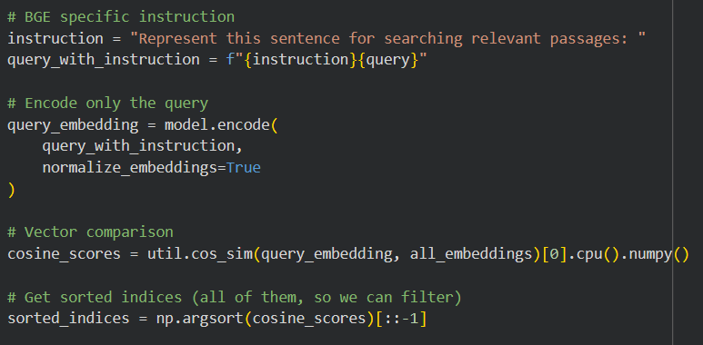
With the embedding model selected, the next major hurdle in the development of this tool was the data ingestion pipeline. A RAG system is only as good as the data it retrieves; if the reservoir of information is stagnant or polluted, the generation will inevitably be flawed. For my purposes, I needed a consistent stream of high-quality financial news and reports. I used the EODhistoricaldata API which fit my needs perfectly. Rate limits were far above my requirements for a quick project and all of the news was accurate and relevant. There were some quirks that I had to get used to. I had to add regex to remove titles and metadata, but besides these minor issues, it was smooth sailing.
Once the raw text was acquired and cleaned, the issue of "chunking" became the primary focus of optimization. As previously mentioned, we convert text into embeddings, but we cannot simply feed an entire ten-page report into a single vector. Doing so would average out the specific details, such as the specific interest rate percentages or tariff schedules, into a muddy, generic vector that represents everything and nothing simultaneously. We must break the text into smaller pieces. I used a possibly naive approach: splitting the text every 500 characters. The idea was that I would split on paragraphs optimally, then sentences, or words only if no other option existed. A more sophisticated approach would be to split on tokens, but with a 50 character overlap, I never suffered from lacking specific intent. I will doubtless build off of this project in the future, and when I do I will pivot to a semantic chunking strategy, utilizing NLP sentence tokenizers to ensure that splits only occurred at logical sentence or paragraph boundaries, but this is not a necessary change.
One unexpected challenge in the development process was the necessity of aggressive data hygiene. During the initial testing phases, I discovered that the 'End of Article' segments were disproportionately appearing in search results. These segments often contain boilerplate text copyright notices, 'related article' links, or disclaimer footers that are semantically generic. Because they are generic, they tend to have a 'neutral' vector direction that can accidentally align with vague user queries. And this did in fact occur during an in class presentation of an early stage of the project. To combat this, I had to implement specific filtering logic to discard chunks that appeared to be metadata or footer content. This ensured that the system was indexing the journalism rather than the website structure.
The actual implementation of this logic relies on a recursive character splitter. The function defined below, process_article_to_data, serves as the core of the ingestion pipeline. It accepts raw article content, applies the splitting parameters (500-character size with 50-character overlap), and filters out metadata artifacts before generating the final embeddings. This ensures that the model encodes only relevant narrative text rather than structural noise which could skew the semantic search.
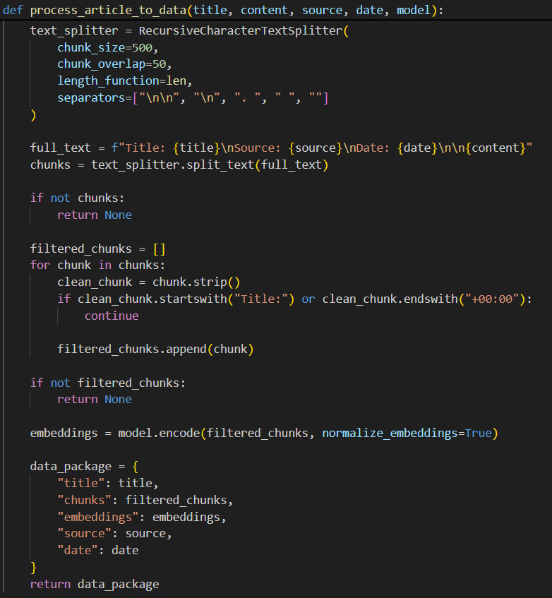

The computational cost of generating these embeddings brought me to the next phase of the project: persistence. In the early builds of the tool, I was re-embedding the entire collection of text every time I ran the script. For a few dozen articles, this was negligible. However, as I expanded the dataset, the startup time became unbearable. The calculation of thousands of 1024-dimensional vectors is a CPU-intensive task (or GPU-intensive, if accelerated). To solve this, I modified the architecture to decouple the embedding process from the retrieval process. I wrote a script to process new articles, generate their embeddings once, and save them to disk, initially using simple Python pickling and later moving to more efficient NumPy array storage. This meant that when I wanted to ask a question, the tool simply had to load the pre-computed vectors. This reduced the query time from minutes to milliseconds. This shift from "on-the-fly" calculation to "vector database" management was the first real step I made that felt meaningful.
To validate the efficacy of the tool, I conducted a series of tests using real-world queries relevant to the current economic cycle. A primary example was the query 'CPI inflation,' which is a broad term that often confuses simple keyword-search algorithms. The system returned three distinct results with similarity scores ranging from 0.7315 to 0.7166. It is important to contextualize these scores: in a high-dimensional vector space, a score of 1.0 represents a perfect mathematical identity. A score above 0.7, however, indicates a strong semantic correlation.
The top result (Score: 0.7315) successfully retrieved a report detailing the 'Personal Consumption Expenditures index,' noting a rise of 2.8% over the 12 months ending in September. This is a critical success for the model because the user query did not contain the words 'Personal,' 'Consumption,' or 'Expenditures.' Yet, the embedding model correctly identified that 'CPI' (Consumer Price Index) and 'PCE' (Personal Consumption Expenditures) are semantically adjacent concepts used to measure inflation. This ability to retrieve conceptually related data without requiring exact keyword matches is the defining advantage of vector-based retrieval over traditional search methods.

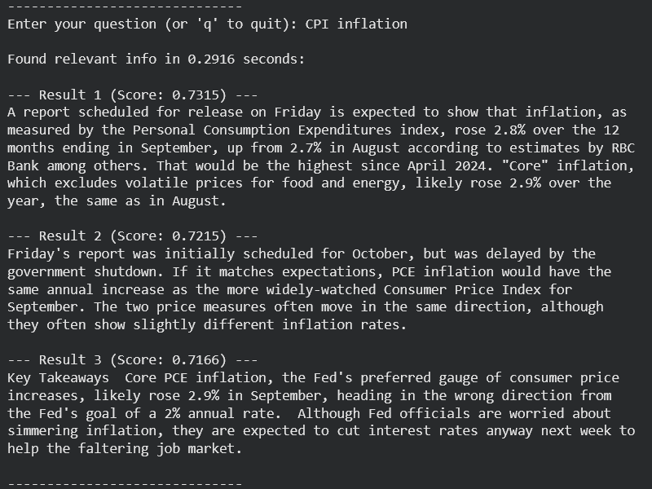

The shift to a persistent vector database was meaningful, but it also exposed the severe hardware limitations of my personal equipment. I encountered significant friction when attempting to run these heavy matrix calculations locally on my primary machine. My laptop is a reliable but aging ThinkPad equipped with an NVIDIA MX-150 graphics card. While sufficient for basic tasks, this GPU proved temperamental for machine learning workloads. I have always had issues with this specific card, and true to form, I could not get it to cooperate with the necessary libraries for this project. Rather than wasting valuable development time debugging driver conflicts or cryptic CUDA errors, I made the pragmatic decision to offload the processing entirely to the CPU. This was functional, but painfully inefficient; generating embeddings for a standard weekly dataset took nearly twenty minutes of sustained processing time, turning what should have been a quick data update into a significant bottleneck that locked up my machine.
The disparity in processing speed between the local CPU and the cloud-based GPU is a fundamental property of the linear algebra required for this project. Calculating the cosine similarity for thousands of vectors involves massive matrix multiplication operations. CPUs are designed for serial processing, for doing one complex task after another very quickly. However, calculating embeddings is a parallelizable task; we need to perform thousands of simple multiplication-and-addition operations simultaneously. GPUs, with their thousands of smaller cores, can perform these matrix operations in parallel. By moving to the cloud and later the HomeLab GPU, I was effectively moving the workload from a processor designed for sequential logic to one designed for massive parallelism, which explains why the ingestion time dropped from twenty minutes to under two minutes
The solution to this computational drag was introduced during our course lectures, where our professor helped familiarize us with Google Collab. He highlighted the platform's access to cloud-based GPUs and TPUs (Tensor Processing Units), noting that while the resources weren’t groundbreaking, they would vastly outpace a laptop CPU. Migrating the code to this environment required minimal changes, but the performance leap was immediate. The processing time for the ingestion pipeline dropped from twenty minutes to approximately two minutes. However, this benchmark became sporadic as I took advantage of the increased power to switch from the smaller MiniLM model to the massive BAAI/bge-large-en-v1.5 model described earlier. The cloud resources allowed me to scale up the complexity of the project without being penalized by hour-long wait times, effectively letting me trade those time savings for higher retrieval accuracy.
Despite the utility of the cloud, I eventually migrated the project to my homelab for the final implementation to maximize control and speed. This setup consists of a full computer setup running Ubuntu Linux via WSL2 (Windows Subsystem for Linux), all managed through Docker containers. This environment offered the best of both worlds: the ease of development I was accustomed to on Windows, combined with the native power and compatibility of a Linux terminal. Crucially, the dedicated GPU in this rig proved superior even to the resources available on Collab. It was simply the quickest way to execute the code reliably, and having a dedicated, powerful machine to code on made the iterative process of refining the retrieval logic much smoother than relying on a disconnected, browser-based interface.
While the current tool functions strictly as a retrieval engine, there is an obvious avenue for future expansion: integrating a generative Large Language Model (LLM) to synthesize the results. In the current architecture, the user is presented with raw excerpts from news articles. A more advanced design would feed these retrieved excerpts into a standard LLM (like GPT-4 or Llama 3) with instructions to 'summarize these three articles into a coherent answer.'
However, I consciously avoided this architecture for this iteration of the project due to two primary constraints: latency and accuracy. My goal was to build a tool with the 'shortest possible delay'. Feeding data into a generative model adds significant processing time, potentially delaying the response by several seconds. More importantly, reintroducing a generative layer reintroduces the risk of hallucinations. By keeping the tool strictly 'extractive' (showing the user the exact text found), I maintain a 100% truthfulness rate relative to the source data. For an economic analyst making investment decisions, the raw source text is often more valuable than a summarized, potentially hallucinated interpretation.
The inspiration for this project, from the laptop struggles to the homelab solution, was my role as the Economic Analyst for the university's Investment Club. My responsibility is to gather market data from the preceding week and present a coherent analysis of the ramifications for our current holdings. This often involves sifting through dense reports to answer incredibly niche questions from other members regarding interest rate projections, specific tariff impacts, or Consumer Price Index shifts. In the past, this required hours of manual reading and synthesis. This RAG tool now allows me to find these deep connections instantly and, most importantly, without the fear of hallucination that plagues standard LLMs. It provides a deterministic, evidence-based foundation for my analysis, ensuring that when I speak on market certainty, I am backed by the source text, not just a probability distribution.

