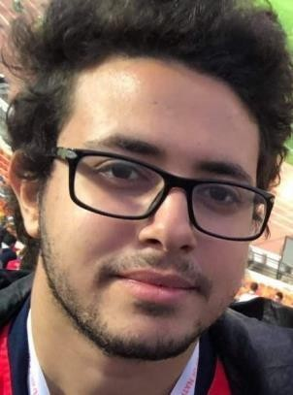
Mohamed
Adel Ezz El-din
Contact
Address:
4 Ammar Ibn Yasser Street, Heliopolis.

Phone:
01094076591

Email:
Mohamedaadelezz3@gmail.com

LinkedIn: linkedin.com/in/mohamed-adel- 86908a1b7/

Languages:
Arabic – Mother Tongue English – Very Good German – Fair

Hobbies
- Reading
- Music
- Photography
- Working out

Summary
Junior Software Engineer, Well-versed in numerous programming languages including C# , C++, Python.
Specialized in Robotics development, GUI , Embedded systems ,Machine learning and Data analysis .
Strong background in project management and customer relations.

Skill Highlights
- C# , Multithreading Programming and Windows form application
- Python , NumPy and Pandas
- Data Visualization
- C++ and OOP
- Version Control System (Git)
- Excel and SQL
- Electronic circuits design and implementation
- Mechanical design using solid works.
- Simulation using MATLAB.
- Complex problem solver.
- Strong decision maker.
- Innovative.

Experience
- Software Engineer at BEEC Company
- Machine learning and data analysis Course in Artronix company.
- Cooperate with azimuth team in the design and manufacturing of wind turbine.
- Develop a five degree of freedom robotic arm.
- Work with azimuth team as a vice head.
- Work as a supervisor for the control department in azimuth team.
- Participate in reel steel for competition.

Education
Bachelor of Mechatronics Engineering – Expected 2022
10th of Ramadan Institute.

Software: Solid works, MATLAB, Altium and Proteus
Programming Languages: Python , SQL , C# , C++, Linux ,HTML5, , CSS 3 and Assembly .

