M

SMB Information Protection Guided Labeling Assistant
User Guide

Version 1.0 | April 2026 | Audience: Stakeholders, IT Professionals, Business Users
<Change this when published> https://brave-sky-02528e10f.7.azurestaticapps.net
This document is provided as an open-source guidance resource and does not constitute official Microsoft advice.
Microsoft Security

Contents
1. What Is This Tool? 3
2. When Should You Use It? 4
3. Why Sensitivity Labels Matter 4
4. Before You Start 5
5. Step-by-Step: Using the Tool 6
Step 1 — Set Your Context 6
Step 2 — Explore the Reference Section 7
Step 3 — Run the Decision Flow 8
Step 4 — Review Your Recommendation 9
Step 5 — Check Exceptions and Examples 10
Step 6 — Export Your Label Plan 11
6. Section Reference 11
7. Exporting Your Label Plan 11
Before Exporting — Edit Your Labels 12
Export CSV 12
Export PS1 (PowerShell) 13
PowerShell Export — Important Notice 13
8. Tips, Edge Cases & FAQs 14
Frequently Asked Questions 14
Edge Cases to Be Aware Of 14
9. Glossary 15

1. What Is This Tool?
The SMB Information Protection Guided Labeling Assistant is a free, browser-based decision tool designed to help small and mid-sized businesses define and configure Microsoft Purview sensitivity labels — without needing deep compliance expertise upfront.
It combines a guided question flow, a curated 8-label reference model aligned to the DEFEND framework, and exportable outputs (PDF, CSV, PowerShell script) that can be handed off directly to an IT administrator or used to configure Microsoft Purview.
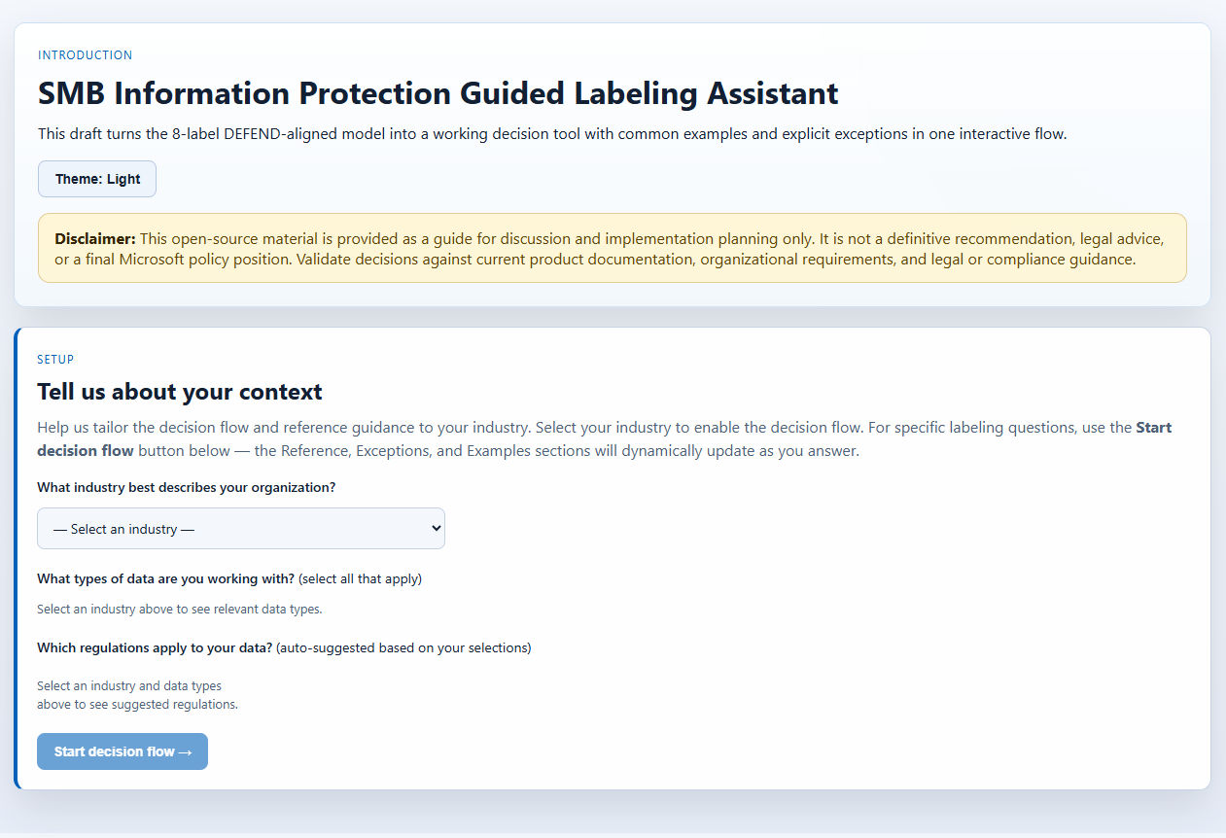The tool runs entirely in your browser — no login required, no data is sent to a server. Everything runs locally.

2. When Should You Use It?
Use this tool in the following situations:
- Starting a Microsoft Purview deployment from scratch — identify which labels you need and how to configure them for your industry.
- Unsure which label applies to a specific document or dataset — walk through a decision flow to arrive at the right label with a documented rationale.
- Preparing for a compliance review or audit — export a structured label plan (CSV or PDF) to share with your compliance team or auditors.
- Handing off label configuration to IT — export a ready-to-review PowerShell script that configures labels in Microsoft Purview.
- Training staff on labeling policy — use the Examples and Exceptions sections to illustrate real-world scenarios for your industry.

3. Why Sensitivity Labels Matter
Sensitivity labels are the foundation of Microsoft Purview Information Protection. Once applied — manually or automatically — they travel with a document or email wherever it goes, triggering protections like encryption, access restrictions, watermarking, and data loss prevention (DLP) policies.
Without a structured label plan, organizations often end up with either too few labels (gaps in protection) or too many (label fatigue and low adoption). This tool is designed to help you find the right balance for your size, industry, and regulatory environment.
Labels follow an escalation path from least to most restrictive:
- Public
- General
- Confidential – All Employees
- Confidential – Specific Groups
- Confidential – Exceptions
- Highly Confidential – All Employees
- Highly Confidential – Specific Groups
- Highly Confidential – Exceptions

4. Before You Start
You do not need to install anything. The tool runs directly in a modern browser (Microsoft Edge, Chrome, Firefox, or Safari).
Access the tool at: https://brave-sky-02528e10f.7.azurestaticapps.net
Have the following on hand if possible:
- Your organization's industry (e.g., Healthcare, Finance, Legal)
- The types of data you handle (e.g., PII, financial records, health records)
- Any regulatory frameworks that apply (e.g., HIPAA, PCI-DSS, GDPR) — the tool will suggest these based on your selections
- Optionally, the name of the IT admin or Microsoft partner who will implement the labels in Purview
The tool automatically matches your system's light or dark mode preference. You can override this using the theme toggle in the top-right corner.
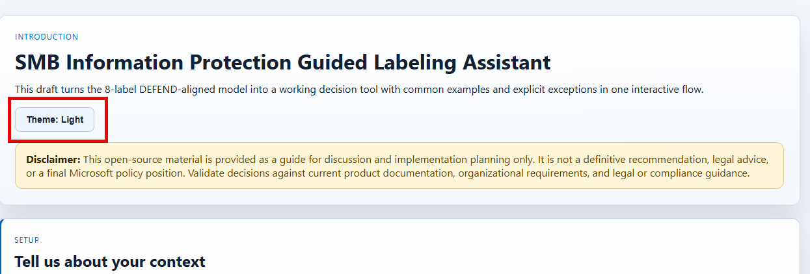

5. Step-by-Step: Using the Tool

Step 1 — Set Your Context
The 'Tell us about your context' section is the starting point. Nothing else on the page will be visible until you complete this step.
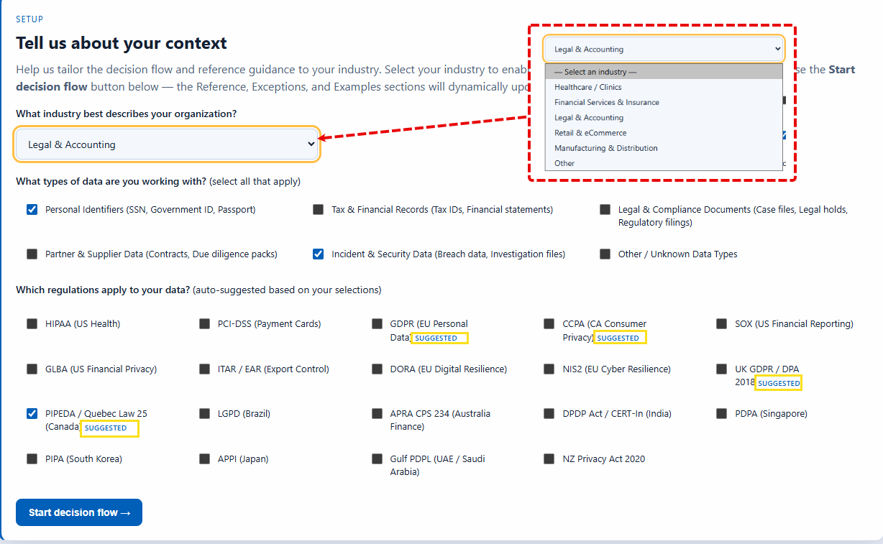
- Select your industry from the dropdown (e.g., Healthcare, Finance, Legal, Retail).
- Select the data types your organization handles by checking the relevant checkboxes.
- Review the regulatory frameworks (Some are automatically suggested based on industry use cases). Adjust if needed.
- Click 'Start decision flow' to confirm. The Reference, Exceptions, and Examples sections will appear.
Note: You can click 'Change context' at any time to go back and adjust. This resets any in-progress labeling decisions.

Step 2 — Explore the Reference Section
Before running the decision flow, review the ‘Relevant labels for <selected industry>' section. Each card shows the label name, what it means, protection baseline, and regulatory considerations for your selected frameworks.
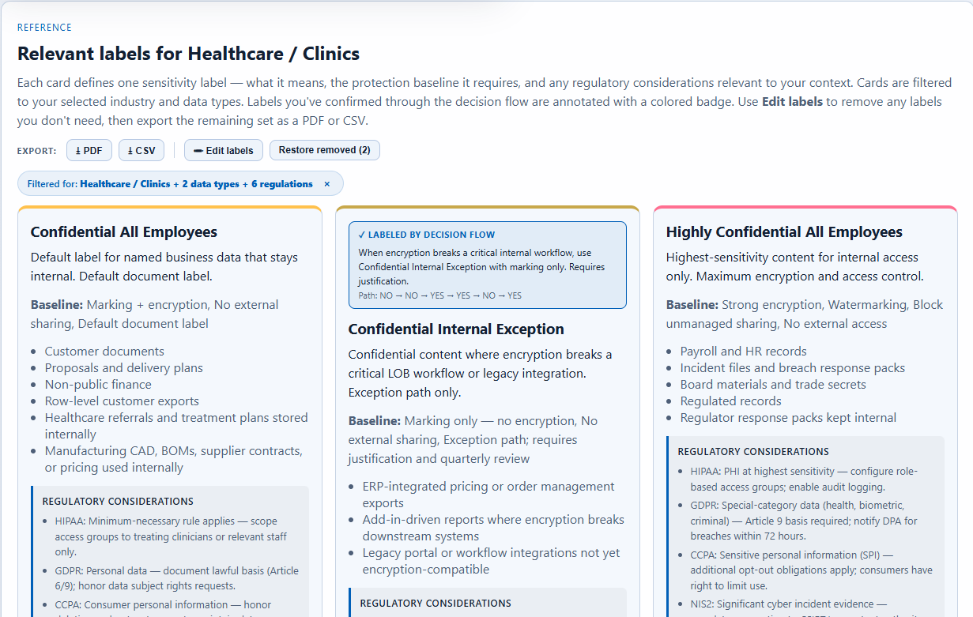

Step 3 — Run the Decision Flow
The 'Start labeling' section is the core decision engine. Use it when you have a specific piece of content and need to determine the right label.
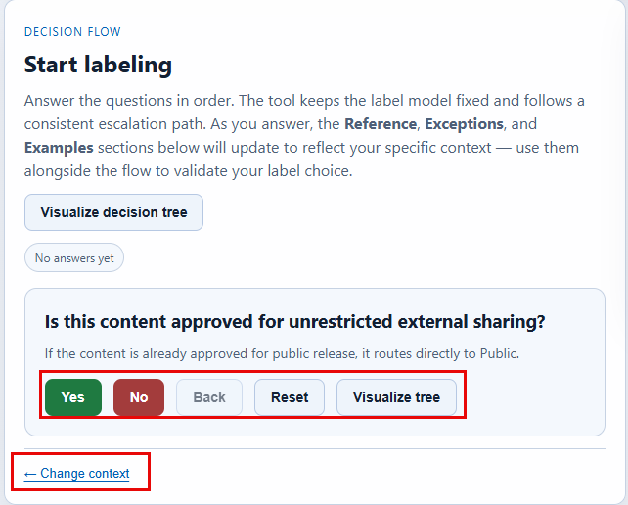
- Answer each question using the Yes or No buttons. The flow follows a consistent escalation path.
- Use the Back button at any time to revise a previous answer.
- Optionally click 'Visualize decision tree' to see the full branch logic map.

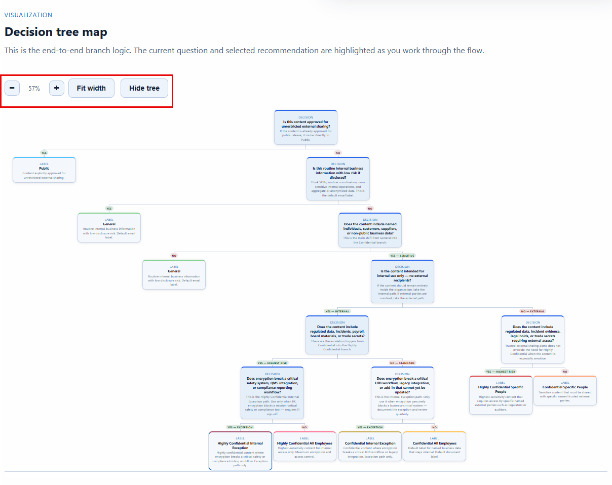

Step 4 — Review Your Recommendation
When you have answered enough questions, the 'Current outcome' panel displays your recommended sensitivity label.
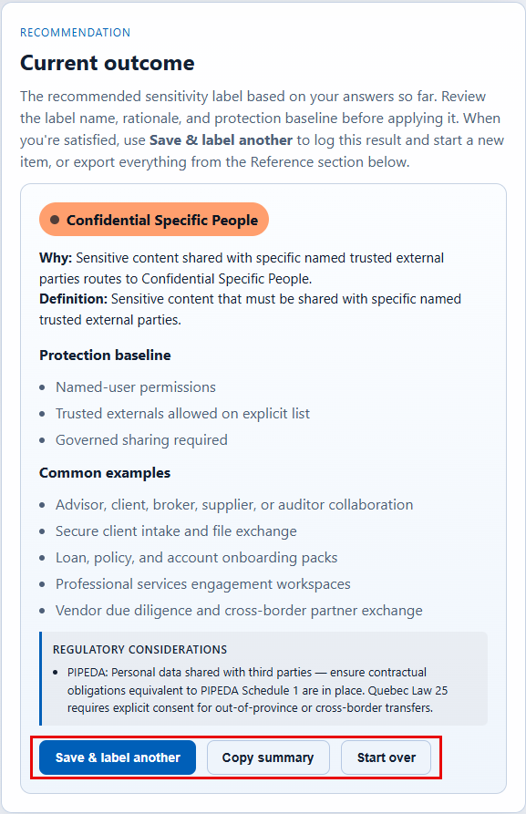
The card shows the recommended label (color-coded), the rationale based on your answers, and the protection baseline. Click 'Save & label another' to log the result and start a new decision. Saved labels appear in the Reference section with a colored annotation badge.

Step 5 — Check Exceptions and Examples
Before finalizing, review the two supporting sections at the bottom of the page.
Exceptions — Known edge cases for your industry. If your situation matches one, the default label recommendation may not apply and a compliance team review may be needed.
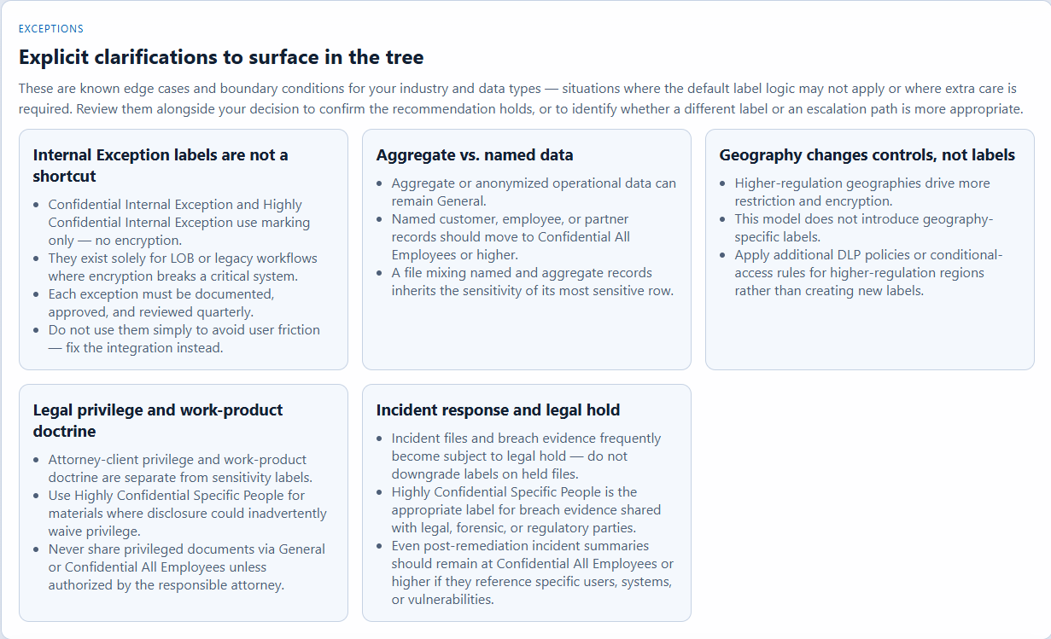Examples — Real-world scenarios mapped to labels. If a scenario matches your situation but points to a different label, revisit your answers.
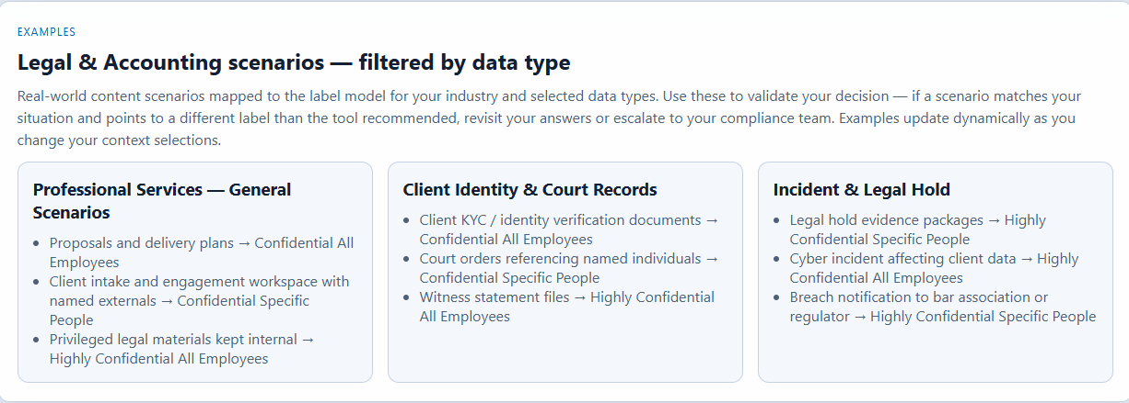

Step 6 — Export Your Label Plan
See Section 7 for full details on export options.

6. Section Reference
- Introduction — Overview of the tool. Theme toggle lives here. All users start here.
- Tell us about your context — Set industry, data types, and regulatory environment. Required before other sections appear.
- Start labeling (Decision Flow) — Guided questions to determine the right label for specific content. Best for business users and data owners.
- Decision Tree Map — Visual map of the full branch logic. Best for IT professionals and compliance leads.
- Current Outcome (Recommendation) — Recommended label with rationale and protection baseline.
- Relevant labels for <Chosen Industry> (Reference) — Full label catalog. Supports edit mode and all exports.
- Exceptions — Edge cases and boundary conditions for your industry.
- Examples — Real-world scenarios mapped to labels for your industry and data types.

7. Exporting Your Label Plan
The export bar appears at the top of the Reference section after context is set. All exports reflect only the labels currently visible in the Reference section.
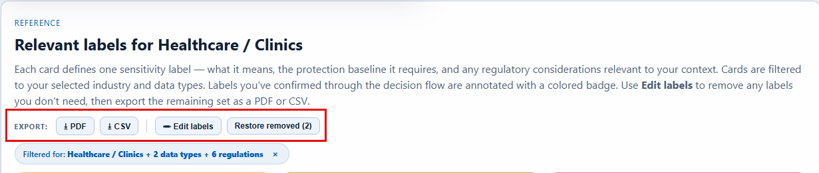

Before Exporting — Edit Your Labels
Use the 'Edit labels' button to enter edit mode. An x button appears on each label card — click it to remove labels you don't need. Use 'Restore removed (N)' to undo. Only visible labels are included in any export.
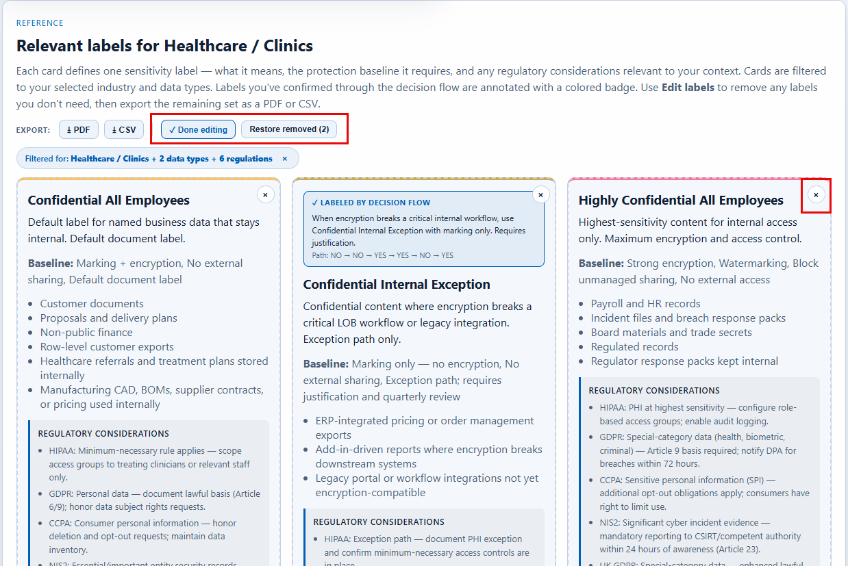Export PDF
Opens the browser print dialog pre-formatted for the Reference section. Save as PDF from the print dialog. Best for: sharing with stakeholders, attaching to audit documentation, or printing for review meetings.

Export CSV
Downloads a spreadsheet with one row per label including: label name, classification tier, protection baseline, sublabel type, regulatory considerations, and session rationale (if generated by the decision flow). Best for: compliance documentation, GRC tools, sharing with a Microsoft partner.

8. Tips, Edge Cases & FAQs

Frequently Asked Questions
Q: Does this tool send my data anywhere?
A: No. The tool runs entirely in your browser. No answers, labels, or organization details are transmitted to any server.

Q: Can I use this tool without a Microsoft 365 subscription?
A: Yes — the tool is free and requires no Microsoft account. The PowerShell export requires a Microsoft 365 subscription with Purview to execute.

Q: What if none of the industries match mine exactly?
A: Choose the Other industry. The label model is broadly applicable — use the Exceptions and Examples sections for gaps, and escalate to your compliance team for industry-specific nuances.

Q: I ran the decision flow multiple times — where are my results?
A: Each saved result is annotated in the Reference section with a colored badge. All confirmed labels accumulate there before you export.

Q: Should my IT admin use the PowerShell script directly?
A: Not without review. Your IT admin or Microsoft partner should inspect it, verify label names against your existing Purview tenant configuration, and test in a non-production environment first.

Edge Cases to Be Aware Of
- Existing labels in Purview: If your tenant already has sensitivity labels, the PS1 script may cause conflicts. Review existing labels before executing.
- Sub-labels: Some labels are sub-labels (e.g., Confidential – Specific Groups). Ensure your Purview tenant supports sub-label hierarchies.
- Regulatory overlap: If your organization spans multiple regulated industries, select all relevant data types and review the Regulatory Considerations column in the CSV carefully.
- Label fatigue: Consider starting with a subset of labels. Use Edit mode to remove labels you don't plan to deploy in your initial rollout.

9. Glossary
Sensitivity Label — A classification tag applied to content that defines how it should be protected. Travels with the content wherever it goes.
Microsoft Purview — Microsoft's compliance and data governance platform that hosts sensitivity labels and information protection policies.
DEFEND Framework — A structured label taxonomy defining 8 sensitivity labels across four tiers: Public, General, Confidential, and Highly Confidential.
Protection Baseline — The default protections applied when a label is used — may include encryption, access restrictions, visual markings, and DLP policy triggers.
Regulatory Considerations — Notes indicating how a label aligns with frameworks such as HIPAA, PCI-DSS, or GDPR.
WhatIf Mode — A PowerShell safety switch that simulates commands without making actual changes. The exported PS1 script uses this by default.
Sub-label — A label that sits beneath a parent label in a hierarchy (e.g., Confidential – Specific Groups). Supported in Microsoft Purview.
DLP — Data Loss Prevention — policies that detect and restrict sharing of sensitive content based on label or content type.
GRC Tool — Governance, Risk, and Compliance software used to manage frameworks, audits, and risk registers. The CSV export can be imported into most GRC platforms.

This guide covers version 1.0 of the SMB Information Protection Guided Labeling Assistant. The tool is provided as an open-source resource intended to guide — not replace — formal compliance review. For questions about your specific regulatory requirements, consult a qualified compliance professional or Microsoft partner.

