Amamio Farm Product Inventory and Sales System — What's in the System
Oct 16, 2026 · @Astra Results Marketing

Overview
All five modules from the brief are built, plus every paper form in "the-forms". Products are followed through the production site: receiving area → inspection & cleaning → storage → production → packing → disbursement or courier → sales on each platform. At any point the system shows how many items or kilos there are, how many were damaged or unusable, where they are, and who handled them.
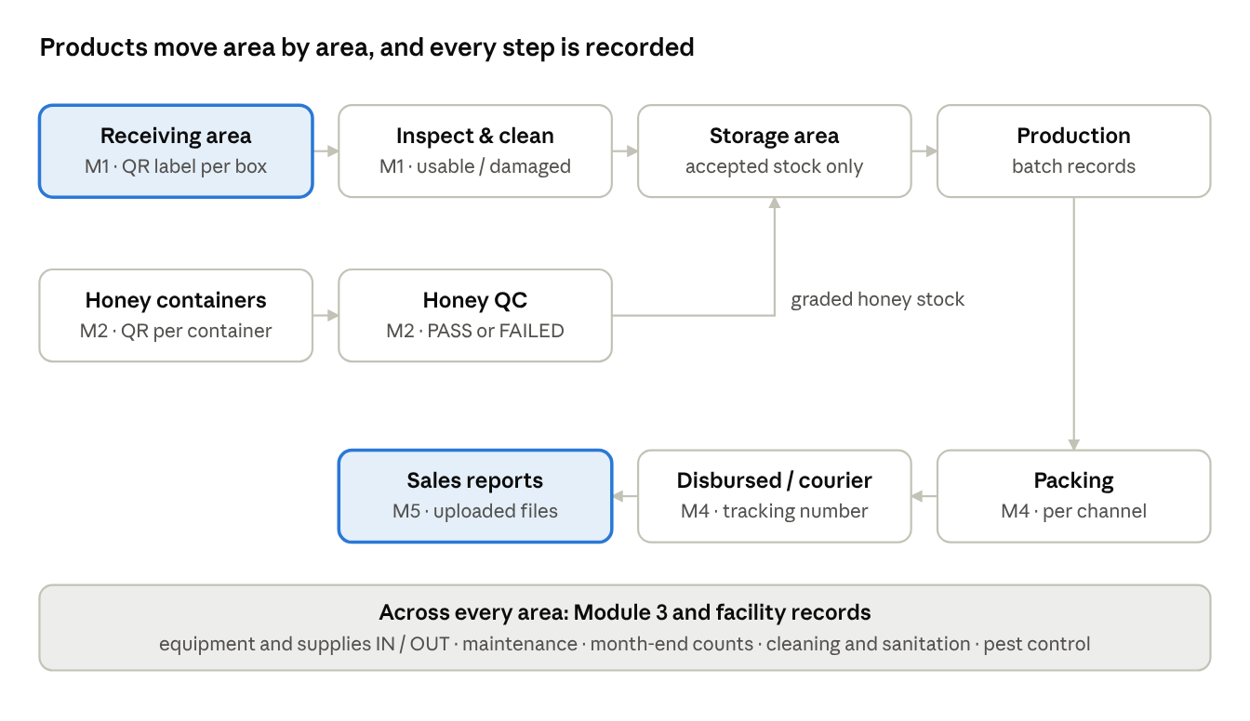
flow through the production site · modules 1 to 5
The highlighted boxes are where a product enters (receiving) and where its sale is recorded (sales reports). Module 3 and the facility records support every area.
It is a web app (Flask) that runs offline on one computer. Phones and tablets on the same Wi-Fi can use it too. Data is kept in files and exports to MySQL with one command.

Users
Each role sees only its own pages and tasks.
User / employee type | What they do in the system
Super Admin | Everything, plus user accounts, roles and the MySQL export
Admin | Approves requests, sees every module, reports and analytics
Receiving Team Head | Records every delivery at the receiving area, prints QR labels, logs honey containers, records supplies in/out
Production Team Head | Inspection & cleaning, honey quality check, batch manufacturing records, daily production report, retention samples, cleaning checks
Packing Team Head | Packing and dispatch, uploads platform sales files, sales reports, sales orders and deliveries
Packing Team Members | Record packing runs, disbursement and courier hand-over
Assets Maintenance Head | Equipment IN/OUT, maintenance, supplies IN/OUT and month-end counts, sanitation and pest control

Module 1 — Receiving area, then inspection & cleaning

Part 1: Receiving
The Receiving Team Head records every delivery that arrives (lemon, ginger, bottles and the rest) in a short step-by-step form:
- Who delivered it: the supplier, or own harvest / walk-in, and the date received.
- The delivery documents: PO no. and DR / delivery receipt no. (optional).
- What arrived: each item, how much is in each box, and how many boxes. Items are counted the way they arrive: kilos for ginger, pieces for lemon, units for bottles. Lot / batch no., expiry date, packaging condition and temperature can also be noted.
- A check screen, then save.
On saving:
- One QR label is made per box. The QR code carries the box code, item, quantity or weight, lot, expiry, delivery number, date received and supplier. Anyone who scans it sees these details.
- The production team is notified that the boxes were received at the Receiving Area and are ready for inspection.
- Nothing joins stock yet; that happens after inspection.

Part 2: Inspection & cleaning
The Production Team Head (or the Receiving Team Head) scans a box or picks it from the "waiting" list. A step-by-step form follows:
- Confirm it is the right box.
- Clean the content, or mark that no cleaning is needed (e.g. sealed bottles).
- Count what was found, split into three: usable, can't be used and damaged. A live tally compares the count with the quantity on the label.
- Why: a short reason, asked only when something can't be used or is damaged.
- Quality checks: visual / organoleptic, COA / documents, sampling / test.
- Decision: Accepted, Rejected or Hold (pending a test, document or QA decision), with nonconformity remarks, action taken and verified by.
What each decision does:
Decision | Stock | Where the box goes
Accepted | Only the usable quantity joins stock | Moves to the Storage Area
Rejected | Nothing joins stock | Stays at the Receiving Area
Hold | Nothing moves until someone decides Accept or Reject on the box's page | Stays at the Receiving Area
"Can't be used" and "damaged" quantities go to a damage report with their reasons. Each box keeps its location: Receiving Area → Storage Area → Production Area → Consumed. The paper Raw Materials Receiving and Inspection Report prints, filled in, for any date range.

Module 2 — Honey
Honey is tracked by container. Each container has its own QR code, and its quality is checked on moisture content and appearance. The result is PASS or FAILED only.
- Log honey containers (Receiving or Production Team Head): the source (own harvest, supplier delivery, contract beekeeper), supplier, net weight per container, number of containers, and the harvest and received dates. A QR label prints for each container, and the production team is notified.
- Check the container (Production Team Head): enter the moisture %, pick the appearance (clear, cloudy, crystallized, with sediment, fermented / off-smell), then choose PASS or FAILED. The system suggests a result (above 20% moisture usually fails), but the checker decides.
- Send the honey to products, by the kilo. A container can be split across several products until it is used up, and the system shows how many kg are left.
Result | Stock | Products it can go to
PASS | Joins the sellable "Raw Honey" stock | The PASS products list
FAILED | Never discarded; kept as "Honey for Processing" | The FAILED products list
The products lists are dummies for now, as requested. PASS: Pure Honey; RFH (Raw Forest Honey) with Comb. FAILED: Honey Lemon Ginger Concentrate; Honey Calamansi Concentrate; Honey Infused Turmeric Ginger; Honey Infused Ginger; Honey Vinegar. They are two short lists in one place (HONEY_PASS_PRODUCTS and HONEY_FAIL_PRODUCTS in services.py). Replacing them changes nothing else.
As with Module 1, every step is recorded against the QR code, and the honey page shows where each container's honey went.

Module 3 — Materials, equipment and supplies: every IN and OUT
Every movement of equipment and supplies is recorded: what, how many, why, who, where and when.

Equipment & assets
The register is the client's Inventory of Assets: 37 items, AFP-001 to AFP-037, grouped as on the paper (Appliances, Machines, Pouch Sealer, Gas Stove, Stainless Table/Sink and so on). For each item it shows the quantity, how many are out, the condition (serviceable / under repair / non-serviceable) and maintenance due.
- Record IN / OUT: choose IN or OUT → the item → the reason and quantity → who and where (and the expected return date) → check and save.
  - OUT reasons: borrowed / used elsewhere, sent for repair, lent to another site, disposed.
  - IN reasons: returned, back from repair, new purchase.
- "Out" counts can't go wrong: you can't return more than went out. Sending an item for repair marks it "Under repair", and admins are notified when equipment goes out.
- Maintenance log per item: date, time, description, performed by, cost, downtime, next maintenance date and notes. The next date becomes a reminder on the home page.
- Printable: the Inventory of Assets and each item's Equipment Maintenance Log.

Supplies
Four categories, as on the month-end reports:
- Raw materials
- Jars / bottles / packaging (sub-groups: jars & bottles, pouches, cap seals, packing supplies)
- Production (cleaning) supplies
- Office supplies
Recording supplies IN / OUT works like equipment: IN or OUT → category → item → quantity and reason → who and a reference → save. Stock updates at once, and an OUT can never exceed what is on hand. Admins are notified when an item drops to its reorder level.
Month-end count: pick a category and month, then enter the physical count of each item. The system shows the variance and, for the current month, can adjust stock to the count. The printable Month-End Report shows, per item: opening, IN, OUT, closing, physical count and variance.

Module 4 — Packing team: packed, disbursed, delivered to the courier
The packing team (head and members) records the number packed, disbursed, and delivered to the logistics / courier.
- Record packing: the channel (VIP, Shopee, TikTok, Lazada, Walk-in) → who packed it, the pack date and the order reference → the products and quantities, plus any damaged while packing → check and save. The run is now packed, and the items leave finished-goods stock. The system refuses to pack more than is in stock.
- Send it out, in one of two ways:
  - Disbursed: handed straight to the customer, VIP buyer, walk-in or another team, with who received it.
  - Delivered to logistics / courier: the courier (SPX, J&T, Flash, LBC, Ninja Van, Lalamove, Grab, own delivery), the rider's name, the tracking number and the parcel count.
The Packing & Dispatch page shows packed / disbursed / to-courier / waiting / damaged totals per channel, for today, this week, this month or all time. It also lists runs waiting to go out and runs recently sent. Each run has a QR code and a printable packing slip.
- Only the packing head or an admin can cancel a run; cancelling returns any stock it took out.
- A run tied to a sales order does not take stock out a second time, since confirming the order already did.
- Items damaged while packing go to the damage report.

Module 5 — Sales file uploads and sales reports
The user uploads the file exported from each selling platform, and the system stores it for sales tracking and reports. The three sample files in "sales-platform" (Shopee, TikTok, Lazada) are already loaded: 104 orders, ₱61,272.95 net.
Uploading (Packing Team Head or Admin):
- Pick the platform: Shopee, TikTok, Lazada, Shopify, VIP, Walk-in or Other.
- Choose the exported file exactly as the platform made it. Excel (.xlsx) and CSV both work.
- Check the preview, then save. The preview shows new lines, lines already uploaded, the order date range, orders, items and net amount, how many lines matched a product, and the first lines as they will be saved.
Built in:
- Shopee: orders export. Each line is counted at its own subtotal, because Shopee's "Grand Total" repeats on every line of a multi-item order and would double-count.
- TikTok Shop: settlement order details. Tax and fee lines count as adjustments, not sales.
- Lazada: orders export.
- Shopify: orders CSV.
- Any other marketplace: an admin maps its columns once under "Column templates"; no programming needed.
How uploads are handled:
- The system recognises the platform from the file's columns and warns if the wrong one was picked.
- Uploading a newer export of the same orders never counts them twice; it updates their status and amounts.
- Listing titles are matched to the product catalog by name and size, e.g. "Honey Lemon Ginger Concentrate 300ml" becomes the catalog's 300 mL product.
Sales Reports have one row of filters: this week, this month, last month, last 90 days, this year, all time, or exact dates; then daily / weekly / monthly / yearly; then platform.
Tab | What it shows
Overview | Net sales, orders, items sold, average order, cancelled / returned; a chart of sales per period split by platform; sales by platform; best-selling products
By period | The same numbers as a table, one row per day / week / month / year, one column per platform
Products | Every product sold: items, net sales, which platforms
Orders | Order status breakdown (completed, in progress, cancelled, returned, adjustment), where buyers are, and every line with search
Uploads | Every file uploaded; removing an upload removes the sales it added
"Download for Excel" exports the period table. Only completed and in-progress orders count as sales.

Additional — the forms in "the-forms"
Every paper form is in the system. Each is filled in through the screens and prints in the same layout as the paper, with the Amamio header.
Paper form | Where it is | What the system does with it
Raw Materials Receiving and Inspection Report | Receiving Area → Inspection report | Filled in from Module 1, for any date range
Batch Manufacturing Record | Production → Batch Records | A guided batch: ingredients filled from the recipe × batch size, then dispensing & weighing sign-off, procedure steps ticked off one by one (conducted by / checked by), then yield, test dates and the QA's APPROVED / DISAPPROVED. Approved adds the yield to stock and uses up the ingredients, exactly once
Daily Production Report | Production → Daily Production Report | Per product and size: balance forward, IN, OUT, BAL, by week or by day, for any month. Built from stock movements
Retention Record | Production → Retention Samples | Keep a sample per batch, flag those due for disposal, record disposal
Inventory of Assets | Equipment & Assets → print | The asset register (Module 3)
Equipment Maintenance Log | Equipment & Assets → an item → maintenance log | Per item (Module 3)
Month End Report (raw materials, packaging, production/cleaning supplies, office supplies) | Supplies In / Out → Month-end report | Opening, IN, OUT, closing, physical count, variance (Module 3)
General Cleaning & Sanitation Record | Cleaning & Sanitation | Pre- and post-production check of each area: Locker Room, Storage, Washing, Production, Finished Products. Areas needing cleaning or repair stay open until marked done
Pest Control Monitoring Record (QMS-PCMR) | Pest Control | Monthly inspection of each area; a 12-month strip shows any missed month; pest activity notifies admins
Supplier Directory | Supplier Directory | 43 suppliers from the paper (with TIN, items, contact / where to buy), grouped Raw / Production / Packing / Office, searchable
The demo data also comes from these forms: the 38 products and sizes from the Daily Production Report, the 73 supply items from the four month-end reports, the asset register and the supplier directory.

Interface — one focus at a time
The brief asked for a user-friendly interface that is not crowded: one focus at a time, many pages if needed. This is how the system does it:
- Home shows only your jobs. Each role gets a few large task cards (e.g. "Receive a delivery", "Inspect & clean boxes"), with a count when something is waiting, plus a short "Waiting for you" list.
- Every transaction is step by step. One question per screen, with Back / Next and a progress bar, then a check screen before saving. Mistakes are caught on the step where they happen, and steps that don't apply are skipped (e.g. no courier question for a disbursed run).
- Every record has its own page. A box, honey container, packing run or batch shows where it is in the flow and the one next action as a highlighted button.
- Short menus. The sidebar lists only the pages your role can open.
- One scanner for everything. "Scan a QR code" takes a handheld scanner, typing, or the phone camera (Chrome on Android, over a secure connection). It shows what the code is, where it is, and the next step.
- Notifications tell the next team when work arrives for them.
- Light or dark. The sun / moon button switches between light, dark and "match my device". It is saved per user.
- "About this page" notes, for demos, explain each page: what it is for, who uses it, how it fits, and which paper form it replaces. They can be folded, or hidden for a user from the sun / moon menu.
- Full width. Every page fills the screen beside the sidebar. On wide screens a step's questions sit side by side; phones and tablets stack them.

Demo logins, running it, and what to confirm

Demo logins
Role | Username / password
Super Admin | superadmin / super123
Admin | admin / admin123
Receiving Team Head | receiving / recv123
Production Team Head | production / prod123
Packing Team Head | packing / pack123
Packing Team Members | packer1 / member123, packer2 / member123
Assets Maintenance Head | assets / assets123
Change these passwords before real use.

Running it
Run pip install -r requirements.txt once, then python run.py, and open http://localhost:5000. To use it from phones on the same Wi-Fi, start it with AMAMIO_HOST=0.0.0.0 (it prints the address to open). python smoke_test.py checks the whole system end to end in about a minute: 112 checks, currently all passing.

To confirm with the client
- ☐ The products PASS honey and FAILED honey go into (the current lists are dummies)
- ☐ "Disbursed" was taken to mean handed straight to the customer / VIP / walk-in / another team, as opposed to delivered to the courier
- ☐ Whether only the Production Team Head should inspect boxes (now the Receiving Team Head can too)
- ☐ Real prices, opening stock and reorder levels (the demo figures are made up)
- ☐ A few supplier rows in the directory photo were hard to align (e.g. which supplier "CDO" belongs to); they are editable in the Supplier Directory

