**M1U2_tcp/IpUtilities_WilliamsCarl**

Log in to NDG Lab and click on NISGTC Networks and begin **Lab3: Tcp\Ip Utilities**. You will need to create a reservation for the lab first. Make sure you give yourself enough time to complete all the exercises.  
You will need to read the instructions and complete each step just looking at the screenshots will not be enough to complete labs. Take screenshots of the steps required as you go through this assignment to show you completed the lab for grading purposes.

**Displaying Computer Information**

Exercise 1.1: Display Computer information

Take a screenshot of the following step: #7, #8, #10a, #10b, #10c

**Displaying IP Information**

Exercise 2.1: Display IP Information

Screenshots for the following steps: #1, #2, #4, #5.

**Displaying DNS Information**

Exercise 3.1: Display DNS Information

Screenshots for the following steps: #1, #3a, #3b, #3c, #4, #5.

Log in to NDG Lab and click on NISGTC Networks and begin Lab2: Types of Networks. Instructions are under the Content tab within NDG. Complete the exercises and insert your screenshots below.

To start Click the following link. [NDG Lab: Tcp\Ip Utilities](https://netlabve.faytechcc.edu/)

**Displaying Computer Information**

Exercise 1.1: Displaying Computer Information

Step #7 **- Insert your screenshot below this line.**

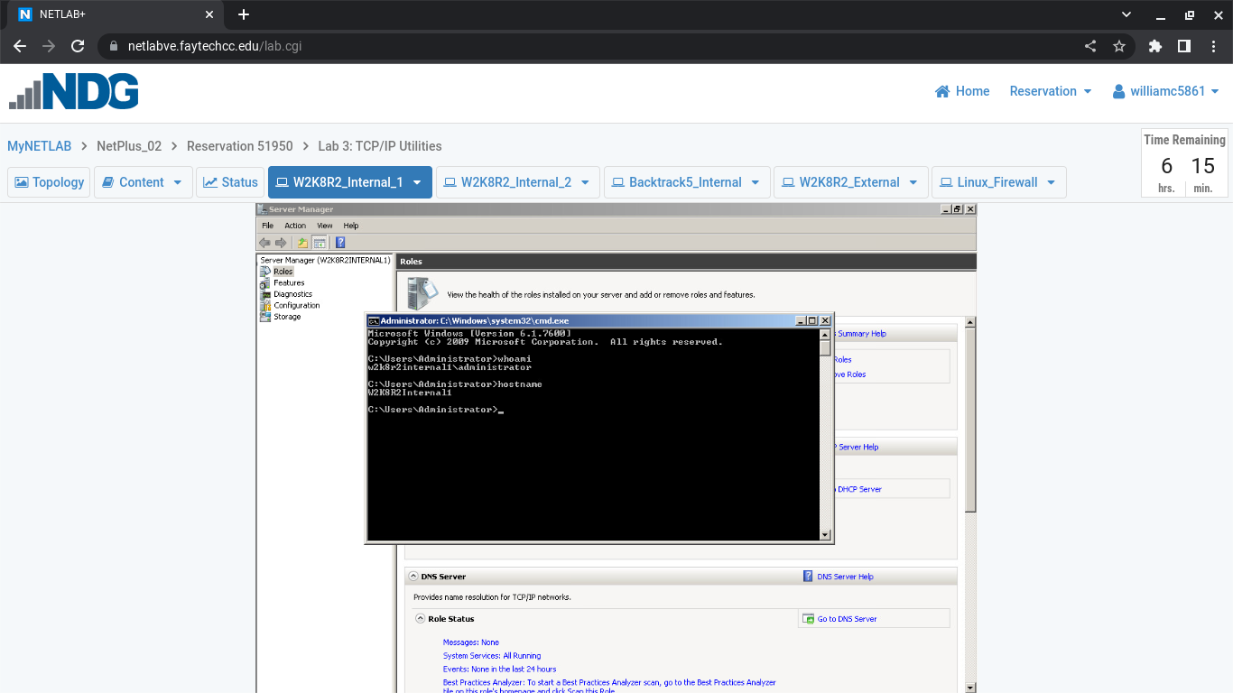

Exercise 1.1: Displaying Computer Information

Step #8 **- Insert your screenshot below this line.**

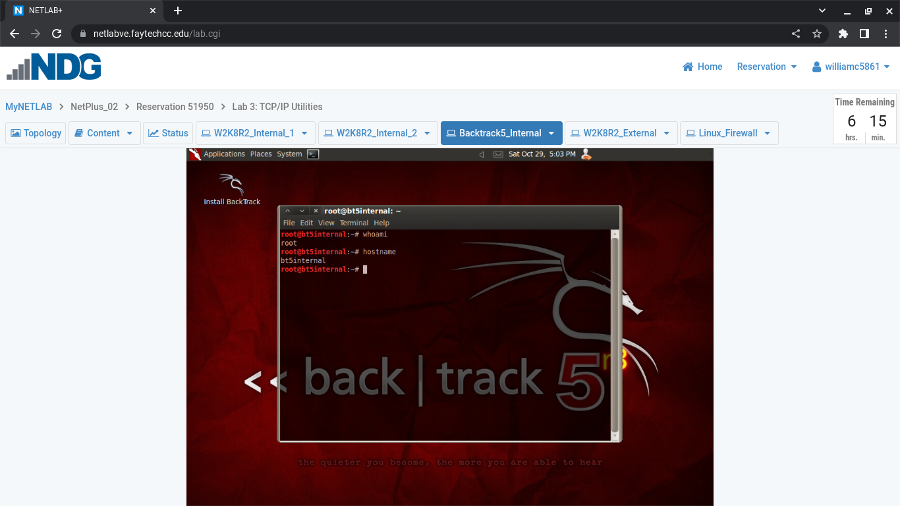

Exercise 1.1: Displaying Computer Information

Step #10a **- Insert your screenshot below this line.**

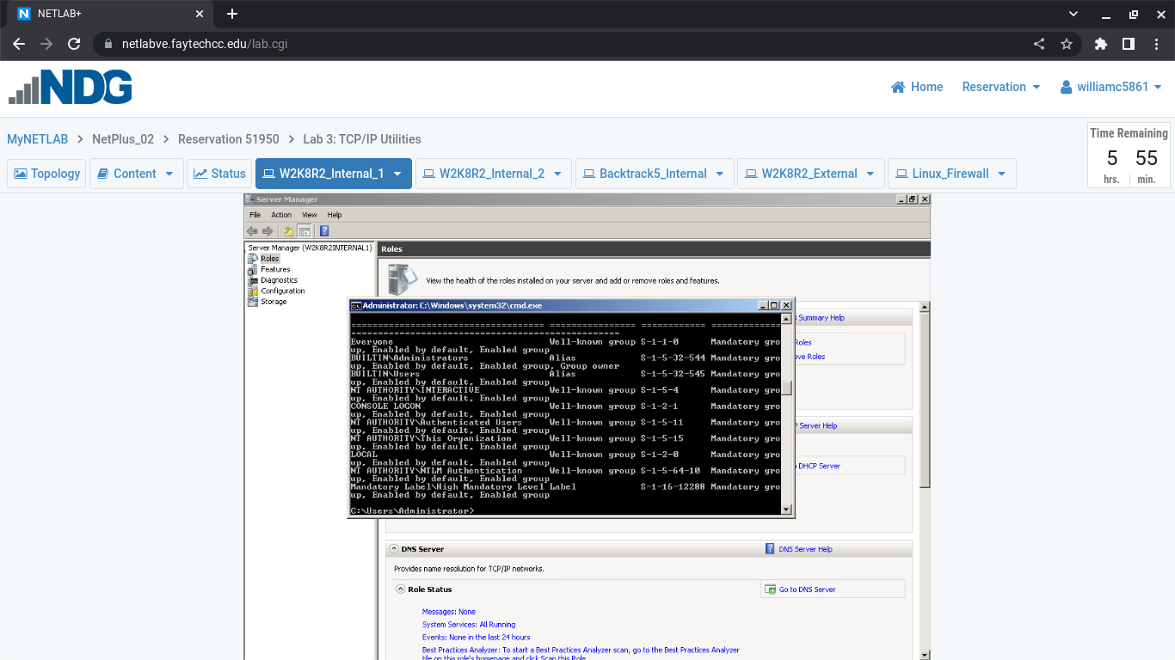

Exercise 1.1: Displaying Computer Information

Step #10b **- Insert your screenshot below this line.**

**showed me 2 entrys and 8.0gb memory**

Exercise 1.1: Displaying Computer Information

Step #10c **- Insert your screenshot below this line.**

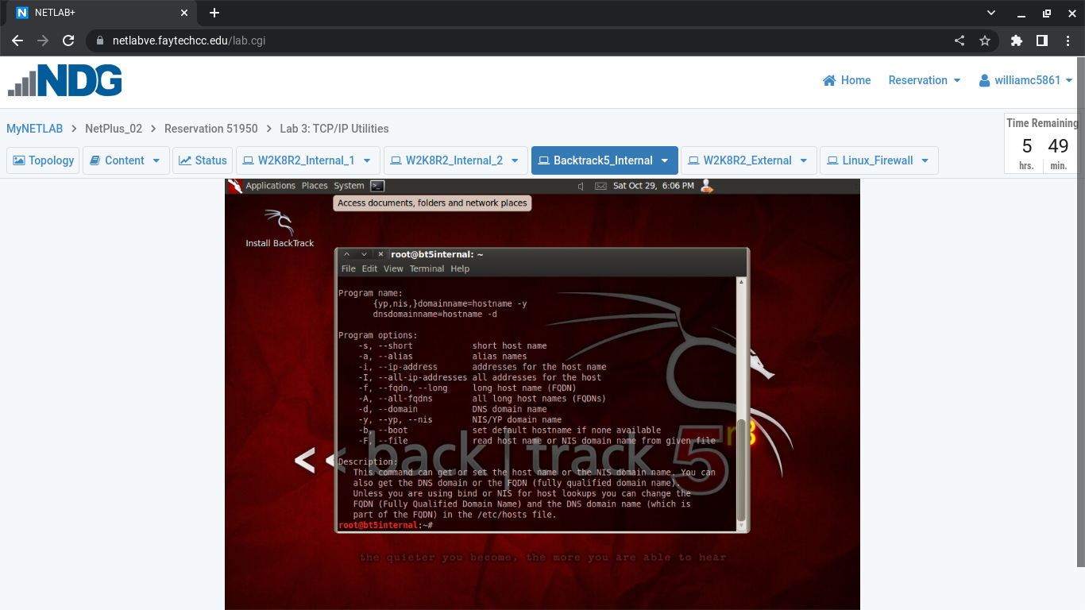

**Displaying IP Information**

Exercise 2.1: Displaying IP Information

Step #1 **- Insert your screenshot below this line.**

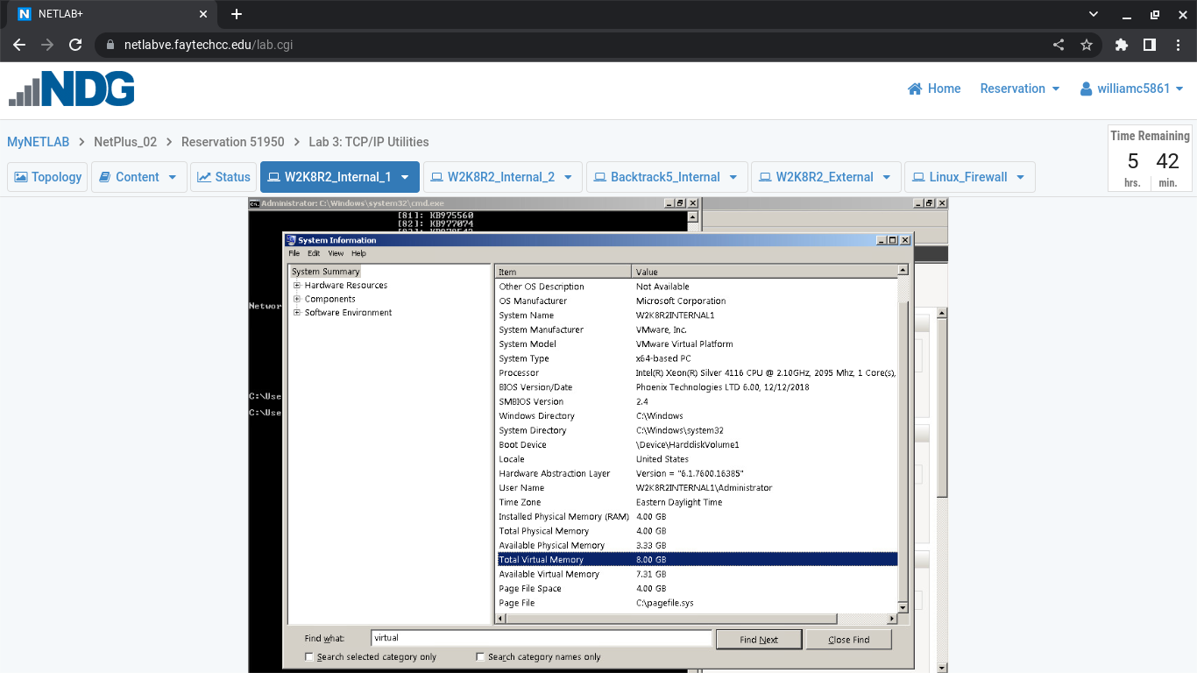

Exercise 2.1: Displaying IP Information

Step #2 **- Insert your screenshot below this line.**

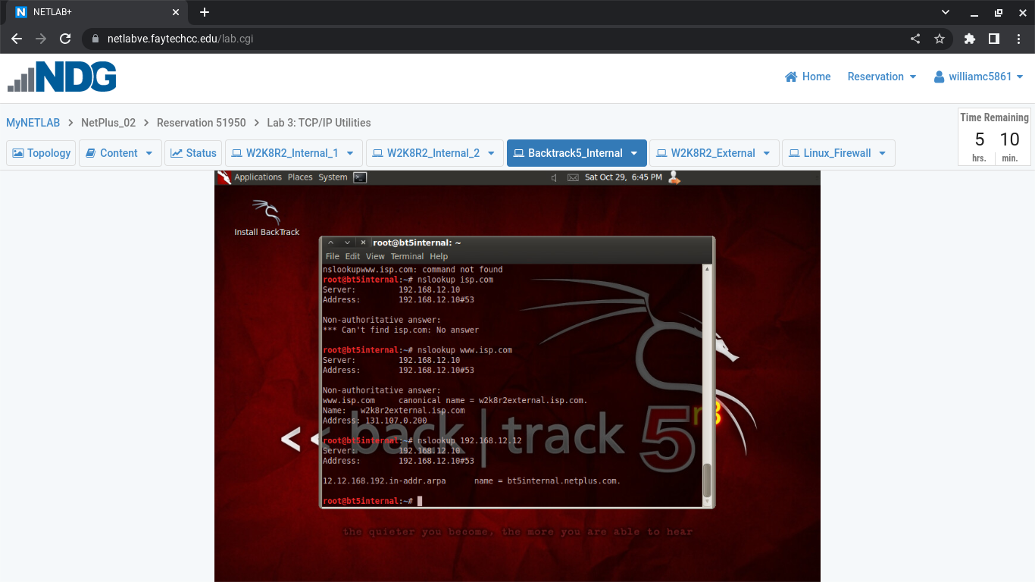

Exercise 2.1: Displaying IP Information

Step #4 **- Insert your screenshot below this line.**

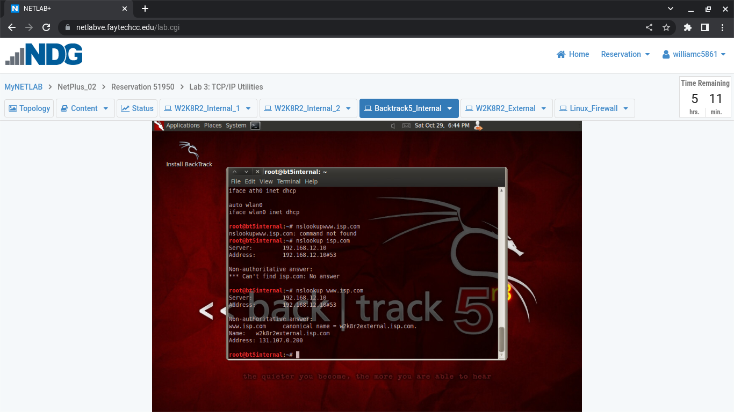

Exercise 2.1: Displaying IP Information

Step #5 **- Insert your screenshot below this line.**

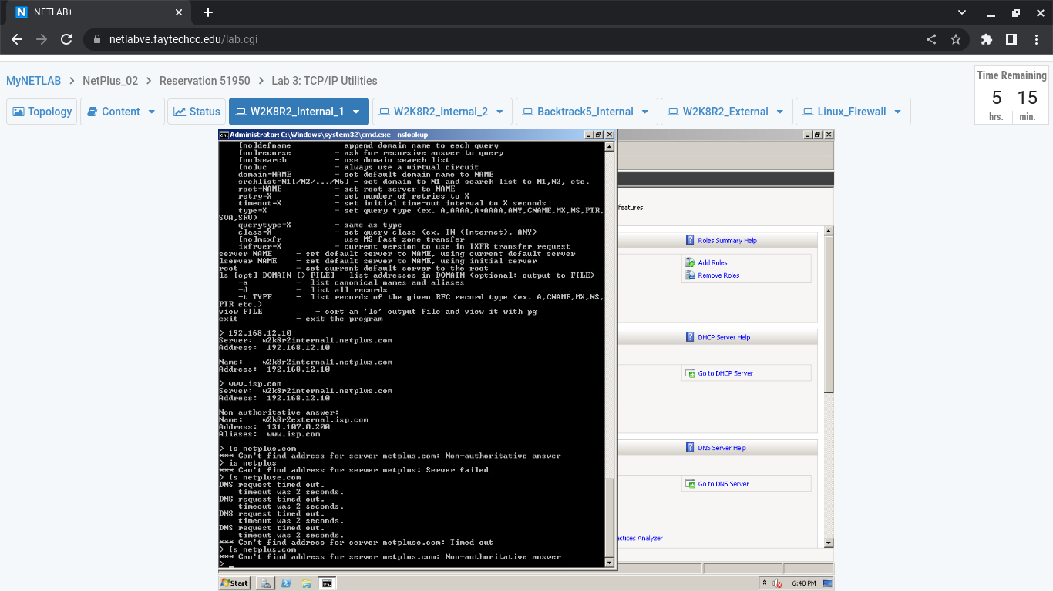

**Displaying DNS Information**

Exercise 3.1: Displaying DNS Information

Step #1 **- Insert your screenshot below this line.**

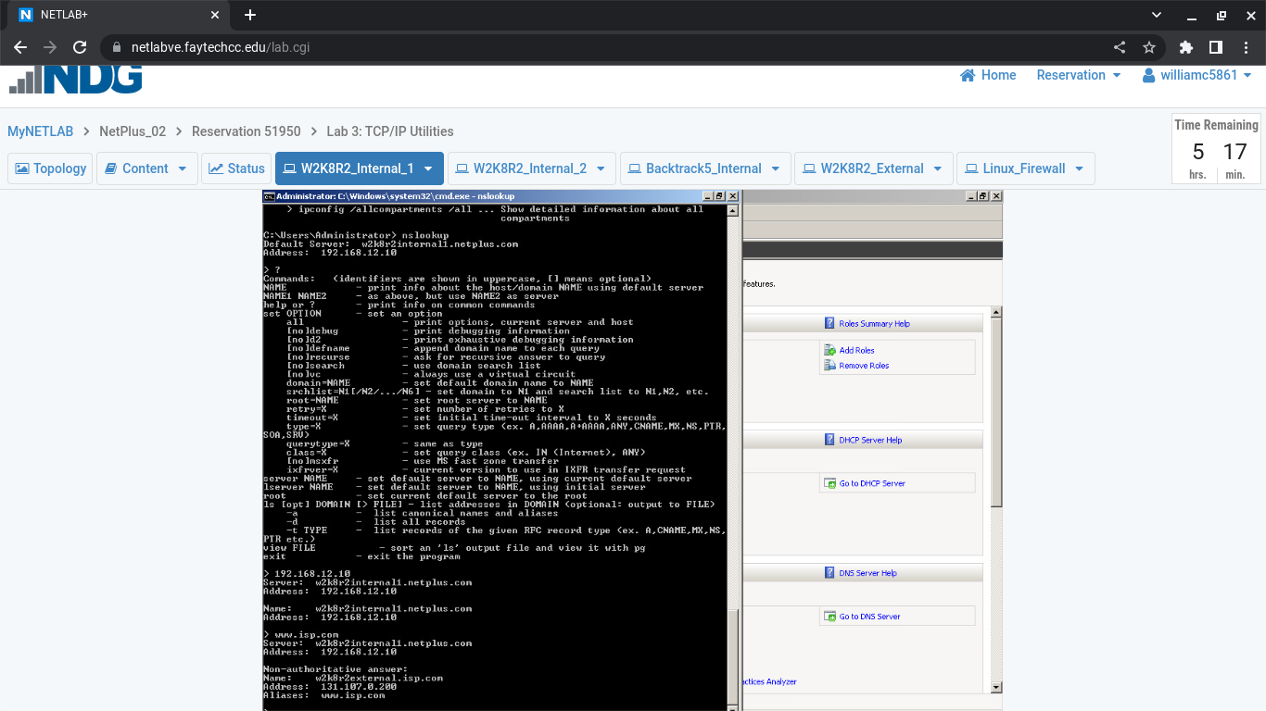

Exercise 3.1: Displaying DNS Information

Step #3a **- Insert your screenshot below this line.**

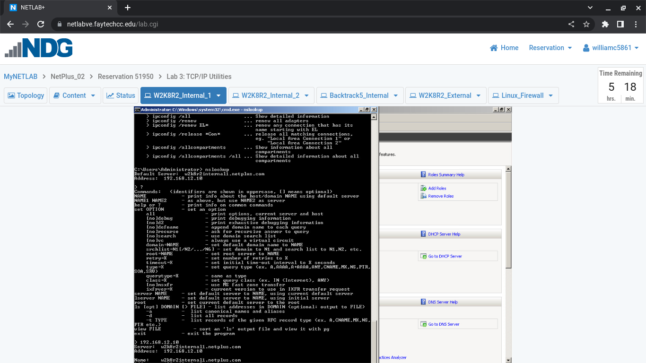

Exercise 3.1: Displaying DNS Information

Step #3b **- Insert your screenshot below this line.**

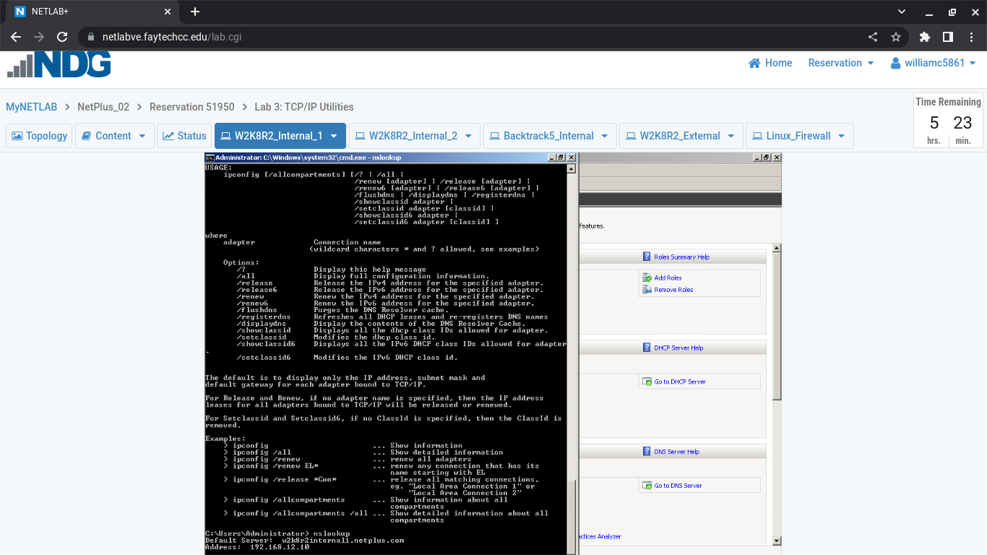

Exercise 3.1: Displaying DNS Information

Step #3c **- Insert your screenshot below this line.**



Exercise 3.1: Displaying DNS Information

Step #4 **- Insert your screenshot below this line.**





Exercise 3.1: Displaying DNS Information

Step #5 **- Insert your screenshot below this line.**



*You have finished the exercises required for this module. Although the lab continues within NDG this is beyond the scope of this module in which we are covering. Please save this document and upload it in blackboard.*