**Lab3: Tcp\Ip Utilities**

Log in to NDG Lab and click on NISGTC Networks and begin **Lab3: Tcp\Ip Utilities**. You will need to create a reservation for the lab first. Make sure you give yourself enough time to complete all the exercises.  
You will need to read the instructions and complete each step just looking at the screenshots will not be enough to complete labs. Take screenshots of the steps required as you go through this assignment to show you completed the lab for grading purposes.

**Displaying Network Connections**

Exercise 4.1: Displaying Network Connections Using the CLI

Take a screenshot of the following step: #2, #4, #6, #8, #12, #13

**Using Commands to Test Network Connectivity**

Exercise 5.1: Using Commands to Test Network Connectivity

Screenshots for the following steps: #1, #2, #3, #5, #6, #7, #8.

**Observing the ARP Process**

Exercise 6.1: Observing the ARP Process

Screenshots for the following steps: #6, #9

Log in to NDG Lab and click on NISGTC Networks and begin Lab2: Types of Networks. Instructions are under the Content tab within NDG. Complete the exercises and insert your screenshots below.

To start Click the following link. [NDG Lab: Tcp\Ip Utilities](https://netlabve.faytechcc.edu/)

**Displaying Network Connections**

Exercise 4.1: Displaying Network Connections Using the CLI

Step #2 **- Insert your screenshot below this line.**

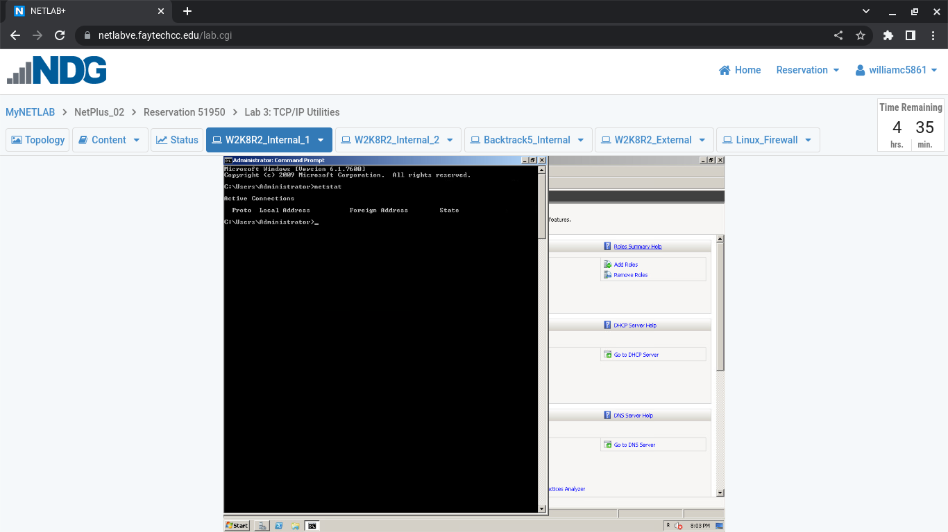

Exercise 4.1: Displaying Network Connections Using the CLI

Step #4 **- Insert your screenshot below this line.**

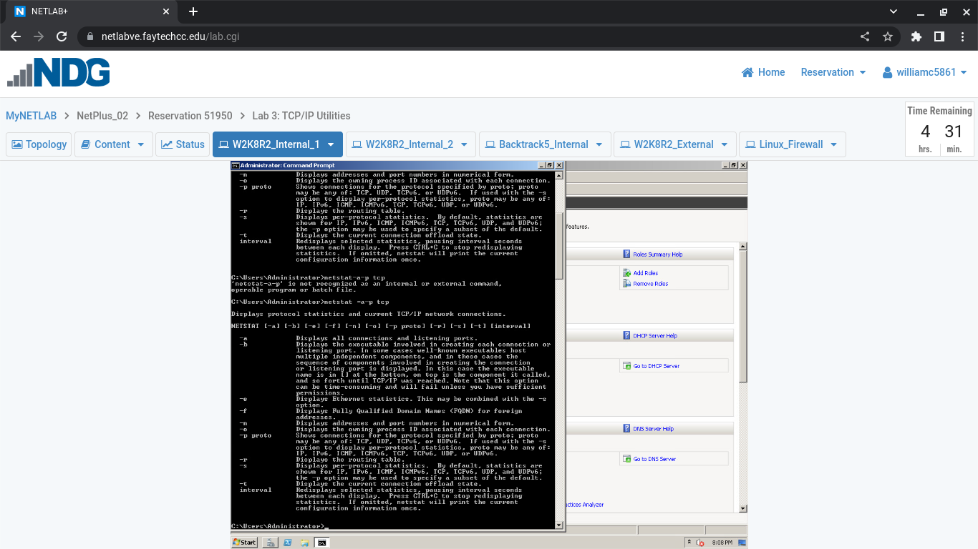

Exercise 4.1: Displaying Network Connections Using the CLI

Step #6 **- Insert your screenshot below this line.**

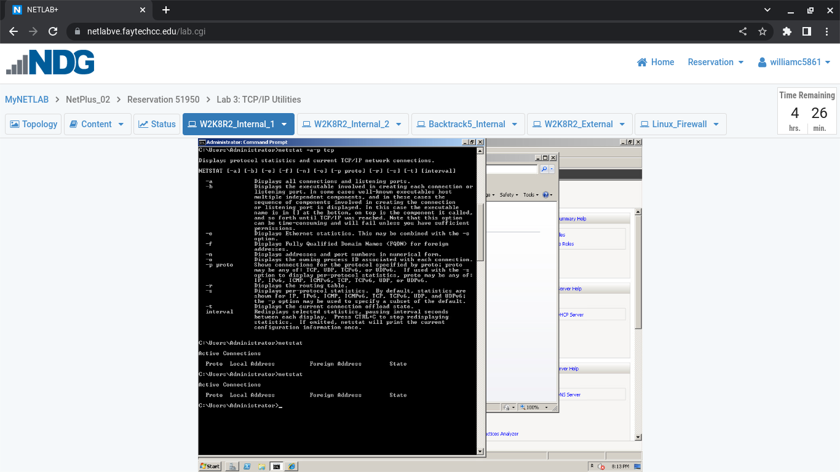

Exercise 4.1: Displaying Network Connections Using the CLI

Step #8 **- Insert your screenshot below this line.**

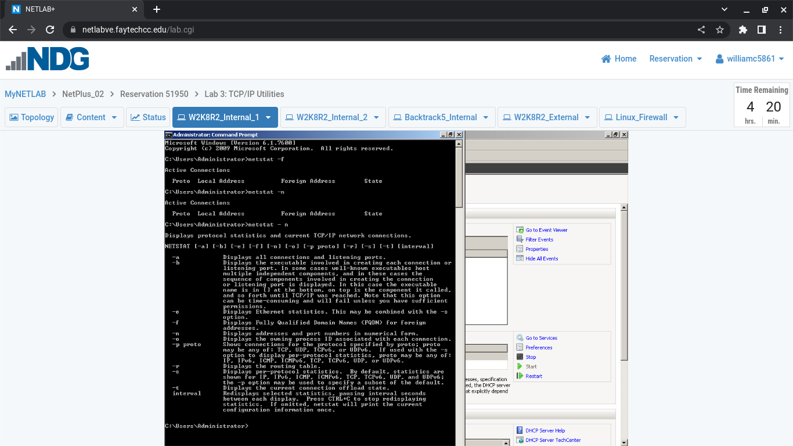

Exercise 4.1: Displaying Network Connections Using the CLI

Step #12 **- Insert your screenshot below this line.**

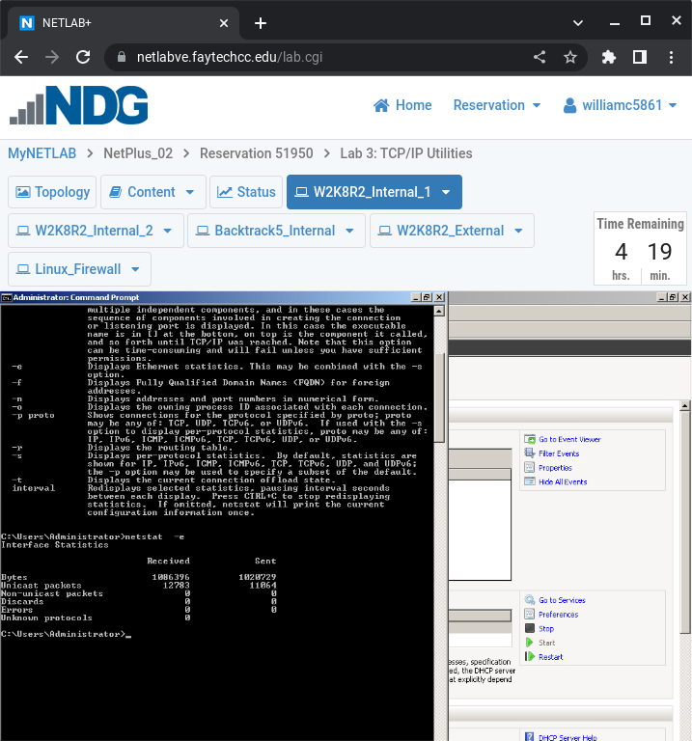

Exercise 4.1: Displaying Network Connections Using the CLI

Step #13 **- Insert your screenshot below this line.**

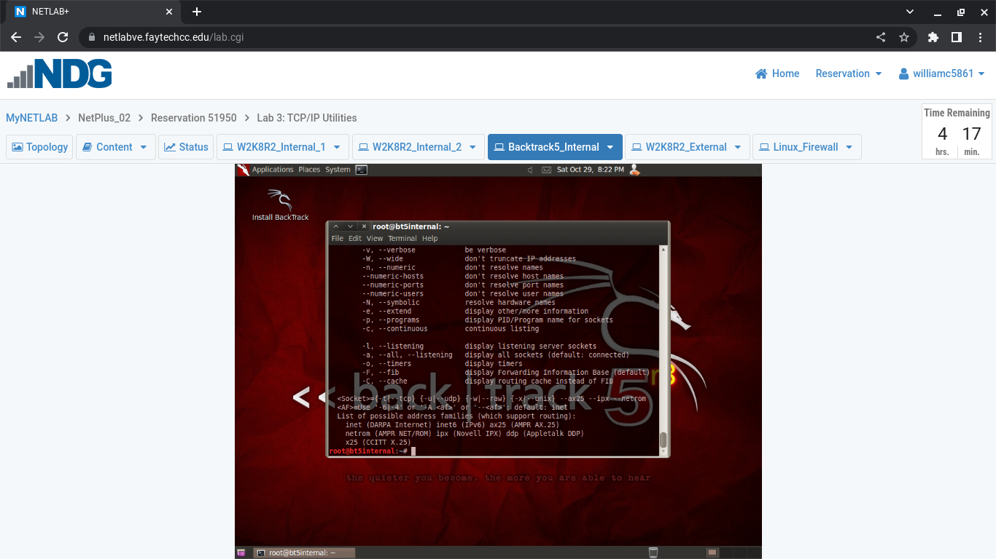

**Using Commands to Test Network Connectivity**

Exercise 5.1: Using Commands to Test Network Connectivity

Step #1 **- Insert your screenshot below this line.**

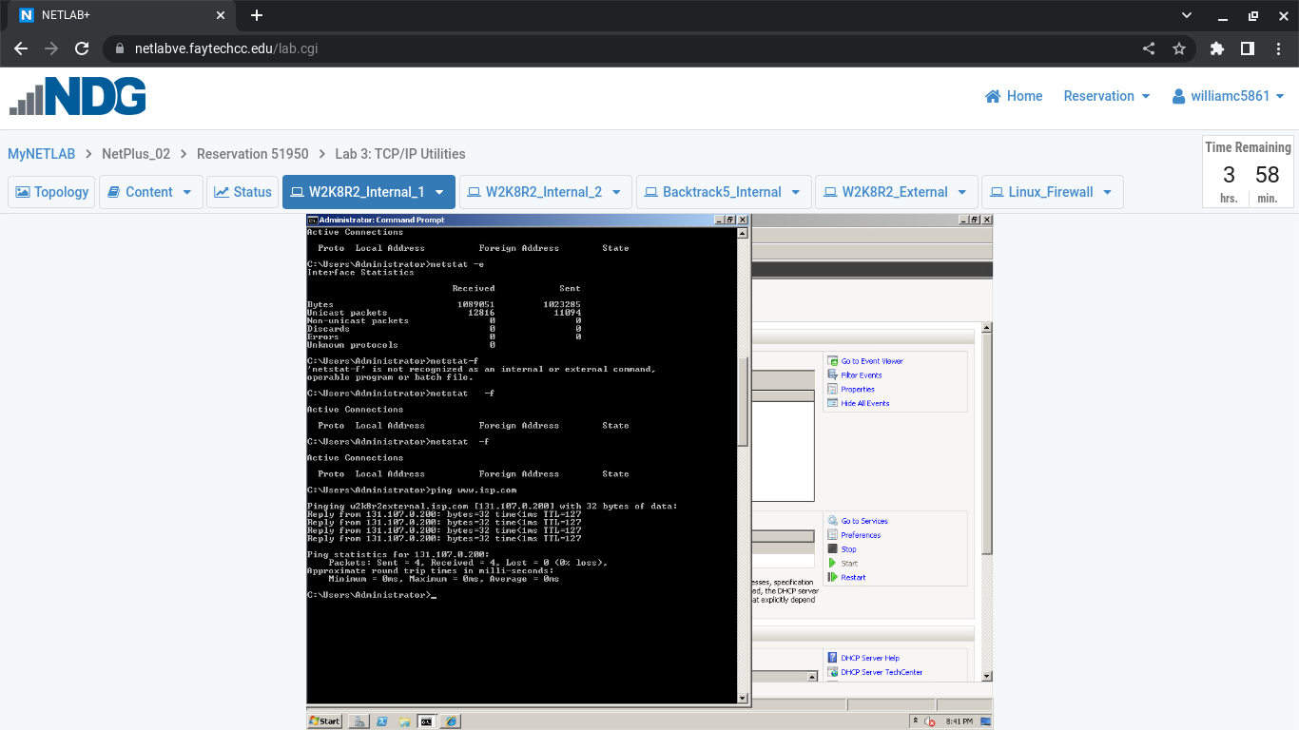

Exercise 5.1: Using Commands to Test Network Connectivity

Step #2 **- Insert your screenshot below this line.**

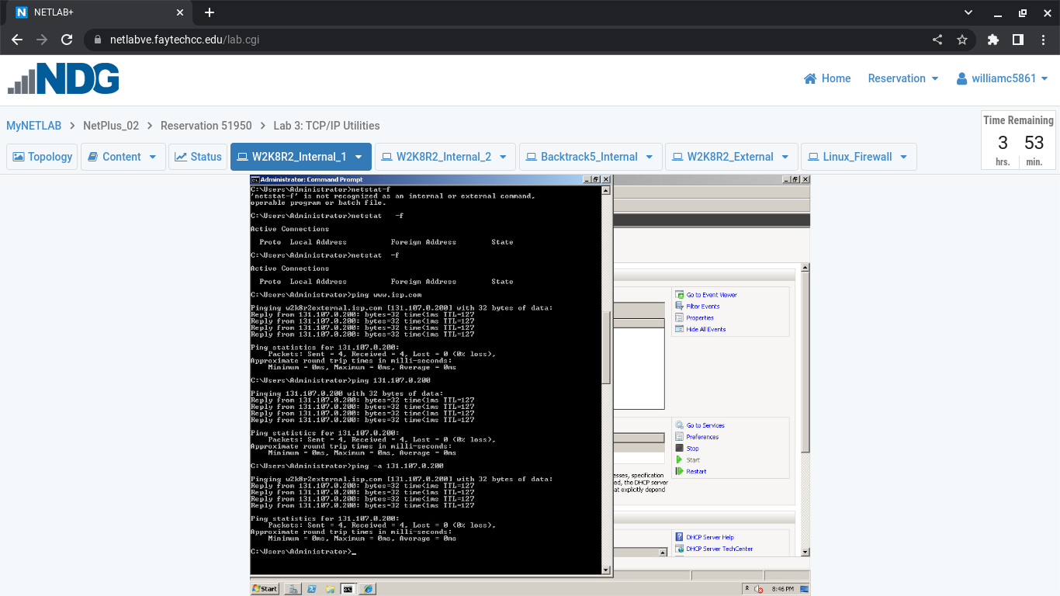

Exercise 5.1: Using Commands to Test Network Connectivity

Step #3 **- Insert your screenshot below this line.**

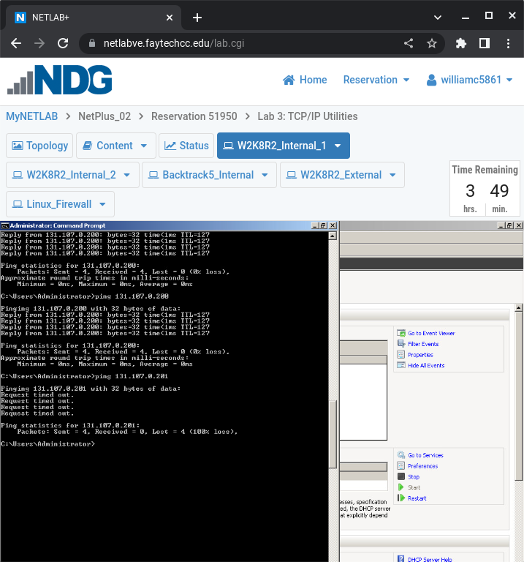

Exercise 5.1: Using Commands to Test Network Connectivity

Step #5 **- Insert your screenshot below this line.**

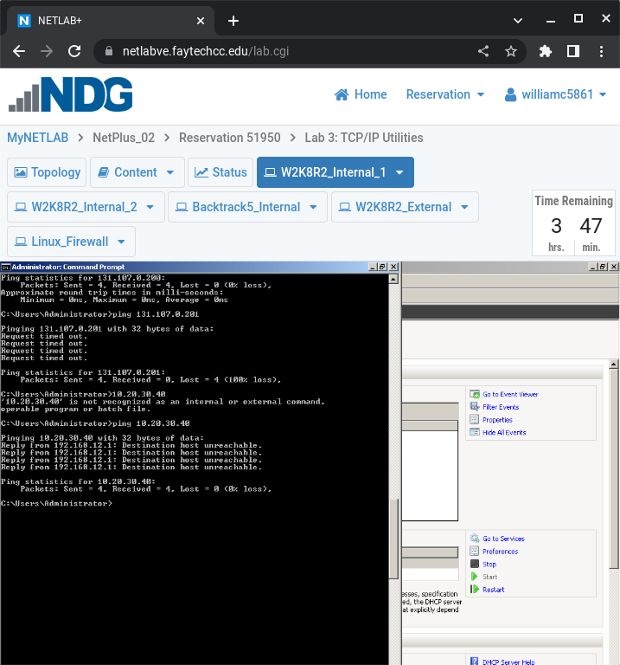

Exercise 5.1: Using Commands to Test Network Connectivity

Step #6 **- Insert your screenshot below this line.**

Exercise 5.1: Using Commands to Test Network Connectivity

Step #7 **- Insert your screenshot below this line.**

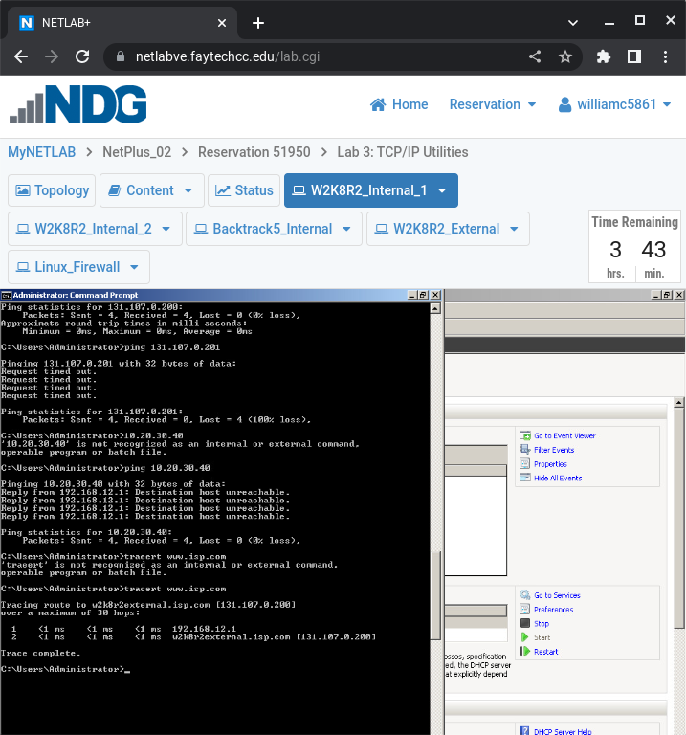

Exercise 5.1: Using Commands to Test Network Connectivity

Step #8 **- Insert your screenshot below this line.**

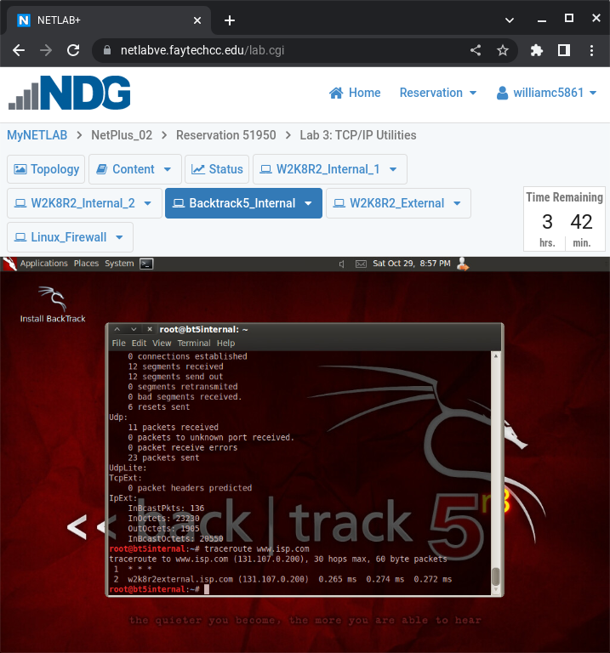

**Observing the ARP Process**

Exercise 6.1: Observing the ARP Process

Step #6 **- Insert your screenshot below this line.**

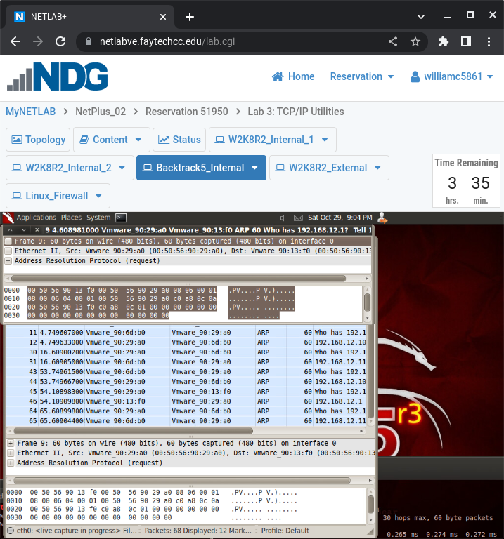

Exercise 6.1: Observing the ARP Process

Step #9 **- Insert your screenshot below this line.**

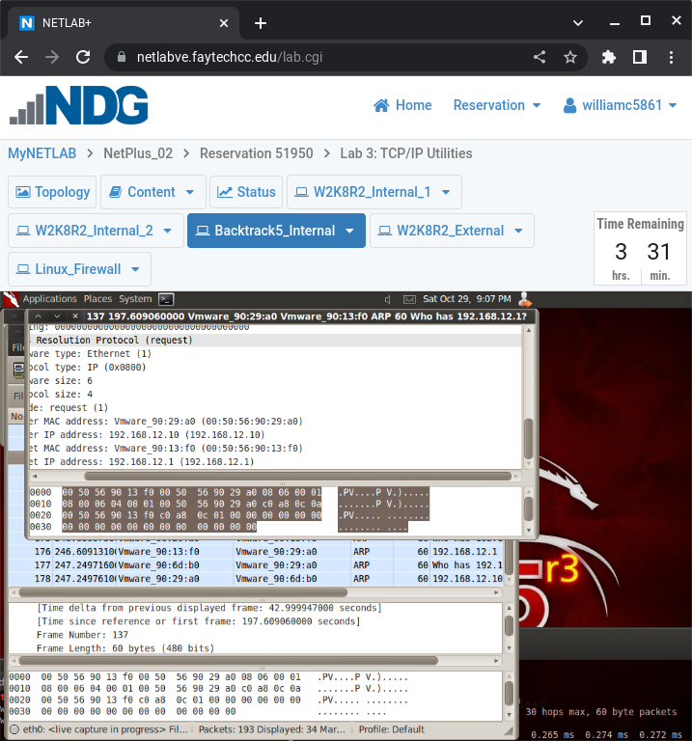

*You have finished the exercises required for this module. Although the lab continues within NDG this is beyond the scope of this module in which we are covering. Please save this document and upload it in blackboard.*