## **Instructions for how to properly capture your labs before beginning the lab.**

1. For the first lab, you will use this template, do not rename the labels.

2. For future labs, ensure you use the same format as this one, for clarity see below

* One screenshot per page ensuring that each screenshot takes up most of the page (minus your labels) The best way to insert the screenshot, so that it goes from margin to margin is to right-click and choose Keep Source Formatting (the first icon on the left under Paste Options)

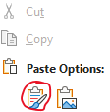

* Ensure your labels are above your screenshot and that the labels are on the same page as the screenshot it is the label for
* Use the Snipping Tool 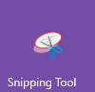 or Snip and Sketch (Win10) 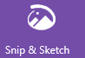 or equivalent to capture your screenshots. They must be in the format you see in the examples in this document
  + NDG username must be in the upper right of your screenshot
  + Entire Windows Taskbar of the virtual machine client must be visible in the screenshot
  + Cropped so that your capture is clear and captures only the NDG portion, see the example shots in this document
  + If your screenshots do not mimic this format, you will get a warning the first time, and no credit for future work

To ensure you setup your browser correctly, do the following. After you log into NDG, if your browser is set to full screen, it will likely be too large for a proper screenshot. The virtual machines desktop needs to fill the span (left to right) of your browser window. To adjust your browser window, use the Minimize square in the upper right (see red circle around the square) to adjust it to the size required. The NDG logo and your NDG username should be included in the screenshot. Adjust the screenshot so it looks like SAMPLE Lab below.

Screen shot example

Exercise 1.1: How copy screenshot in word document under the correct label

Example **- Insert your screenshot below this line.**

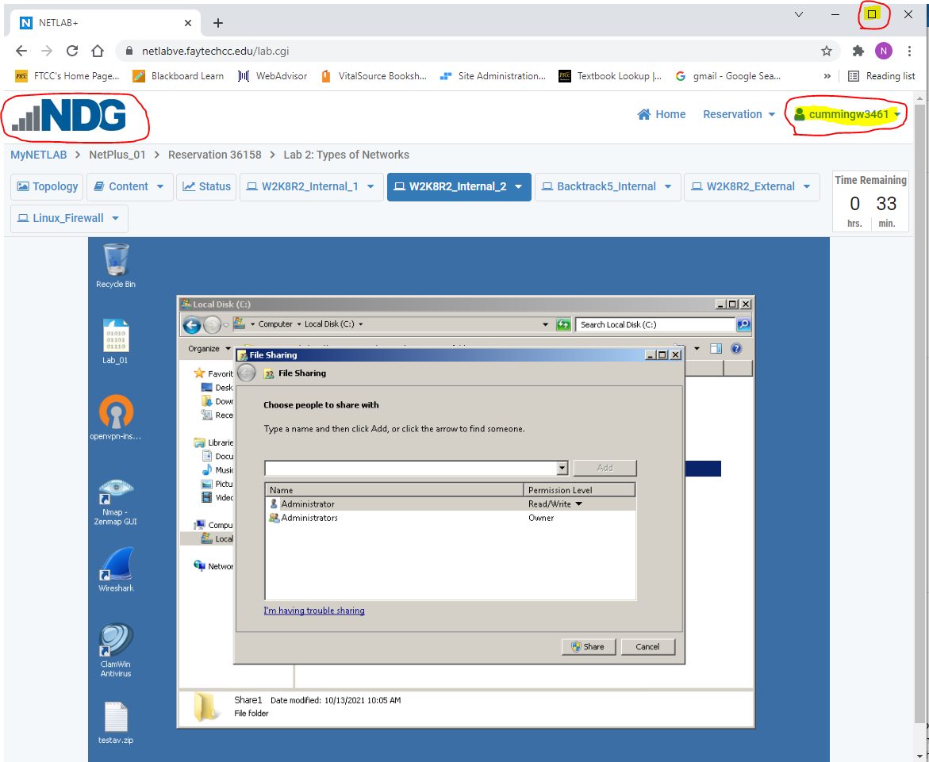

**Lab2: Type of Networks**

Log in to NDG Lab and click on NISGTC Network + and begin **Lab2: Types of Networks**. You will need to create a reservation for the lab first. Make sure you give yourself enough time to complete all the exercises.  
You will need to read the instructions and complete each step just looking at the screenshots will not be enough to complete labs. Take screenshots of the steps required as you go through this assignment to show you completed the lab for grading purposes. Exercises to be completed for this module

**Sharing Files**

Exercise 1.1: Create a Shared File

Take a screenshot of the following step: #4, #9.

**Share Permissions**

Exercise 2.1: Testing the Share and Re-assigning Permissions

Screenshots for the following steps: #4, #12, #20.

**Mapping a Drive**

Exercise 3.1

Screenshots for the following steps: #6.

Log in to NDG Lab and click on NISGTC Networks and begin Lab2: Types of Networks. Instructions are under the Content tab within NDG. Complete the exercises and insert your screenshots below.

To start Click the following link. [NDG Lab: Types of Networks](https://netlabve.faytechcc.edu/)

**Sharing Files**

Exercise 1.1: Create a Shared File

Step #4 **- Insert your screenshot below this line.**

Exercise 1.1: Create a Shared File

Step #9 **- Insert your screenshot below this line.**

**Share Permissions**

Exercise 2.1: Testing the Share and Re-assigning Permissions

Step #4 **- Insert your screenshot below this line.**

Exercise 2.1: Testing the Share and Re-assigning Permissions

Step #12 **- Insert your screenshot below this line.**

Exercise 2.1: Testing the Share and Re-assigning Permissions

Step #20 **- Insert your screenshot below this line.**

**Mapping a Drive**

Exercise 3.1: Testing the Share and Re-assigning Permissions

Step #6 **- Insert your screenshot below this line.**

*You have finished the exercises required for this module. Although the lab continues within NDG this is beyond the scope of this module in which we are covering. Please save this document and upload it in blackboard.*