TRIBHUVAN UNIVERSITY
INSTITUTE OF ENGINEERING
ADVANCED COLLEGE OF ENGINEERING AND MANAGEMENT
DEPARTMENT OF ELECTRONICS AND COMPUTER ENGINEERING
KALANKI, KATHMANDU

A Minor Project Final Defense Report On
“MACHINE LEARNING–BASED CAFE LOCATION AND CAFE TYPE SUITABILITY PREDICTION SYSTEM”
[CT-654]

Submitted By:
Santosh Mahato Koiri (ACE079BCT059)
Sijan Shrestha (ACE079BCT065)
Upendra Khadka (ACE079BCT077)

Supervisors:
Dr. Binayak Ojha
Er. Ramesh Sharma

A Minor Project Final Report submitted to the Department of Electronics and Computer Engineering in the partial fulfillment of the requirements for Degree of Bachelor of Engineering in Computer Engineering
Kathmandu, Nepal
26th March, 2026
ADVANCED COLLEGE OF ENGINEERING AND MANAGEMENT
KALANKI, KATHMANDU

DEPARTMENT OF ELECTRONICS AND COMPUTER ENGINEERING

LETTER OF APPROVAL

The undersigned certify that they have read and recommended to the Institute of Engineering for acceptance a project report entitled “MACHINE LEARNING–BASED CAFE LOCATION AND CAFE TYPE SUITABILITY PREDICTION SYSTEM” submitted by:
Santosh Mahato Koiri (ACE079BCT059)
Sijan Shrestha (ACE079BCT065)
Upendra Khadka (ACE079BCT077)

In partial fulfillment for the degree of Bachelor in Computer Engineering.

...................................
Project Supervisor

......................................
Head of Department
Er. Roshani Ghimire
Department of Electronics and Computer Engineering

26th March, 2026

COPYRIGHT

The author has agreed that the library, Advanced College of Engineering and Management, may make this report freely available for inspection. Moreover, the author has agreed that permission for extensive copying of this project report for scholarly purposes may be granted by the supervisors who supervised the project work recorded herein or, in their absence, by the Head of the Department wherein the project was done. It is understood that recognition will be given to the report’s author and the Department of Electronics and Computer Engineering, Advanced College of Engineering and Management for any use of the material of this project report. Copying publication or the other use of this project for financial gain without the approval of the Department and author’s written permission is prohibited.

Request for permission to copy or to make any other use of the material in this report in whole or in part should be addressed to:

Head of Department,
Department of Electronics and Computer Engineering
Advanced College of Engineering and Management
Kalanki, Kathmandu
Nepal

ACKNOWLEGEMENTS

We take this opportunity to express our deepest and sincere gratitude to our project supervisors Dr. Binayak Ojha and Er. Ramesh Sharma for their insightful advice, motivating suggestions, invaluable guidance, help and support in successful completion of this project and for their constant encouragement and advice throughout our Bachelor's programme.
We express our deep gratitude to Er. Roshani Ghimire, Head of Department of Electronics and Computer Engineering, Er. Navaraj Banstola and Dr. Raksha Dangol, Deputy Heads of Department of Electronics and Computer Engineering for their regular support, co-operation, and coordination. The in-time facilities provided by the department throughout the Bachelors program are also equally acknowledgeable.
We would like to convey our thanks to the teaching and non-teaching staff of the Department of Electronics and Computer Engineering, ACEM for their invaluable help and support till the date. We are also grateful to all our classmates for their help, encouragement and invaluable suggestions.
Finally, yet more importantly, we would like to express our deep appreciation to my grandparents, parents, siblings for their perpetual support and encouragement throughout the Bachelor’s degree period.

Santosh Mahato Koiri (ACE079BCT059)
Sijan Shrestha (ACE079BCT065)
Upendra Khadka (ACE079BCT077)

ABSTRACT

Selecting the right location is one of the most important decisions for any cafe business. Traditional location scouting methods rely on personal observation and intuition, which are subjective and inefficient. This project presents CafeLocate ML, a web-based location recommendation system that helps prospective cafe owners identify suitable business locations in Kathmandu Metropolitan City, Nepal, using real spatial data and machine learning.
The system integrates data from multiple real sources including 1,072 cafe locations collected via the Mapbox Geocoding API, road network data from OpenStreetMap, ward-level population data from the Nepal Census 2021 (862,400 total population across 32 wards), and 9,265 OSM amenity points. For any location pinned on the map, the system performs buffer-based spatial analysis using the Haversine distance formula and computes a suitability score based on three criteria: competitor density (40%), road accessibility (30%), and population density (30%).
A Random Forest Classifier trained on 2,676 balanced location samples with 11 spatial features achieved a classification accuracy of 99.63% across three suitability classes (High, Medium, Low). The system is built using Django 4.2 for the backend, Django REST Framework for API endpoints, JWT for authentication, and Leaflet.js for the interactive frontend map.
CafeLocate ML translates complex geospatial analysis into simple, actionable recommendations, making data-driven location decisions accessible to non-technical users.
Keywords: Buffer Analysis, Cafe Location, Kathmandu, Location Recommendation, OpenStreetMap, Random Forest, Spatial Analysis

Table of Contents

LETTER OF APPROVAL i
COPYRIGHT ii
ACKNOWLEGEMENTS iii
ABSTRACT iv
List of Tables viii
List of Figures ix
List of Abbreviations x
CHAPTER 1 1
INTRODUCTION 1
1.1 Background 1
1.2 Motivation 1
1.3 Problem Statements 2
1.4 Project Objective 3
1.5 Significance of the Study 3
CHAPTER 2 4
LITERATURE REVIEW 4
2.1 Related Works 4
2.2 Summary of Literature Review 5
2.3 Research Gap 6
CHAPTER 3 7
REQUIREMENT ANALYSIS 7
3.1 Functional Requirements 7
3.2 Non-Functional Requirements 7
3.3 System Requirements 8
3.3.1 Hardware Requirements 8
3.3.2 Software Requirements 8
3.4 Feasibility Analysis 8
3.4.1 Technical Feasibility 8
3.4.2 Economic Feasibility 9
3.4.3 Operational Feasibility 9
CHAPTER 4 10
METHODOLOGY 10
4.1 Multi-Source Data Acquisition 10
4.2 Spatial Feature Engineering and Buffer Analysis 11
4.3 Multi-Criteria Suitability Analysis (MCSA) 12
4.4 Model Training 12
4.5 Evaluation Metrics 13
4.6 Software Development Model: Agile Model 13
CHAPTER 5 15
SYSTEM DESIGN AND ARCHITECTURE 15
5.1 System Architecture Design 15
5.2 Use Case Diagram 18
5.3 Data Flow Diagram (DFD) 19
5.4 Flowchart of the System 20
CHAPTER 6 23
RESULT AND ANALYSIS 23
6.1 Overview of Work Completed 23
6.2 Data Acquisition and Integration 23
6.2.1 Cafe Location Data 23
6.2.2 Road Network Data 23
6.2.3 Population and Census Data 23
6.2.4 Ward Boundary Data 24
6.2.5 OSM Amenities Data 24
6.3 System Architecture and Backend Development 24
6.3.1 Technology Stack 24
6.3.2 Database Models 24
6.3.3 API Endpoints Implemented 25
6.4 Spatial Analysis Methodology 25
6.4.1 Buffer-Based Spatial Feature Engineering 25
6.4.2 Haversine Distance Formula 25
6.4.3 Point-in-Polygon Query 26
4.4 Road Accessibility Computation 26
6.5. Multi-Criteria Suitability Scoring 26
6.6. Machine Learning Pipeline 27
6.1 Dataset Preparation 27
6.6.2 Train/Test Split 27
6.6.3 Model: Random Forest Classifier 27
6.6.4 Model Evaluation Results 28
6.6.5 Model Deployment 28
6.7. Frontend Development 29
6.8. Remaining Work 29
CHAPTER 7 31
CONCLUSION, LIMITATIONS AND FUTURE ENHANCEMENTS 31
7.1 Conclusion 31
7.2 Limitations 31
7.3 Future Enhancements 31
REFERENCES 32
APPENDICES 33
Appendix A: System Architecture Diagram 33
Appendix B: User Interfaces 34

List of Tables

Table 1: Literature Review 4
Table 2: Evaluation Metrics 22
Table 3: API Endpoints 26
Table 4: Hyperparameters with their values 28
Table 5: Model Evaluation Matrices 29

List of Figures

Figure 1: Design of System Architecture 10
Figure 2: User Interface Layer 11
Figure 3: Application Layer 11
Figure 4: Machine Learning Layer 12
Figure 5: Data Layer 13
Figure 6: Use Case Diagram for Overall Operation 14
Figure 7: DFD Level 0 15
Figure 8: DFD Level 1 15
Figure 9: Flowchart of the System 16
Figure 10: Methodology Overview 17
Figure 11: Agile Software Development Model 21
Figure 12: System Architecture Diagram 31

List of Abbreviations
AHP | Analytic Hierarchy Process
API | Application Programming Interface
CSV | Comma-Separated Values
DFD | Data Flow Diagram
GB | Gigabyte
GCN | Graph Convolutional Networks
GIS | Geographic Information System
HTTP | Hypertext Transfer Protocol
JSON | JavaScript Object Notation
LBRS | Location-Based Recommender Systems
MCDM | Multi-Criteria Decision Making
MCSA | Multi-Criteria Suitability Analysis
ML | Machine Learning
NSO | National Statistics Office (Nepal)
OAuth | Open Authorization
OSM | OpenStreetMap
PROMETHEE | Preference Ranking Organization Method for Enrichment of Evaluations
RAM | Random Access Memory
UI/UX | User Interface / User Experience
WGS84 | World Geodetic System 1984

CHAPTER 1

INTRODUCTION

1.1 Background
Choosing the physical location for a business is a decision of strategic importance that significantly influences the survival and performance of a company [1]. In the hospitality sector, particularly for cafes and restaurants, location is often considered the most critical determinant of success. Traditionally, these decisions were based on intuition or basic observation, weighing factors such as population density, local economic conditions, and accessibility [1]. However, with the rapid urbanization of cities like Kathmandu, the complexity of these variables has increased, transforming location selection into a multi-criteria decision problem that requires sophisticated analysis rather than simple estimation.
The emergence of Location-Based Recommender Systems (LBRS) has provided a technological solution to this challenge. LBRS are specialized context-aware systems that utilize geographical data to provide users with timely and relevant items or information [3]. By integrating Geographic Information Systems (GIS) with machine learning techniques, it is now possible to process vast amounts of spatial data such as competitor locations, road networks, and demographic data to generate actionable business insights [4]. While traditional recommender systems focus on suggesting products to users, a business-oriented LBRS focuses on recommending the optimal location or business type for a specific area.
This project proposes a web-based application designed to assist entrepreneurs in Kathmandu Metropolitan City. By leveraging spatial data from OpenStreetMap and Google Maps, combined with demographic data, the system analyzes the "business influence area" to evaluate suitability and predict the success of new cafe ventures using machine learning algorithms like Random Forest.

1.2 Motivation
The primary motivation for this project stems from the high failure rate of new establishments in the food and beverage industry. Statistics indicate a harsh reality where a significant percentage of restaurants fail within their first year, often due to suboptimal location choices and an inability to adapt to the local market saturation [2]. Chain restaurants may afford to close underperforming outlets, but for small-scale entrepreneurs in Kathmandu, a wrong location choice can lead to irreversible financial loss.
Furthermore, there is a lack of accessible, data-driven tools for local investors. Most existing systems are descriptive rather than prescriptive [2]. There is a growing need for "Prescriptive Analytics" in business location selection systems that not only analyze the current state but also recommend the best course of action [2]. This project is motivated by the desire to bridge this gap, providing a user-friendly platform that democratizes access to complex spatial analysis and machine learning predictions, ultimately fostering a more sustainable business ecosystem in Kathmandu.

1.3 Problem Statements
Despite the availability of map services like Google Maps, entrepreneurs in Kathmandu face significant challenges in assessing the viability of a potential cafe location. The core problem lies in the difficulty of manually aggregating and analyzing dispersed spatial data to make an informed decision. Specifically, the problems addressed by this project include:
- Information Asymmetry:
Entrepreneurs often lack a consolidated view of critical parameters such as competitor density, population demographics, and road accessibility within a specific radius of a proposed site.
- Subjectivity in Decision Making:
Without a quantitative system, decisions are often driven by intuition, leading to businesses opening in oversaturated areas or missing opportunities in underserved locations [1].
- Lack of Predictive Insight:
While a user might know where existing cafes are, they often lack the analytical tools to predict what type of cafe (e.g., Coffee shop vs. Bakery vs. Restaurant) would be most suitable for a specific neighborhood based on market gaps and historical data.
- High Failure Risks:
The inability to accurately assess the "co-location" patterns in which types of businesses thrive near each other increases the risk of business failure [2].

1.4 Project Objective
General Objective:
To develop a web-based cafe location recommendation system that utilizes GIS and Machine Learning to assist users in identifying the most suitable cafe type for a specific location in Kathmandu Metropolitan City.
Specific objectives:
- To develop an interactive web interface that allows users to pin specific locations in Kathmandu and visualize spatial data, including existing cafes and road networks, within a specified radius buffer.
- To analyze site suitability parameters by integrating diverse datasets (Google Maps, OpenStreetMap, and Population Census) to calculate competitor density, road accessibility, and business influence.
- To implement Machine Learning models that predicts the most suitable cafe type for a selected area based on identified market gaps and saturation levels.
- To provide actionable recommendations by displaying the top 5 existing cafes and suggesting one optimal new cafe type to open in that location, or the specified cafe type in another location.

1.5 Significance of the Study
The system reduces the uncertainty and financial risk associated with opening new businesses. By providing a data-backed recommendation (e.g., suggesting a "Bakery Cafe" where there is high footfall but low competition), it aids in strategic decision-making [1].
The project demonstrates the application of GIS in analyzing urban business distributions. It highlights how "co-location" patterns the tendency of certain businesses to cluster can be quantified and used for planning [2].
The project showcases the successful integration of web-based GIS visualization with backend Machine Learning logic. It contributes to the field of Location-Based Recommender Systems (LBRS) by moving beyond simple "nearest neighbor" searches to complex, multi-criteria suitability prediction [3].

CHAPTER 2

LITERATURE REVIEW

2.1 Related Works
The research studies related to location-based recommendation systems, spatial data mining, and multi-criteria decision-making (MCDM) for business suitability:
Table 1: Literature Review
Ref | Authors | Title | Methodology | Key Findings
[1] | V. Perez-Benitez, G. Gemar, and M. Hernandez (2021) | Multi-Criteria Analysis for Business Location Decisions | Integrated PROMETHEE with AHP and GAIA analysis to rank 66 European cities. | Validated that security and technology are critical dimensions for business location decisions. Produced a preferential ranking of cities (e.g., London, Paris) for investment.
[2] | S. Han et al. (2024) | Restaurant location recommendation based on spatial data mining | Proposed a "LocationGCN" model combining spatial co-location pattern mining with GCN to capture spatial correlations of restaurants. | Demonstrated that different restaurant types have distinct co-location patterns. Achieved 74.88% accuracy in predicting suitable locations, outperforming traditional methods.
[3] | R. Sujithra and B. Surendiran (2020) | Location Based Recommender Systems (LBRS) – A Review | A comprehensive review of existing LBRS services, categorizing them into geo-tagged media, point location, and trajectory-based services. | Identified that context-aware attributes (time, user preference) significantly improve recommendation quality. Bayesian networks are noted for solving "cold start" problems.
[4] | M. Sarath, S. Saran, and K. V. Ramana (2018) | Site Suitability Analysis for Industries Using GIS and MCDM | Used GIS and AHP to evaluate land suitability for industrial establishment based on six criteria (slope, road proximity, land use, etc.) in Andhra Pradesh. | Proved that integrating GIS with MCDM provides a scientific basis for site selection, minimizing environmental damage, and optimizing resource use.
[5] | C. A. Onyekwelu et al. (2024) | GIS-Based Site Suitability Study of Rice Farm Location | Employed GIS overlay analysis and reclassification of soil, slope, and accessibility data to map suitable farming sites in Nigeria. | Identified that 83.43% of the studied land was suitable for production. Demonstrated the efficacy of GIS in optimizing land resource utilization.

2.2 Summary of Literature Review
The review of existing literature highlights a significant evolution in location selection strategies, moving from manual, intuition-based decisions to sophisticated, data-driven approaches. Early methods and broad reviews, such as those by Sujithra & Surendiran [3], established the foundation of Location-Based Recommender Systems (LBRS), emphasizing the importance of geo-tagged data and user context. Building on this, studies like Perez-Benitez et al. [1] and Sarath et al. [4] demonstrated the power of integrating GIS with Multi-Criteria Decision Making (MCDM) techniques like AHP. These studies successfully validated that mathematical weighting of spatial factors (such as road accessibility and land use) yields highly accurate suitability maps, though they often focused on macro-level city selection or industrial zoning rather than small business needs.
More recent advancements, particularly by Han et al. [2], have introduced machine learning and "Prescriptive Analytics" into the domain. By utilizing advanced algorithms like Graph Convolutional Networks, researchers have begun to model the complex "co-location" patterns of how specific businesses thrive when clustered near certain other types. However, a distinct gap remains for a localized, accessible tool for Kathmandu. Most existing systems are either too computationally complex for general users or lack the specific micro-level focus on cafe types (e.g., predicting "Bakery" vs. "Coffee Shop"). This project aims to bridge this gap by combining the proven GIS suitability analysis methods of [4] and [5] with a machine learning prediction model tailored to the specific urban dynamics of Kathmandu Metropolitan City.

2.3 Research Gap
Despite the extensive research in location suitability analysis, significant gaps remain when applying these methodologies to small-scale commercial enterprises like cafe in developing urban centers. Existing studies, such as the work by Perez-Benitez et al. (2021) and Sarath et al. (2018), predominantly focus on macro-level analysis ranking entire cities for investment or selecting large industrial zones which lacks the micro-level granularity required to evaluate specific street corners or neighborhoods for a coffee shop.
Furthermore, while recent advancements by Han et al. (2024) have introduced sophisticated deep learning models for location prediction, these systems are often computationally intensive and focus on binary suitability (whether a location is "good" or "bad") rather than recommending the optimal business type (e.g., Bakery vs. Cafe) from multiple options.
Additionally, traditional GIS approaches, as seen in Onyekwelu et al. (2024), are frequently tailored to agriculture, relying on physical factors like soil and slope while neglecting dynamic socio-economic indicators such as competitor density and market saturation that are critical for the hospitality industry.
Finally, comprehensive reviews like those by Sujithra & Surendiran (2020) provide theoretical frameworks but highlight a lack of practical, hybrid systems that effectively solve the "cold start" problem for new businesses without historical data. This project aims to address these limitations by developing a specialized, web-based tool that combines micro-level spatial analysis with machine learning to provide accessible, type-specific recommendations for Kathmandu's cafe entrepreneurs.

CHAPTER 3

REQUIREMENT ANALYSIS

3.1 Functional Requirements
Functional requirements define the specific behaviors or functions the system must perform. Based on the project roadmap, the key functional requirements include:
- User Authentication: The system shall allow users to sign in securely using existing accounts to maintain a personalized profile of saved locations.
- Interactive Map Visualization: The system shall provide a high-resolution map of Kathmandu Metropolitan City with zoom-in/out capabilities using OpenStreetMap and Mapbox Maps API.
- Location Pinning: Users shall be able to pin a specific geographic location on the map to define the center of their business interest.
- Buffer Analysis (Specified Radius): The system shall automatically calculate and visualize a specified radius buffer around the pinned location to analyze the "business influence area".
- Spatial Data Retrieval: The system shall fetch and display existing cafes, road networks, and population density data within the selected buffer.
- Recommendation Engine:
  - Existing Success: The system shall list the Top 5 existing cafes in the area based on popularity and ratings.
  - Predictive Suggestion: The system shall utilize a Random Forest algorithm (with others if it fails) to predict and recommend one specific cafe type (e.g., Bakery, Coffee Shop) that is most suitable for the location based on market gaps.
- Suitability Parameter Display: The system shall display a dashboard showing the quantitative values for parameters like competitor density, accessibility, and demographic suitability.

3.2 Non-Functional Requirements
Non-functional requirements specify the criteria that can be used to judge the operation of a system rather than specific behaviors.
- Performance: The spatial analysis and ML prediction should be processed within 3 to 5 seconds to ensure a smooth user experience.
- Usability: The web interface must be intuitive, requiring minimal technical knowledge for an entrepreneur to navigate the map and interpret results.
- Reliability: The system should provide consistent recommendations based on the underlying datasets from Google Maps and OSM.
- Scalability: The architecture should be designed to allow for the inclusion of other Metropolitan Citys beyond Kathmandu or additional business categories in the future.
- Accuracy: The ML model should aim for high precision in its predictions, validated against historical business success patterns in the urban context [2].

3.3 System Requirements
To ensure the effective development and deployment of the cafe recommendation system, the following hardware and software specifications are required:

3.3.1 Hardware Requirements
- Processor: Intel i5 or higher (for handling local ML model training and spatial data processing).
- RAM: Minimum 8GB (to handle GIS rendering and data manipulation).
- Storage: 20GB of free space (for local datasets and environment setup).

3.3.2 Software Requirements
- Operating System: Windows 10/11, macOS, or Linux.
- Frontend: HTML/CSS/JavaScript with Leaflet.js for map rendering.
- Backend: Python (Django) to handle GIS logic and ML integration.
- Database: PostgreSQL with PostGIS extension (for spatial queries).
- Machine Learning: Scikit-learn library for the Random Forest algorithm.
- Data Sources: Mapbox API, OpenStreetMap data, and National Population Census datasets.

3.4 Feasibility Analysis

3.4.1 Technical Feasibility
The project is technically feasible as the tools required Python for ML, PostGIS for spatial data, and HTML, CSS, JS for the frontend are well-documented and widely used. The availability of APIs like Google Maps and open data from OSM ensures that the necessary spatial datasets can be retrieved and integrated effectively.

3.4.2 Economic Feasibility
The project is economically feasible because it primarily utilizes open-source technologies (Python, Leaflet, PostgreSQL). The primary costs involved are related to API usage (Mapbox) and hosting, which can be managed within a student project budget or via free-tier credits. For the end-user, this system provides high value by reducing the financial risk of business failure [1].

3.4.3 Operational Feasibility
The system is highly operational as it solves a real-world problem for entrepreneurs in Kathmandu. By automating the complex process of spatial co-location mining and market gap analysis tasks that currently require expensive consultants the platform offers a practical solution that users can easily adopt into their business planning workflow [2].

CHAPTER 4

METHODOLOGY
This chapter details the technical steps, the mathematical foundations of the predictive model, and the software development lifecycle adopted for this project.
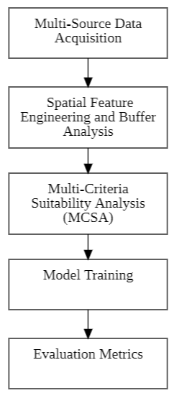
Figure 10: Methodology Overview

4.1 Multi-Source Data Acquisition
To build a comprehensive recommendation engine, data is harvested from three heterogeneous sources:
- Mapbox API: This is the primary source for identifying current market players. It provides the most "real-world" and updated dataset for existing businesses.
  - Collection Method: We utilize the Places API via HTTP GET requests. For a specific pinned location in Kathmandu, the system triggers a nearby search or search text query.
  - Parameters used:
    - location: Latitude and longitude of the pinned point.
    - radius: 500 meters (adjustable).
    - type: Filtered for cafe, bakery, and restaurant.
  - Extracted Attributes: Business Name, Place ID, Global Rating, Total User Ratings, and current operational status.
  - Validity Check: Google data is validated by millions of users; however, to ensure "freshness," we only extract businesses with a business status labeled as OPERATIONAL.
- OpenStreetMap (OSM): Provides the structural framework for the analysis. We extract the "Highway" and "Amenity" layers to analyze road connectivity and existing urban infrastructure. Data is mined using the Overpass Turbo API. We execute a specialized query to extract all "Highways" (roads) and "Amenity" points within the Kathmandu Metropolitan City boundary.
- National Population Census (2021): Provides the demographic weight. Population density data is linked to ward-level shapefiles to estimate the potential customer volume in specific neighborhoods.
To understand the "potential customer base," we integrate the latest official statistics from the National Statistics Office (NSO) of Nepal.
- Collection Method: Data is sourced from the Census Nepal 2021 Data Portal. We extract ward-level CSV files for Kathmandu Metropolitan City.
- Key Metrics: Population density (people per sq. km) and household counts at the ward level.
- Data Linking: Since census data is tabular, we perform a Spatial Join in the backend, linking the tabular population counts to a GIS Shapefile of Kathmandu’s administrative wards.

4.2 Spatial Feature Engineering and Buffer Analysis
Once the data is cleaned and standardized to the WGS84 coordinate system, the system performs "Buffer Analysis."
- Centroid Selection: When a user clicks on the map, the system captures the latitude and longitude (x, y).
- 500m Influence Zone: A circular buffer with a radius of 500 meters is generated around the pin. This distance is chosen based on urban "walkability" standards for food services.
- Feature Extraction: The system counts all existing cafes (Competitor Density), measures total road length (Accessibility Index), and extracts ward-level density (Demographic Demand) within this buffer.

4.3 Multi-Criteria Suitability Analysis (MCSA)
Following the methodology of Sarath et al. (2018), the system applies weighted scoring to these spatial features. This transforms raw counts into a suitability score. If a location has low competitor density but high population density and road accessibility, it receives a high "Market Opportunity" rank.

4.4 Model Training
The core of the system’s "Prescriptive Analytics" is the Random Forest Classifier. Unlike simple search tools, it predicts the optimal type of cafe for a given location based on patterns learned from successful businesses.
4.4.1 Random Forest:
Random Forest is an ensemble learning method that constructs a multitude of Decision Trees during training and outputs the class that is the mode of the classes of the individual trees.
The model chooses the best "split" at each node of a decision tree using Gini Impurity or Entropy.
- Gini Impurity (G): Measures the frequency at which a randomly chosen element from the set would be incorrectly labeled.
$G=1-\sum_{i=1}^{c}{P_{i}^{2}}$ . .....................................................................................(1)
(Where P_{i} is the probability of an item belonging to class i).
- Entropy (H): Measures the level of impurity or "randomness" in the data.
$H=-\sum_{i=1}^{c}{P_{i}\log_{2}\left(P_{i}\right)}$ .........................................................................(2)
- Information Gain (IG): The model calculates which feature (e.g., population vs. road density) provides the most information to reduce entropy.
$IG=H \left(Parent\right)-\sum_{ }^{ }{\left(\frac{N_{child}}{N_{parent}}×H\left(child\right)\right)}$................................................(3)
4.4.2 Training Process
- Bootstrap Aggregating (Bagging): The model creates multiple subsets of the training data with replacement.
- Feature Randomness: In each tree, only a random subset of spatial features (e.g., just road density and competitors) is considered at each split to ensure diversity and prevent overfitting.
- Voting: The final recommendation (e.g., "Bakery") is the one predicted by the majority of the individual trees.

4.5 Evaluation Metrics
To ensure the recommendation system is reliable, the Random Forest model is evaluated using a Confusion Matrix to compare predicted vs. actual successful business types in Kathmandu.
Table 2: Evaluation Metrics
Metric | Formula | Description
Accuracy | $$\frac{TP+TN}{TP+TN+FP+FN}$$ | Overall percentage of correct predictions.
Precision | $$\frac{TP}{TP+FP}$$ | Measures the quality of the positive predictions (how many predicted "Bakeries" were suitable).
Recall | $$\frac{TP}{TP+FN}$$ | Measures the ability to find all suitable locations in the dataset.
F1-Score | $$2×\frac{\operatorname{Pr}{e}cision×Recall}{\operatorname{Pr}{e}cision+Recall}$$ | The harmonic mean of precision and recall, providing a single score for model performance.

4.6 Software Development Model: Agile Model
For this project, the Agile Development Model is adopted due to its iterative nature, which is ideal for refining complex ML models and GIS interfaces.
Phase 1: Planning and Backlog
In this phase, we define the "Product Backlog," which includes setting up the PostgreSQL/PostGIS database and integrating the Google Maps API.
Phase 2: Design and Prototyping
The UI/UX is designed using React.js. An initial prototype of the interactive Kathmandu map is built, allowing for simple coordinate pinning.
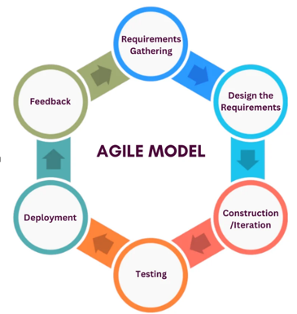
Figure 11: Agile Software Development Model
Source: https://medium.com/tech-stack-insights/the-software-development-lifecycle-sdlc-a-deep-dive-with-agile-methodology-f7846853b7a3
Phase 3: Development and Iteration
This is the core "Build" phase. The Random Forest model is trained on Kathmandu business data. The backend (Django/Flask) is developed to handle the spatial queries between the frontend map and the ML engine.
Phase 4: Testing & Review
The system undergoes unit testing for the spatial buffer logic and accuracy testing for the recommendation engine. Feedback is used to "tune" the hyperparameters of the Random Forest model to improve the F1-score.

CHAPTER 5

SYSTEM DESIGN AND ARCHITECTURE

5.1 System Architecture Design
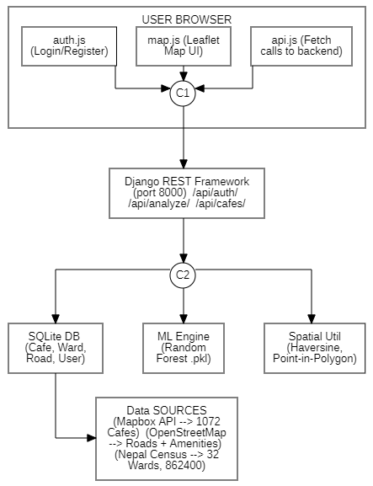
Figure 1: Design of System Architecture
This diagram illustrates the structural layers of the map-based cafe location recommendation system for Kathmandu Metropolitan City. The User Interface and Application Layer represent the web-based platform where users sign in via Google, interact with the Kathmandu Metropolitan City map, select cafe types, and pin locations. The Machine Learning Models layer utilizes algorithms like Random Forest to process spatial and historical data including market gaps and competitor density to predict ideal business types. Supporting this is the Data Layer, which integrates the project's multi-source datasets from Google Maps, OpenStreetMap, and Population Census records to determine site suitability within a 500m radius.
5.1.1 User Interface Layer
The User Browser is the platform through which the user accesses the system using a web browser such as Chrome or Edge. It allows the user to open the website, sign in with a Google account, and interact with the map-based features of the application. The Web Interface provides the visual and interactive elements of the system. It includes the login page, cafe selection options, buttons, forms, and result panels. This interface captures user inputs such as cafe type selection, map pin location, and recommendation requests, and sends them to the application layer for processing. The Interactive Kathmandu Map displays a zoomable and clickable map of Kathmandu Metropolitan City. It allows users to pin a location, view a 500-meter radius area (default), see existing cafes, and visualize suitability using heatmaps. This component enables intuitive location-based interaction and presents analysis results in a user-friendly manner.
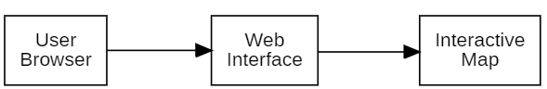
Figure 2: User Interface Layer
5.1.2 Application Layer
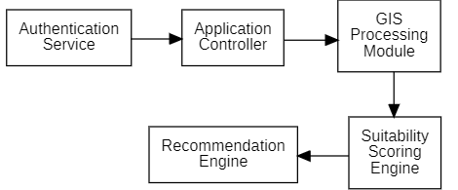
Figure 3: Application Layer
Google Authentication Service allows users to securely sign in using their existing Google account. It ensures authorized access to the system before users can interact with the Kathmandu Metropolitan City map and cafe analysis features. Application Controller manages all user requests such as cafe selection, map pinning, and recommendation requests. It controls the workflow and coordinates communication between different system modules. GIS Processing Module processes the pinned map location and creates a 500-meter analysis radius. It extracts spatial data such as existing cafes, roads, and nearby facilities using Google Maps, OpenStreetMap, and census data. Suitability Scoring engine evaluates how suitable the selected location is for the chosen cafe type. It analyzes factors like competition, population density, accessibility, and demand to calculate a suitability score. The Recommendation Engine provides the final results by suggesting the top five existing cafes in the area and predicting one new cafe type that can be successfully opened within the selected radius.
5.1.3 Machine Learning Layer
The Machine Learning layer serves as the core analytical engine of the system, responsible for processing complex spatial datasets and generating predictive insights for cafe site selection. This layer begins with a robust feature engineering process where raw data including competitor density within a 500-meter buffer, accessibility indices from OpenStreetMap, and demographic statistics from the 2021 Census are converted into numerical vectors. At the heart of this layer lies the Random Forest Classifier, an ensemble learning model that utilizes a collection of decision trees to evaluate these spatial features. During the training phase, the model identifies non-linear patterns from historical cafe performance data in Kathmandu, learning to differentiate between optimal and sub-optimal business locations. When a user interacts with the web-based GIS interface, the ML layer performs real-time inference by passing the selected coordinate spatial attributes through its trained forest of trees. Each tree contributes a vote toward a final suitability classification, ensuring that the recommendation is backed by a statistical consensus rather than a single variable. Finally, the layer outputs a suitability score which is passed back to the frontend for visualization, effectively bridging the gap between raw geographical data and prescriptive business decision-making.
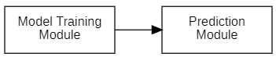
Figure 4: Machine Learning Layer
5.1.4 Data Layer
The Data Layer forms the backbone of the proposed location-based cafe recommendation system by providing reliable and structured data for analysis and prediction. This layer integrates multiple real-world data sources into a centralized database, ensuring consistency and efficient data access across the system. All collected datasets are preprocessed to remove duplicates, handle missing values, and standardize geographic coordinates before storage.
The Google Maps dataset supplies detailed information about existing cafe in Kathmandu Metropolitan City, including their geographic locations, cafe categories, user ratings, and review counts. This data is essential for identifying competitors, analyzing cafe popularity, and ranking existing cafe within the selected 500-meter radius.
The OpenStreetMap dataset provides geospatial and infrastructure-related information such as road networks, nearby facilities, and land-use patterns. These features help evaluate accessibility, connectivity, and environmental suitability of a location, which directly influence cafe success.
The population census dataset contributes to demographic information such as ward-wise population density and distribution. This data is used to estimate potential customer demand and footfall in the selected area. By combining these datasets within a central database, the Data Layer ensures accurate spatial analysis, effective suitability scoring, and reliable machine learning–based prediction of new cafe opportunities.
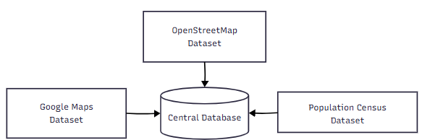
Figure 5: Data Layer

5.2 Use Case Diagram
The system involves three main actors: the User, who wishes to open a cafe and interacts with the application to view maps, analyze locations, and receive recommendations; the Admin, who manages datasets such as census and map data and retrains the machine learning model to maintain accuracy; and the Map Service (OpenStreetMap/Google Maps), which provides the base map of Kathmandu Metropolitan City with zoom and pan functionalities. The user logs in using a Google account, views the interactive Kathmandu map, selects a cafe type, and pins a location to define the analysis area. Based on the pinned point, the system displays nearby cafes and suitability factors such as population, road access, and cafe ratings within the specified radius. Using this data, the system recommends the top existing cafes and predicts the most suitable type of new cafe to open in that location, while the admin continuously updates datasets and the ML model to ensure reliable and accurate recommendations.

5.3 Data Flow Diagram (DFD)
It provides a way to visualize how data enters and leaves the system, what changes the data, and where data is stored.
DFD Level 0
It defines the scope of the system by identifying the boundaries between the system and external entities, such as the User and external Data Sources (Google Maps, OSM, and Census Data). In this system, the user provides inputs like cafe type, and the system provides recommendations and suitability analysis as output.
DFD Level 1
It illustrates how user inputs are processed through various stages: authentication, data retrieval, spatial analysis, and machine learning prediction. This level highlights the interaction between functional components and internal data stores like the spatial database.
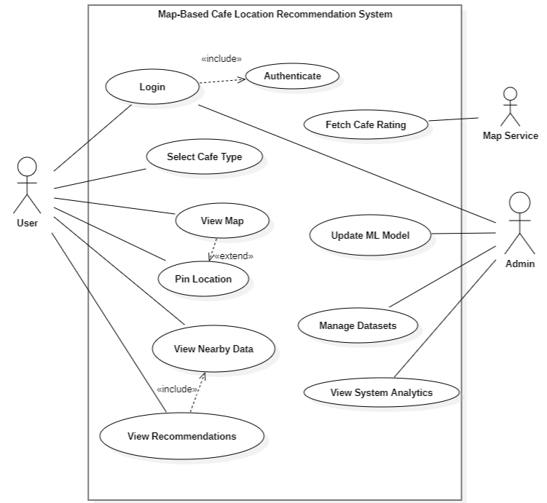
Figure 6: Use Case Diagram for Overall Operation

5.4 Flowchart of the System
The process begins with user login, followed by loading a map of Kathmandu Metropolitan City where users select their preferred cafe type and pin their desired location on the map. The system then analyzes a 500-meter radius (specified) around the pinned location and calculates the suitability of that area for opening a cafe based on various factors. If the location is deemed suitable, the system proceeds to recommend the top 5 cafes in that area and uses predictive analytics to determine which cafe type would be best to open there, finally displaying these results to the user. If the location is not suitable, system will automatically suggests the best location, and also users can return to pin a different location and repeat the analysis process until they find an appropriate spot for their cafe business.
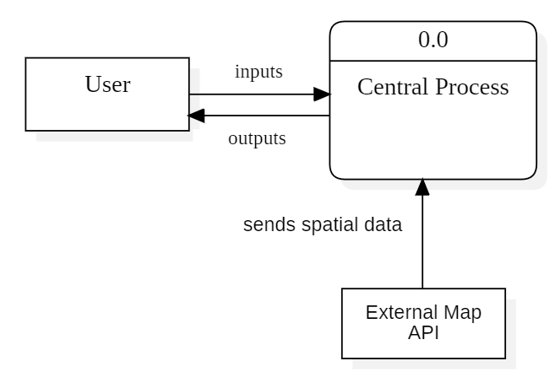
Figure 7: DFD Level 0
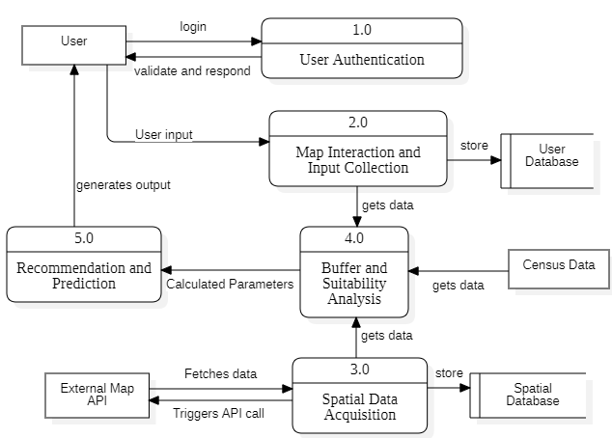
Figure 8: DFD Level 1
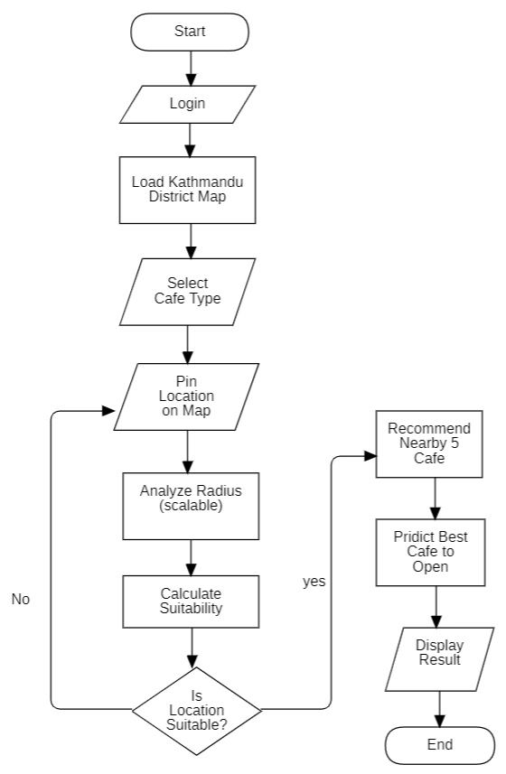
Figure 9: Flowchart of the System

CHAPTER 6

RESULT AND ANALYSIS

6.1 Overview of Work Completed
During the mid-term phase of the project, significant progress has been made across all major components of the CafeLocate ML system: data acquisition, backend API development, machine learning pipeline, and frontend interface. The system has transitioned from a conceptual prototype to a functional, data-integrated application capable of analysing real cafe location suitability in Kathmandu Metropolitan City.

6.2 Data Acquisition and Integration

6.2.1 Cafe Location Data
Real cafe location data for Kathmandu was collected using the Mapbox Geocoding API. A total of 1,072 cafe records were collected and stored in the system database, covering cafe types including coffee shops, bakeries, dessert shops, and restaurants. Each record includes the place identifier, name, cafe type, geographic coordinates (latitude and longitude), star rating, review count, and open/closed status.

6.2.2 Road Network Data
Road network data for Kathmandu was acquired from OpenStreetMap (OSM) in GeoJSON format. Road segments are stored as LineString and MultiLineString geometries and are used to approximate road accessibility within a user-defined buffer radius around any selected location. Each road record includes its OSM identifier, road classification type (primary, secondary, residential, footway, etc.), and geometry.

6.2.3 Population and Census Data
Ward-level population data was extracted from the official Nepal Census 2021 document (ktm_city.pdf) using the PyPDF2 library. The extraction used regular expression pattern matching to parse tabular population figures by ward number. The total population of Kathmandu Metropolitan City as recorded is 862,400, distributed across 32 administrative wards. For each ward, the following fields are stored: ward number, total population, number of households, area in square kilometres, and calculated population density (persons/km²).

6.2.4 Ward Boundary Data
Geographic boundary polygons for all 32 wards of Kathmandu were loaded into the system. Boundaries are stored in GeoJSON format (Polygon and MultiPolygon types) and are used for spatial point-in-polygon queries to determine which ward a selected location falls within, enabling accurate population density retrieval for that area.

6.2.5 OSM Amenities Data
An additional dataset of 9,265 OSM amenity points was integrated into the system from osm_amenities_kathmandu.csv. These amenities are classified by type including schools, hospitals, pharmacies, bus stations, health posts, and cafés. This data supports a richer spatial analysis by providing proximity-based counts of key urban facilities in any selected buffer area.

6.3 System Architecture and Backend Development

6.3.1 Technology Stack
The backend is built on Django 4.2 with the Django REST Framework (DRF), using SQLite as the database for local development with a migration path to PostgreSQL for production. The system uses JWT (JSON Web Tokens) via the PyJWT library for stateless user authentication. Cross-Origin Resource Sharing (CORS) is handled by django-cors-headers to allow the frontend (served on port 5500) to communicate with the backend API (served on port 8000).

6.3.2 Database Models
Four core database models were designed and implemented:
- Cafe: Stores all collected cafe records with spatial coordinates and metadata. Location is stored as a GeoJSON Point object. Default ordering is by star rating (descending).
- Ward: Stores the 32 administrative wards with their population statistics and GeoJSON boundary polygons used for spatial queries.
- Road: Stores OSM road network segments as GeoJSON LineString and MultiLineString geometries for road accessibility calculations.
- UserProfile: A custom Django user model extending AbstractUser, with a mandatory unique email field, supporting full username/email + password authentication. JWT tokens are issued on successful login and registration.

6.3.3 API Endpoints Implemented
The following RESTful API endpoints have been implemented and tested:
Table 3: API Endpoints
Endpoint | Method | Description
/api/auth/register/ | POST | Register a new user account
/api/auth/login/ | POST | Authenticate and receive JWT token
/api/cafes/nearby/ | GET | Return all open cafes within a specified radius
/api/analyze/ | POST | Full suitability analysis for a pinned location

6.4 Spatial Analysis Methodology

6.4.1 Buffer-Based Spatial Feature Engineering
The core analytical method of the system is buffer-based spatial analysis. When a user pins a location on the map, the system creates a conceptual circular buffer of radius R (default 500 metres, adjustable from 100 m to 2,000 m) centred on the selected point. All spatial features: competitor cafes, road segments, and population data, are computed within this buffer.

6.4.2 Haversine Distance Formula
Point-to-point distance calculations are performed using the Haversine formula, which computes the great-circle distance between two points on a sphere given their geographic coordinates. This is used throughout the system to determine whether a given cafe, road node, or geographic point falls within the user's selected buffer radius.
The formula is as follows. Given two points with latitudes φ₁, φ₂ and longitudes λ₁, λ₂ (all in radians):
$α=\sin^{2}\left(\frac{ϕ_{2}-ϕ_{1}}{2}\right)+\cos\left(ϕ_{1}\right).\cos\left(ϕ_{2}\right).\sin^{2}\left(\frac{λ_{2}-λ_{1}}{2}\right)$……….………………...…….(4)
$c=2\arcsin\left(\sqrt{a}\right)$…………………………………………………………...……….(5)
$d=R_{earth}.c$………………………………………………………………...……….(6)
Where R_earth ≈ 6,371 km. The result d is the straight-line distance in kilometres, multiplied by 1,000 to obtain metres. This formula accounts for the curvature of the Earth and is appropriate for the relatively short distances involved in urban-scale analysis.

6.4.3 Point-in-Polygon Query
To determine the ward that contains a selected location (for retrieving ward-level population density), a ray-casting algorithm is employed. The algorithm casts a horizontal ray from the query point and counts the number of times it crosses the edges of the ward polygon boundary. An odd count indicates the point is inside the polygon; an even count indicates it is outside. This is applied iteratively across all 32 ward boundaries until the containing ward is identified.

4.4 Road Accessibility Computation
Road accessibility is estimated by counting the number of OSM road segments that have at least one coordinate node within the buffer radius of the selected location, using the Haversine distance check on each node of each road's LineString geometry. Each qualifying road segment contributes an estimated 100 metres to a total road_length_m value, which is used as a proxy measure of road network density.

6.5. Multi-Criteria Suitability Scoring
A Multi-Criteria Suitability Analysis (MCSA) framework is used to produce a composite suitability score on a 0–100 scale for each pinned location. Three spatial criteria are combined with assigned weights:
Criterion 1: Competitor Density (weight: 40%) Measures the number of existing cafes within the buffer radius. A higher number of competitors indicates market saturation and reduces suitability. The score is computed as:
$Competitor Score=\max\left(0,1-\frac{N_{competitors}}{20}\right)×40$………………………………(7)
Criterion 2: Road Accessibility (weight: 30%) Measures the estimated road network length within the buffer. Higher road density indicates better foot traffic potential and ease of customer access. The score is:
$Road Score=\min\left(1,\frac{L_{road}}{3000}\right)×30$……………………………..…………………..(8)
Criterion 3: Population Density (weight: 30%) Uses the population density of the ward containing the selected location as a proxy for market size. Higher population density implies greater customer potential. The score is:
$Population Score=\min\left(1,\frac{D_{pop}}{15000}\right)×30$………………………………………….(9)
Final Composite Score:
$Suitability Score=Competitor Score+Road Score+Population Score$...(10)
The result is a value from 0 (least suitable) to 100 (most suitable), displayed to the user alongside the individual metric values.

6.6. Machine Learning Pipeline

6.1 Dataset Preparation
A preprocessed training dataset of 2,676 labelled records was prepared with balanced class distribution; 892 samples each for the High, Medium, and Low suitability classes. Each record contains 11 engineered spatial features derived from the buffer analysis:
- competitors_min_distance: minimum distance to nearest competitor café
- roads_within_500m: number of road segments within 500 m
- roads_avg_distance: average distance to road segments
- schools_within_500m, schools_within_200m, schools_min_distance: school proximity features
- hospitals_within_500m, hospitals_min_distance: hospital proximity features
- population_density_proxy: standardised population density value
- accessibility_score: composite road and amenity accessibility measure
- foot_traffic_score: composite foot traffic estimation score
All features are standardised (zero mean, unit variance) prior to model training.

6.6.2 Train/Test Split
The dataset was split into 80% training (2,140 samples) and 20% testing (536 samples) using stratified sampling to preserve the equal class distribution across both splits.

6.6.3 Model: Random Forest Classifier
A Random Forest Classifier from the scikit-learn library was selected as the prediction model. The Random Forest is an ensemble learning method that constructs a large number of decision trees during training and outputs the class receiving the majority vote across all trees. It is robust to overfitting, handles non-linear feature relationships well, and provides interpretable feature importance scores.
The model was trained with the following hyperparameters:
Table 4: Hyperparameters with their values
Hyperparameter | Value
Number of estimators (trees) | 200
Maximum tree depth | 15
Minimum samples to split | 5
Minimum samples per leaf | 2
Class weight | Balanced
Random state | 42

6.6.4 Model Evaluation Results
The trained model was evaluated on the held-out test set of 536 samples. The results are as follows:
Table 5: Model Evaluation Matrices
Class | Precision | Recall | F1-Score | Support
High | 0.99 | 0.99 | 0.99 | 178
Low | 1.00 | 1.00 | 1.00 | 179
Medium | 0.99 | 0.99 | 0.99 | 179
Overall Accuracy |  |  | 99.63% | 536
Only 2 out of 536 test samples were misclassified. The macro-averaged F1-score is 0.9963 and the weighted-averaged F1-score is 0.9963, indicating near-perfect generalisation across all three suitability classes.
The most important features as determined by mean decrease in impurity are: foot_traffic_score (28.8%), population_density_proxy (25.5%), schools_within_500m (14.9%), and schools_min_distance (12.2%).

6.6.5 Model Deployment
The trained Random Forest model and its label encoder are saved as .pkl binary files using the joblib library and loaded by the Django backend's ml_engine module to serve real-time predictions via the /api/analyze/ endpoint.

6.7. Frontend Development
The frontend is a single-page web application built with HTML5, CSS3, and vanilla JavaScript, served via a local HTTP server on port 5500. The interactive map is powered by the Leaflet.js library (v1.9.4) with OpenStreetMap tile layers, constrained to the geographic bounds of the Kathmandu Valley.
The application provides the following user-facing functionality:
- Authentication: Users can register a new account, log in with username or email, or continue as a guest. Sessions are persisted using browser localStorage with JWT tokens.
- Interactive Map: Users click anywhere on the Kathmandu map to pin a location. A visual circle overlay shows the selected analysis radius.
- Cafe Type Selection: A dropdown allows the user to select the intended cafe type (coffee shop, bakery, dessert shop, restaurant, etc.).
- Radius Control: A slider allows the analysis radius to be adjusted between 100 m and 2,000 m.
- Live Results Panel: On location selection, the right sidebar displays the suitability score (0–100), the ML model's predicted suitability level with confidence percentage, the top 5 competitor cafés ranked by a weighted score (rating × log(review_count + 1)), and three key metrics: competitor count, road access length, and population density.
- Full Report Modal: A detailed modal displays complete analysis including all metric breakdowns and actionable business recommendations.

6.8. Remaining Work
The following tasks are planned for completion before the final submission:
- Population Accuracy Improvement: The current population estimate sums the full population of any ward that intersects the buffer. A more precise method would compute the area of intersection between the buffer polygon and each ward polygon, calculate the fraction of the ward area covered, and apply that fraction to the ward population. This requires reprojecting ward geometries from WGS84 to a metric coordinate reference system (such as UTM Zone 45N) using pyproj, then performing polygon intersection with Shapely.
- Extended ML Feature Engineering: The ML model will be retrained with additional features including distance-weighted competitor density, amenity counts by type (schools, hospitals, bus stations) as direct features, and road type classification scores. K-fold cross-validation will be performed to report precision, recall, F1-score, and ROC-AUC.
- Map Overlays for Amenities: The frontend will be updated to display amenity points (schools, hospitals, etc.) as colour-coded circle markers within the buffer on the map when a full report is generated.
- PDF Export of Report: Users will be able to download a PDF version of the full location analysis report, generated either client-side using print CSS or server-side using an HTML-to-PDF renderer.
- Production Deployment: The application will be containerised using Docker, with environment-specific settings for production (PostgreSQL database, DEBUG=False, static file serving via WhiteNoise or Nginx, HTTPS configuration).
- Unit and Integration Testing: Test coverage will be added for all API endpoints, spatial geometry functions (haversine, point-in-polygon), and the ML prediction pipeline.
This chapter documents the mid-term state of the CafeLocate ML project. All implemented features are operational and tested in a local development environment. The system is built on real spatial data from Mapbox, OpenStreetMap, and the Nepal Census 2021.

CHAPTER 7

CONCLUSION, LIMITATIONS AND FUTURE ENHANCEMENTS

7.1 Conclusion

7.2 Limitations

7.3 Future Enhancements

REFERENCES

[1] V. Perez-Benitez, G. Gemar, and M. Hernández, "Multi-Criteria Analysis for Business Location Decisions," Mathematics, vol. 9, no. 2615, 2021.
[2] S. Han, L. Chen, Z. Su, S. Gupta, and U. Sivarajah, "Identifying a good business location using prescriptive analytics: Restaurant location recommendation based on spatial data mining," Journal of Business Research, vol. 179, p. 114691, 2024.
[3] R. Sujithra @ Kanmani and B. Surendiran, "Location Based Recommender Systems (LBRS) – A Review," in International Conference on Computational Intelligence and Data Science (ICCIDS 2020), 2020.
[4] M. Sarath, S. Saran, and K. V. Ramana, "Site Suitability Analysis for Industries Using GIS and Multi Criteria Decision Making," ISPRS Annals of the Photogrammetry, Remote Sensing and Spatial Information Sciences, vol. IV-5, pp. 447–454, 2018.
[5] C. A. Onyekwelu et al., "GIS-Based Site Suitability Study of Rice Farm Location in Bende Local Government Area, Abia State, Nigeria," African Journal of Food, Agriculture, Nutrition and Development, vol. 24, no. 5, pp. 26312–26332, May 2024.

APPENDICES

Appendix A: System Architecture Diagram

Figure 12: System Architecture Diagram

Appendix B: User Interfaces
