**DVA-TEAM14**

**WEEK 3: MAPPING TABLE AND ANNONATED WIREFRAME DESIGN REPORT**

**Date of Submission: 25 Aug 2025**

**Team Members:**

* Sakshitha K
* Laiba Jawaid
* Chaitanya Jori
* Bharadwaj K
* Faiza Jawaid
* Talha Z

**MAPPING TABLE :**

In continuation of the previous week’s task where the Master Table was designed by joining all the relevant datasets and relevant columns, this week’s work focused on building a Mapping Table.

The purpose of this mapping table is to clearly define the relationship between raw source data and the fields used in the dashboard. It ensures transparency in data lineage and provides guidelines for ETL and visualization teams.

Additionally, we’ve incorporated a section for Marketing fields (Campaign-level metrics that remain independent of the Master Table). Although these fields are not joined to learner data, they’re crucial for building separate marketing performance dashboards in Looker Studio.

**✅ Key Highlights of the Mapping Table:**

**Check Size and Structure**

➢~113,000 rows × 21 columns.

➢Contains learner details, opportunity info, cohort details, and application status.

**Key Fields**

➢**Learner profile:** learner_id, country, degree, institution, major, gender.

**➢Opportunity info**: opportunity_id, opportunity_name, category.

➢**Cohort info**: cohort_code, start date, end date, size.

➢**Tracking:** apply_ts, status.

**Data Quality Notes**

➢Some missing values (mainly in cohort details).

➢Country names, degree, and institution require standardization.

**Dashboard Field vs Master Table Column** → Defines which fields will directly appear on the dashboard.

**Original Source Table & Column** → Tracks the root source of each field for data lineage.

**Datatype** → Standardized formats (Text, Int, Timestamp, Date) for consistency.

**Transformation Applied / Formula** → Shows whether SQL cleaning or standardization was done.

**Business Logic / Role** → Explains the analytical purpose (KPI, Dimension, Metric).

**Field Category** → Groups columns as KPI, Metric, or Dimension for dashboard design.

**Relation** → Specifies how fields connect with each other (e.g., learner_id joins with opportunities, cohorts).

**Business Logic (Future Use)** → Explains how the field will be used in reporting (filters, grouping, trend analysis).

**Marketing Table Mapping Section**

Focuses on campaign-level fields like Campaign Name, Reach, Spend, etc.

Specifies which fields drive marketing dashboards (e.g., Cost-per-Result KPI, CPC metric).

Clearly states there’s no relational join to the Master Table and explains each field’s dashboard utility.

**Outcome:**

With this mapping table, the data flow from **source → master table → dashboard** is well documented. It will help the ETL team apply transformations consistently and guide the visualization team in building **dashboards** with correct **KPIs** and **filters**.

**Our Mapping Table Link is attached here:**

[WEEK3_MAPPING_TABLE_TEAM14.xlsx](https://docs.google.com/spreadsheets/d/12eVGX9Ixf8juAqcvoJ2hbk5f8oucqJb0y_wZAbRi7Mw/edit?usp=sharing)

**WIREFRAME :**

**Structure of the Wireframe Dashboard:**

The wireframe dashboard is designed to present a consolidated view of **learners, opportunities, and cohorts**. Its structure is divided into three main layers: **KPIs, Graphs, and Comparative Analysis.**

1. Structure of the Unified Analytics Dashboard Wireframe

* Wireframe:  
  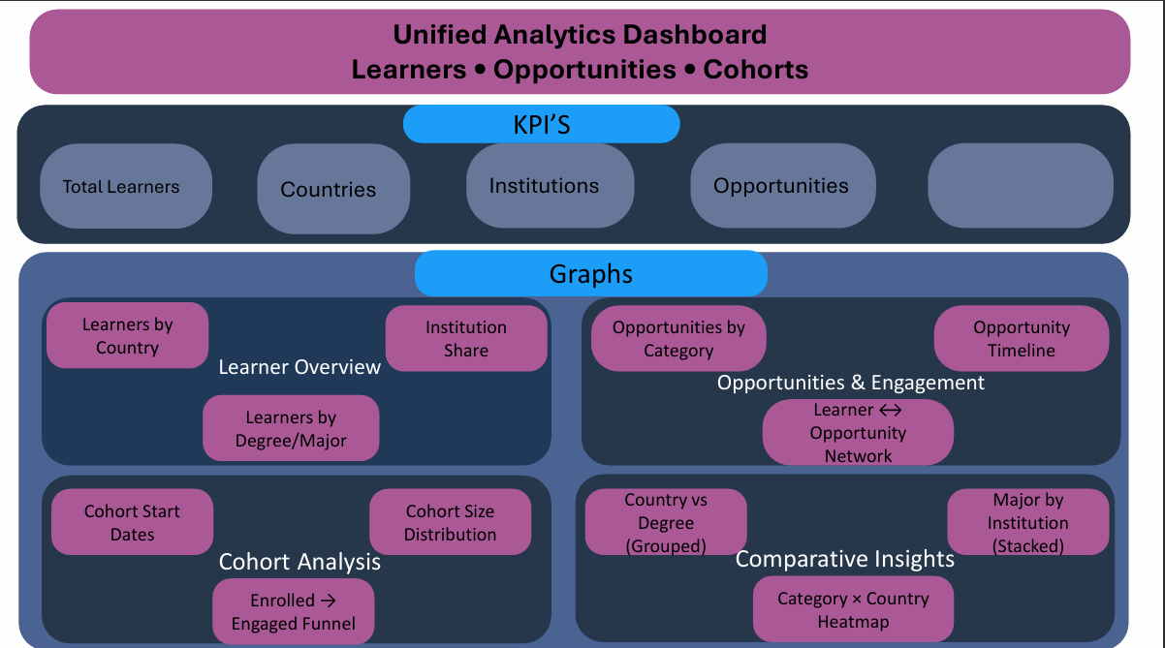
* **KPI Section**
* Displays **high-level metrics** for quick insights.
* Includes:
* **Total Learners**
* **Opportunities**
* **Institutions**
* **Countries**
* **Graphical Insights**
* Visual breakdown of learner and opportunity data.
* Covers:
* **Learner Overview:** Learners by degree, major, institution, and country.
* **Opportunities & Engagement:** Opportunities by category, learner–opportunity network, opportunity timeline.
* **Cohort Analysis**
* Focuses on learner participation over time.
* Includes:
* Cohort start dates.
* Enrolled → Engaged funnel.
* Cohort size distribution.
* **Comparative & Cross-Analysis**
* Provides multi-dimensional insights.
* Includes:
* Major by institution (stacked view).
* Category × country heatmap.
* Country vs degree (grouped view).