HLookUp Exercises

Assume you have the following dataset in an Excel worksheet starting from cell

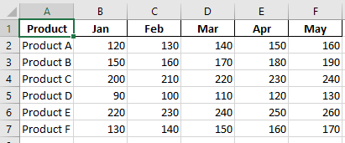

Task 1: Use HLOOKUP to find the sales for Product A in March.

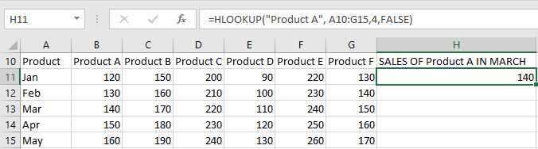

Task 2: Use HLOOKUP to find the sales for Product D in May.

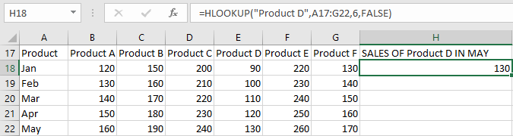

Task 3: Use HLOOKUP to find the sales for Product C in February.

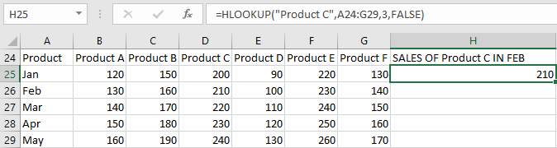

Task 4: Use HLOOKUP to find the sales for each month for a product, then calculate the

total sales for that product.

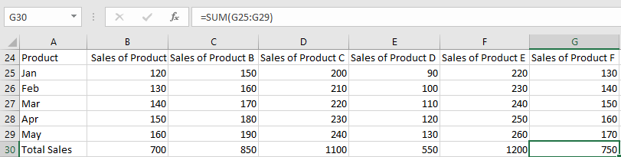

Task 5: Use HLOOKUP to find the maximum sales value for Product B across all months.

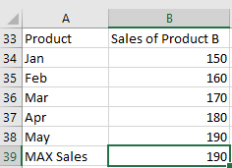

Task 6: Use HLOOKUP to find the minimum sales value for Product F across all months.

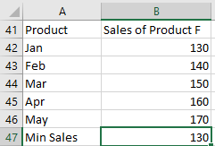

Task 7: Use HLOOKUP to find the average sales value for Product E across all months.

