Assume you have the following dataset in an Excel worksheet starting from

cell A1:

Worksheet: SalesData

ProductID Product Sales Target Region

101 Product A 120 150 North

102 Product B 150 140 South

103 Product C 200 200 East

104 Product D 90 100 West

105 Product E 220 210 North

106 Product F 130 160 South

1. Use the IF function to evaluate whether each product met its sales

target.

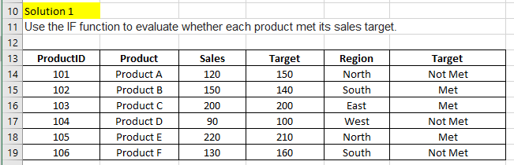

2. Use the IF function to determine if a product is eligible for a regional

bonus. Products in the "North" region with sales over 200 are eligible.

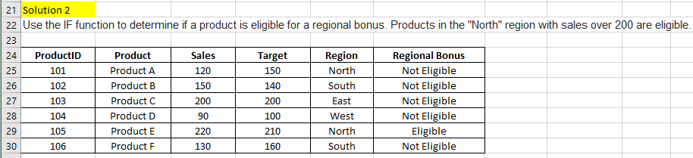

3. Use nested IF functions to assign a commission rate based on sales.

Sales >= 200 get a 10% commission, sales >= 150 get a 7%

commission, and others get a 5% commission.

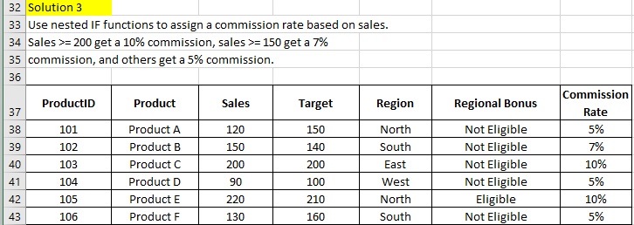

4. Use the IF function to calculate a bonus amount. If sales met or

exceeded the target, the bonus is 10% of the sales; otherwise, it's

5%.

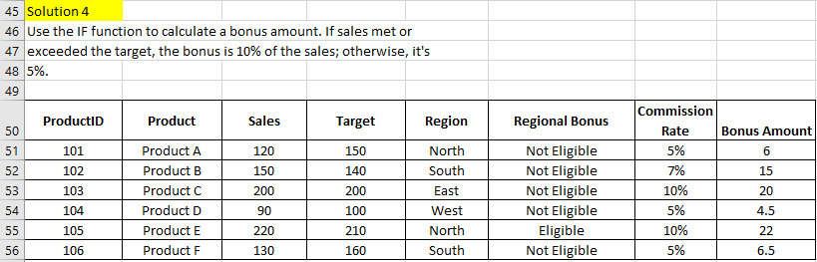

5. Use the IF function to categorize sales performance as "Excellent"

(>=200), "Good" (>=150), or "Needs Improvement" (<150).

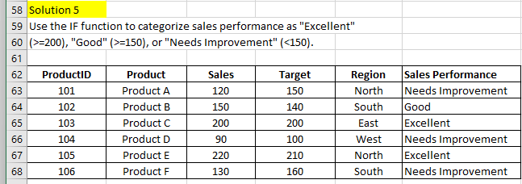

6. Use the IF function to assign a price tier based on the sales value.

"High" for sales > 200, "Medium" for sales between 100 and 200, and

"Low" for sales < 100.

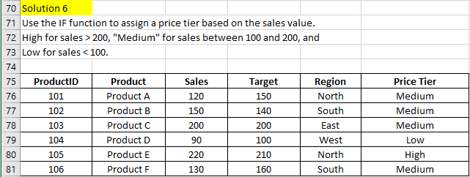

7. Use the IF function to calculate the year-end bonus. If sales >= 150

and region is "North", the bonus is $500, otherwise, it's $300.

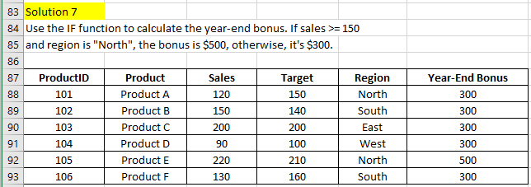

8. Use the IF function to mark high performers. A product is a high

performer if its sales are in the top 25% of all sales.

