**Project work INT404**

**Salary Estimator**

**(Business Intelligence Tool)**

**Name: M G Raju**

**Reg.ID: 11811924**

**Section: K18AZ**

**Group: 01**

**Project Name: Salary Estimator**

**Email: Raju.11811924@lpu.in**

**Repository Link:** [**https://github.com/Radioactive92177/Salary-Estimator.git**](https://github.com/Radioactive92177/Salary-Estimator.git)

**Report Link: https://sway.office.com/VDUjuTNy4hkqdzXj?ref=Link**

**Introduction**

Salary Estimator is a **business intelligence tool**. It uses its artificial intelligence to predict the salary of new employers with respect to their years of experience in the field.

It uses the concept of **Linear regression** from **Machine Learning** to perform the operation.

It can be used in **small business and start-ups** where the HR intends to give the salary in accordance to the years of experience the employee have.

**Concept:**

Linear Regression is a concept or approach in machine learning where we intend to predict the data which is not present in the records.

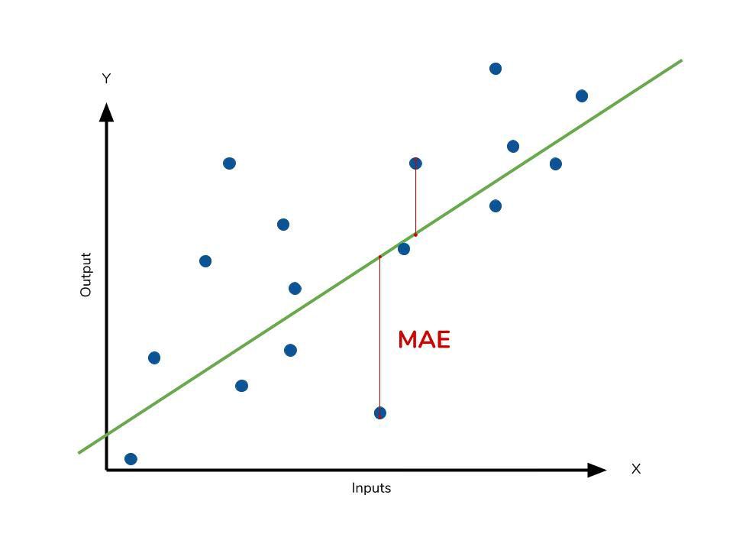

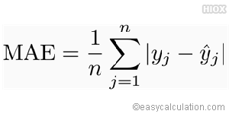

It uses **linear algebra** to markdown the **Mean Absolute Errors** (MAE) in the graph and gives an approximate **coefficient** and **intercept** to perform the mathematical operations.

**Working:**

Perform the following steps to make use of it:

1. Enter the **Path to the Dataset** (in csv format).
2. Select the **Field** you would like to predict.
3. Type **Y** to see the **graph** of the dataset **N** to ignore and proceed.
4. Enter the **Years of Experience** of the new employee.
5. See the results.

**Screenshots:**

**Libraries & Dependencies Used:**

* **Matplotlib**

For the graph

* **Scikit-Learn**

For Linear Regression and Model training

* **Pandas**

For Accessing Data and Representing

* **NumPy**

For performing Array operations

* **Win32Com**

For the voice of the program

**End Notes:**

Run the file name **app.py** using **pipenv shell** environment for best results.

