Requirements Analysis Document
ATM System
CSCI 4711 Software Engineering
Fall 2014
Georgia Regents University
Augusta, GA
Date: 9/8/2014
Version 3

Team Members

Name 1
Name 2

Abstract

This document contains the requirements, analysis and design artifacts for the Automatic Teller Machine (ATM). ATM is an electronic computing device that will enable customers of the bank to perform financial transactions without the need for a human bank teller.
The customer will be identified via a unique pin number and account number. An authenticated customer is able to access their account information and perform various transactions including deposit, withdrawal, balance inquiry and change pin. An administrative user of the ATM is able to view a history of all customer transactions at the ATM. The administrative user is also identified via a unique pin number.
This document describes the requirements, analysis and design of the ATM system. The rest of this document is structured as follows. Chapter 1 contains the introduction. This chapter presents a brief description of the system. Chapter 2 outlines the functional requirements of the system. Chapter 3 contains user interface mockups. Class diagrams are in Chapter 4, while the appendix is in Chapter 5.
Table of Contents

1 | INTRODUCTION……………………………………………............. |  |  | 4
 | 1.1 | OVERVIEW OF SYSTEM…………………………………………... | 4
 | 1.2 | SCOPE OF SYSTEM………………………………………………… | 4
 | 1.3 | OVERVIEW OF DOCUMENT……………………………………… | 4
2 | REQUIREMENTS OF SYSTEM……………………………………. |  |  | 5
 | 2.1 | FUNCTIONAL REQUIREMENTS………………………………….. | 5
 | 2.2 | USE CASES………………………………………………………….. | 6
 | 2.3 | USE CASE DESCRIPTIONS………………………………………… | 7
 | 2.4 | REQUIREMENTS ANALYSIS……………………………………… | 13
3 | USER INTERFACE MOCKUPS……………………...….…………. |  |  | 26
 | 3.1 | VERIFYUSER……………………………………………………….. | 26
 | 3.2 | WITHDRAWAL…………………………………………….……….. | 27
 | 3.3 | DEPOSIT…………………...………………………………………… | 27
4 | OBJECT DESIGN……………..……………………...….…………. |  |  | 28
 | 4.1 | OBJECT RELATIONSHIPS……………………………………...… | 28
5 | APPENDIX……………………..……………………...….…………. |  |  | 29
 | 4.1 | REVISION HISTORY……………………………………………...… | 30

Introduction

Overview of System
ATM is a computing system for financial account management. It includes actors such as Customer who represent account holders of the financial institution, and Admin, the administrative employee of the financial institution who can view the history of all transactions at the ATM. The system supports both actors by keeping track account information and financial transactions. It also has access to a database of customer financial accounts. The Customer and the Admin actors interact with the ATM system through its user terminal.

Scope of system
The system includes functionality for verifying the customer, as well as account management activities such as making deposits, withdrawals, and balance inquiries from the customer. Administrative users can view transaction histories for all users of the system. All data stores are internal and part of system. The system is stand-alone, external interaction is solely with customers and administrative users.

overview of document
The rest of this document is structured as follows. Chapter 2 outlines the functional requirements of the system. Within this chapter is a list of functional requirements of ATM. It also includes a use case model of those functional requirements. A detailed description of each functional requirement then follows. Chapter 3 outlines initial ideas on user interface objects. Object design is in Chapter 4, and Chapter 5 contains the appendix which includes a revision history.

requirements of system

Functional Requirements
- VerifyUser – All users of the system have to be verified as either a customer or an employee of the bank before they can use the ATM. This function verifies the user and grants them access to other functionality.
- Deposit – Customers of the bank can add money to their own account via this function. The customer will specify a certain amount to be added to the account balance.
- Withdrawal – This function lets customers of the bank withdraw money from their own account. The customer will specify a certain amount to be withdrawn from the account.
- ChangePin – All valid users of the system can change the personal identification number (PIN) that is associated with their own account. This function lets the user change their PIN.
- ViewTransactions – This function is used by an employee of the bank to view all canceled transactions at the ATM.
- CancelTransaction – This function is used by the customer whenever they wish to cancel certain transactions. Information about that particular transaction is stored by the system when this function is initiated.

use cases

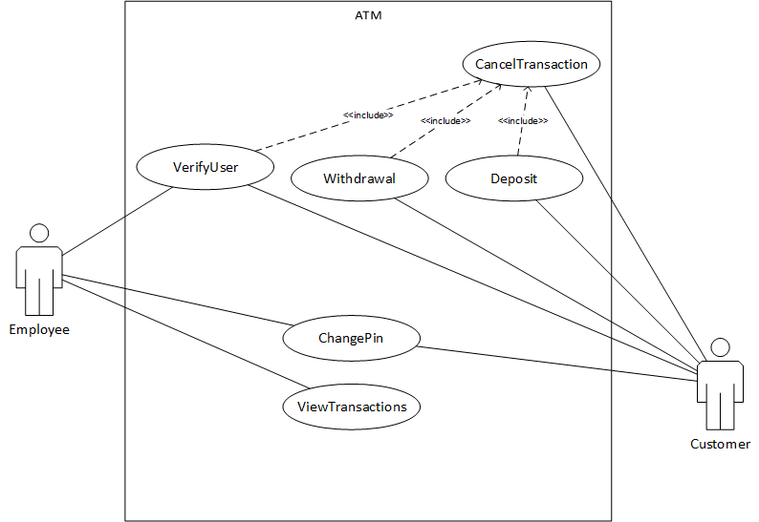
Figure 1: use case diagram for ATM

use case descriptions
Use case name | VerifyUser
Participating  actors | Initiated by Employee and Customer
Flow of events | - The “VerifyUser” function is activated when a valid credit or debit card is inserted into the card reader.  - ATM responds by presenting a login screen to the user. The login screen contains a field for the PIN number.  - The user fills out the form by entering their PIN number. Once the form is completed, the user submits the form. If the user selects the cancel button, the “CancelTransaction” use case is activated. The system should then display the Welcome screen.  - ATM receives the form and verifies that the PIN is correct. If the PIN is incorrect, the login screen is displayed with an error message. For valid users, the Main menu is displayed.
Entry condition | - A valid credit or debit card is inserted.
Exit condition | - The Main screen is displayed for the user.
Quality  requirements | - The PIN number should not be displayed as number during entry.

START EACH USE CASE DESCRIPTION ON A NEW PAGE

Use case name | CancelTransaction
Participating  actors | Initiated by Employee and Customer
Flow of events | - This function is activated when a user selects the cancel button on the Login screen, Main menu, Withdraw menu or the Deposit menu.  - The system stores persistently, information about the canceled transaction, the user, the current date and time.
Entry condition
Exit condition | - Information about the canceled transaction is correctly saved.
Quality
requirements

Use case name | Withdrawal
Participating  actors | Initiated by Customer
Flow of events | - This function is activated when a user selects the “withdrawal” button on the Main menu.  - ATM presents the Withdrawal menu for the customer to select the amount to withdraw.  - The customer selects the amount they wish to withdraw. If the customer selects the cancel button, the “CancelTransaction” use case is activated. The system should then display the Main menu.  - ATM presents an alert dialog for the customer to confirm or decline the withdrawal.  - The customer accepts the withdrawal by pressing the “yes” button on the alert dialog screen.  - ATM dispenses the withdrawal amount through the Cash Dispenser and updates the customer account balance. ATM displays the Welcome screen.
Entry condition
Exit condition | - The customer’s balance is correctly updated to reflect the withdrawal
Quality  requirements | - The customer can press the “no” button on the alert dialog screen in order to cancel the withdrawal amount selected. The system should display the Withdrawal menu.

Use case name | Deposit
Participating  actors | Initiated by Customer
Flow of events | - This function is activated when a customer selects the “deposit” button on the Main menu.  - ATM presents the Deposit menu for the customer to select the amount to deposit.  - The customer selects the amount they wish to deposit. If the customer selects the cancel button, the “CancelTransaction” use case is activated. The system should then display the Main menu.  - ATM presents a Message screen instructing the customer to insert the cash into the Deposit slot.  - Customer inserts the cash into the Deposit slot.  - ATM updates the customer account and displays the Welcome screen.
Entry condition
Exit condition | - The customer’s balance is correctly updated to reflect the deposit
Quality
requirements

Use case name | ChangePin
Participating  actors | Initiated by Customer and Employee
Flow of events | - This function is activated when a user selects the “change pin” button on the Main menu.  - ATM presents the Pin form for the user to input their old and new pin numbers.  - The user enters their old and new pin numbers and submits the form.  - ATM verifies that the old pin is correct, and if so, updates the pin number of the user. ATM displays the Main menu.
Entry condition
Exit condition | - The user’s pin is correctly updated
Quality  requirements | - If the old pin is incorrect, ATM displays the Pin form with a message stating that the old pin was incorrect.

Use case name | ViewTransactions
Participating  actors | Initiated by Employee
Flow of events | - This function is activated when an Employee selects the “view transactions” button on the Main menu.  - ATM retrieves every transaction that is stored in the system and displays them on the Transaction window.  - The employee, after viewing the transactions, can close the Transaction window by pressing the “done” button.  - ATM destroys the Transactions window and displays the Main menu.
Entry condition
Exit condition
Quality
requirements

REQUIREMENTS ANALYSIS

This page intentionally left blank

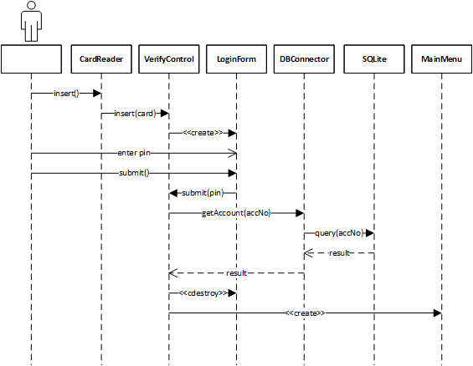
Figure 2: VerifyUser sequence
PUT EACH SEQUENCE DIAGRAM ON A NEW PAGE
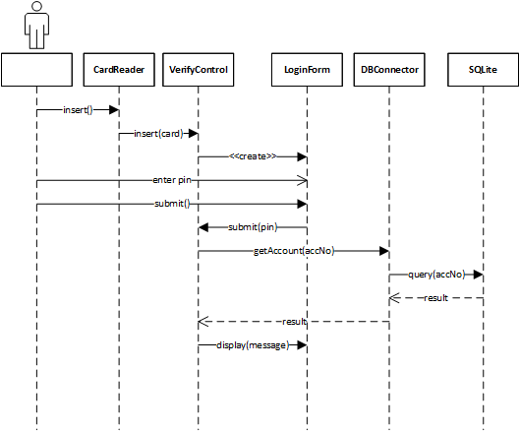
Figure 3: VerifyUser (invalid pin) sequence
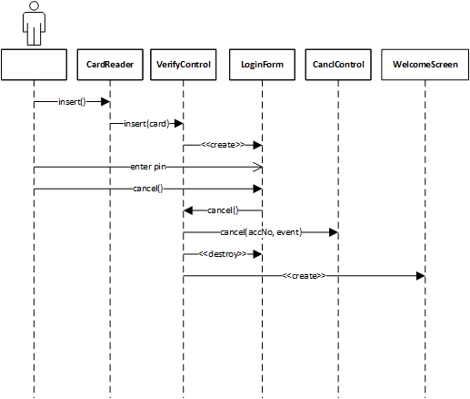
Figure 4: VerifyUser (cancel) sequence
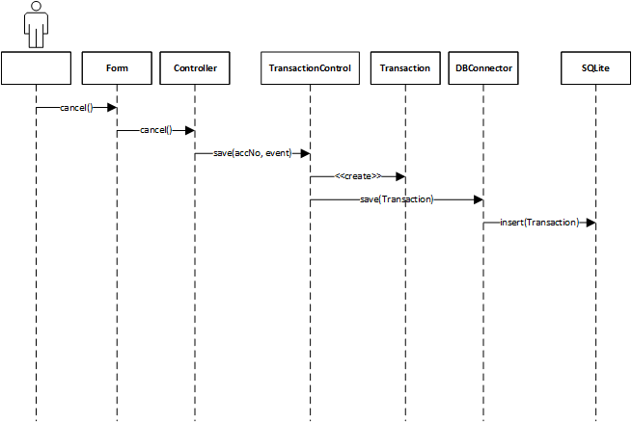
Figure 5: CancelTransaction Sequence

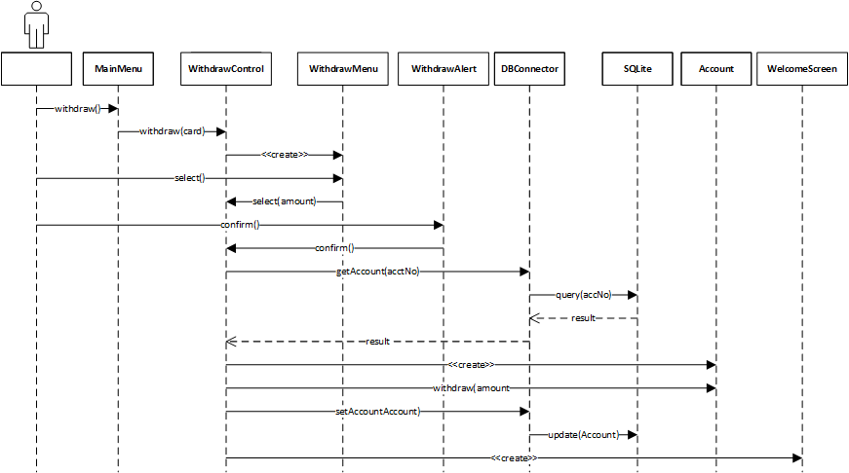
Figure 6: Withdraw sequence
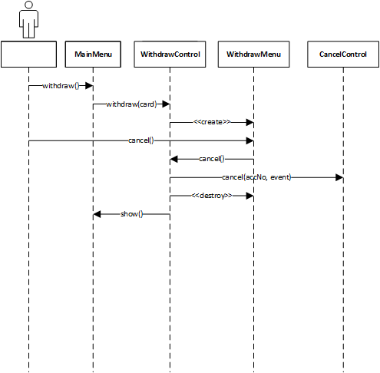
Figure 7: Withdrawal (cancel) sequence
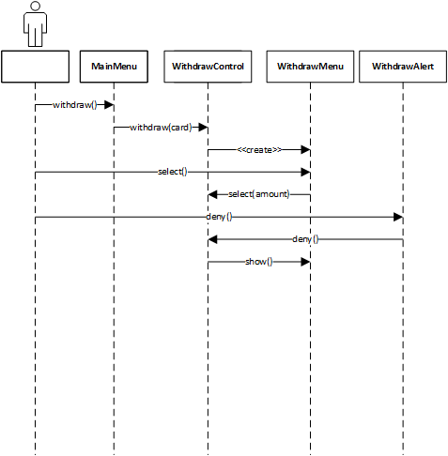
Figure 8: Withdrawal (deny confirm amount) sequence
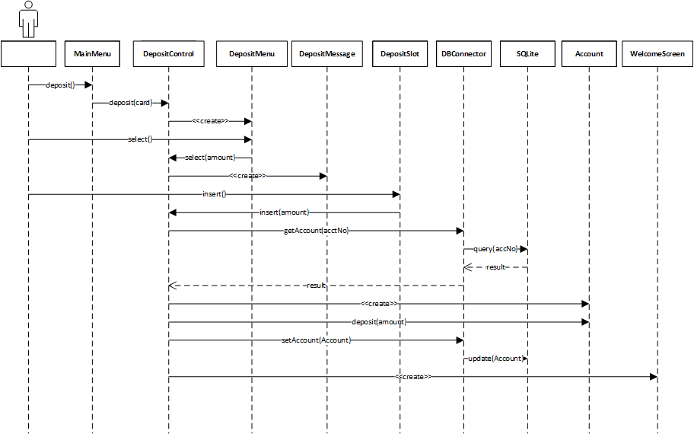
Figure 9: Deposit sequence
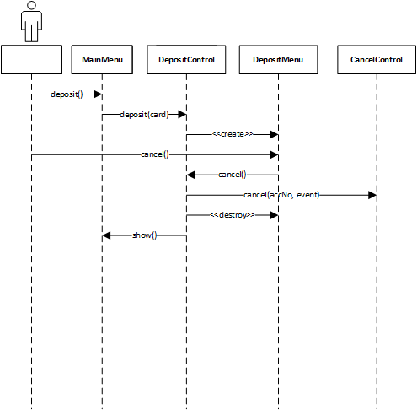
Figure 10: Deposit (cancel) sequence
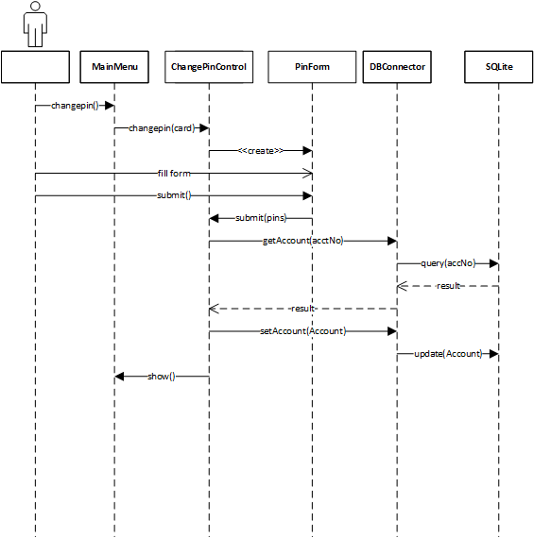
Figure 11: ChangePin sequence
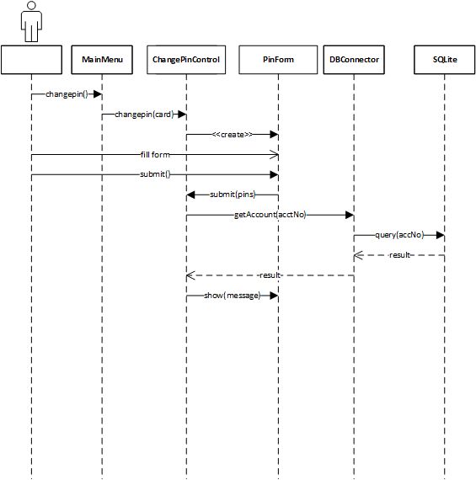
Figure 12: ChangePin (invalid PIN) sequence
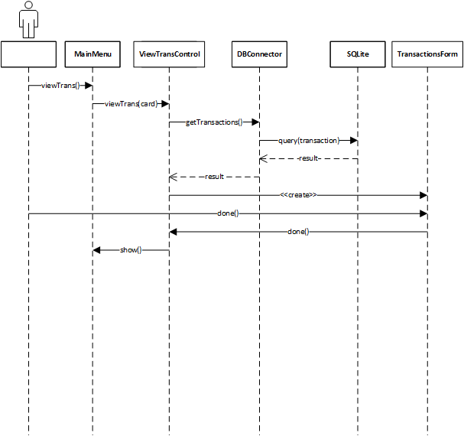
Figure 13: ViewTransactions sequence

USER INTERFACE MOCKUPS

VERIFYUSER

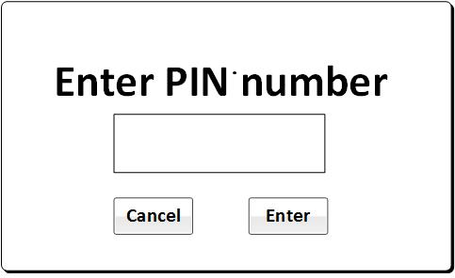
Figure 7: Login screen

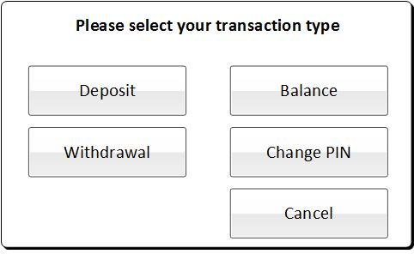
Figure 8: Main menu

WITHDRAWAL
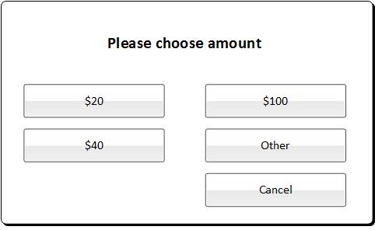
Figure 9: Withdrawal menu

DEPOSIT
Figure 10: Withdrawal menu

OBJECT DESIGN

OBJECT INTERACTION

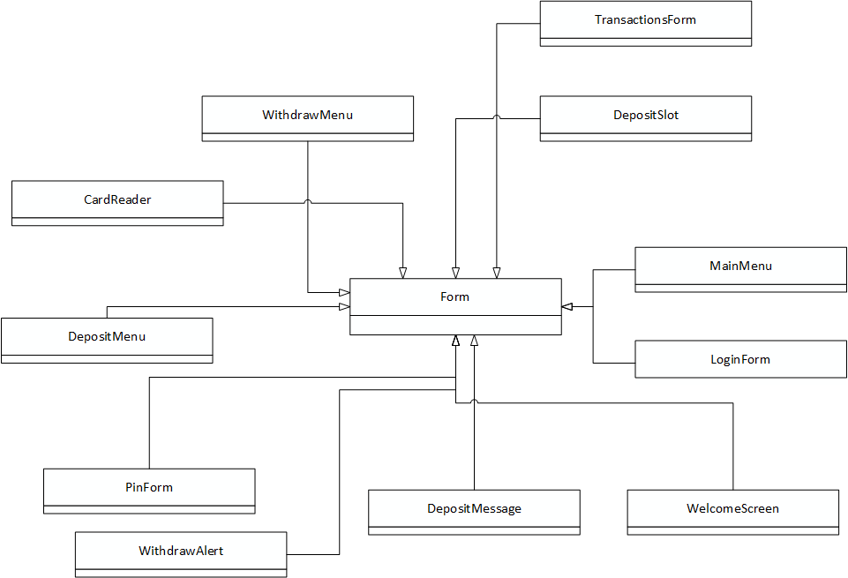
Figure 11: Class Diagram
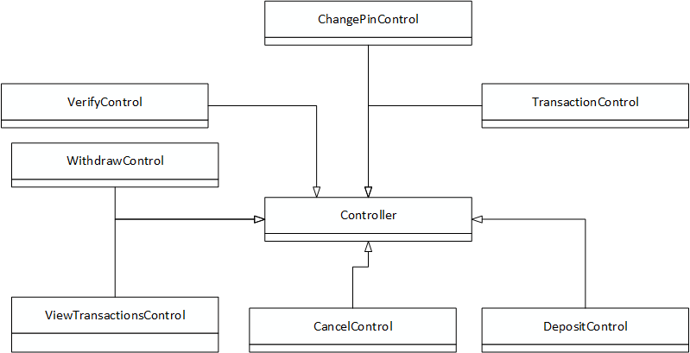
Figure 12: Class Diagram
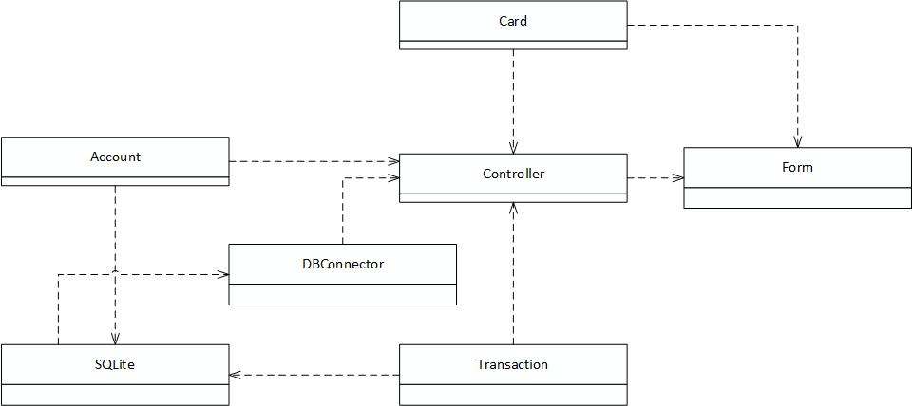
Figure 13: Class Diagram

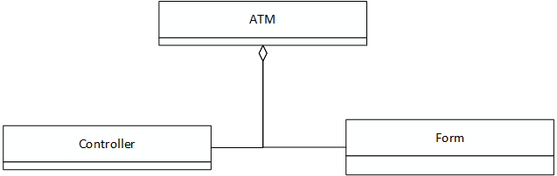
Figure 14: Class Diagram

APPENDIX

This page intentionally left blank

APPENDIX A – REVISION HISTORY

