Requirements Analysis Document
CDJ Scheduling System
CSCI 4711 Software Engineering
Fall 2014
Georgia Regents University
Augusta, GA
Date: 12/1/2014
Version 5

Team Members

Darcie Odom
Chad Reynolds
Jeremy Scott

Abstract

This document contains the requirements, analysis and design artifacts for the CDJ Scheduler. The CDJ Scheduler is a software system designed to automate a portion of scheduling for a business with employees that potentially work varying hours, as opposed to a typical schedule where hours are set.
The employees will have a username and password built into the system to give them access. A logged in employee is able to view the current schedule or alter their availability for future scheduling. The scheduling manager is able to log in with their own username and password to generate a new schedule based on stored employee availability, and alter employee’s availability as needed.
This document describes the requirements, analysis and design of the CDJ Scheduler system. The rest of this document is structured as follows. Chapter 1 contains the introduction. This chapter presents a brief description of the system. Chapter 2 outlines the functional requirements of the system. Chapter 3 contains screen mock-ups of the user interfaces for the system. Chapter 4 consists of class diagrams, their relationships, and state chart diagrams. Chapter 5 contains the subsystem decomposition. Chapter 6 includes an appendix with the revision history of the document and source code for selected objects in the system.

Table of Contents
1 | INTRODUCTION…………………………………………………...... |  |  | 5
 | 1.1 | OVERVIEW OF SYSTEM…………………………………………... | 5
 | 1.2 | SCOPE OF SYSTEM………………………………………………… | 5
 | 1.3 | OVERVIEW OF DOCUMENT……………………………………… | 5
2 | REQUIREMENTS OF SYSTEM…………………………………...…. |  |  | 6
 | 2.1 | FUNCTIONAL REQUIREMENTS………………………………..….. | 6
 | 2.2 | USE CASES…………………………………………………………….. | 7
 | 2.3 | USE CASE DESCRIPTIONS………………………………………….. | 8
 | 2.4 | REQUIREMENTS ANALYSIS………………………………………… | 14
3 | USER INTERFACE MOCK-UPS…………..…….……………….….. |  |  | 30
 | 3.1 | LOGIN…………………………………………………………………... | 30
 | 3.2 | LOGOUT………………………………………………………………… | 30
 | 3.3 | ALTERAVAILABILITY……………………………………………….. | 30
 | 3.4 | SELECTEMPLOYEE…………………………………………………… | 31
 | 3.5 | GENERATESCHEDULE……………………………………………….. | 31
 | 3.6 | DISPLAYSCHEDULE………………………………………………….. | 31
4 | OBJECT DESIGN……………………………………………………… |  |  | 32
 | 4.1 | OBJECT RELATIONSHIPS……………………………………………. | 32
 | 4.2 | DETAILED CLASS DESIGN..…………………………………………. | 33
 | 4.3 | STATE CHART DIAGRAMS………………………………………….. | 36
5 | SYSTEM DESIGN……………………………………………………… |  |  | 42
 | 5.1 | SUBSYSTEM DECOMPOSITION…………………………………… | 42
6 | APPENDIX…………………………………………………………...... |  |  | 43
 | 6.1 | REVISION HISTORY………………………………………………….. | 44
 | 6.2 | SOURCE CODE………………………………………………………… | 46

Introduction

Overview of System
The CDJ Scheduler is a system for employee scheduling. Its actors are Employee, the workers to be scheduled, and ScheduleManager, the administrator who does the scheduling. The scheduling system provides the functionality for employees and their manager to collaborate during the scheduling process rather than focus the workload on a single scheduling manager.
CDJ Scheduler allows the employees the ability to enter and store their working availability and view the current schedule. It provides the scheduling manager the ability to use the employee availability data, entered by the employees rather than the schedule manager, to generate a schedule and make that viewable to all users automatically. The CDJ Scheduler is accessed through a computer running the stand-alone software system.

Scope of system
The scheduler system provides the functionality for employees to alter their working availability, and view the current schedule. The scheduling manager can generate a schedule to fill the business hours with workers, and alter employee availability to fit the needs of the schedule. All data stores are internal and part of system. The system is stand-alone, external interaction is solely with employees and schedule manager users.

overview of document
The rest of this document is structured as follows. Chapter 2 outlines the functional requirements of the system. Within this chapter is a list of functional requirements of CDJ Scheduler. It also includes a use case model of those functional requirements. A detailed description of each functional requirement then follows. The final section of Chapter 2 shows sequence diagrams of these descriptions. Chapter 3 shows mock-ups of the user interfaces of the system. Chapter 4 displays the object design. Chapter 5 contains the subsystem decomposition. Chapter 6 is the appendix with a revision history of the document and source code for selected objects.

requirements of system

Functional Requirements
- Login –All users of the system have to be verified as either an employee or a schedule manager of the business before they can access the CDJ Scheduler. This function verifies the user and grants them access to other functionality.
- Logout –All users need to be able to leave the system available to other users once they have completed their interaction. This allows the user to end their session and return the system to login.
- AlterAvailability –This function allows the given employee’s working availability to be changed, within the bounds of the business’ hours.
- SelectEmployee -This allows the schedule manager to choose an employee’s identity to assume in the AlterAvailability function.
- GenerateSchedule –Provides the schedule manager an option to determine what priority will be used to generate the work schedule. Then the system generates a schedule based on priority and stored employee availability.
- DisplaySchedule –Allows users to view the schedule.

use cases
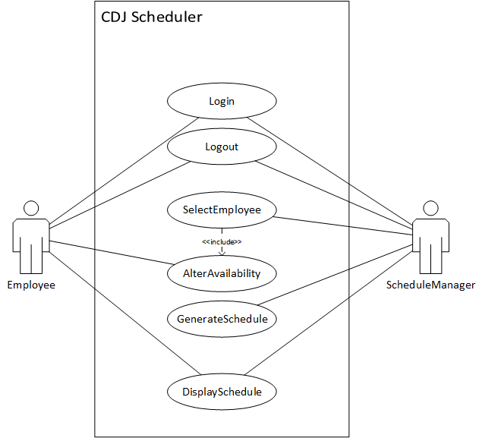
Figure 1: use case diagram for CDJ Scheduler

use case descriptions
Use case name | Login
Participating  actors | Employee or ScheduleManager (User)
Flow of events | 1. CDJ Scheduler displays login form: text boxes to enter username and password along with a submit button.  2. User enters login information and then clicks the submit button.  3. CDJ Scheduler queries data store with submitted user information, then compares to see if login information is valid.  a. If invalid user information has been submitted, CDJ Scheduler shows error message and User is able to repeat the login process again.  b. Once valid login information is submitted and verified, CDJ Scheduler closes login screen and displays the main menu screen that corresponds to their user role.
Entry condition
Exit condition | - The main menu screen is displayed.
Quality
requirements

Use case name | Logout
Participating  actors | Employee or ScheduleManager (User)
Flow of events | 1. The User initializes use case by clicking logout button on the main menu screen.  2. CDJ Scheduler closes main menu screen and initializes the Login use case.
Entry condition | - The User is currently viewing the main menu screen.
Exit condition | - The User is logged out.
Quality
requirements

Use case name | AlterAvailability
Participating  actors | Employee or ScheduleManager (User)
Flow of events | 1. Employee initializes use case by clicking the AlterAvailability button on the main menu screen OR  ScheduleManager initializes use case by clicking the submit button on the SelectEmployee screen.  2. The CDJ Scheduler replaces the current screen with the AlterAvailability screen: a checkbox for every day of the week; each checkbox corresponding to a pair of drop-down menus for start and end times. There are also two buttons, save and back. The starting values for the form are determined by the system.  a. If the given employee has availability already saved in the data store and it is valid with the currently set business hours, that previous information is loaded into the form.  b. If the given employee has availability already saved in the data store and it is not valid with the set business hours, OR  if the given employee does not have availability already saved in the data store, then the currently set business hours are loaded into the form.  3. User selects availability by marking checkboxes and then selects the start and end times for the days marked. Once the User has filled in the form, they can click the save button if they choose to store the information.  4. If the save button is clicked, the CDJ Scheduler error-checks the entered information.  a. If the information is valid then the system saves it in the data store and displays a successful save message to the User.  b. If the information is invalid then the system displays a message on the screen describing the error it found. The User can then repeat the information entering process, correct the error, and click the save button to submit again.  5. Whether the save button has been clicked or not, the back button is clicked by the User to indicate they are done working on the AlterAvailability screen.  6. The CDJ Scheduler closes the AlterAvailability screen and displays the main menu screen.
Entry condition | - The Employee is currently viewing the main menu screen OR  the ScheduleManager is currently viewing the SelectEmployee screen.
Exit condition | - The main menu screen is displayed.
Quality
requirements

Use case name | SelectEmployee
Participating  actors | ScheduleManager
Flow of events | 1. ScheduleManager initializes use case by clicking the AlterAvailability button on the main menu screen.  2. The CDJ Scheduler replaces the current screen with the SelectEmployee screen: a drop down menu for choosing an employee, populated from the data store, and a submit button.  3. ScheduleManager selects an employee from the drop down menu and clicks the submit button.  4. CDJ Scheduler closes the SelectEmployee screen and initializes the AlterAvailability use case for the ScheduleManager as the selected employee.
Entry condition | - The ScheduleManager is currently viewing the main menu screen.
Exit condition | - The AlterAvailability screen is displayed.
Quality
requirements

Use case name | GenerateSchedule
Participating  actors | ScheduleManager
Flow of events | 1. ScheduleManager initializes use case by clicking the generate schedule button on the Main Menu.  2. The CDJ Scheduler replaces the current screen with the GenerateSchedule screen: a drop down menu for choosing scheduling priority, and two buttons. A button each for generate schedule and back.  3. ScheduleManager can select a scheduling priority and clicks the generate schedule button.  4. CDJ Scheduler attempts to create a schedule based on employee availability saved in the data store.  a. If it is successful, then a message is displayed to the ScheduleManager and the CDJ Scheduler saves the schedule in the data store.  b. If there is an error, then a message describing the problem encountered along with information to help solve that problem is displayed.  5. The back button is clicked by the ScheduleManager to indicate they are done working on the GenerateSchedule screen.  6. The CDJ Scheduler closes the GenerateSchedule screen and displays the main menu screen.
Entry condition | - The ScheduleManager is currently viewing the main menu screen.
Exit condition | - The main menu screen is displayed.
Quality
requirements

Use case name | DisplaySchedule
Participating  actors | Initiated by Employee or ScheduleManager (User)
Flow of events | 1. User initializes use case by clicking the display schedule button on the main menu.  2. The CDJ Scheduler replaces the current screen with the DisplaySchedule screen: a text area and a back button. The system determines how the text area is filled.  a. If there is a schedule saved in the data store, that schedule is loaded into the text area.  b. If there is not a schedule in the data store, an error message is displayed in the text area.  3. User can then click the back button to indicate they are done working on the DisplaySchedule screen.  4. The CDJ Scheduler closes the DisplaySchedule screen and displays the main menu screen.
Entry condition | - The User is currently viewing the main menu screen.
Exit condition | - The main menu screen is displayed.
Quality
requirements

2.4 REQUIREMENTS ANALYSIS

This page intentionally left blank

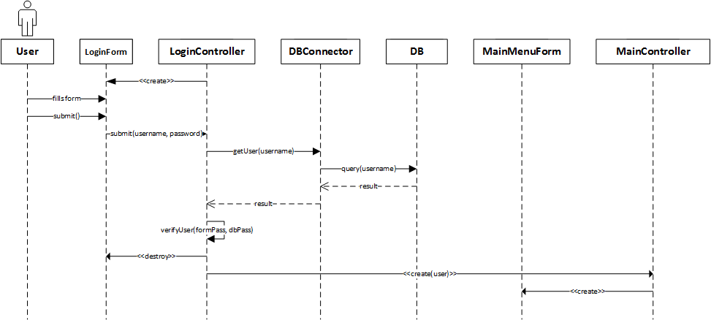

Figure 1: Login success

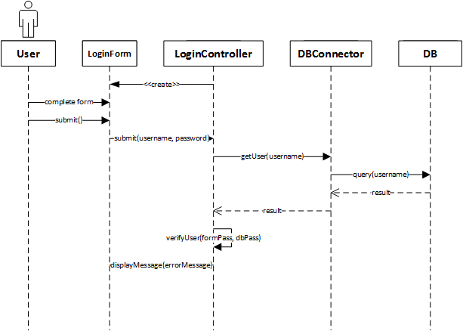

Figure 2: Login failure

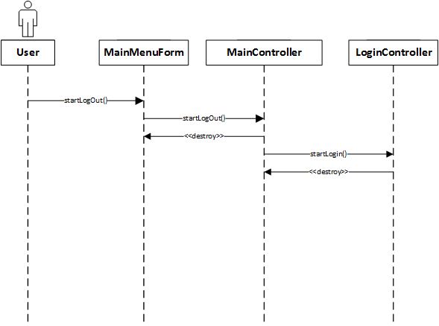

Figure 3: Logout

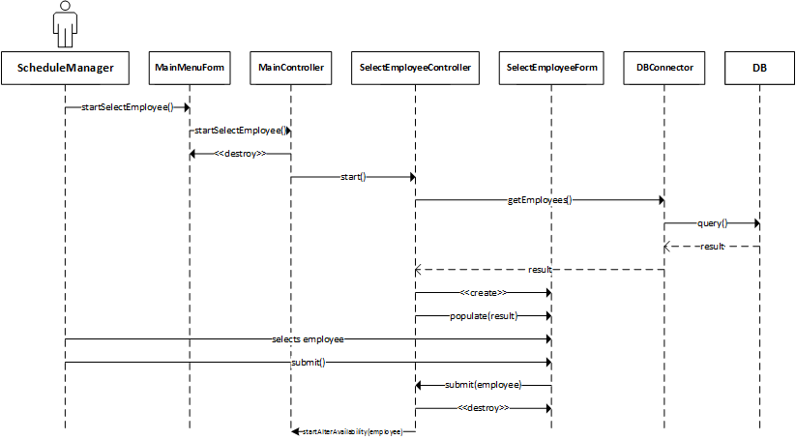

Figure 4: SelectEmployee

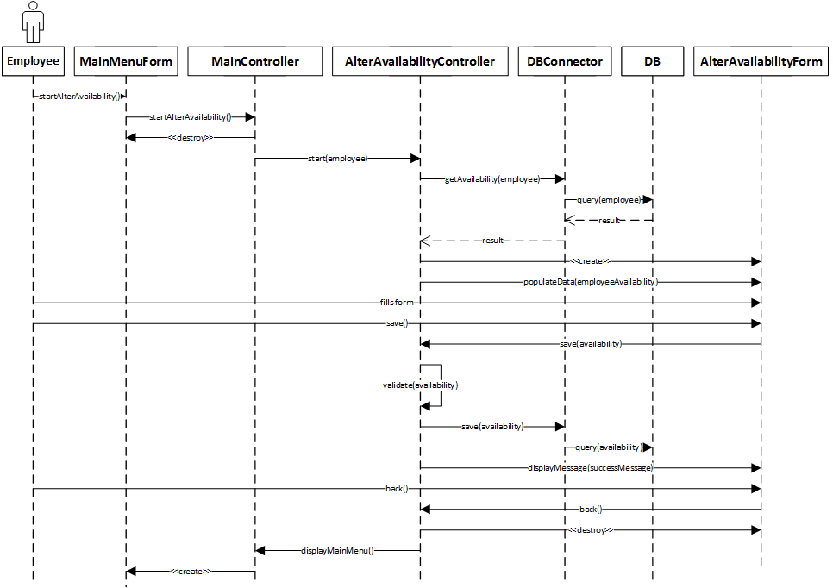

Figure 5: Employee AlterAvailability success

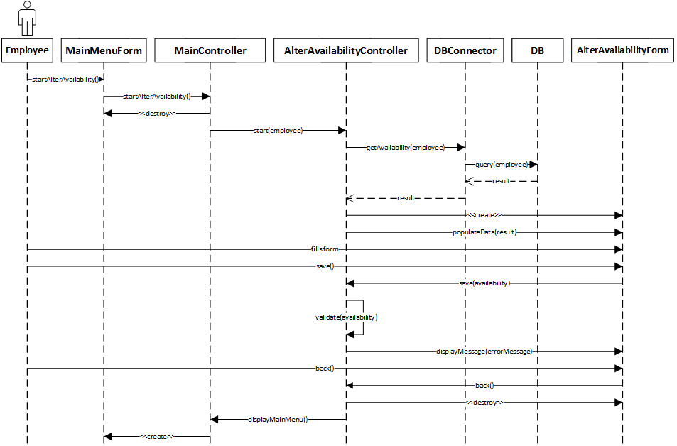

Figure 6: Employee AlterAvailability failure

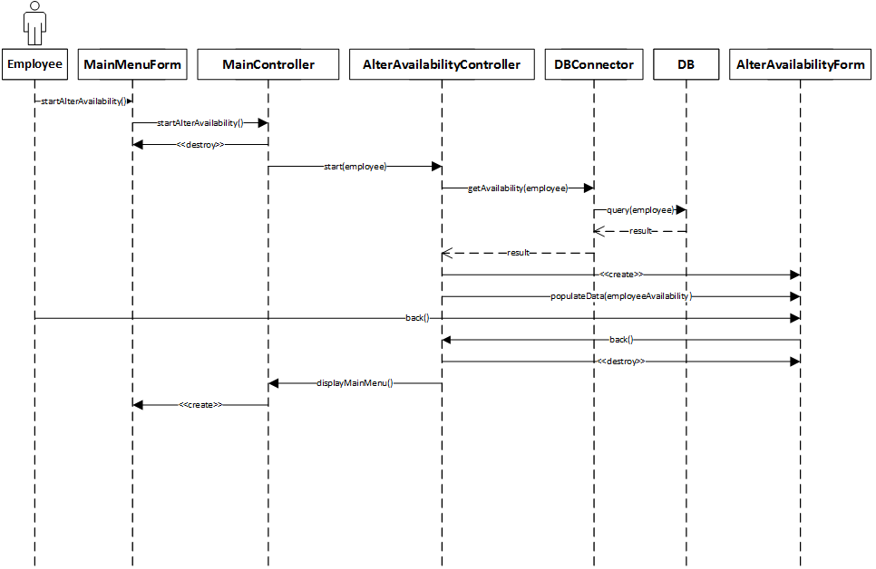

Figure 7: Employee AlterAvailability back

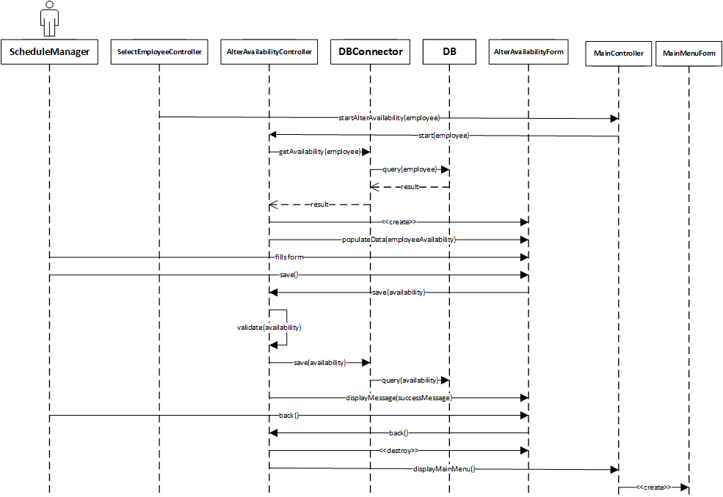

Figure 8: ScheduleManager AlterAvailability success

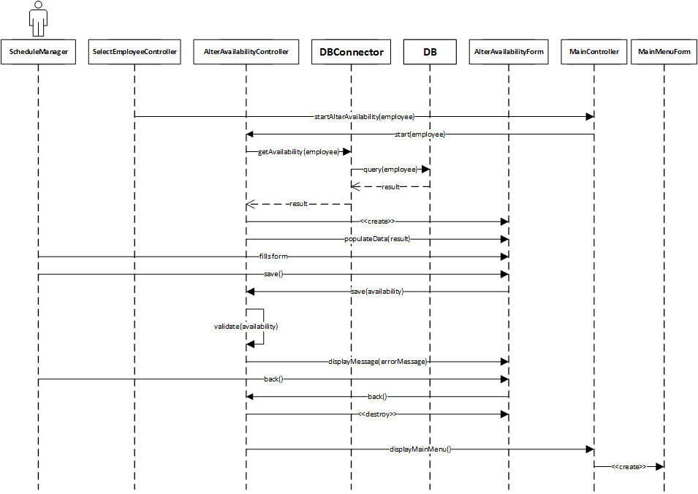

Figure 9: ScheduleManager AlterAvailability failure

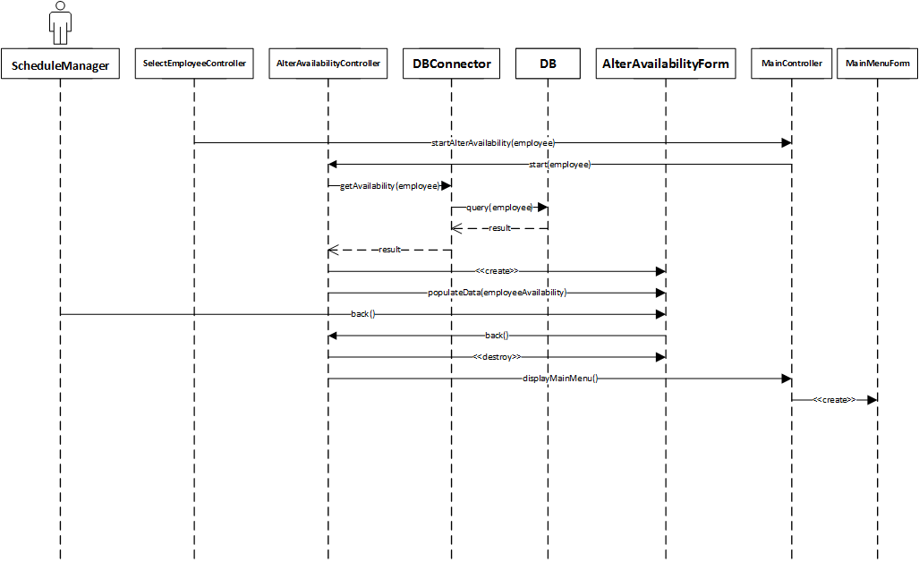

Figure 10: ScheduleManager AlterAvailability back

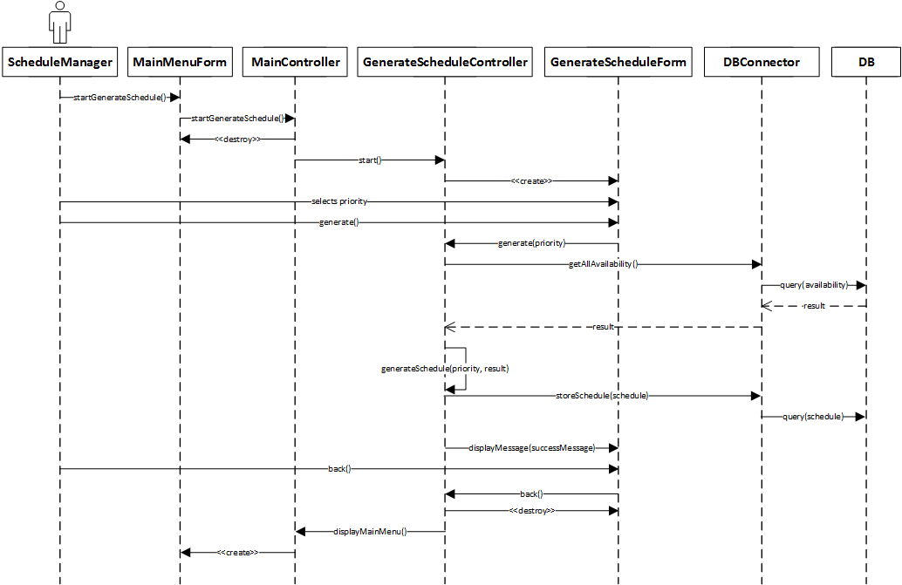

Figure 11: GenerateSchedule success

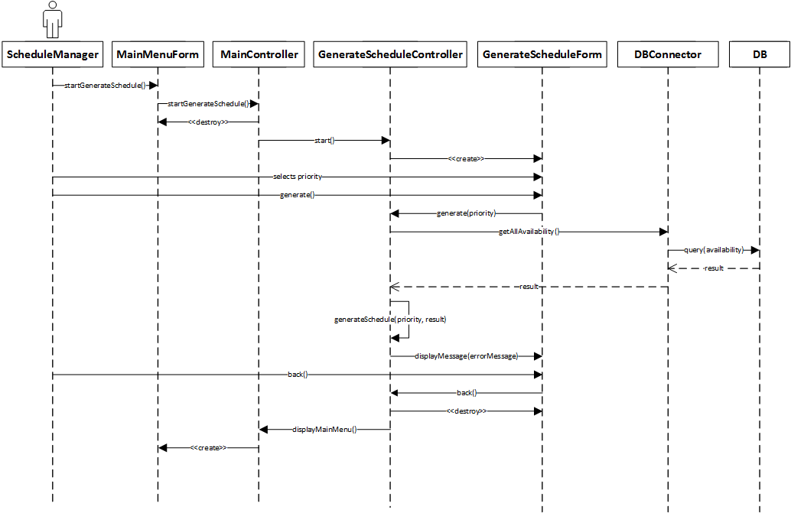

Figure 12: GenerateSchedule failure

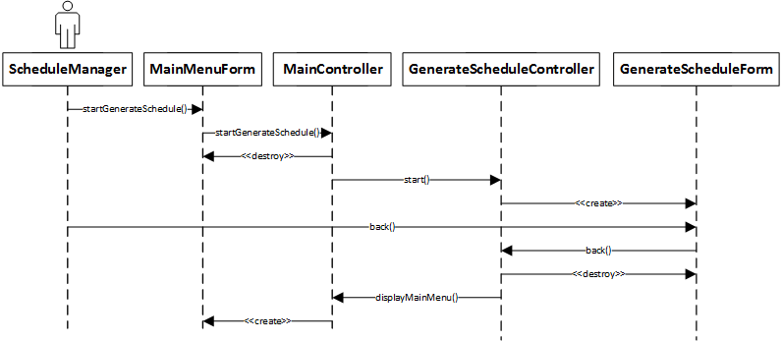

Figure 13: GenerateSchedule back

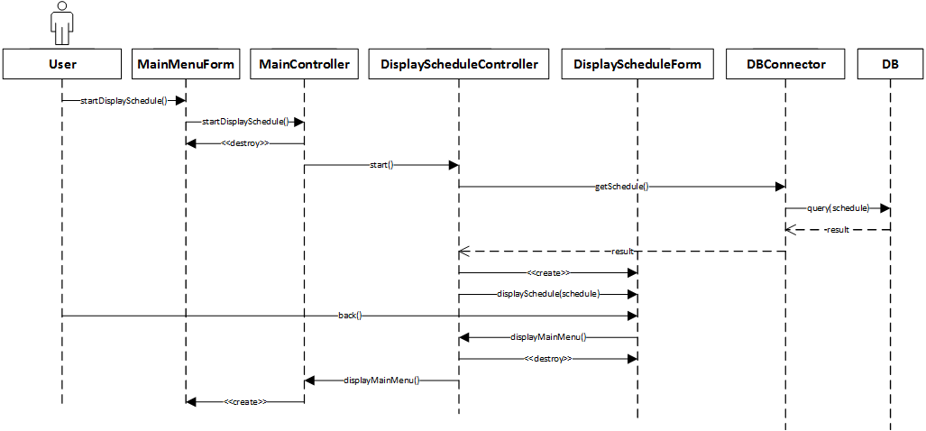

Figure 14: DisplaySchedule success

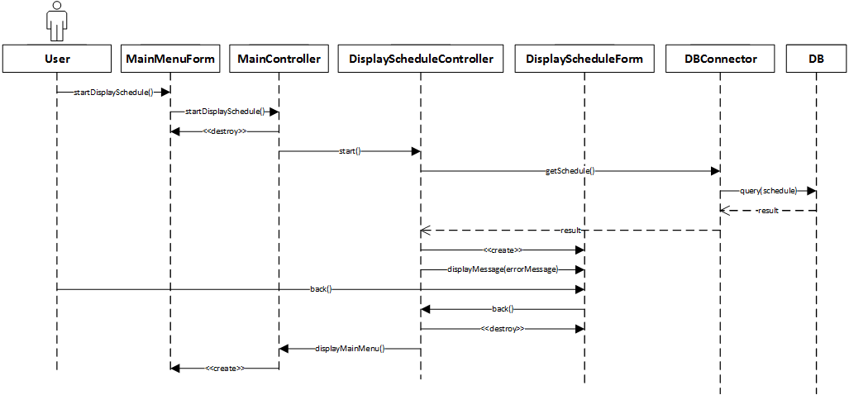

Figure 15: DisplaySchedule failure

USER INTERFACE MOCK-UPS

login
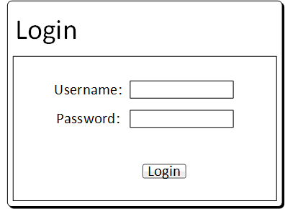
Figure 1: Login screen

Logout
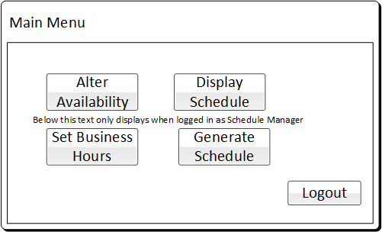
Figure 2: Main Menu screen

alteravailability
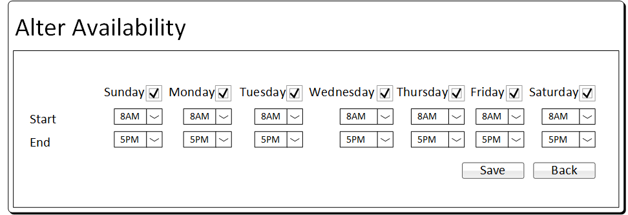
Figure 3: AlterAvailability screen

selectemployee
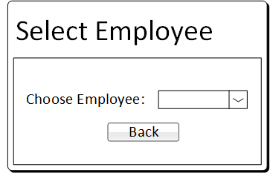
Figure 4: SelectEmployee screen

generateschedule
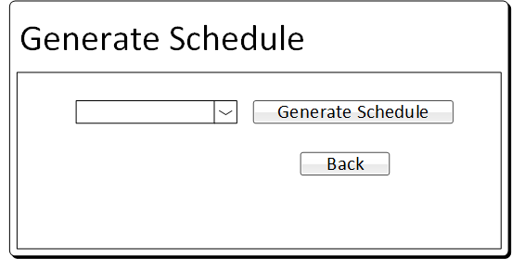
Figure 5: GenerateSchedule screen

displayschedule
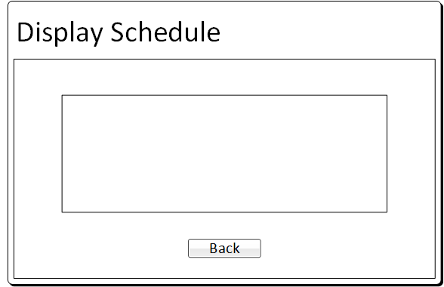
Figure 6: DisplaySchedule screen

OBJECT DESIGN

OBJECT INTERACTION

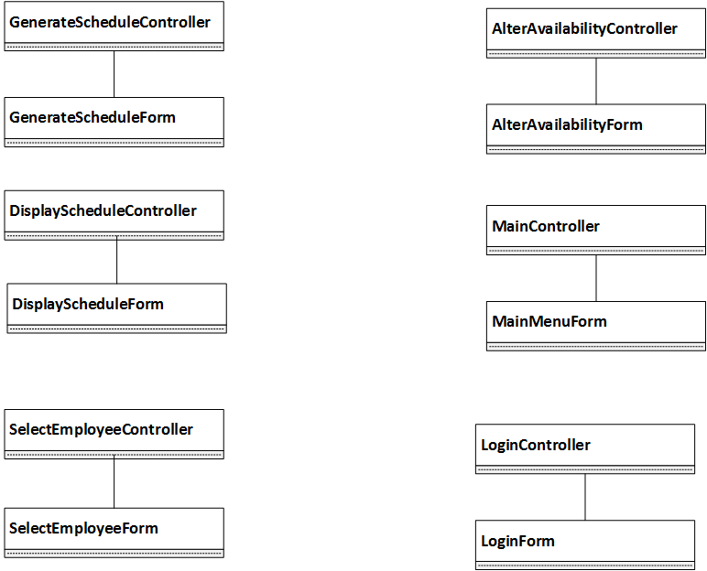

Figure 1: Controller-Form Associations
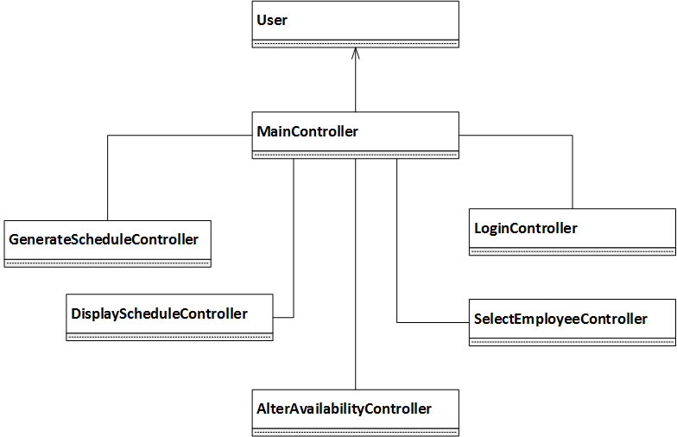

Figure 2: MainController Associations
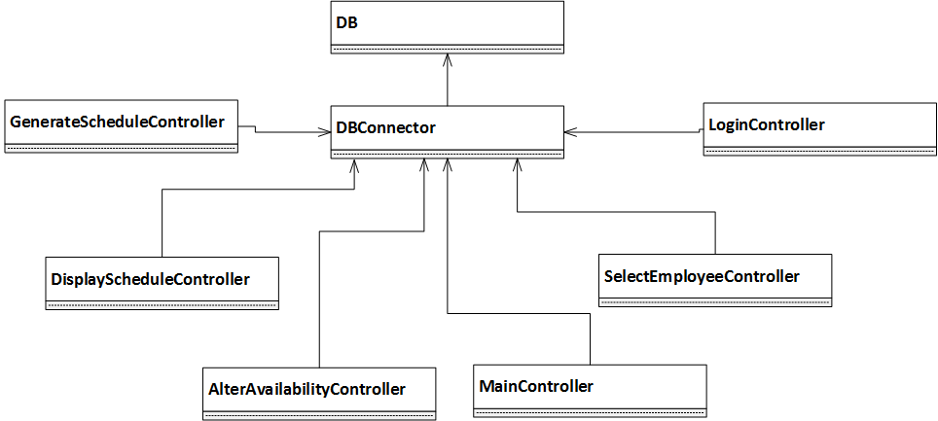

Figure 3: DBConnector Associations

4.2 DETAILED CLASS DESIGN
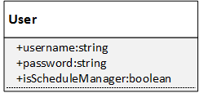
Figure 1: User Class
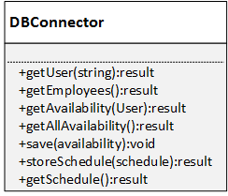
Figure 2: DBConnector Class
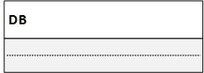
Figure 3: DB (not implemented by CDJ Scheduler)
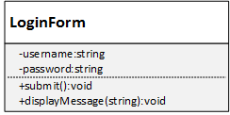
Figure 4: LoginForm Class
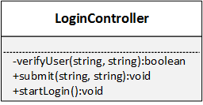
Figure 5: LoginController Class
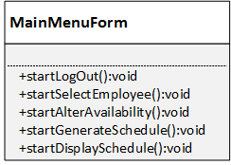
Figure 6: MainMenuForm Class
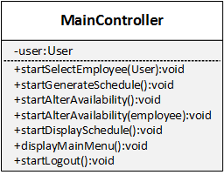
Figure 7: MainController Class
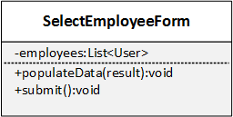
Figure 8: SelectEmployeeForm Class
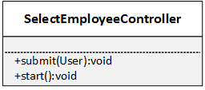
Figure 9: SelectEmployeeController Class
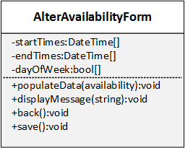
Figure 10: AlterAvailabilityForm Class
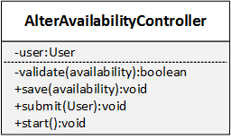
Figure 11: AlterAvailabilityController Class
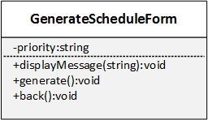
Figure 12: GenerateScheduleForm Class
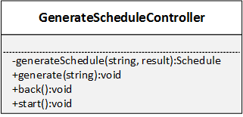
Figure 13: GenerateScheduleController Class
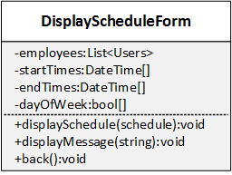
Figure 14: DisplayScheduleForm Class
Figure 15: DisplayScheduleController Class

4.3 STATE CHART DIAGRAMS

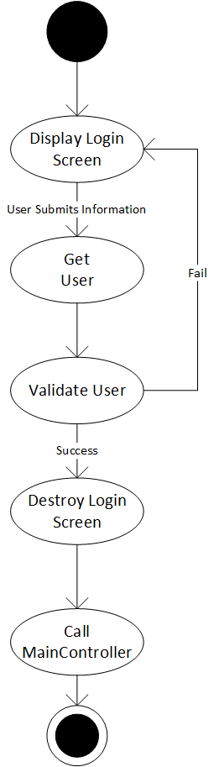
Figure 1: LoginController State Chart

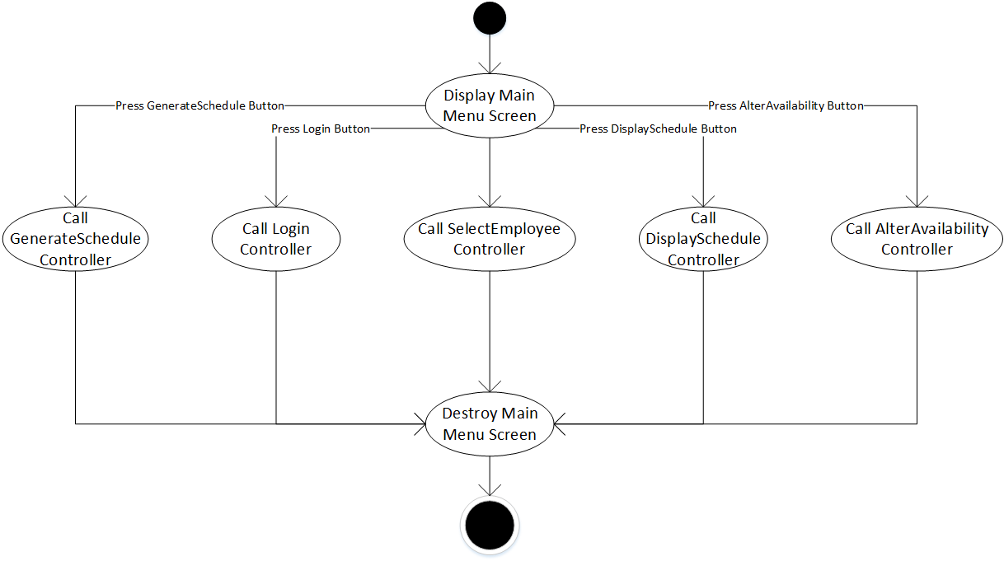
Figure 2: MainController State Chart

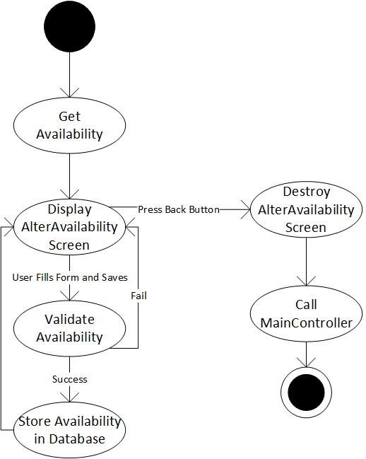
Figure 3: AlterAvailabilityController State Chart

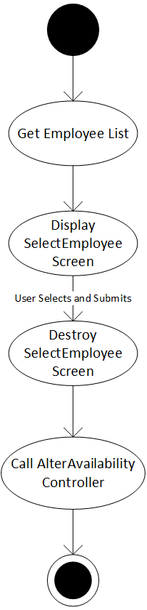
Figure 4: SelectEmployeeController State Chart

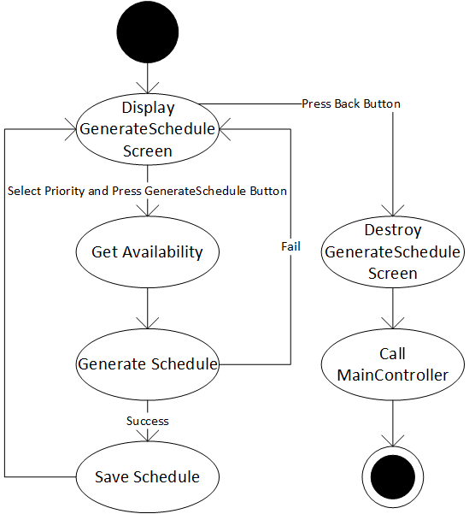
Figure 5: GenerateScheduleController State Chart

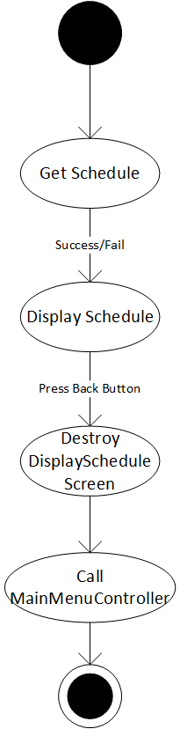
Figure 6: DisplayScheduleController State Chart
5 SYSTEM DESIGN

5.1 subsystem decomposition

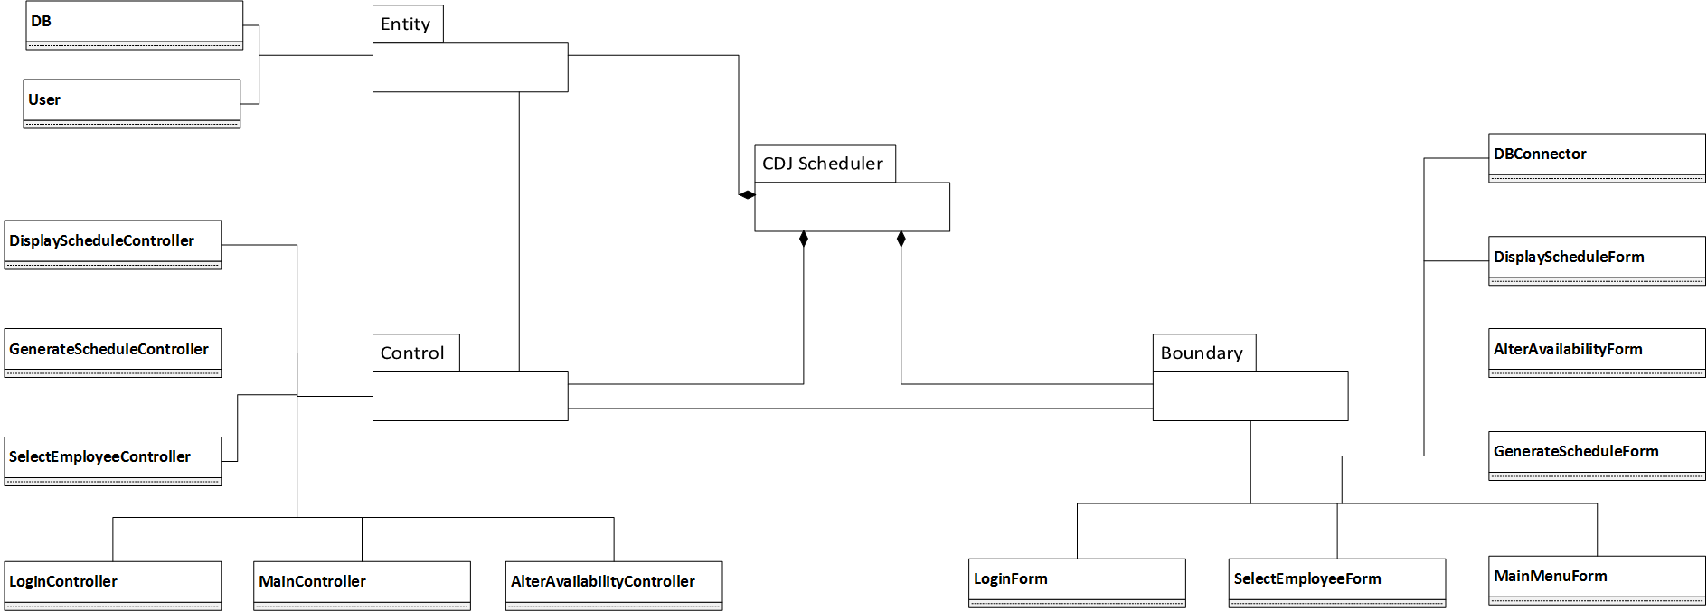
Figure 1: Composition of CDJ Scheduler

6 APPENDIX

This page intentionally left blank

6.1 APPENDIX A – REVISION HISTORY
Version 4, Section 2.4 Figure 1 Login success
Version 4, Section 2.4 Figure 2 Login failure
Version 4, Section 2.4 Figure 4 SelectEmployee
Version 4, Section 2.4 Figure 5 Employee AlterAvailability success
Version 4, Section 2.4 Figure 6 Employee AlterAvailability failure
Version 4, Section 2.4 Figure 7 Employee AlterAvailability back
Version 4, Section 2.4 Figure 8 ScheduleManager AlterAvailability success
Version 4, Section 2.4 Figure 9 ScheduleManager AlterAvailability failure
Version 4, Section 2.4 Figure 10 ScheduleManager AlterAvailability back
Version 4, Section 2.4 Figure 11 GenerateSchedule success
Version 4, Section 2.4 Figure 12 GenerateSchedule failure
Version 4, Section 2.4 Figure 13 GenerateSchedule back
Version 4, Section 2.4 Figure 14 DisplaySchedule success
Version 4, Section 2.4 Figure 15 DisplaySchedule failure
Version 4, Section 4.1 Figure 2 MainController Associations
Version 4, Section 4.1 Figure 3 DBConnector Associations
Version 4, Section 4.2 Figure 5 LoginController Class
Version 4, Section 4.2 Figure 7 MainController Class
Version 4, Section 4.2 Figure 9 SelectEmployeeController Class
Version 4, Section 4.2 Figure 11 AlterAvailabilityController Class
Version 4, Section 4.2 Figure 13 GenerateScheduleScheduleController Class
Version 4, Section 4.2 Figure 15 DisplayScheduleController Class
Version 4, Section 4.3 Figure 1 LoginController State Chart
Version 4, Section 4.3 Figure 2 MainController State Chart
Version 4, Section 4.3 Figure 3 SelectEmployeeController State Chart
Version 4, Section 4.3 Figure 4 AlterAvailabilityController State Chart
Version 4, Section 4.3 Figure 5 GenerateScheduleController State Chart
Version 4, Section 4.3 Figure 6 DisplayScheduleController State Chart

6.2 APPENDIX D – SOURCE CODE

class User
{
public string Username { get; set; }
public string Password { get; set; }
public bool IsScheduleManager { get; set; }

public User(string un, string pw, bool sm)
{
Username = un;
Password = pw;
IsScheduleManager = sm;
}
}

class SelectEmployeeController
{
private DBConnector dbconn;
private SelectEmployeeForm seform;

public SelectEmployeeController(DBConnector dbc)
{
dbconn = dbc;
seform = new SelectEmployeeForm(this);
seform.Populate(dbconn.GetEmployees());
}

public void Submit(User user)
{
seform.Destroy();
new AlterAvailabilityController(user);
}

}

