ReportEmergency
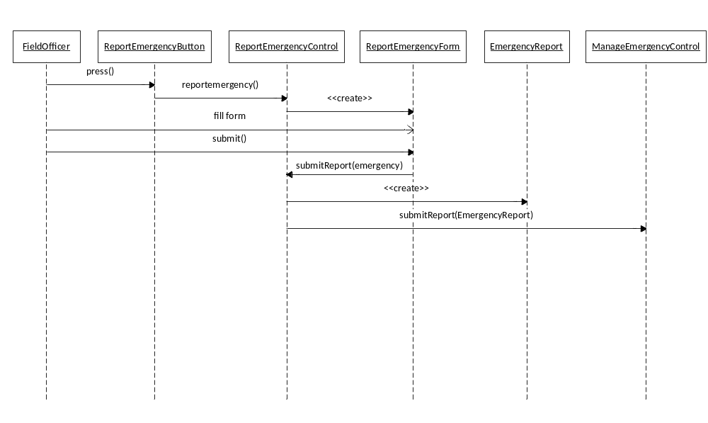
ReportEmergency (continued)

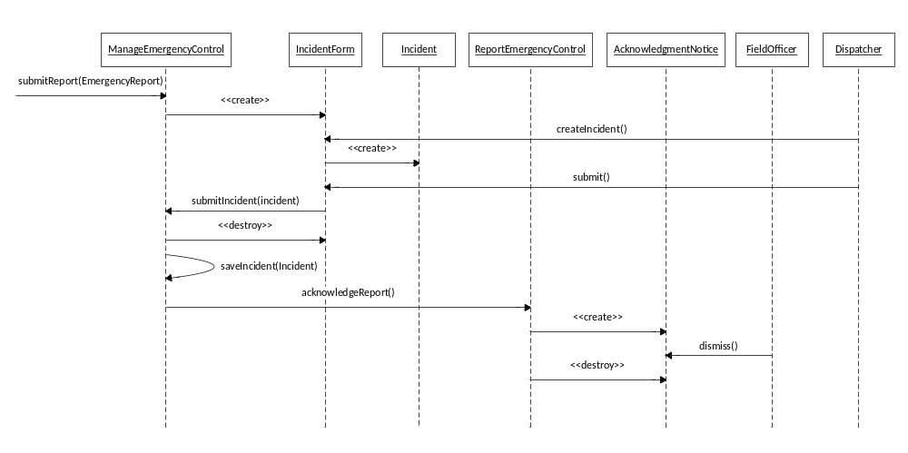

Detailed Class Diagram

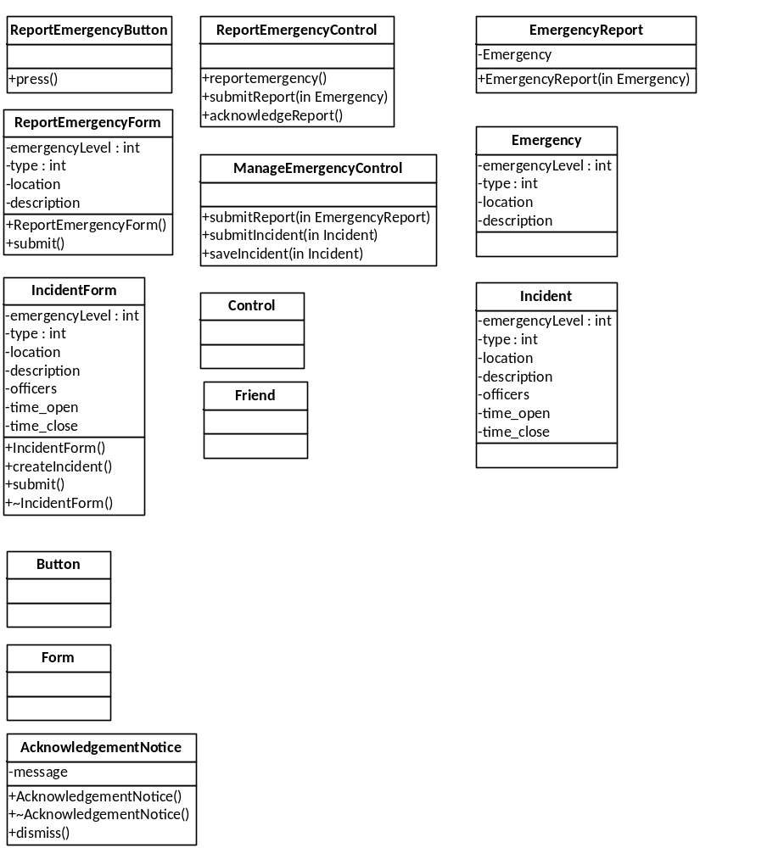

Statechart Diagram

This page intentionally left blank

ReportEmergencyControl

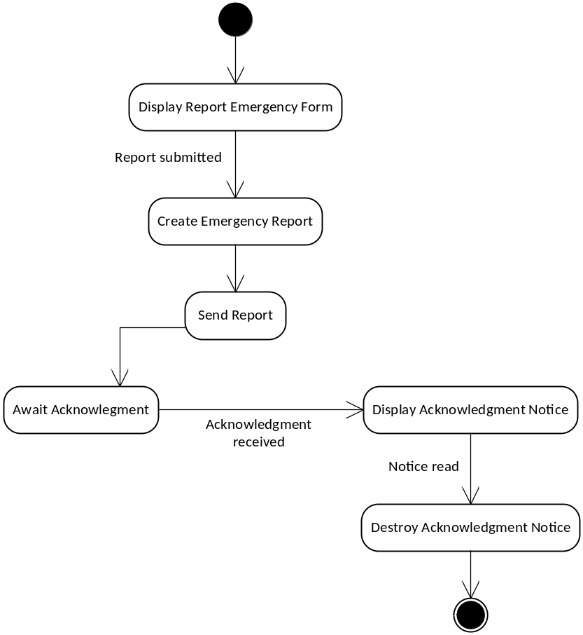

PUT EACH STATECHART DIAGRAM ON A NEW PAGE

Subsystem Decomposition

