Outside The Bot — Comprehensive Project Documentation
Revision date: 2025-09-16 07:26 UTC

Table of Contents
- Executive Summary
- Project Goals
- High-Level Architecture
- Architecture Diagrams (Placeholders & Description)
- Data Flow (Detailed)
- Frontend — In-Depth
- Backend — In-Depth
- Backend Modules (Deep Dive)
- API Reference & Example Requests
- Deployment, Testing & CI/CD
- Security, Privacy & Cost Considerations
- Limitations, Challenges & Future Work
- Placeholders for UI Images (3 slots)
- Glossary
- Appendix: File Map & Key Scripts
- Contact & Maintainers
- License

1. Executive Summary
Outside The Bot (OTB) is a geospatial, semantic-analytics platform for exploring public conversations on X (formerly Twitter). It pairs a map-centric frontend with a robust backend that performs semantic search over embeddings stored in Qdrant and produces concise summaries using large language models (Mistral, with OpenAI as a fallback). The goal is to make it easy to discover what people are talking about in specific places, compare regions, and extract trends at scale.

2. Project Goals
- Provide researchers, journalists and product teams an intuitive map-based interface to discover regional conversations.
- Offer hybrid (semantic + geospatial) search for more relevant local retrieval.
- Deliver compact, structured summaries of local conversations suitable for dashboards or reports.
- Provide a reproducible ingestion pipeline for large historical tweet datasets with resumable uploads.
- Be modular and extensible so components (embeddings, LLMs, DB) can be swapped as needed.

3. High-Level Architecture
OTB is divided into two primary surfaces:
Frontend (OTB_Frontend): interactive web client (Mapbox) that allows users to select locations, run queries, view tweets and summaries, and compare regions side-by-side.
Backend (OTB_AI): FastAPI service that provides endpoints for semantic search, hybrid location+semantic search, batch processing, static metrics, and LLM summarization. Qdrant stores tweet vectors and payloads (text, latitude, longitude).

4. Architecture Diagrams (Placeholders & Description)
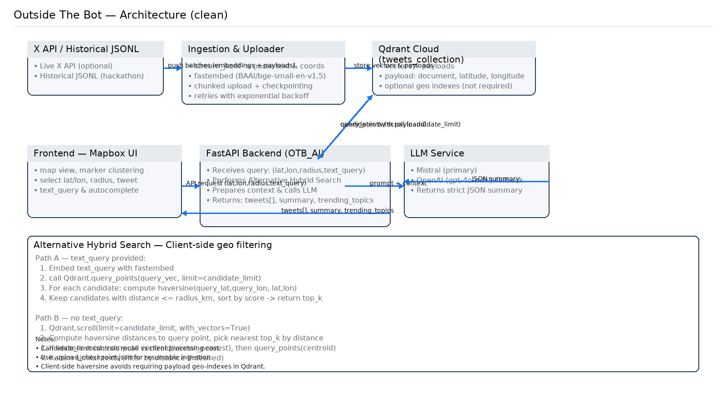

4.1 System Overview (Diagram placeholder)
Caption: High-level system architecture showing Frontend, Backend (FastAPI), Qdrant, LLM providers (Mistral/OpenAI), and external services (Mapbox, optional X API).
Textual diagram (use in a diagram tool):
User (browser) --> OTB Frontend (Mapbox UI)
OTB Frontend --> FastAPI (OTB_AI)
FastAPI --> Qdrant (vectors + payloads)
FastAPI --> Embedding service (fastembed) [for queries or ingestion]
FastAPI --> LLM (Mistral primary, OpenAI fallback)
FastAPI --> Optional External APIs (Mapbox for tiles, X API for realtime)

4.2 Data Flow — Ingestion & Indexing (Diagram placeholder)
Textual flow:
Raw JSONL tweets -> uploader script (stream_jsonl) -> fastembed embeddings -> batch upload -> Qdrant
Uploader writes .upload_checkpoint.json after each batch to allow resume.

4.3 Query & Summarization Flow (Diagram placeholder)
Textual flow:
Frontend sends query (lat, lon, topic) -> FastAPI hybrid_search -> Qdrant query_points/scroll -> client-side distance filtering -> select tweets -> prepare_context_text -> LLM prompt -> Mistral/OpenAI -> JSON summary -> Frontend displays summary

5. Data Flow (Detailed)
This section describes the lifecycle of data in OTB from ingestion through to presentation:
1. Ingestion:
- Source: historical JSONL of tweets (fields: text, coordinates).
- The uploader script uses fastembed to generate embeddings in chunks. Each point's payload includes document, latitude, longitude.
- The uploader writes a checkpoint (.upload_checkpoint.json) after each successful batch; uploader supports resume and exponential backoff.
2. Storage & Indexing:
- Qdrant stores vector embeddings and payloads. A collection (e.g., tweets_collection) is created with vector size matching the embedding model.
- Optional payload indexes for latitude/longitude can be created for server-side geo filtering.
3. Querying:
- Frontend calls FastAPI endpoints. Depending on request, backend uses search_similar_tweets or hybrid_search.
- If a text query is present, the backend embeds the text and queries Qdrant for vector hits, then filters by haversine distance client-side.
- If no text query, backend scrolls points to find nearest by distance and may compute centroid to refine textual similarity.
4. Summarization:
- Backend prepares a concatenated context_text and builds a prompt requesting strict JSON: {description, trending topics}.
- Mistral is invoked; if it fails or returns invalid JSON, OpenAI fallback is used and parsing/fallback logic handles non-JSON outputs.
5. Presentation:
- Frontend receives tweets and JSON summary, displays tweets on the map, and shows summary cards and comparison panes.

6. Frontend — In-Depth
The frontend is responsible for user interaction, map rendering, and orchestrating requests to the backend. This section details components, data model, UX flows and developer notes.

6.1 Architecture & Components
- Map Component: encapsulates Mapbox map, markers, clustering, and geo interactions.
- Search Component: autocomplete, recent searches, topic suggestions.
- Region Controls: radius selector, comparison toggles, location picker.
- Tweet List / Detail Pane: displays raw tweets and metadata.
- Summary Panel: renders structured JSON results and provides copy/export options.
- State Management: use of a lightweight state store (Context API, Zustand or Redux) to persist selections across panes.

6.2 Data Contracts (Frontend ↔ Backend)
Example request (single-location):
GET /get_tweets_inspo?query_lat=40.7128&query_lon=-74.0060&topic=food&radius_km=10
Expected response shape:
{
"tweets": [ {"document":"...","latitude":...,"longitude":...,"score":...}, ... ],
"summary": {"description":"...","trending topics":"a,b,c,d"}
}

6.3 UX Considerations & Accessibility
- Make map interactions keyboard-accessible and support screen readers for the tweet list.
- Provide clear loading states and error messages for network/LLM delays.
- Allow users to export summaries as JSON or CSV.
- Include pagination or lazy-loading for tweet lists to avoid performance issues.

6.4 Developer Notes & Build
Development commands:
npm install
npm run dev
Production build:
npm run build
Mapbox key: store as runtime environment variable and never commit it to the repo.

7. Backend — In-Depth
The backend exposes REST endpoints, manages Qdrant interactions, runs embedding and summarization, and orchestrates batch processing.

7.1 Core Technologies
- FastAPI for endpoints and docs
- Qdrant for vector storage
- fastembed for embeddings (BAAI/bge-small-en-v1.5)
- mistralai client for Mistral LLM
- langchain/OpenAI for fallback LLM
- numpy, geopy (optional)

7.2 Data Model: Qdrant Point Schema
Each point stored in Qdrant uses the following payload schema:
{
"document": <string>,
"latitude": <float>,
"longitude": <float>
}
Vector: embedding array (length determined by embedding model)

7.3 Scalability & Performance Tips
- For large datasets, tune chunk_size and candidate_limit; consider batching uploads parallelized across workers.
- Use Qdrant managed clusters for high availability and larger storage.
- Monitor and limit LLM prompt size; summarize or sample tweets if context is too large.
- Cache summaries (e.g., Redis) keyed by (lat,lon,topic,radius) to reduce LLM calls.

8. Backend Modules (Deep Dive)

8.1 Uploader Module (embed_and_upload_in_chunks_resumable)
Key functions:
- stream_jsonl(file_path, start_line)
- embed_and_upload_in_chunks_resumable(...)
- reliable_upload(...)
Edge cases handled:
- Robust coordinate ordering (lon/lat vs lat/lon), skipping malformed lines.
- Idempotent integer IDs (line numbers) so re-running uploader does not create duplicates.
- Exponential backoff and checkpointing for unreliable network or Qdrant issues.

8.2 Summarizer Module (get_llm_response, prepare_context_text)
Key functions:
- get_text_embedding(text)
- prepare_context_text(results)
- build_prompt(context_text)
- get_llm_response(prompt_text, context_text)
Resilience:
- Parses and sanitizes LLM outputs, strips code fences, and falls back to free-text summaries when JSON parsing fails.
- Uses OpenAI via LangChain as a fallback if Mistral errors occur.

8.3 Qdrant Utilities (analytics)
Key functions:
- get_total_tweets(client)
- get_unique_locations(client)
- search_similar_tweets(client, collection_name, query_text, top_k)
These utilities are lightweight and intended to be called by FastAPI endpoint handlers to provide metrics or similarity search features.

9. API Reference & Examples
See section 11 for environment and running instructions. Below are canonical examples you can paste into scripts or curl.
Get API status:
curl http://localhost:8000/
Response: {"message": "Welcome to the Tweet Classification App"}
Get static metrics:
curl -X POST http://localhost:8000/get_static_metrics
Response example: {"total_conversations": 10000, "active_hotspots": 150}
Search tweets by location and topic:
curl "http://localhost:8000/get_tweets_inspo?query_lat=40.7128&query_lon=-74.0060&topic=food&radius_km=10"
Response example JSON (formatted):
{
"tweets": ["Loving the pizza in NYC!", "Best tacos in town!"],
"summary": {"description": "New Yorkers are obsessed with food", "trending topics": "pizza, tacos, dining, foodie"}
}
Batch search for two locations (curl):
curl -X POST http://localhost:8000/get_tweets_inspo_batch \
-H "Content-Type: application/json" \
-d '{"locations": [{"lat": 40.7128, "lon": -74.0060}, {"lat": 34.0522, "lon": -118.2437}], "radius_km": 10, "topic": "food"}'

10. Deployment, Testing & CI/CD
Deployment options:
- Backend: Deploy FastAPI with Uvicorn/Gunicorn on a Linux server, or use managed services (Render, Fly.io, AWS ECS/EKS, GCP Cloud Run).
- Qdrant: managed Qdrant Cloud or self-hosted Qdrant on a VM/cluster.
- Frontend: Host static frontend on Vercel, Netlify, or an S3 + CloudFront setup.
CI/CD Recommendations:
- Run unit tests and linting on PRs.
- Integration tests should validate endpoints against a test Qdrant instance (or mock client).
- Use GitHub Actions for automated builds and deployment pipelines.
Testing:
- Unit test uploader parsing logic, chunking, and checkpoint behavior.
- Test hybrid_search with mocked Qdrant responses to ensure distance filtering behaves correctly.

11. Security, Privacy & Cost Considerations
- Keep API keys out of source control; use environment variables or a secrets manager.
- Redact or remove PII from tweets before sharing datasets.
- Track and limit LLM usage; set budgets for Mistral and OpenAI API calls.
- Rate-limit public API endpoints and authenticate internal tools.

12. Limitations, Challenges & Future Work
A. Current Limitations:
- No real-time streaming from X due to lack of paid API access; analysis is limited to historical datasets.
- Hybrid search client-side filtering may not scale without pagination or server-side geo indexes.
- LLM outputs can vary; strict JSON enforcement requires robust parsing and potential prompt engineering.
B. Specific Hackathon Challenge and Financial Constraint (verbatim):
We could not pay for API key for X realtime data fetching due to financial constraints and also since it is a hackathon and when we are done, we might finish the app where we pay for all necessary API keys (Mistral, Qdrant, Mapbox, etc.).
C. Future Work / Roadmap:
- Add optional real-time ingestion using X API once funding is available.
- Add server-side geo indexing in Qdrant or use dedicated geospatial DB for scale.
- Improve LLM prompts and caching to reduce costs and improve consistency.
- Build user authentication and role-based access for production usage.

13. Sample UI images
Below are three images from the UI to give a visual of what to expect and format.

Chirpmap interface
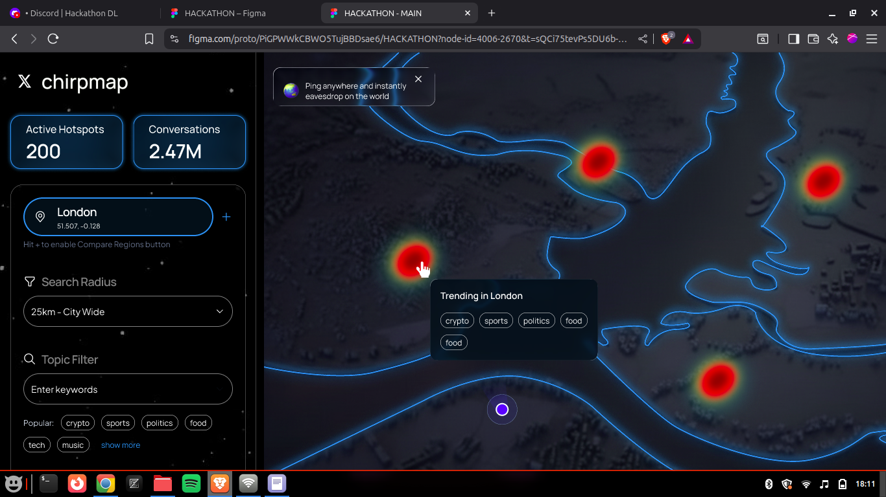

Echo Grid
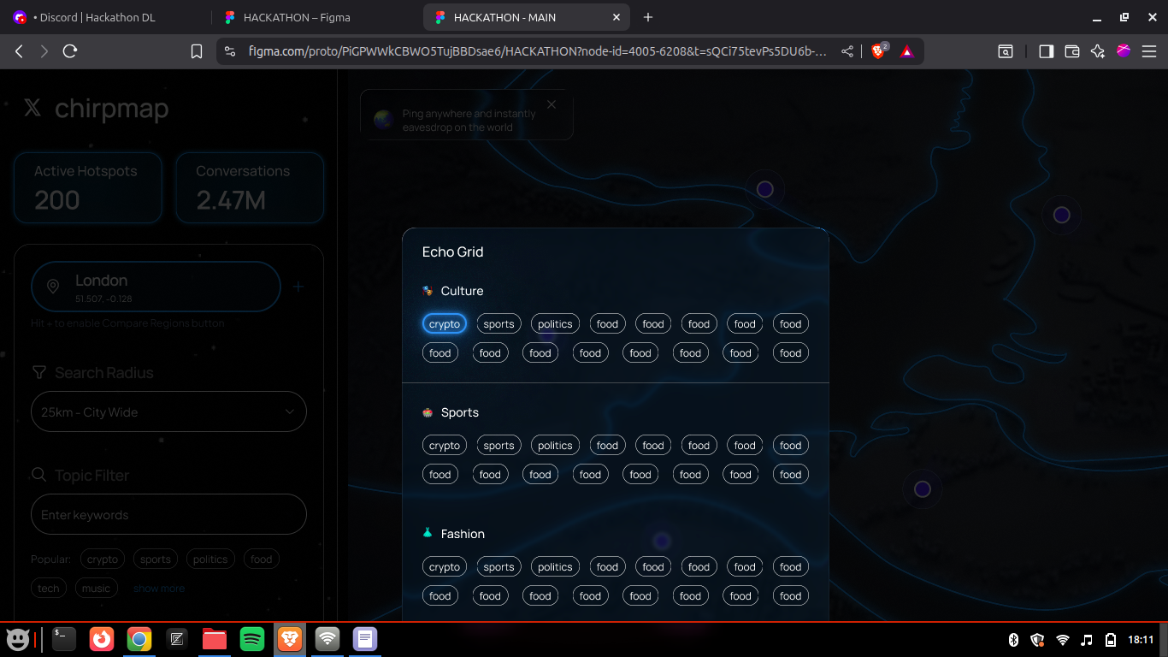

Tweets fetched and Trending Topics
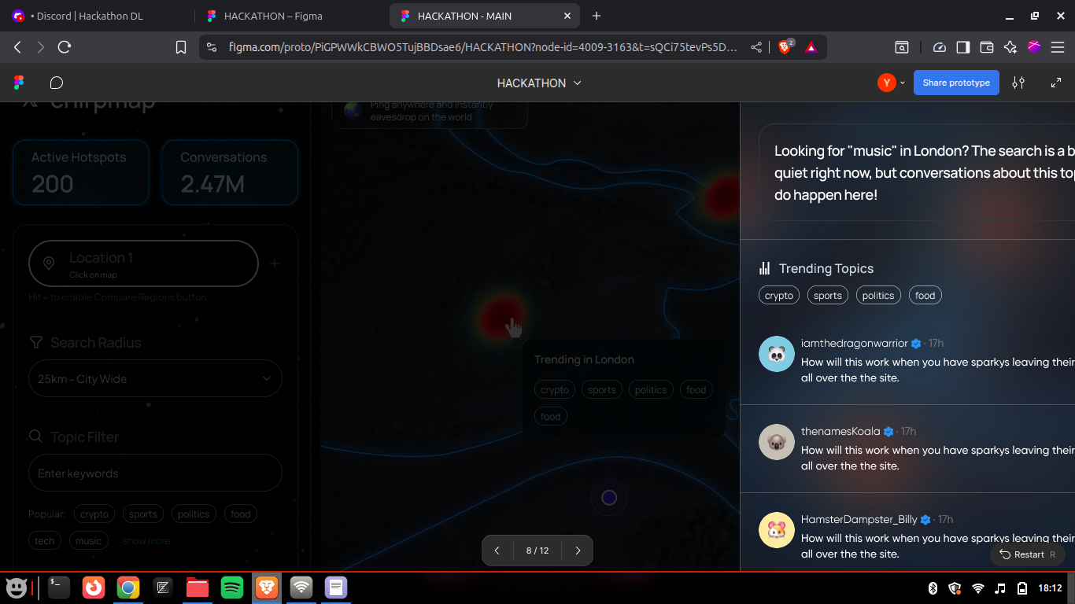

14. Glossary
- Embedding: numeric vector representing semantic meaning of text.
- Qdrant: vector database for storing embeddings and payloads.
- LLM: large language model (Mistral, OpenAI).
- Hybrid Search: combination of vector similarity + geospatial filtering.

15. Appendix: File Map & Key Scripts
- OTB_frontend/: frontend source
- OTB_AI/: backend FastAPI server
- src/embeddings/upload.py # uploader: chunked, resumable embed and upload
- src/embeddings/search.py # hybrid_search implementation
- src/summarizer/summarizer.py # LLM summarization pipeline
- src/qdrant_utils.py # analytics utilities
- datasets/: sample JSONL datasets
- .upload_checkpoint.json # checkpoint

16. Contact & Maintainers
Maintainers:
- Theophilous Asante Frimpong (@littlegod20)
- collinsyaotse (@collinsyaotse)
- CodewithCollins (@Cjyyaotse)
For questions, open an issue on the repository or contact the maintainers via the project channels.

17. License
This project is licensed under the MIT License. See the LICENSE file for details.

