$Σ$ = {1, 2, 3, 4, 5, 5a, 5b, 6, 6a, 6b, 7, 8, 9, 9a, 10, 11}

Q = {Start, Keyword, Separator, Operator, Punctuation, Comment, String, Unknown, Integer, Float, Identifier, End}

q0 = {Start}

F = {End}

N:

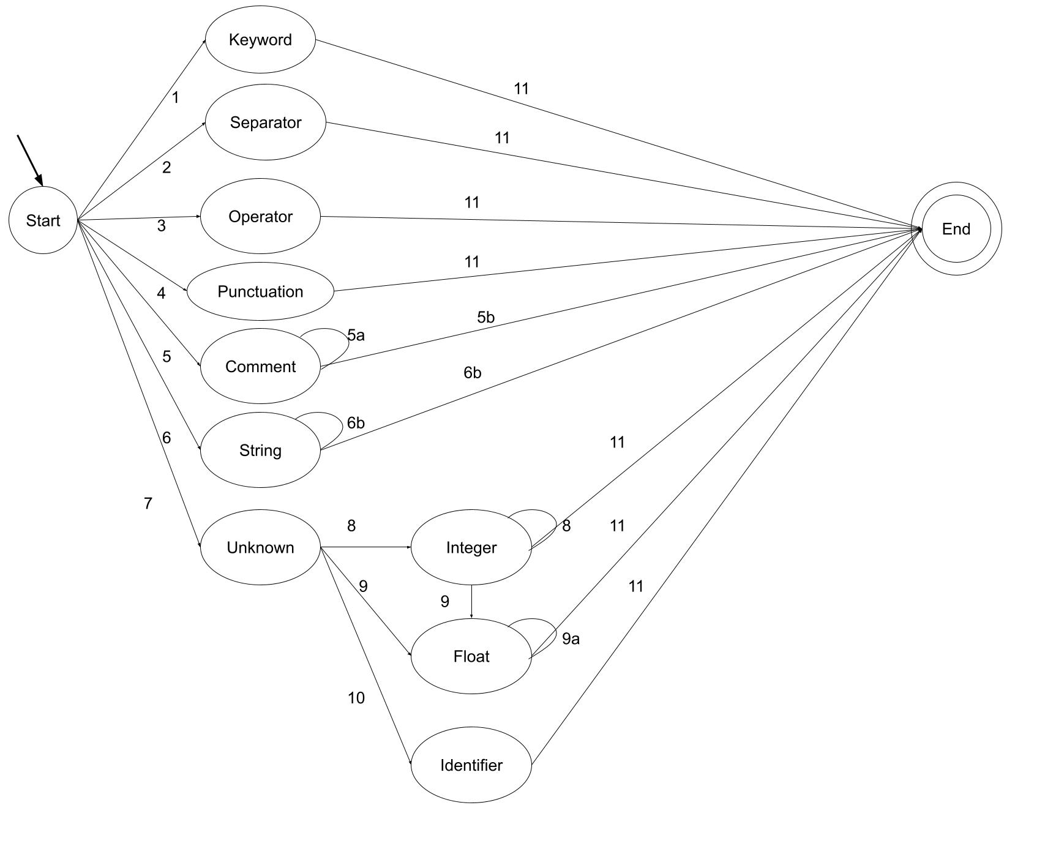

1. Current string is a keyword
2. Current string is a separator
3. Current string is an operator
4. Current string is a punctuation
5. Current string is a “//”, starting a comment

5a. Current string is anything

5b. End of line

1. Current string isa “, starting a string

6a. Current string is anything

6b. Current string is a “, ending a string

1. Current string not found in dictionary
2. Current character is a digit
3. Current character is a decimal

9a. Current character is a digit

1. Neither an integer or float, meaning it must be an identifier
2. Reached end of string