**Project Pitch: DailyForge**

**Problem**

Many individuals struggle to maintain consistent habits despite motivation and access to information. While popular tools like Habitica, Notion templates, and Google Sheets exist, they often introduce complexity, excessive gamification, or lack social support. Research in behavioral psychology shows that habit adherence improves with simplicity, clear feedback, and community reinforcement, yet current tools rarely combine these effectively in a lightweight, science-informed matter.

DailyForge is designed to fill that gap. It’s a habit-building platform that helps users “forge” lasting routines with a clean, science-based interface, visual progress tools, and a collaborative tips exchange. Our mission: make consistency as rewarding and empowering as possible - one day, one habit at a time.

**Stakeholders**

* **Primary Users:** Students, professionals, and self-improvement enthusiasts seeking a structured yet intuitive habit system.
* **Secondary Users:** Productivity coaches, wellness communities, and personal development groups.
* **Community Contributors:** Users sharing practical strategies for habit success (e.g., habit stacking, cue-based reminders).
* **Moderators:** Volunteers or automated systems ensuring shared content remains constructive and helpful.

**Scope**

**In-Scope**

* **Habit Setup:** Users define habits, frequency (e.g., 3 times per week), and duration goals (e.g., 30 days).
* **Progress Dashboard:** Visual feedback with streak indicators, completion charts, and motivational status updates.
* **Forge Tips Board:** A community section where users share and upvote habit-building strategies.
* **Knowledge Base (“The Anvil”):** A quick-access section with evidence-based habit principles for credibility and guidance.

**Out-of-scope (for the minimal viable artifact)**

* Mobile apps (MVP will be web-based).
* Advanced AI recommendations (could be added in future iterations).
* Gamified avatars or reward systems (beyond basic streak visualization).

**Success Metrics**

* **Engagement:** A good portion (at least 70%) of sessions include adding or completing a habit task
* **Community Interaction:** 30% of users interact with the Forge Tips Board within their first week.
* **Trust & Transparency:** Evidence-based strategies prominently displayed for credibility.
* **Early Retention:** At least 50% of new users return within 7 days of first use.

**Minimal Viable Artifact (MVA)**

The MVA for DailyForge will provide a foundation that delivers immediate value and sets the stage for later additions. The MVA will feature:

1. **Habit Tracker Core:** Enables users to create habits, check them off daily with a simple toggle, and view progress through a streak counter or weekly charts.
2. **Forge Tips Board:** A lightweight feed where users can submit short tips and upvote others’ contributions, keeping interactions simple and low-friction.
3. **The Anvil (Knowledge Base):** A static section presenting three to five evidence-based habit strategies with citations, displayed as clear reference cards.

**Core Features**

**Habit Tracker Core**

Users can create habits by specifying name, frequency, and duration. Each day, they check off habits with a simple “done/not done” toggle. A streak counter and weekly bar chart visualize progress, reinforcing consistency. Research shows that consistent repetition of a behavior in stable contexts is the most reliable way to form habits (Gardener et al., 2012). For example, exercising four times per week for six weeks has been identified as the minimum threshold for establishing habit strength (Kaushal & Rhodes, 2015). Streak tracking and weekly summaries align with this evidence by motivating both short-term consistency and long-term sustainability.

**Forge Tips Board**

Users can submit short habit tips that appear in a community feed, with a simple upvote system. This feature encourages peer-to-peer sharing of strategies and reinforces social accountability. McCaw (2023) argues that habit is not simply mechanical repetition but a form of embodied knowledge enriched by awareness and practice. By surfacing collective strategies, the Forge Tip Board amplifies tacit knowledge - making habit-building feel more achievable and relatable.

**The Anvil (Knowledge Base)**

The Anvil is a static section featuring evidence-based strategies for habit-building, presented as markdown or static cards with citations. These strategies include habit stacking, starting small, and staying aware. Habit stacking is pairing new actions with existing cues. For example, drinking water after brushing your teeth. Starting small approaches habit-building by starting with a simple action as opposed to complex ones. Simpler actions form habits faster and more reliably than complex actions (Kaushal & Rhodes, 2015). Finally, staying aware looks at the principle that habits should remain adaptive, shaped by noticing the environment your in, rather than sliding into “autopilot” mode (Segundo-Ortin & Heras-Escribano, 2021).

**Iterative Design Approach**

Development will proceed in short cycles. Cycle 1 will build the core habit tracking dashboard and The Anvil (knowledge base). Cycle 2 will add the Forge Tips Board with upvote/downvote functionality and basic moderation. Each cycle will include a planning and requirements phase, an analysis and design phase, an implementation phase, a testing phase, and an evaluation and review phase. These cycles will also be reviewed against the success metrics before advancing on.

**System Sketch**

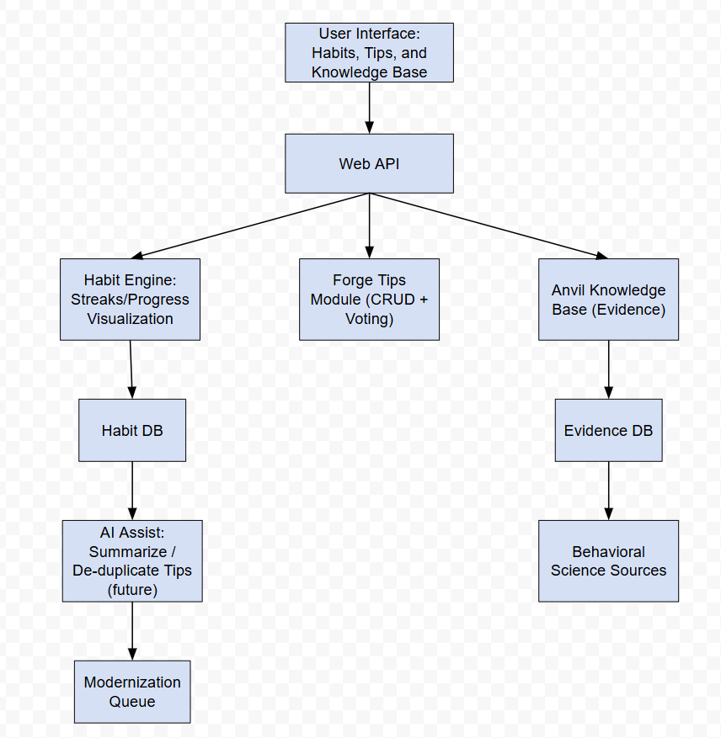

**Evidence Base**

* Gardner, B., Lally, P., & Wardle, J. (2012). Making health habitual: the psychology of ‘habit-formation’ and general practice. British Journal of General Practice, 62(605), 664–666. https://doi.org/10.3399/bjgp12X659466
* Kaushal, N., & Rhodes, R. E. (2015). Exercise habit formation in new gym members: a longitudinal study. Journal of Behavioral Medicine, 38(4), 652–663. https://doi.org/10.1007/s10865-015-9640-7
* McCaw, D. (2023). Habit. Performance Research, 28(6), 14–22. https://doi.org/10.1080/13528165.2023.2334613
* Segundo-Ortin, M., & Heras-Escribano, M. (2021). Neither mindful nor mindless, but minded: habits, ecological psychology, and skilled performance. *Synthese (Dordrecht)*, *199*(3/4), 10109–10133. https://doi.org/10.1007/s11229-021-03238-w
* Spotswood, F. (2016). Beyond behaviour change : key issues, interdisciplinary approaches and future directions / edited by Fiona Spotswood.

**Risk Register**

| **Risk** | **Impact** | **Likelihood** | **Mitigation** |
| --- | --- | --- | --- |
| Low user engagement | High | Medium | Focus on clean user experience, progress visualization, and simple onboarding |
| Spam or irrelevant tips | Medium | Medium | Implement a voting system and community flagging to keep the tip board useful. |
| Scope creep beyond MVA | Medium | High | Focus on only those features for the MVA. |

**AI Log**

AI Used: ChatGPT-5

Prompt: Can you help me brainstorm ideas for a web app project?

Answer Used and Rationale: Answer was partially used as it mentioned a healthy habit tracker among other items.

AI Used: ChatGPT-5

Prompt: Can you help me make sure my problem and core features section flows well?   
Answer Used and Rationale: Answer was partially used . It helped clean up some language but all was not used as it made it sound too rigid and started applying made up information and sources. The sources used and listed in the evidence base was found on the WTAMU library website.