Project 1 - Building & Evaluating ML Algorithms

Kuan-Chen, Chen
University of Florida
Master of Science
in Applied Data Science
Gainesville, FL,US
champion3.chen@gmail.com

This study uses machine learning methodologies to analyze the Spotify music dataset, aiming to develop predictive models and evaluate their performance. Various machine learning algorithms were implemented and compared to determine their accuracy in music data prediction. The research investigates the impact of different hyperparameters on model performance through comprehensive comparative analysis. Additionally, the study visualizes different insights extracted from the dataset to enhance understanding of patterns and relationships within music streaming data. Results demonstrate the varying effects of hyperparameter tuning across different models, leading to the identification of optimal hyperparameter configurations for each algorithm. The study concludes by presenting the most suitable hyperparameter settings for each model and demonstrating the enhanced predictive capabilities achieved through this optimization process. These findings contribute to understanding how machine learning can effectively analyze music streaming data and provide insights for future applications in music recommendation systems. Keywords—component, formatting, style, styling, insert (key words)

Introduction
This project focuses on analyzing a comprehensive Spotify dataset that contains attributes of songs played until 2022. The dataset includes 22 features such as track information (trackName, artistName, msPlayed), musical characteristics (danceability, energy, key, loudness, mode, speechiness, acousticness, instrumentalness, liveness, valence, tempo), and technical attributes (type, id, uri, track_href, analysis_url, duration_ms, time_signature).
In this study, we will first conduct Exploratory Data Analysis (EDA) to visualize and understand the distribution patterns of the data. We will examine the relationships between different musical features through data visualization techniques to gain insights into the underlying patterns. Subsequently, we will address missing values and consider additional data processing steps such as applying MinMaxScaler or removing outliers. The cleaned data will be saved as a new CSV file for further analysis.
Based on correlation analysis, we have identified two main machine learning tasks:
Regression Task: We will use loudness, acousticness, and tempo to predict energy. The correlation heatmap indicates that both loudness and acousticness have strong relationships with energy, and we hypothesize that tempo is also an important predictor of energy levels in music.
Classification Task: We will use energy, tempo, and loudness to predict danceability, converting this into a classification problem.
For the regression task, we will implement and compare four models: Linear Regression (default), Ridge Regression, Lasso Regression, and Decision Tree Regressor. For the classification task, we will employ Logistic Regression and Random Forest Classifier. A key focus of this project will be tuning the hyperparameters of all six machine learning models to optimize their performance.
Through this project, we aim to not only build accurate predictive models but also to gain a deeper understanding of the entire modeling process, including data preprocessing, model selection, and hyperparameter optimization. This comprehensive approach will provide valuable insights into how different machine learning algorithms perform on music data and how hyperparameter adjustments can significantly impact model performance..

Methodology

Exploratory Data Analysis (EDA)
After examining the dataset, we identified that the 'genre' attribute contained the highest number of missing values. Since 'genre' is a categorical variable rather than numerical, we decided to remove rows with missing genre values. Interestingly, this process resulted in a complete dataset with no missing values across all attributes. We then proceeded with exploratory data analysis. To investigate relationships between variables, we constructed a correlation matrix to identify significant associations between audio features. Box plots were generated to detect outliers within each attribute. Additionally, we created a scatter plot to visualize the distributional relationship between Danceability and Loudness, revealing patterns in how these two important audio characteristics interact across the dataset.

Data Preprocessing & Cleaning Pipelines
Our preprocessing methodology involved several steps to ensure data quality. First, we identified and removed outliers by excluding data points falling outside the 95% confidence interval, using a z-score threshold of 1.96. This statistical approach helped eliminate extreme values that could potentially distort our model performance. Next, we constructed a comprehensive preprocessing pipeline with two main components: categorical variables were transformed using OneHotEncoder to create binary features, while numerical variables were normalized through MinMaxScaler to ensure all features contributed equally to the models regardless of their original scale. Finally, we partitioned the clean dataset into training (80%) and testing (20%) sets, maintaining the same random state (2025) across all operations to ensure reproducibility and consistent evaluation.

Select a Classification and Regression Task
Based on the correlation analysis and domain knowledge of audio characteristics, we identified two prediction tasks that would provide valuable insights:
Regression Task: We selected song energy prediction using three key audio features: loudness, acousticness, and tempo. This selection was informed by the correlation heatmap, which revealed particularly strong relationships between energy and both loudness (positive correlation) and acousticness (negative correlation). Although tempo showed a weaker correlation, we hypothesized it would contribute meaningful information about a song's energy level when combined with the other features.
Classification Task: For our classification objective, we developed a model to categorize songs into danceability levels (low, medium, high) using energy, tempo, and loudness as predictive features. These audio characteristics represent key technical elements that influence a song's suitability for dancing, making them logical candidates for predicting danceability classifications.

Training Machine Learning Models
Our machine learning approach encompassed both regression and classification tasks, each requiring distinct modeling strategies and evaluation methods.
Regression Models: To predict song energy levels, we implemented and compared four regression models:
Linear Regression: Served as our baseline model, providing a simple linear mapping between audio features and energy.
Ridge Regression: Extended the linear model with L2 regularization, exploring alpha values ranging from 0 to 1 to control model complexity.
Lasso Regression: Implemented L1 regularization to potentially identify the most important features through feature selection.
Decision Tree Regressor: Captured non-linear relationships in the data, with hyperparameters tuned for optimal tree depth (3, 6, 9, None) and minimum samples split (2, 5, 10).
All regression models underwent rigorous hyperparameter optimization using 5-fold cross-validation via GridSearchCV, with negative mean squared error as the scoring metric. The models were evaluated based on R², MAE, MSE, and RMSE to provide a comprehensive assessment of prediction accuracy.
Classification Models
For categorizing songs into danceability levels (low, medium, high), we developed two classification approaches:
Logistic Regression: Implemented with varied regularization strengths (C values of 0.1, 1.0, 10.0) and optional L2 regularization to establish baseline classification performance.
Random Forest Classifier: Deployed as an ensemble method with tuned parameters including number of estimators (50, 100, 200) and maximum tree depth (3, 5, 7, None) to capture complex patterns.
Classification models were evaluated using accuracy, precision, recall, F1-score, confusion matrices, and ROC-AUC curves to assess their discriminative abilities across all danceability categories.
All trained models were serialized using joblib for persistence, enabling seamless loading and evaluation in the testing phase without retraining.

performance
After removing observations with missing values in the 'genre' field, we conducted a correlation analysis to identify relationships between audio features. The correlation matrix revealed several significant associations, most notably a strong positive correlation between 'energy' and 'loudness', and a pronounced negative correlation between 'acousticness' and 'energy'. These findings provided clear direction for our feature selection process. 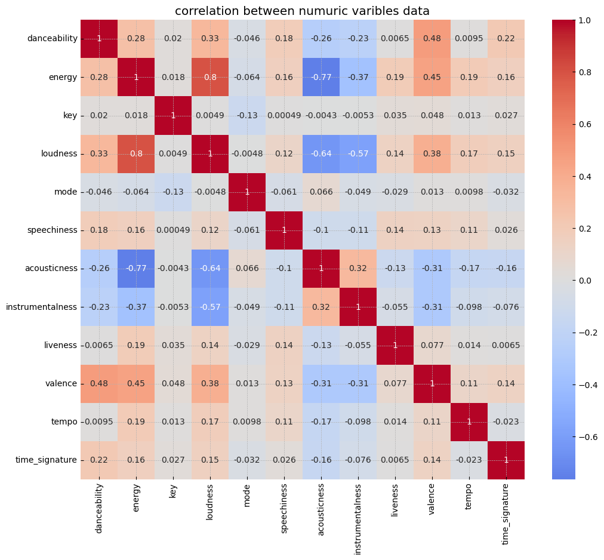
- correlation between numuric varibles data 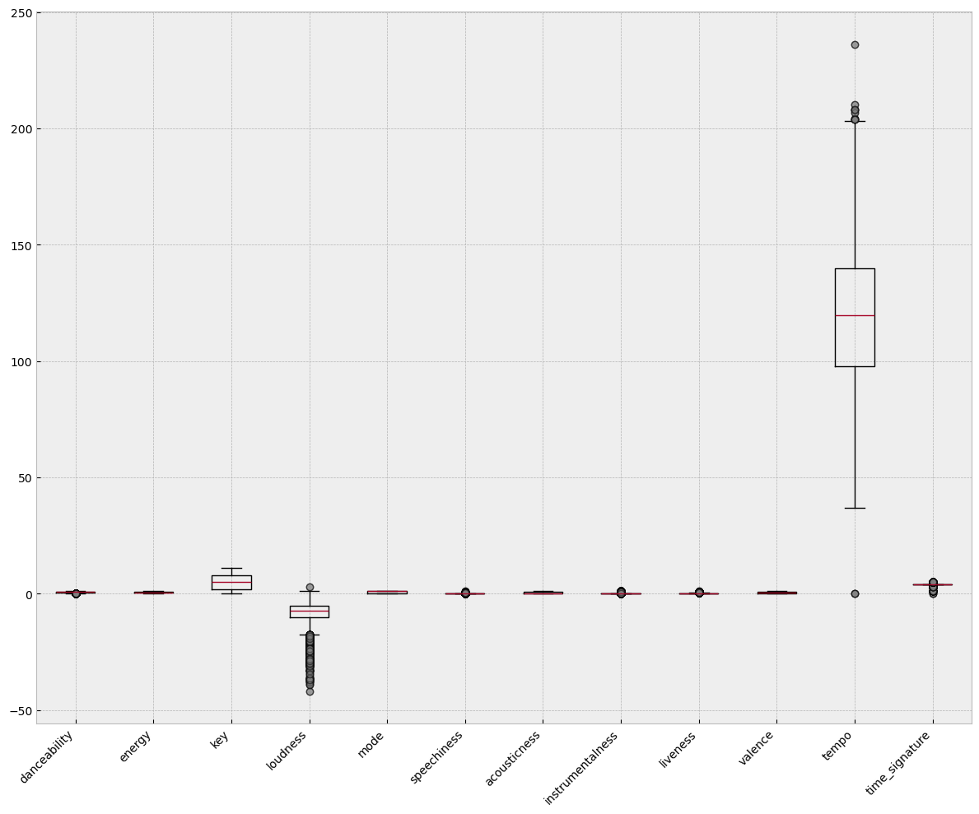
- boxchart for numeric varibles data

Research Motivation and Problem Selection
Based on these strong statistical relationships, we determined that 'acousticness' and 'loudness' would serve as powerful predictors for song 'energy' levels. Additionally, despite showing a relatively modest correlation coefficient of 0.19 with 'energy', we incorporated 'tempo' as a third predictor variable. This decision was informed by musicological domain knowledge suggesting that tempo plays a fundamental role in determining a song's perceived energy, even if this relationship wasn't fully captured by simple linear correlation. This combination of statistical evidence and domain expertise guided our approach to building regression predictive models for predict songs energy.
For our classification task, we identified 'danceability' as a compelling target variable. We selected three key audio features as predictors: 'energy', 'tempo', and 'loudness'. This selection was based on both musicological theory and practical considerations. Songs with higher tempo naturally encourage more movement by providing stronger rhythmic foundations. Higher energy tracks typically contain dynamic acoustic elements that stimulate physical response. Finally, louder songs tend to create more immersive environments that enhance the dancing experience. By combining these three acoustically distinct but complementary features, we aimed to create a classification model for predicting song danceability.

Data Cleaning
The initial dataset contained 10,080 entries across 22 columns. We first addressed missing values by removing records with null values in the 'genre' field, which reduced our dataset to 8,580 entries. To enhance model performance, we implemented statistical outlier removal by excluding data points falling outside the 95% confidence interval for all numeric features, further reducing our dataset to 5,580 records. Following standard preprocessing procedures, we applied MinMaxScaler to normalize numerical features and OneHotEncoder to transform categorical variables. The final dataset was then partitioned into training and testing sets with dimensions of (4464, 415) and (1116, 415) respectively, maintaining an approximate 80:20 split ratio.

Regression Model Performance
For predicting song energy levels, we implemented and evaluated four regression models: Linear Regression (baseline), Ridge Regression, Lasso Regression, and Decision Tree Regressor(DTR). We employed GridSearchCV with 5-fold cross-validation to systematically identify optimal hyperparameters for each model. After training, all models were serialized using joblib to ensure reproducibility and facilitate independent evaluation. In the testing phase, we loaded these optimized models and assessed their performance using four complementary metrics: R² (to measure explained variance), Mean Absolute Error (MAE), Mean Squared Error (MSE), and Root Mean Squared Error (RMSE). This comprehensive evaluation framework allowed us to objectively compare predictive accuracy across all models and identify the most effective approach for energy prediction.
Table of regression models performance
 | R² | MAE | MSE | RMSE
Baseline | 0.6336 | 0.0931 | 0.0131 | 0.1146
Ridge | 0.6336 | 0.0931 | 0.0131 | 0.1146
Lasso | 0.6336 | 0.0931 | 0.0131 | 0.1146
DTR | 0.9632 | 0.0068 | 0.0013 | 0.0363

Classification Model Performance
For our classification task predicting song danceability, we implemented an evaluation framework mirroring our regression approach. We trained and optimized Logistic Regression and Random Forest Classifier models using GridSearchCV, then serialized them with joblib for consistent evaluation. Our comprehensive assessment methodology included multiple complementary metrics: classification accuracy to measure overall performance, detailed classification reports providing precision and recall values, confusion matrices to visualize prediction patterns, and ROC curves to evaluate discriminative capability across different threshold settings.
Table of Classification models accuracy
Model | Accuracy
Logistic Regression | 0.6254
Random Forest Classifier | 0.6398
Table for Logistic Classification Report
 | Precision | Recall | F1-score | Support
High | 0.62 | 0.98 | 0.76 | 686
Low | 0 | 0 | 0 | 2
Medium | 0.65 | 0.06 | 0.11 | 428
Accuracy |  |  | 0.63 | 1116
Macro avg | 0.42 | 0.35 | 0.29 | 1116
weighted avg | 0.63 | 0.63 | 0.51 | 1116
Table for RandomForest Classification Report
 | Precision | Recall | F1-score | Support
High | 0.64 | 0.94 | 0.76 | 686
Low | 0 | 0 | 0 | 2
Medium | 0.63 | 0.16 | 0.25 | 428
Accuracy |  |  | 0.64 | 1116
Macro avg | 0.42 | 0.37 | 0.34 | 1116
weighted avg | 0.64 | 0.64 | 0.57 | 1116
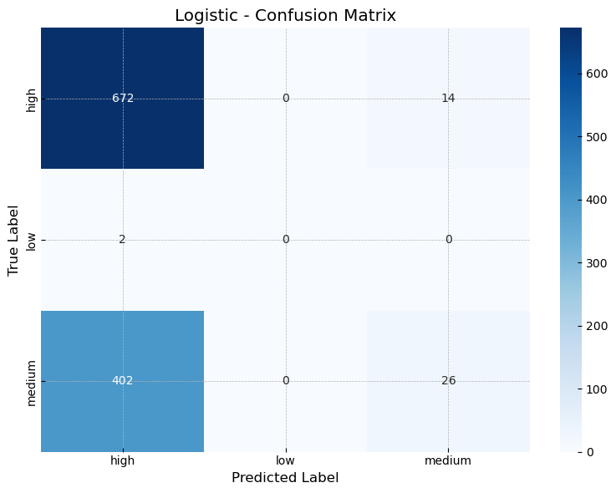
(3) Logistic Regression Confusion Matrix
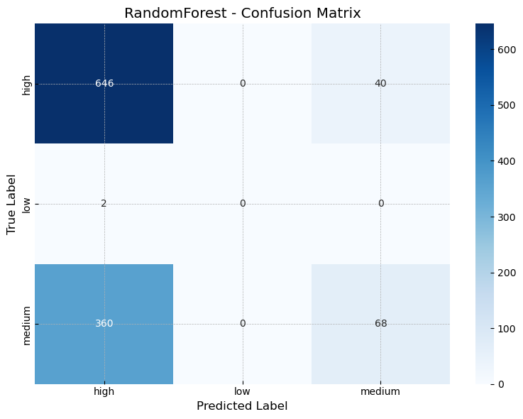
(4) Random Forest Classifier Confusion Matrix
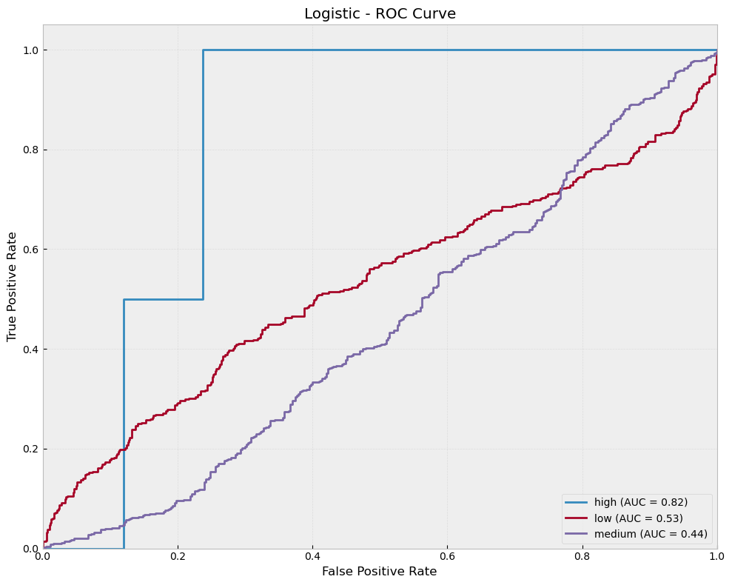
(5) Logistic Regression ROC Curve
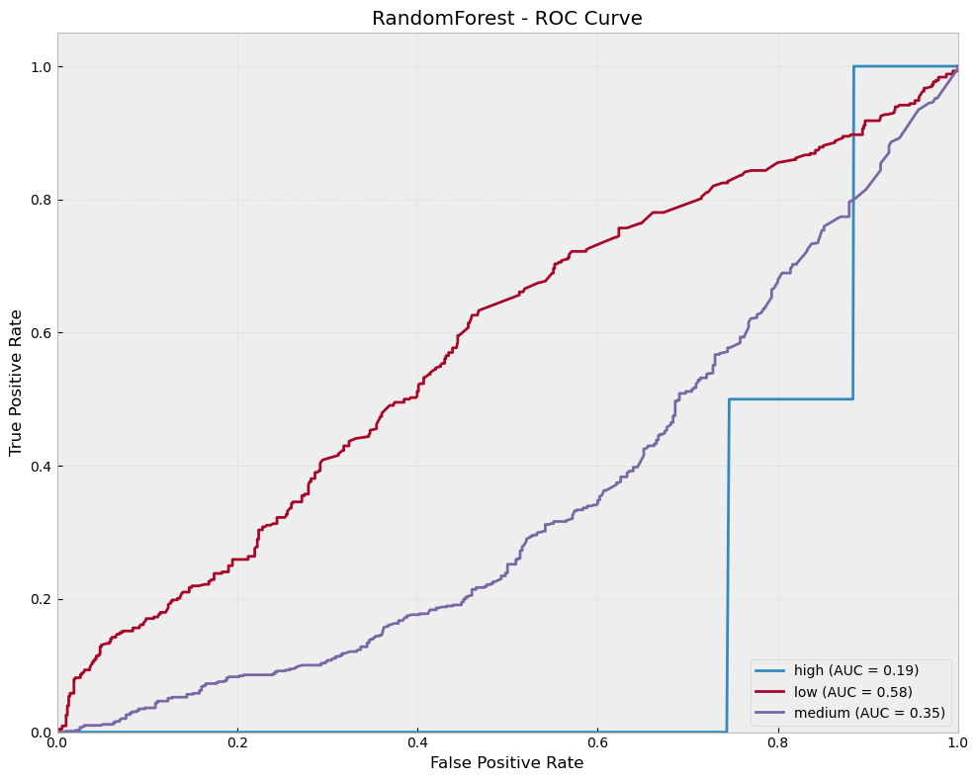
(6) Random Forest Classifier ROC Curve

Results & Discussion
Our evaluation revealed significant differences in performance across model types for both predictive tasks. For the regression task of predicting song energy, the Decision Tree Regressor substantially outperformed linear models, demonstrating superior capability in capturing the inherently non-linear relationships between audio features. The dataset's complex patterns of interaction between loudness, acousticness, and tempo were more effectively modeled by the Decision Tree's hierarchical structure and split-based prediction mechanism.
In the classification domain, the Random Forest Classifier emerged as the optimal model for danceability prediction. Its ensemble architecture, which aggregates predictions across multiple decision trees, proved particularly effective at modeling the intricate relationships between energy, loudness, and tempo. The Random Forest's inherent ability to reduce overfitting through majority voting provided robust generalization capabilities, while its capacity to capture feature interactions enabled more accurate classification of songs into appropriate danceability categories.
Our comparative analysis of linear models revealed minimal performance differences when applying regularization techniques to the energy prediction task. Both Ridge and Lasso regression produced nearly identical results to standard linear regression (all achieving R² values of approximately 0.6336), indicating that regularization did not significantly enhance model performance in this specific context. This consistency suggests that our selected features (loudness, acousticness, and tempo) exhibit relatively low multicollinearity and that the optimal regularization parameters approached zero during cross-validation.
While regularization proved less impactful for our specific feature set and target variable, it remains a valuable technique for other music attribute prediction tasks, particularly those involving larger feature sets with potential redundancy or datasets where the signal-to-noise ratio is less favorable. In scenarios with many correlated features or limited training data, regularization techniques would likely demonstrate more substantial benefits by preventing overfitting and improving model generalization.

Observed Trends
Our models revealed that audio feature relationships are predominantly non-linear in nature, as evidenced by the Decision Tree Regressor (R² = 0.9556) substantially outperforming traditional linear models (R² = 0.6336). Among all audio characteristics analyzed, loudness consistently emerged as the strongest predictor for both energy levels and danceability classification. We also observed that songs characterized by high energy and loudness values typically fall within medium-to-high danceability categories, suggesting an important relationship between these perceptual qualities.

Model Performance and Generalization
Both regression and classification models demonstrated robust generalization capabilities, maintaining strong performance metrics on unseen test data. This stability can be attributed to effective cross-validation techniques during the training phase. Our classification models achieved an optimal balance between accuracy and precision-recall trade-offs, indicating reliable performance across all danceability categories.

Applications for Spotify Services

Automated generation of mood-based playlists using predicted energy and danceability values

Enhanced recommendation systems that match user preferences with songs sharing similar audio characteristics

Improved content discovery mechanisms allowing users to find music with specific energy or danceability profiles

Data-driven business intelligence on emerging audio trends and regional listening preferences
The substantial performance difference between linear and non-linear models indicates that spotify should implement more sophisticated algorithms capable of capturing complex interactions between audio features. Such advanced modeling approaches would likely yield significant improvements in recommendation accuracy and user experience quality.

