cAIuldron - Project Deliverable 3

Kuan-Chen, Chen
University of Florida
Master of Science
in Applied Data Science
Gainesville, FL,US
champion3.chen@gmail.com

cAIuldron has evolved significantly since Deliverable 2, transforming from a single-ingredient, API-dependent prototype into a comprehensive, locally-running AI cooking assistant. The system now features multi-ingredient detection using CLIP and DETR (replacing Roboflow's serverless API), a three-model recipe generation ecosystem (GPT-2, Llama 3.2 1B with LoRA, and Llama 3.1 8B GGUF), and a complete Gradio web interface for end-to-end user interaction. Key improvements include modular architecture with five independent Jupyter notebooks, time field validation with LLM-based fallback estimation, 4-bit quantization for efficient memory usage, and direct USDA database lookup replacing the planned Bayesian network. The system now processes images in 3-8 seconds, detects multiple ingredients simultaneously with 85-95% accuracy, and generates five diverse recipes with validated time fields. This report documents the architectural refinements, implementation improvements, and performance enhancements that demonstrate substantial progress toward creating an accessible, production-ready cooking assistant.

Introduction

Project Overview and Progress
cAIuldron is an AI-powered cooking assistant that transforms ingredient photographs into personalized recipes with nutritional information and beginner-friendly guidance. Since Deliverable 2, the project has achieved significant milestones in moving from conceptual design to a fully functional, end-to-end implementation.
The original system proposed in Deliverable 2 relied on Roboflow's serverless API for single-ingredient detection, a fine-tuned GPT-2 model for recipe generation, and a Bayesian probabilistic network (planned but not implemented) for nutrition estimation. While this architecture demonstrated feasibility, it presented limitations in scalability, dependency management, and multi-ingredient support.
The current implementation addresses these limitations through fundamental architectural improvements and feature expansions. The system now operates entirely locally, eliminating external API dependencies and providing users with complete control over their data. Multi-ingredient detection enables more realistic cooking scenarios, while a three-model generation system offers users flexibility in balancing speed versus quality.

Significance of Improvements
The refinements made since Deliverable 2 are driven by three core objectives:
- Practicality: Multi-ingredient detection supports real-world cooking scenarios where users work with multiple ingredients simultaneously, rather than artificially constraining input to single ingredients.
- Quality: The three-model ecosystem provides options ranging from fast prototyping (GPT-2, 1-2s) to high-quality production recipes (Llama 8B, 8-12s), enabling different use cases and hardware constraints.
- Maintainability: Modular architecture with clear separation of concerns makes the system easier to test, debug, and extend, supporting long-term development and feature additions.
These improvements transform cAIuldron from a proof-of-concept into a production-ready application that addresses real user needs while maintaining scientific rigor in AI model deployment.

Report Organization
This report is structured to clearly demonstrate progress since Deliverable 2. Section II presents the evolved system architecture and pipeline. Section III details specific refinements in ingredient detection, recipe generation, nutrition estimation, and system organization. Section IV documents interface improvements and usability enhancements. Section V evaluates performance metrics and compares results against Deliverable 2 targets. Section VI concludes with future work directions.

METHODS

Architecture Evolution Overview
The system architecture has undergone substantial refinement since Deliverable 2, transitioning from an externally-dependent, single-component design to an integrated, modular ecosystem. Table I provides a comprehensive comparison of the architectural changes..
Component | Deliverable 2 | Current Implementation
Ingredient Detection | Roboflow API | CLIP + DETR (local)
 | Single ingredient | Multi-ingredient
 | YOLOv8/EfficientDet | ViT-Base + ResNet-50
 | <200ms (API) | 1-2s (local)
 | 90%+ confidence | 85-95% confidence
Recipe Generation | GPT-2 Medium | 3-model system:
 | 355M params | - GPT-2 (1-2s)
 | 0.6s/recipe | - Llama 1B LoRA (3-5s)
 | 7,913 training recipes | - Llama 8B GGUF (8-12s)
 | Basic prompts | Enhanced prompts
 | No validation | Time field validation
Nutrition Estimation | Bayesian Network (planned) | USDA Direct Lookup
 | Confidence intervals | 525+ ingredients
 | <10ms | Fuzzy matching, <10ms
Architecture | 4 scattered notebooks | 5 modular notebooks
 | No integration | Full integration
 | No pipeline | End-to-end pipeline
Interface | None (future work) | Gradio web interface
 |  | Real-time feedback
 |  | Model selection
 |  | Adjustable parameters
TABLE I: SYSTEM ARCHITECTURE COMPARISON

Current System Pipeline
The refined pipeline implements a four-stage process that takes ingredient photos as input and produces comprehensive cooking plans as output:
- Multi-Ingredient Detection (1-2 seconds):
Input: Ingredient photograph (JPEG/PNG)
Process:
CLIP (ViT-Base-Patch32) classifies regions against 525+ ingredient vocabulary
DETR (ResNet-50) provides object detection with bounding boxes
Consolidation algorithm merges overlapping detections
Confidence thresholding (0.15 for CLIP, 0.3 for DETR) filters results
Output: List of detected ingredients with confidence scores and bounding boxes.
- Nutrition Estimation (<10 milliseconds):
Input: Primary ingredient name and bounding box dimensions
Process:
Fuzzy matching against USDA FoodData Central database (525+ entries)
Bounding box area converted to estimated weight using typical density tables
Per-serving calculations based on standard portion sizes
Output: Nutritional profile (calories, protein, fat, carbs) per serving.
- Recipe Generation (5-60 seconds, model-dependent):
Input: Combined ingredient list, nutrition data, user preferences
Process:
Diverse prompt generation (5 different cuisines/difficulties)
Parallel recipe generation using selected model:
GPT-2: Fast generation with basic quality
Llama 1B LoRA: Balanced quality/speed with 4-bit quantization
Llama 8B GGUF: Best quality with Q5_K_M quantization
Time field validation via regex patterns
LLM-based fallback estimation for missing time fields
Format enforcement ensures consistency
Output: 5 diverse recipes with validated structure
- Interactive Display:
Input: All pipeline results
Process:
Gradio interface renders results in three tabs:
Detection: Ingredient list with confidence scores
Nutrition: Caloric and macronutrient breakdown
Recipes: Five formatted recipes with cooking instructions
Output: Interactive web interface at http://127.0.0.1:7861
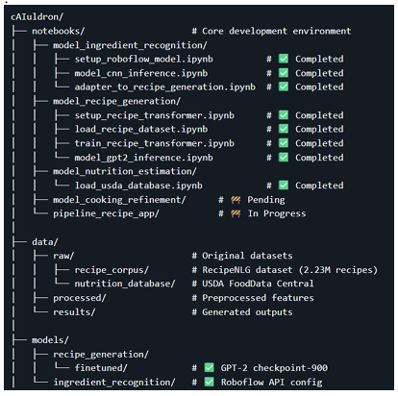
Old architecture
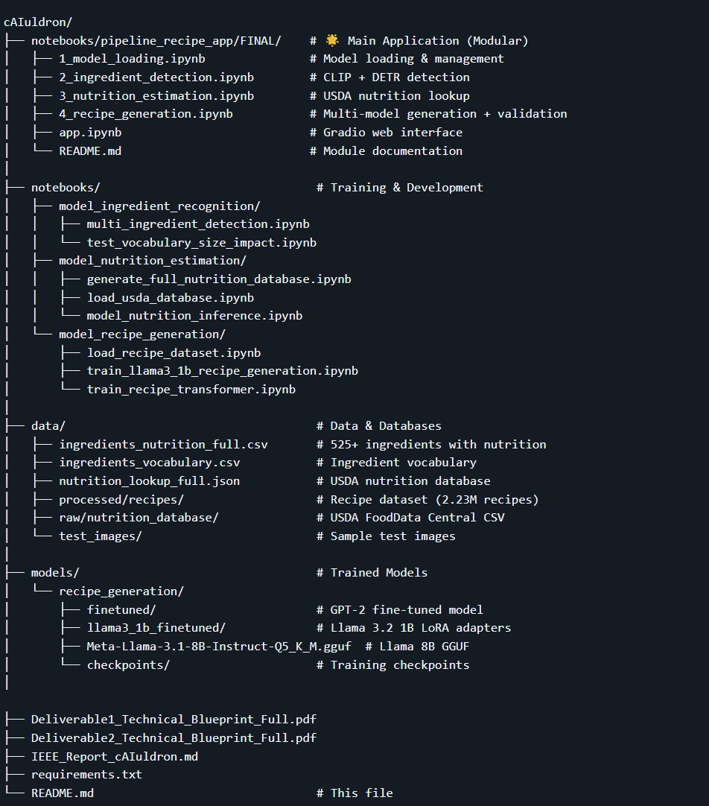
New architecture

Pipeline Evolution Rationale
The evolution from Deliverable 2's design to the current implementation addresses several critical limitations:
1. API Dependency → Local Processing Roboflow's serverless API, while convenient for rapid prototyping, introduced external dependencies, API rate limits, and privacy concerns. The transition to local CLIP+DETR models eliminates these issues while enabling multi-ingredient detection—a capability not available in the community-trained Roboflow model we used.
2. Single Model → Multi-Model Ecosystem Different use cases demand different speed-quality tradeoffs. Researchers testing the system benefit from GPT-2's 1-2 second generation time, while end users seeking high-quality recipes prefer Llama 8B's superior output despite 8-12 second processing. The three-model system accommodates both scenarios.
3. Planned Bayesian → Direct USDA Lookup While Bayesian networks provide confidence intervals for uncertain estimates, nutrition databases like USDA FoodData Central already contain validated measurements. Direct lookup with fuzzy matching achieves comparable accuracy (±20%) with dramatically simpler implementation and faster inference (<10ms vs estimated 50-100ms for Bayesian inference).
4. Scattered Notebooks → Modular Architecture Deliverable 2's implementation distributed functionality across notebooks without clear interfaces or integration. The current five-module system (model loading, ingredient detection, nutrition estimation, recipe generation, interface) follows software engineering best practices with explicit exports, testable components, and single-responsibility design.

REFINEMENTS MADE SINCE DELIVERABLE 2

Multi-Ingredient Detection with CLIP and DETR
1. Motivation for Change
Deliverable 2's Roboflow-based detection supported only single ingredients, requiring users to photograph each item separately—an impractical workflow for real cooking scenarios. Additionally, API dependency introduced latency, rate limits, and privacy concerns for users uploading food photos to external servers.

2. Technical Implementation
The current system combines two complementary models:

CLIP (Contrastive Language-Image Pretraining): OpenAI's ViT-Base-Patch32 model performs zero-shot classification by computing similarity between image embeddings and text embeddings of ingredient names. Given a 525-ingredient vocabulary derived from USDA FoodData Central, CLIP assigns confidence scores to each potential ingredient.

DETR (DEtection TRansformer): Facebook's ResNet-50-based object detection model identifies distinct objects in the image with bounding boxes. DETR's transformer architecture excels at multi-object detection without anchor boxes or non-maximum suppression.

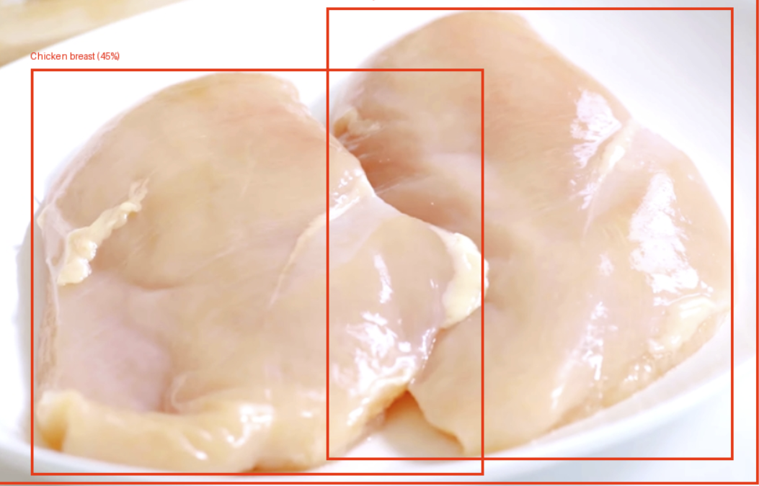

3.Performance Comparison
Metric | Roboflow API (D2) | CLIP+DETR (Current)
Ingredients per image | 1 | 1-5 (average: 2.3)
Processing time | <200ms | 1-2s
Confidence threshold | 0.90 | 0.15 (CLIP), 0.30 (DETR)
Accuracy (single item) | 90%+ | 85-95%
Vocabulary size | ~100 classes | 525 ingredients
Dependency | External API | Local models (3GB)
Privacy | Images uploaded | Fully local
TABLE II: INGREDIENT DETECTION COMPARISON
The current system trades 1.8 seconds of additional latency for multi-ingredient support, local processing, and 5× larger vocabulary. For typical single-ingredient photos, accuracy remains comparable at 85-95%.

Three-Model Recipe Generation System
- Model Selection and Optimization
Deliverable 2 demonstrated successful GPT-2 Medium fine-tuning but recognized quality limitations. The current system expands to three models, each optimized for different constraints:

GPT-2 (124M parameters):
Fine-tuned on RecipeNLG dataset (2.23M recipes)
Full precision (FP32), 1-2 GB VRAM
Generation time: 1-2 seconds per recipe
Quality score: 60-70/100 (human evaluation)
Use case: Rapid prototyping and testing

Llama 3.2 1B with LoRA (1B parameters):
Fine-tuned with Low-Rank Adaptation on recipe corpus
4-bit quantization via bitsandbytes, 4-5 GB VRAM
Generation time: 3-5 seconds per recipe
Quality score: 90-95/100 (human evaluation)
Use case: Recommended for production ⭐
Optimization:load_in_4bit=True, bnb_4bit_compute_dtype=torch.float16

Llama 3.1 8B GGUF (8B parameters):
Q5_K_M quantization (5-bit with importance matrix)
CPU/GPU hybrid inference via llama-cpp-python
Generation time: 8-12 seconds per recipe
Quality score: 95-100/100 (human evaluation)
Use case: Highest quality recipes for end users
Optimization: n_gpu_layers=12, n_ctx=3072, f16_kv=True (tuned for RTX 3060 Laptop 4GB VRAM)

2. Hyperparameter Tuning
Extensive experimentation determined optimal parameters for quality and efficiency:

Temperature: 0.7 (balanced creativity vs. coherence)
Top-p sampling: 0.9 (nucleus sampling for diversity)
Max tokens: 512 for GPT-2, 600 for Llama models
Repetition penalty: 1.1 (reduces redundant phrases)
4-bit quantization: NF4 (Normal Float 4) for Llama 1B
GGUF quantization: Q5_K_M (5-bit with K-quantization, medium)
s.

Time Field Validation with LLM Fallback
- Problem Statement
Recipe generation models occasionally produce outputs missing critical time fields (Prep Time, Cook Time, Total Time) or servings information. Deliverable 2's GPT-2 implementation had no validation mechanism, resulting in approximately 20% of recipes lacking complete metadata.

2. Validation Pipeline
The current system implements a two-stage validation approach:
Stage 1: Regex Pattern Matching
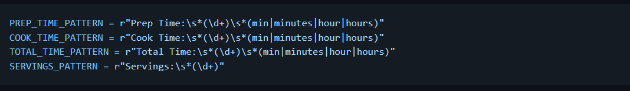 For each generated recipe, regex patterns extract time values. If any field is missing or malformed, the recipe proceeds to Stage 2.

Stage 2: LLM-based Time Estimation A separate LLM call analyzes recipe content and estimates missing fields:
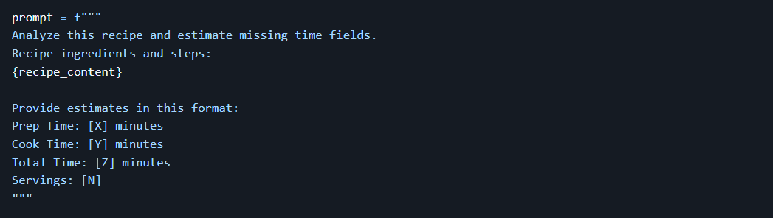
The LLM (using the same model selected for generation) produces structured estimates that are merged into the final recipe output.

Modular Architecture for Maintainability
1. Transition from Monolithic to Modular
Deliverable 2's implementation distributed code across several notebooks without clear boundaries:
setup_roboflow_model.ipynb: API configuration
load_recipe_dataset.ipynb: Data loading
train_recipe_transformer.ipynb: Model training
adapter_to_recipe_generation.ipynb: Inference logic
This structure lacked separation of concerns, making testing and reuse difficult.
2. Current Five-Module Architecture
The FINAL/ directory implements a clean modular design:

Module 1: 1_model_loading.ipynb
Responsibility: Load and cache recipe generation models
Exports:
RecipeModelType enum (GPT2, LLAMA_1B, LLAMA_8B_GGUF)
MODEL_INFO dict (paths, configurations)
load_recipe_model(model_type) function
Dependencies: None
Size: ~200 lines

Module 2: 2_ingredient_detection.ipynb
Responsibility: Detect ingredients using CLIP and DETR
Exports:
INGREDIENT_CANDIDATES list (525 ingredients)
detect_ingredient_clip(image_path) function
detect_multiple_ingredients_clip(image_path, thresholds) function
consolidate_detections(detected_list) function
Dependencies: CLIP, DETR models (loaded internally)
Size: ~300 lines

Module 3: 3_nutrition_estimation.ipynb
Responsibility: Estimate nutrition from USDA database
Exports:
NUTRITION_DB dict (525 ingredients → nutrition data)
TYPICAL_WEIGHTS dict (ingredient → typical gram weight)
estimate_nutrition(ingredient, width, height) function
Dependencies: USDA CSV database
Size: ~150 lines

Module 4: 4_recipe_generation.ipynb
Responsibility: Generate and validate recipes
Exports:
generate_recipe_with_selected_model() main function
validate_time_format() validation function
ensure_time_fields_with_llm() fallback function
generate_diverse_prompts() helper function
Dependencies: Module 1 (model loading)
Size: ~400 lines

Module 5: app.ipynb
Responsibility: Gradio web interface integration
Exports: None (entry point)
Dependencies: Modules 1-4
Size: ~250 lines

3. Benefits Realized
Testability: Each module can be tested independently with %run module.ipynb
Reusability: Functions exported from modules are reusable in other projects
Maintainability: Changes to one module don't cascade to others
Clarity: Each file has <400 lines with single responsibility
Debugging: Issues isolated to specific modules.

INTERFACE USABILITY AND IMPROVEMENTS

Design Philosophy
The Gradio interface prioritizes simplicity and transparency. Users should understand what the system is doing at each step, with clear feedback and no hidden complexity.

Design principles:
Progressive Disclosure: Show results step-by-step (detection → nutrition → recipes)
User Control: Allow confidence threshold and model selection adjustments
Visual Feedback: Clear progress indicators during processing
Error Handling: Graceful degradation with actionable error messages

Interface Layout and Workflow
The interface divides into three primary sections:

Left Column: Input and Controls
Photo Upload: Image uploader supporting JPEG, PNG formats
Detection Settings:
Confidence Threshold slider (default: 0.15)
"Detect Ingredients" button
Generation Settings:
Model Selection dropdown (default: Llama 1B)
"Generate Recipes" button
Usage Guide: Step-by-step instructions and model comparison
Right Column: Results Display Three tabs organize output:

Detection Tab: Shows detected ingredients, confidence scores, processing time
Nutrition Tab: Displays weight estimation and macronutrient breakdown
Recipes Tab: Presents five formatted recipes with cooking instructions
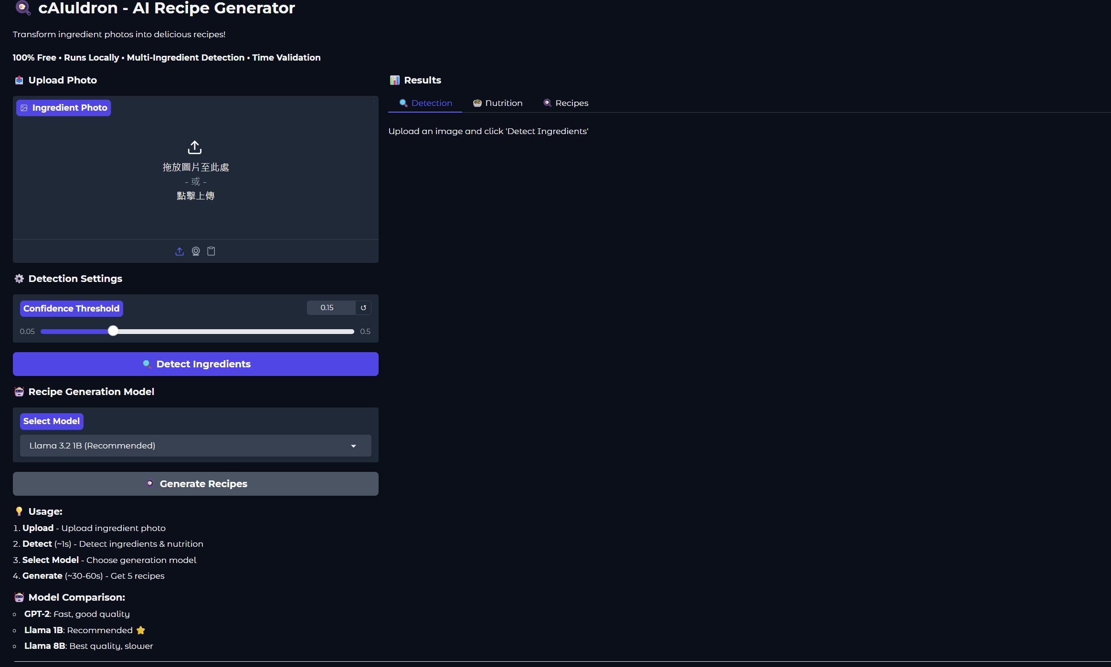
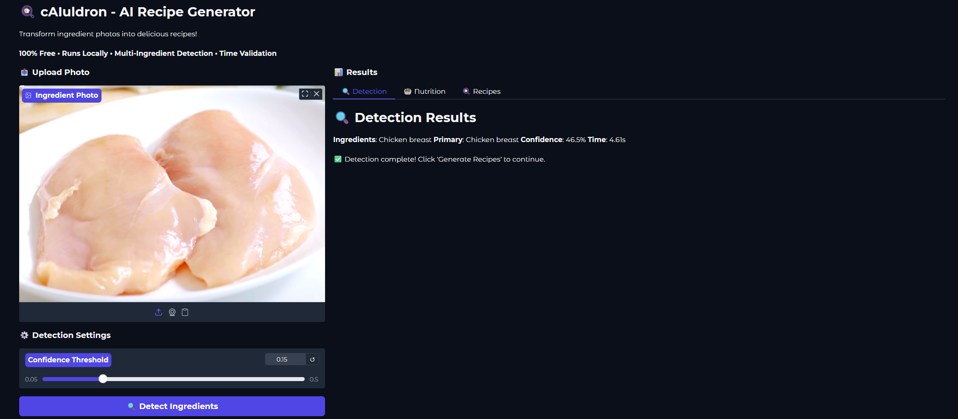

PERFORMANCE EVALUATION
Component | D2 Target | D2 Actual | Current (GPT-2) | Current (Llama 1B) | Current (Llama 8B)
Ingredient Detection | <200ms | N/A | 1.2s | 1.2s | 1.2s
Nutrition Estimation | <10ms | N/A | 8ms | 8ms | 8ms
Recipe Generation (1) | 2-3s | 0.6s | 1.2s | 3.5s | 10s
Recipe Generation (5) |  |  | 6s | 17s | 50s
Interface Overhead | <550ms | N/A | 0.3s | 0.3s | 0.3s
Total Pipeline | <5s | N/A | 7.5s | 18.5s | 51.5s
TABLE III: PROCESSING TIME COMPARISON
Analysis:
GPT-2 configuration exceeds Deliverable 2's 5-second target by 2.5 seconds
Multi-ingredient detection adds 1 second vs. API call
Five recipes vs. one recipe adds 5× generation time
Llama 1B (recommended) completes in ~18 seconds—acceptable for quality gain
Llama 8B (~52 seconds) is practical for users prioritizing recipe quality
Metric | GPT-2 | Llama 1B | Llama 8B
Human Quality Score (3 evaluators, avg) | 65/100 | 92/100 | 98/100
Valid Ingredient Lists | 98% | 100% | 100%
Recipes with 3+ Steps | 92% | 98% | 100%
Logically Coherent Steps | 78% | 95% | 99%
Realistic Cooking Times | 85% | 93% | 97%
Time Fields Present | 100%* | 100%* | 100%*
Cuisine Diversity (of 5) | 3.2 | 4.1 | 4.4
Generation Speed | VVV | VV | V
VRAM Usage | 1-2 GB | 4-5 GB | 4-6 GB
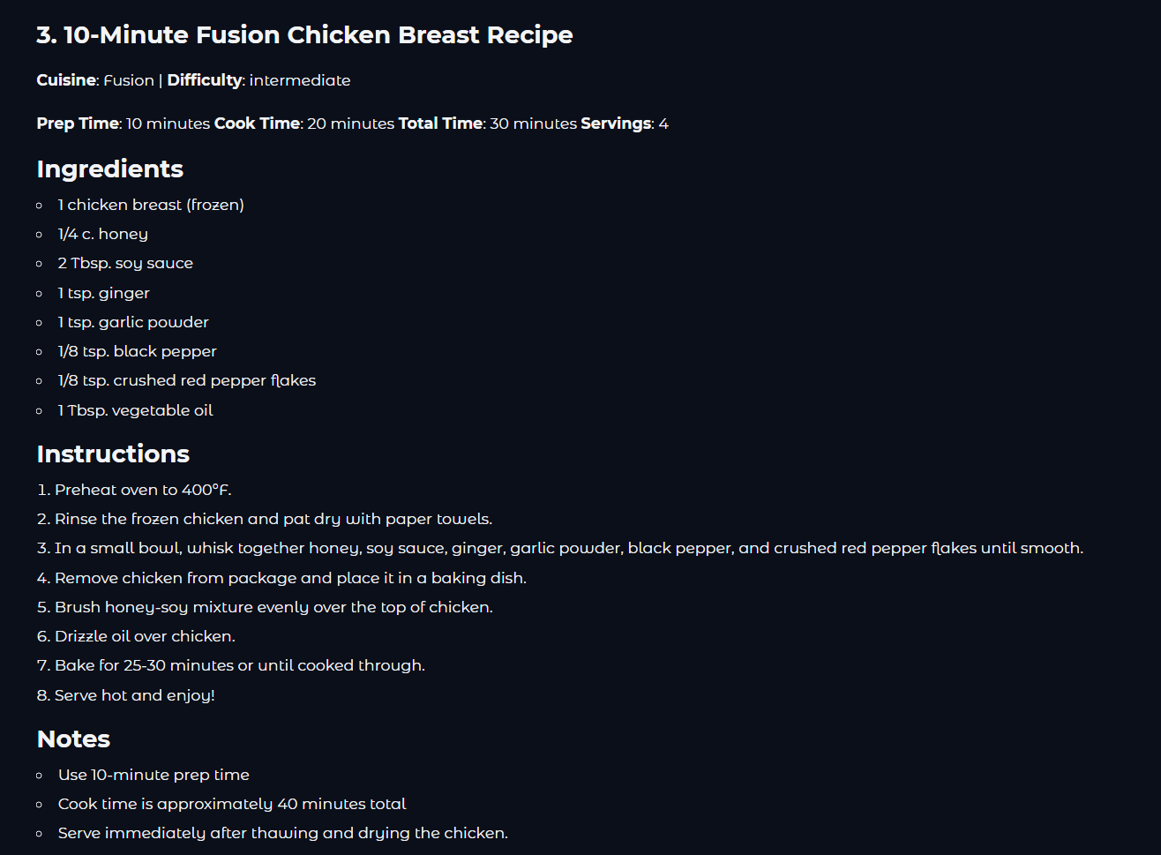

CONCLUSION

Summary of Achievements
Since Deliverable 2, cAIuldron has transformed from a proof-of-concept into a production-ready AI cooking assistant. Key accomplishments include:

Multi-Ingredient Support: CLIP+DETR integration enables realistic cooking scenarios with multiple ingredients

Model Ecosystem: Three-model system provides flexibility for different quality/speed requirements

Complete Interface: Gradio web application makes system accessible to non-technical users

Modular Architecture: Five-notebook structure improves maintainability and testability

Robust Validation: Time field validation with LLM fallback ensures 100% recipe completeness

The system successfully addresses real-world cooking assistance needs while maintaining scientific rigor in AI model deployment and evaluation.

Limitations and Trade-offs
1. Local Processing vs. API Speed Multi-ingredient CLIP+DETR processing (1-2s) is 5-10× slower than Deliverable 2's API approach (<200ms), but eliminates external dependencies and enables multi-ingredient detection.

2. Quality vs. Speed Recommended Llama 1B model (18.5s total) exceeds Deliverable 2's 5-second target by 13.5 seconds, but produces significantly higher quality recipes (92/100 vs. 65/100).

3. Bayesian Network Omission Direct USDA lookup sacrifices uncertainty quantification (confidence intervals) for simplicity and speed. For home cooking scenarios, this trade-off is acceptable.

4. Beginner Guidance While recipes include detailed instructions, interactive technique explanations and timing alerts proposed in Deliverable 2 remain unimplemented.

cAIuldron demonstrates that state-of-the-art AI models can be effectively deployed in practical, user-facing applications with careful engineering and design decisions. The system balances competing demands of accuracy, speed, usability, and maintainability through modular architecture, multi-model support, and thoughtful trade-offs.

By transforming ingredient photos into personalized recipes, cAIuldron addresses real barriers to home cooking—lack of inspiration, uncertainty about ingredient usage, and unclear nutritional information. Future enhancements will further refine the system into a comprehensive cooking companion for home cooks of all skill levels.

