Requirements for thesis execution

Materials in 1 page of typewritten text (A4 format) must be created in Latex. Page format: margins indent in 25 mm from all sides, size of type – 12 pt; line spacing – single. Abstracts are sent by e-mail. The template and instructions for abstracts can be found on the conference page in the site of the Polotsk State University:

www.psu.by/gkm2020

The application form is following:
PARTICIPANT’S REQUEST
Full Name __________________________________
Organization ________________________________
Position ____________________________________
Degree ____________________________________
Scientific title _______________________________
Post address and tel. (fax) _____________________
E-mail _____________________________________
Section name _______________________________
Report title _________________________________
Technical means for presentation ________________
Need for a hostel ____________________________

PRESENTATION OF MATERIALS
To participate in the conference, you must send an application for participation and abstracts to the organizing committee by April 15, 2020. The organizing committee plans to publish collections before the conference. Additional information will be in the second information report.
Travel, meals and accommodation of the conference participants are at the expense of sending organizations.

ADDRESS
OF ORGANIZING
COMMITTEE
Republic of Belarus, 211440
Novopolotsk, street. Blokhina, 29
Polotsk State University
Department of Higher Mathematics
Phone number: +375(0214)-59-95-75
E-mail: gkm_novopolotsk@tut.by

The Ministry of Education
of the Republic of Belarus

Polotsk State University

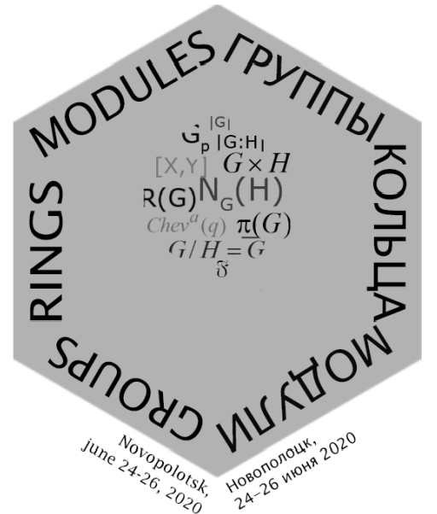

International conference
«GROUPS, RINGS, MODULES»
dedicated to the memory
of Professor E.M. Palchik

FIRST
INFORMATION
REPORT

Novopolotsk, Belarus
24 – 26 June 2020 year

Organizing committee invite you to take part in the conference, which will be held from 24 to 26 June 2020 in Novopolotsk (Vitebsk region) on the basis of the educational Institution "Polotsk State University”.

WORK OF CONFERENCE
IT IS PLANNED FOR
THE FOLLOWING SECTIONS:

1. GROUP Theory.
2. rings and modules.
3. TEACHING METHODS of MATHEMATIC DISCIPLINES IN HIGHER EDUCATION.
The languages of the conference:
Russian, Belarusian, English.

Report’s continuance:
• plenary – 45 minutes;
• sectional – 15 minutes.

PROGRAM COMMITTEE OF THE CONFERENCE

- Yanchevski V.I. – head of the department of Algebra, Doctor of Physical and Mathematical Sciences, academic of NASB, Institute of Mathematics of NASB, Minsk, Belarus (chair);
- Suprunenko.I.D. – principal researcher of the department of Algebra, Doctor of Physical and Mathematical Sciences, professor, Institute of Mathematics of NASB, Minsk, Belarus (co-chair);
- Skiba A.N. – professor of the department of Algebra and Geometry, Doctor of Physical and Mathematical Sciences, professor, Francisk Skorina GSU, Gomel, Belarus (co-chair);
- Vorob'ev N.T.. – head of department of Algebra and Teaching Methods of Mathematics, Doctor of Physical and Mathematical Sciences, professor, VSU named after P.M. Masherov, Vitebsk, Belarus (co-chair);
- Benyash-Krivets. V.V. – Head of the department of Higher Algebra and Information Security, Doctor of Physical and Mathematical Sciences, professor, BSU, Minsk, Belarus;
- Drozd Yu.A. – head of the department of Algebra and Topology, Doctor of Physical and Mathematical Sciences, corresponding member of NASU, Ukraine, Institute of Mathematics of NASU, Kiev, Ukraine;
- Gal’mak A.M. – head of the department of Higher Mathematics, Doctor of Physical and Mathematical Sciences, Mogilev State University of Food Technologies, Mogilev, Belarus;
- Kazarin L.S. – head of the department of Algebra and Mathematical Logic, Doctor of Physical and Mathematical Sciences, professor, the Yaroslavl Demidov State University, Yaroslavl, Russia$
- Kamornikov S.F. – professor of the department of Finance and Credit, Doctor of Physical and Mathematical Sciences, professor, Francisk Skorina GSU, Gomel, Belarus;
- Kondrat’ev A.S.– senior research scientist of the department of Algebra and Topology, Doctor of Physical and Mathematical
Sciences, professor, N.N. Krasovskii Institute of Mathematics and Mechanics of UB RAS, Yekaterinburg, Russia;
- Kulazhenko Yu.I. – rector of BSUT, Doctor of Physical and Mathematical Sciences, Gomel, Belarus;
- Kurdachenko L.A. – head of the department of Geometry and Algebra, Doctor of Physical and Mathematical Sciences, professor, Dnipro, Ukraine;
- Mazurov V.D. – principal researcher of the Laboratory of Group Theory, Doctor of Physical and Mathematical Sciences, corresponding member of RAS, Sobolev, Institute of Mathematics, Novosibirsk, Russia;
- Makhnev A.A. – head of the department of Algebra and Topology, Doctor of Physical and Mathematical Sciences, corresponding member of RAS, N.N. Krasovskii Institute of Mathematics and Mechanics of UB RAS, Yekaterinburg, Russia;
- Monakhov V.S – professor of the department of Algebra and Geometry, Doctor of Physical and Mathematical Sciences, professor, Francisk Skorina GSU, Gomel, Belarus;
- Revin D.O. – senior research scientist of the laboratory of Group Theory, Doctor of Physical and Mathematical Sciences, Sobolev Institute of Mathematics, Novosibirsk, Russia;
- Safonov V.G. – Pro-rector of Research, Doctor of Physical and Mathematical Sciences, professor, BSU, Minsk, Belarus;
- Selkin V.M. – head of the department of Algebra and Geometry, Doctor of Physical and Mathematical Sciences, professor, Francisk Skorina GSU, Gomel, Belarus;
- Selkin M.V. – professor of the department of Fundamental and Applied Mathematics, Doctor of Physical and Mathematical Sciences, professor, Francisk Skorina GSU, Gomel, Belarus;
- Shcherbakov V.A.– principal researcher of Vladimir Andrunachievici Institute of Mathematics and Computer Science of ASM, Doctor of Physical and Mathematical Sciences, Kishinev, Moldova;
- Tyutyanov V.N. – professor of the department of Foreign Languages and Intercultural Communications, Doctor of Physical and Mathematical Sciences, professor, MITSO, Gomel, Belarus;
- Vasilyev A.F. – professor of the department of Algebra and Geometry, Doctor of Physical and Mathematical Sciences, professor, Francisk Skorina GSU, Gomel, Belarus;
- Vdovin E.P. – deputy director of Sobolev Institute of Mathematics of SB of RAS, Doctor of Physical and Mathematical Sciences, Sobolev Institute of Mathematics of SB of RAS, Novosibirsk, Russia;
- Vedernikov V.A. – professor of the department of Higher Mathematics and Teaching Methods of Mathematics,
Doctor of Physical and Mathematical Sciences, professor, MCU, Moscow, Russia;
- Vorob'ev N.N. – professor of the department of Algebra and Teaching methods of mathematics, Doctor of Physical and Mathematical Sciences, VSU named after P.M. Masherov, Vitebsk, Belarus;
- Wenbin Guo – professor of School of Mathematical Sciences, Doctor of Physical and Mathematical Sciences, professor, University of Science and Technology of China, Hefei, China;
- Yadchenko A.A. – head of the Laboratory of finite group theory and applications, Doctor of Physical and Mathematical Sciences, Gomel branch of Institute of Mathematics of NASB, Gomel, Belarus;
- Zalesskii A.E.– Doctor of Physical and Mathematical Sciences, corresponding member of NASB, Institute of Mathematics of NASB, Minsk, Belarus;

CO-CHAIR OF THE CONFERENCE
Lazovski D.N. – rector of PSU, Doctor of Technical Sciences, professor, Novopolotsk;
ORGANIZING COMMITTEE
OF THE CONFERENCE
Golubev Yu.P. – pro-rector of Research, Candidate of Technical Sciences, docent, PSU (chair);
Kozlov A.A. – head of department of Higher Mathematics, Candidate of Physical and Mathematical Sciences, PSU (co-chair);

Members of organizing committee:
1. Bashun S.Yu. – senior lecturer of the department of Higher Mathematics (secretary of organizing committee);
2. Grozberg Yu.G. – Dean of the Faculty, Candidate of Technical Sciences;
3. Goncharova T.V. – head of the department of support of scientific research;
4. Vakulchick V.S. – docent of the department of Higher Mathematics, Candidate of Pedagogic Sciences, docent;
5. Skoromnik O.V. – docent of the department of Higher Mathematics, Candidate of Physical and Mathematical Sciences; docent
6. Yasko F.F.– docent of the department of Higher Mathematics; Candidate of Physical and Mathematical Sciences, docent
7. Matsyalyonak A.P. – senior of the department of Higher Mathematics;
8. Zavistovskaya T.I. – Assistant Professor of the department of Higher Mathematics;
9. Aleksandrovich T.A. – Assistant Professor of the department, of Higher Mathematics;
10. Kechko I.L. – department supervisor of social and information technologies and services;
11. Puhachova S.N. – specialist in support of the educational process of the department of Higher Mathematics;
12. Zenchenkova I. Yu. – Assistant Professor of the department of Architecture.

