Colton Kohler

Module 5.2 Assignment

This week I explored the SQL commands CREATE TABLE, INSERT INTO, UPDATE, and SELECT while working with last module’s movies database. To start, I realized that I needed to create a table since the one I intended to use didn’t exist. Using the CREATE TABLE command, I defined a table named movies with columns for the film's ID, name, release date, runtime, and director. This command helped me establish the structure of the table, ensuring it could store the required data.

Then, I used INSERT INTO to add the movie Harry Potter and the Sorcerer's Stone to the database. I included details such as its director, Chris Columbus, the U.S. release date of November 16, 2001, and a runtime of 150 minutes. This command allowed me to populate the table with new data accurately, which is particularly useful when building or expanding a database. I also used the command SELECT \* FROM movies to view the values I just submitted. I found this syntax on a forum discussion https://www.quora.com/How-do-you-display-the-contents-of-a-table-in-SQL.

Next, I tried to use the UPDATE function to modify the runtime of the movie to its correct value of 152 minutes. This function demonstrates how to adjust information in an existing record without deleting or re-entering it. However, I was met with an error message when I executed the function. So I went into my preferences to turn off safe mode so I was able to rerun and execute my function.

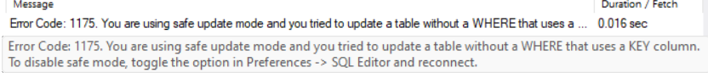



Finally, I used the SELECT function to retrieve a list of films and their release dates, displaying the results with column aliases for better readability. The process showed how these SQL commands work together for managing and querying a database effectively.

