Colton Kohler

Module 6.2 Assignment

11/24/24

I wasn’t able to use the command “source” to run the script. I was seeing online that it might be because I’m using the MySQL Workbench. I ended up copy and pasting the script into my workbench and running it. This was my output.

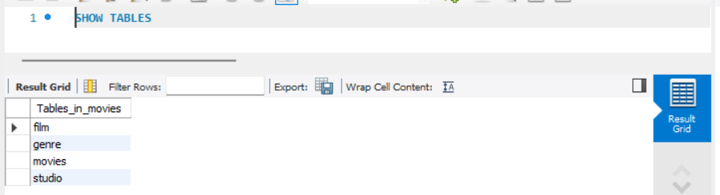

The movies table is one that I added last week for the assignment.

