The electric double layer is the theoretical foundation that gives a supercapacitor its unmatched qualities. Helmholtz was the first to lay down the framework for electric double layers. His idea was that at the boundary between an electrode and an ionic liquid dielectric, a high potential could be created. As indicated in the figure below, the charges that build up on the electrode like in a conventional capacitor attract oppositely charged ions in the dielectric.

Helmholtz built his theory on the assumption that there is a rigid layer formed at the boundary of the electrode and dielectric. This does not occur in nature, and it wasn’t until Guoy and Chapman both independently put forth their theories that the EDL was better understood. The Guoy-Chapman model proposed that the potential doesn’t just depend on the ions at the boundary but also the ions in the “diffuse” layer. The counter ions (the ions countering the charge on the electrode) will diffuse into the liquid layer in the dielectric. The more ions that have diffused the harder it is for the counter ions to continue to diffuse, due to the counter-potential that is created in the diffuse layer. It was theorized that the change in concentration of these ions follows the Boltzmann distribution *n = $n0*exp(-ZeѰ/kT)$* . Where n0 is the bulk concentration, Z the charge of the ion and e the charge of the proton[1]. This theory is already in error because it assumes that the amount of dispersion is equal to the concentration of the ions in the dielectric. This is a good approximation, but this is not true at the charged surface layer between the dielectric and electrode. Guoy-Chapman concerned themselves with the volume charge density, in general i  = zieni. The potential can be found using this relation Poisson’s equation d2/dx2 = -4/d. The boundary conditions for this potential are that the potential is o at the surface of boundary and zero at the end of the bulk solution. Finally the potential at a distance from the surface is given by double = [rkT/(4e2niozi2)]1/2 and simplified at room temperature to be double = 3.3*106r/(zc1/2).

As it turns out, the Guoy-Chapman model does not accurately describe the double layer potential, it only offers a very good approximation. It was Stern who finally completed the theory when he integrated the ideas that the ions did indeed have a finite size, and that their approach to the surface between electrode and dielectric was inhibited by this. Thus there is a spacing taken to be the radius of the ion that separates the ions from the surface. This spacing is what is called the Stern Layer. The potential changes linearly across this Stern Layer and then exponentially decreases once in the diffuse layer as indicated in figure 1.

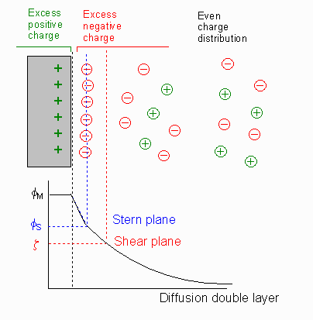**Fig 1. The voltage through the Stern Layer drops off linearly. Once the diffuse**

**Layer is reached the voltage drops off exponentially.5**

Notes

* I feel like I have a really good start on the electric double layer except for a derivation of the Guoy-Chapman potential. This I wasn’t sure if I should include in the main body of the paper or in an appendix at the end.
* I would like to do the same thing with the dielectrics as I did for the double layer and add the figures that were recommended into the final paper for sure.
* From there I would like to keep distilling what I already have in my paper while adding as much relevant research diagrams and adding ways in which supercapacitors are applied. Including the circuits they are built into and specs on their power outputs and such.

1. https://web.nmsu.edu/~snsm/classes/chem435/Lab14/double_layer.html