**[RWAR: Moooorrreee drivers](http://www.chrisseto.com/wordpress/?p=186" \o "Permanent Link to RWAR: Moooorrreee drivers)**

Posted on August 18th, 2010 Chris Seto [No comments](http://www.chrisseto.com/wordpress/?p=186#comments)

[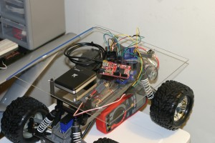](http://www.chrisseto.com/wordpress/wp-content/uploads/2010/08/IMG_0095.jpg)

I have released a new set of drivers for hobby grade RC car control. Although the note was posted on TinyCLR, I wanted to make sure that a few points were made VERY clear about the changes in the new driver set, which meant I needed to use my own formatting tools.

Drivers link: [*(Visual Studio 2010, NETMF 4.1)*](http://files.chrisseto.com/c5V)

**WARNING:**

* The ESC drivers in this release have a MUCH faster ramp time. No more pansy 25ms per ramp iteration, I pushed it down to 1ms. **In other words, your truck will accelerate and decelerate (theoretically, of course) *25x faster*!!**
* This release has a new drive demo. If you decide to use it, it turns your RC car into an. …RC car… with the help of the receiver. To connect the receiver to the FEZ…
  1. Connect the signal pins (channel 1 and 2, 1 being steering and 2 being throttle) to two digital in ports on your FEZ (by default, these are D10 [throttle] and D11 [steering])
  2. GND on the RX to GND on the FEZ
  3. Power for the RX comes from the BEC (6V out from the ESC). Power must be connected ONLY to channel 2 +

If you need help finding the right pins on the ESC, they are embossed just below the first channel 1 connector

* Use EXTREME caution when using the new drive demo. DO NOT deviate from the following power up procedure:
  1. Transmitter: ON
  2. RC Battery: Connected
  3. ESC: ON
  4. FEZ:ON
* The RC systems **MUST** be turned on before the FEZ, as the RC systems supply power to the RX. If the FEZ doesn’t sense a signal from the RX, it may do unwanted stuff. Unfortunately, the default failure mode is full throttle. This is not a good thing and it will be fixed next release.
* In the event of the truck going out of control with the new drive demo, immediately push full forward on the throttle _trigger_. This will cut the motor. FULL FORWARD means to push the throttle trigger AWAY from you. Pulling the trigger back toward you will only make the problem much, much worse.
* The PPM decoder is still in BETA. There are issues with it, and the values it reads from the receiver are NOT inherently stable. They are stable enough that I am comfortable releasing them, but you need to follow the truck around if you are using the PPM decoder to drive it.
* This is somewhat of a minor note, but the configuration class for the Xl-5 now includes 500ms of arm time. This means that it will take a minimum of 500ms to initialize the ESC driver from now on, since the constructor has to hold the throttle at 0% for 500ms before it exits.

I know, lots and lots of warnings there, but believe me, it’s a good idea to read all of those. My truck took off at full throttle a few times while I was testing. That’s why I made sure to make these at prominent as possible. My truck is not too heavily loaded down with stuff yet, but my counterpart’s is. If his truck were to crash at full throttle, it would not be pretty. For the time being, mine doesn’t seem to be bothered by crashes, although I do try to keep them to an absolute minimum ;-).

[**RWAR: Drivers (almost) Done**](http://www.chrisseto.com/wordpress/?p=162)

Posted on August 11th, 2010 Chris Seto [No comments](http://www.chrisseto.com/wordpress/?p=162#comments)

Today brought a few things…

First off, the nice FedEx man brought me my Netduino from Secret Labs, LLC.  
[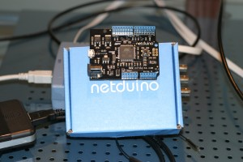](http://www.chrisseto.com/wordpress/wp-content/uploads/2010/08/IMG_0052.jpg)

The Netduino is a new development board running NETMF much like the FEZ Domino. The key difference is that the Netduino is 100% open source, including the drivers, board design, and firmware. The Netduino will be used to operate all of the “side function” on RWAR while the FEZ Domino will be used for actual navigation.

Second, I finally finished the servo and ESC drivers after lots of trial and error. It turns out that the XL-5 ESC used in the project is quite sensitive to how it’s signaled. I finished the beta driver last night, but I kept seeing small glitches in the motor operation. For example, in certain situations the motor would suddenly reverse when the ESC was being signaled to go forward. After much testing, I realized that the ESC absolutely required that the pulse be ramped when changed. For example, if I wanted to go from a 0% to 20% power setting, I would have to ramp the pulse up through every whole number between 0 and 20. If the signal was suddenly changed from a 0% power setting to 20%, the ESC would spin the motor up in a random direction, then immediately stop. The fix was to implement a loop that ramps the signal up or down, waiting 50ms before the next step. Any faster than 50ms and the un-ramped behavior would return.

So far, I have tested the ESC driver from a 0% to 100% power setting in forward mode. I have not tested reverse yet, and therefor I do not recommend using it in this release. Theoretically, it should work fine since the signal looks fine on the scope, but I would still be cautious. My Stampede has already tried to run away from me once…

The improved servo driver was also tested and run through a complete test.

The full NETMF project (including test code) maybe downloaded [here.*(Visual Studio 2010, NETMF 4.1)*](http://files.chrisseto.com/c5V)  
**The timing settings included in this source package are ONLY for the Traxxas XL-5 speed control! If you have a different model ESC, make sure to verify proper timings for yourself.**

Wiring diagram:  
[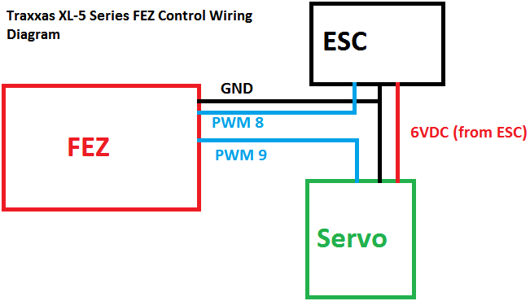](http://www.chrisseto.com/wordpress/wp-content/uploads/2010/08/xl5wiring.png)

Note: In this configuration the FEZ is left unpowered. In my case, I use a USB battery pack to power it. I have not yet looked at powering the FEZ from the XL-5′s BEC.

By the way, there is now at least one more person doing this same project for himself. Hai Nguyen from TinyCLR bought the exact same model of Traxxas Stampede immediately after I bought mine to use as a high performance robot platform in the same way I’m using mine.