

Website Development Strategy & Implementation Plan

Prepared for Parrish Family Trucking LLC
Prepared by Cleintech Solution KE

Project Overview
This project focuses on developing a bold, responsive, and enterprise-ready digital platform for Parrish Family Trucking (PFT).

The website will position PFT as an industry leader in flatbed and stepdeck transportation while preparing infrastructure for future reefer operations. The platform will unify branding, recruiting, customer tracking, and employee access into one secure digital ecosystem.

Core Project Foundations
All systems will be built on four fundamental pillars:

  - Flexibility – The platform will be designed to easily adapt to new services, additional modules, and evolving business requirements without requiring major redevelopment.

  - Scalability – The infrastructure will support growth in traffic, data, users, and integrations while maintaining performance and reliability.

  - User-Friendly Interface – Every page will be structured for intuitive navigation, fast access to information, and smooth usability across desktop, tablet, and mobile devices.

  - Security – Security will be embedded into every layer of development, including secure authentication, protected data handling, role-based access control, and system hardening to prevent unauthorized access or data breaches.

Design & User Experience
- Looping hero video showcasing fleet operations
- Strong headline branding: Design With Purpose and Power
- Industrial yet modern visual identity reflecting reliability and authority
- Mobile-first responsive layout for drivers and customers
- Fast-loading, clean, and professional interface

Certifications Section
- Dedicated Certification tab
- Prominent display of 100% SDVOB certification
- Structured framework allowing easy addition of future certifications
- Trust-focused presentation for government and commercial clients

Services Structure
- Flatbed Transportation
- Stepdeck Transportation
- Reefer Services (Coming Soon)
- Dedicated Freight Solutions
- Contract Transportation
- Regional & National Hauling

Each service will have its own optimized page for clarity and SEO.

Tracking Integration

- Integration with Verizon Connect tracking portal
- Secure shipment tracking access for customers
- Clean and intuitive tracking interface
- Controlled access to shipment data

Careers & Recruitment
- Drive for PFT portal
- Work for PFT employment section
- TenStreet integration for driver applications
- Mobile-optimized application forms

Maintenance & Safety
- DOT compliance showcase
- Preventative maintenance program
- Equipment inspection protocols
- Driver safety and training standards

Interactive Forms
- Contact form with spam protection
- Quote request form optimized for conversions
- Booking request form
- Driver application form

All forms will include validation and security filtering.

Employee Portal
- Secure login system
- Webmail access
- Pay and benefits information
- Internal announcements dashboard
- Role-based access controls

Search Engine Optimization
- Strategic keyword integration
- Structured headings and metadata
- Performance optimization
- SEO-ready page architecture

SITE FEATURES SUMMARY
- Responsive Mobile-First Design
- Secure Tracking Portal Integration
- TenStreet Recruitment Connectivity
- Certification Visibility Module
- SEO-Optimized Framework
- Interactive Conversion Forms
- Social Media Integration
- Secure Employee Access Portal

Site Architecture Diagram
This diagram visually defines the full navigation and functional layout of the Parrish Family Trucking platform, including Home, About, Services, Tracking, Safety & Compliance, Drivers, Careers, Employee Portal, and Contact sections.
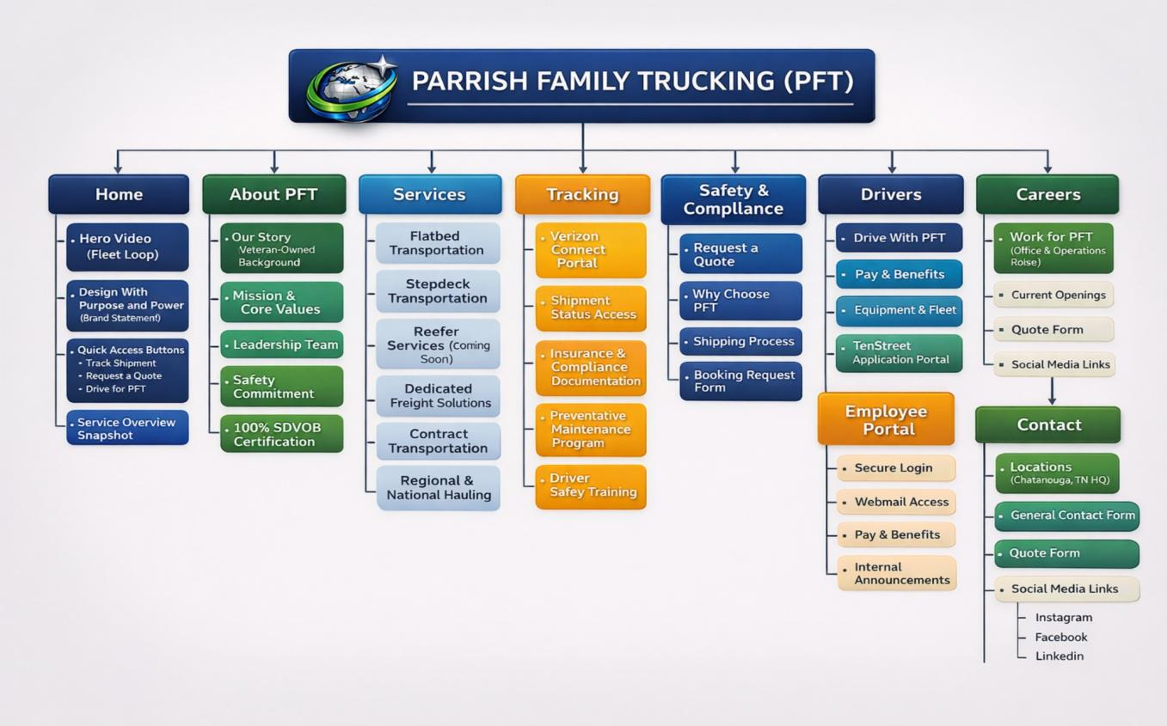

Development Phases & Timeline

Phase | Description | Duration
Discovery | Planning & Requirements | 1 Week
Design | UI/UX & Branding | 1 Week
Development | Build & Content | 2 Weeks
Integration | Systems & Security | 1 Week
Testing | QA & Optimization | 1 Week
Launch | Deployment & Training | 1 Week

