Compiler Exam Prep

Understanding
- what are clauses and rules
- what aspect of programm does what
Coding
- implement an new language feature with if and while
- one new language feature e.g x=a+b
- return error message
-how many var are defined via counter

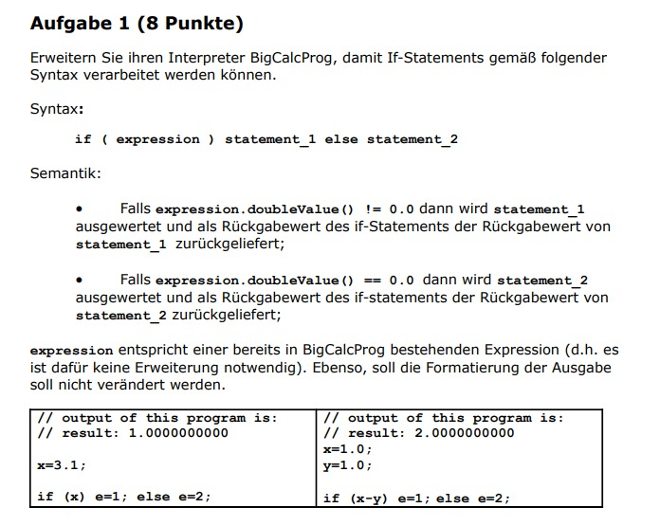

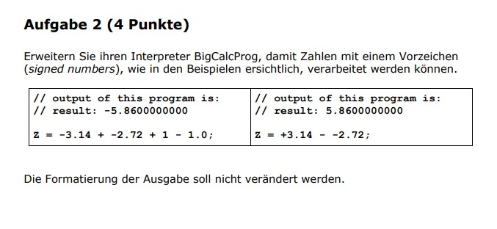

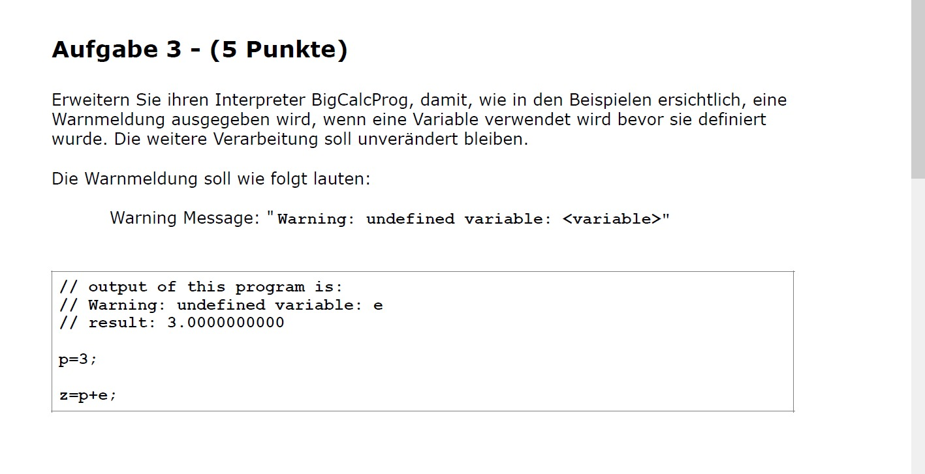

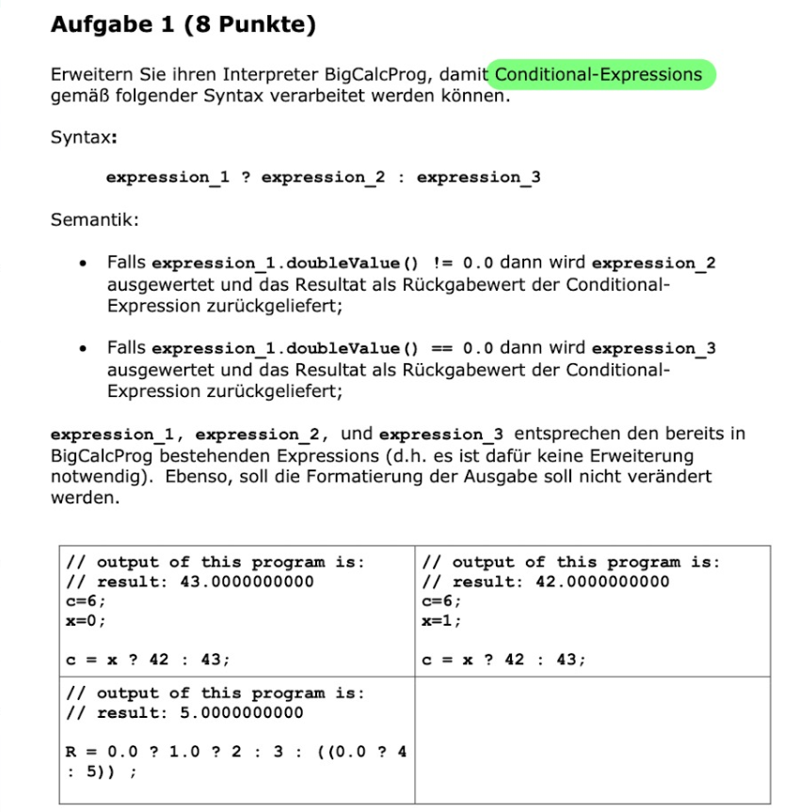
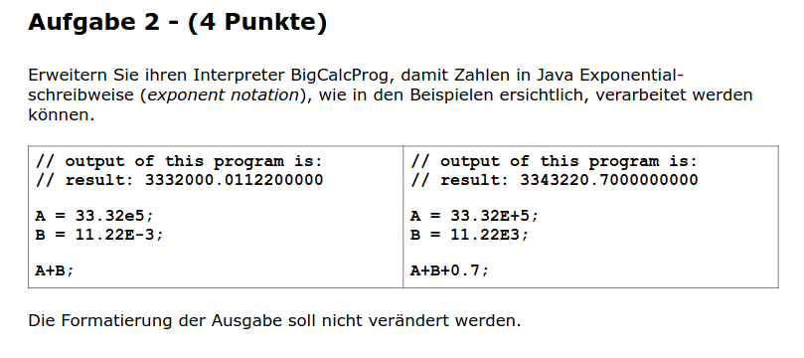

1. What are the key phases of a compiler?
- Answer: The key phases include Lexical Analysis, Syntax Analysis, Semantic Analysis, Intermediate Code Generation, Optimization, and Code Generation.
- Explanation:
  - Lexical Analysis: Converts the source code into tokens.
  - Syntax Analysis: Validates the structure of code against grammar rules.
  - Semantic Analysis: Ensures that the syntax follows language semantics, such as type checks.
  - Intermediate Code Generation: Produces an intermediate representation of code.
  - Optimization: Refines the code for better performance.
  - Code Generation: Translates intermediate code into machine or assembly code.

2. How does Prolog approach problem-solving differently from imperative languages?
- Answer: Prolog uses declarative programming, focusing on the logic of the problem rather than the control flow.
- Explanation: Prolog defines problems using facts and rules. Its execution engine searches for solutions by applying logical inference and backtracking, making it ideal for AI, pattern matching, and symbolic reasoning tasks.

3. What is Aspect-Oriented Programming (AOP) and its primary benefit?
- Answer: AOP is a programming paradigm that increases modularity by allowing the separation of cross-cutting concerns.
- Explanation: Cross-cutting concerns (e.g., logging, security) are modularized using "aspects," improving code maintainability and reducing repetition.

4. How do parsers work in compilers?
- Answer: Parsers analyze the source code's syntax against the grammar of the language to build a parse tree.
- Explanation: Parsers ensure the code adheres to the grammar rules and construct a hierarchical representation (parse tree) of the program for further processing.

5. What role does a lexer play in a compiler?
- Answer: The lexer, or lexical analyzer, processes the source code into tokens, the basic syntax units.
- Explanation: It simplifies parsing by breaking the code into meaningful elements like identifiers, keywords, and operators, ignoring whitespace and comments.

6. What is an Abstract Syntax Tree (AST) in compilers?
- Answer: An AST is a tree representation of the abstract syntactic structure of the source code.
- Explanation: It captures the hierarchical relationships between program constructs, omitting irrelevant details like punctuation and formatting.

7. How does Prolog's backtracking mechanism work?
- Answer: Prolog automatically backtracks to find alternative solutions when the current path of execution fails.
- Explanation: Backtracking explores all possible solutions by returning to previous decision points and trying alternative paths, essential for solving logical queries.

8. What is the significance of context-free grammars in compiler design?
- Answer: Context-free grammars define the syntax rules of programming languages, guiding the parsing process.
- Explanation: They provide a structured way to describe the hierarchical and recursive constructs of programming languages, enabling efficient parser construction.

9. How does just-in-time (JIT) compilation enhance performance?
- Answer: JIT compilation translates bytecode into native machine code at runtime, optimizing execution speed.
- Explanation: By compiling at runtime, JIT can apply optimizations based on the actual data and runtime environment, outperforming interpreted execution.

10. In what way do Prolog's predicates define logic?
- Answer: Predicates in Prolog encapsulate logic by defining relationships between terms and rules for deriving facts.
- Explanation: Predicates serve as the foundation for logical statements in Prolog, enabling complex reasoning and inference.

11. What is the difference between static and dynamic AOP?
- Answer: Static AOP weaves aspects at compile time, while dynamic AOP weaves them at runtime.
- Explanation:
  - Static AOP: Faster and more predictable but lacks runtime flexibility.
  - Dynamic AOP: Offers runtime adaptability but can incur performance overhead.

12. How do semantic analyzers in compilers work?
- Answer: They check the source code for semantic consistency, ensuring that the syntax structures are meaningful.
- Explanation: Semantic analysis verifies type correctness, scope resolution, and logical consistency, ensuring that the code adheres to the language's rules.

13. What are the benefits of using ANTLR in compiler design?
- Answer: ANTLR simplifies the process of generating parsers, lexers, and tree walkers for various languages.
- Explanation: ANTLR provides tools for building robust compilers, interpreters, and translators by abstracting away much of the complexity of syntax analysis.

14. How does Prolog's unification algorithm work?
- Answer: It tries to make terms equal by finding a set of variable bindings that make the terms identical.
- Explanation: Unification underpins Prolog's logical inference, enabling pattern matching by recursively comparing structures and values.

15. What is the role of optimization in compilers?
- Answer: Optimization improves the efficiency of the generated machine code, enhancing performance and reducing resource usage.
- Explanation: Techniques include eliminating redundant computations, improving data locality, and minimizing memory and CPU cycles, all while preserving program semantics.

16. In AOP, what are pointcuts and advice?
- Answer:
  - Pointcuts: Define join points where advice is applied.
  - Advice: Contains the additional behavior to be executed.
- Explanation: Together, they enable modular implementation of cross-cutting concerns like logging or transaction management.

17. What is the significance of leftmost derivation in context-free grammars?
- Answer: Leftmost derivation ensures that the leftmost non-terminal is always expanded first in the parse tree.
- Explanation: This strategy is essential in parsers like LL parsers, maintaining consistency in syntax tree construction.

18. How does Prolog's logic programming differ from other paradigms?
- Answer: Logic programming in Prolog focuses on declaring facts and rules, and computation proceeds by querying and logical inference.
- Explanation: Unlike imperative paradigms that specify step-by-step instructions, Prolog focuses on describing the relationships and constraints of the problem.

19. What challenges are associated with code generation in compilers?
- Answer: Code generation must translate high-level code into efficient machine code, considering the target architecture's constraints.
- Explanation: Challenges include selecting optimal instructions, register allocation, and adhering to calling conventions while maintaining correctness.

20. How does dynamic AOP handle cross-cutting concerns?
- Answer: Dynamic AOP weaves aspects into the codebase at runtime, allowing for on-the-fly modifications.
- Explanation: It provides flexibility to adapt behavior based on runtime conditions, enabling features like dynamic logging or on-demand security checks.

Aspect oriented Programming
-finde out what will be the output of an aspect

Prolog
- Simple Programm finde output

