青 岛 理 工 大 学
课程实验报告
课程名称 | Android开发技术 | 班级 | 软件201 | 实验日期 | 2021.11.04
姓名 | 刘如意 | 学号 | 201911010119 | 实验成绩
实验名称 | ListView实现音乐列表
实验目的  及要求 | 熟悉ListView的使用方法;  掌握自定义列表项布局的方法；  掌握自定义Adapter的实现方法。
实验环境 | Win10, Android Studio
实验内容 | 能够列出手机上的歌曲列表（模拟即可，不必读取/播放实际歌曲文件）；  列表内容包括：歌手图片，歌曲名称，歌曲简介，选中（CheckBox）等；  点击任何一行，显示AlertDialog提示，提示正在播放该歌曲；  可以“选中”若干行，删除之。
算法描述及实验步骤 | //创建适配器--自定义适配器  MusicAdapt adapter = new MusicAdapt(this,R.layout.music_option,musics);  listView.setAdapter(adapter);  String inflater = Context.LAYOUT_INFLATER_SERVICE;  LayoutInflater vi = (LayoutInflater)getContext().getSystemService(inflater);  convertView = vi.inflate(resourceId, music_list_item, true);  //创建dialog构造器  AlertDialog.Builder normalDialog = new AlertDialog.Builder(this);  //设置title  normalDialog.setTitle(musics.get(i).getName());  //设置icon  normalDialog.setIcon();  //设置内容  normalDialog.setMessage("正在播放该歌曲");  //设置按钮  normalDialog.setPositiveButton("确定"  , new DialogInterface.OnClickListener() {  @Override  public void onClick(DialogInterface dialog, int which) {  dialog.dismiss();  }  });  //创建并显示  normalDialog.create().show();
调试过程及实验结果 | - 歌曲列表  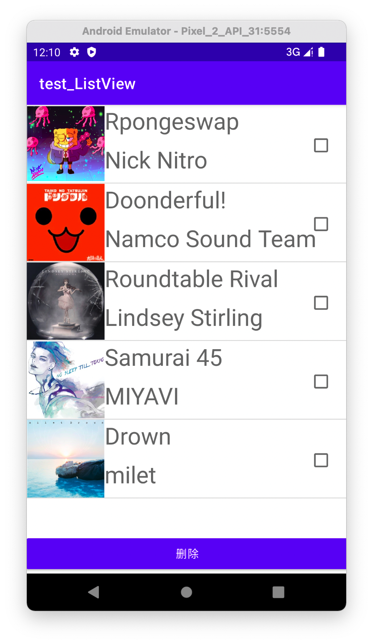  - AlertDialog  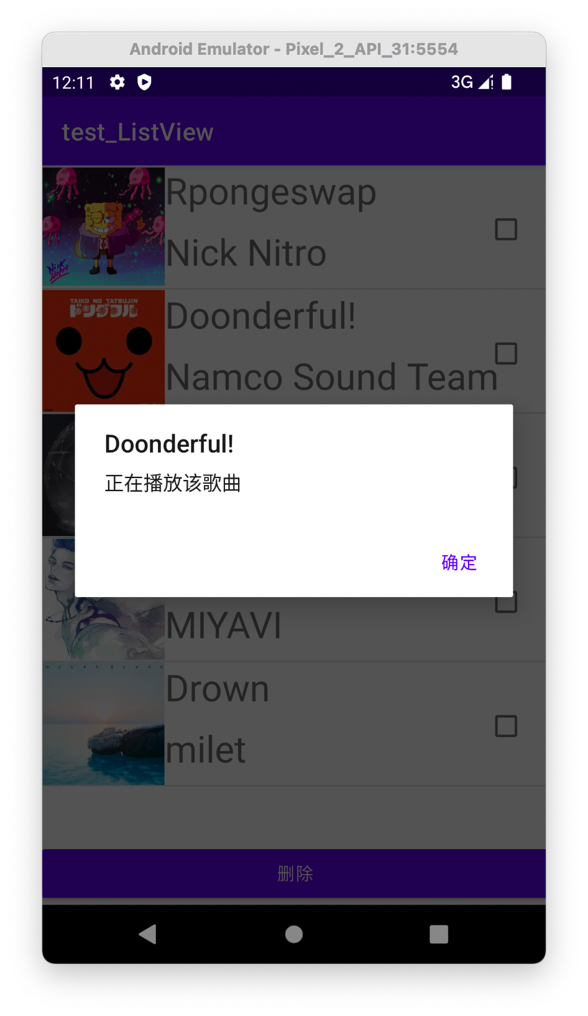  - “选中”若干行，删除之  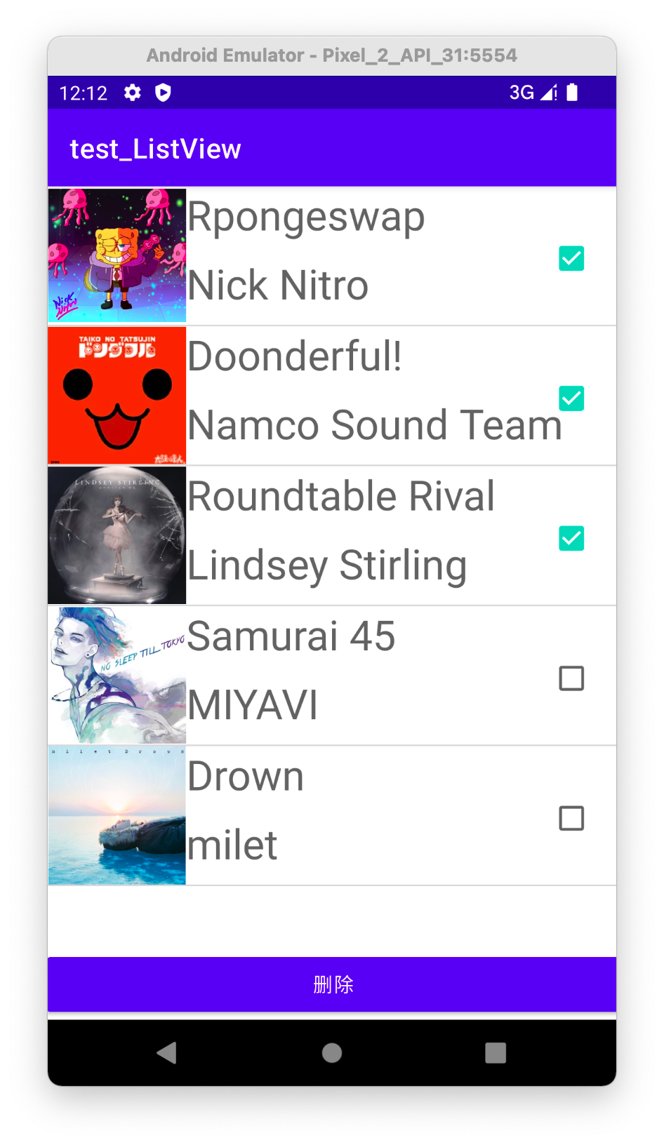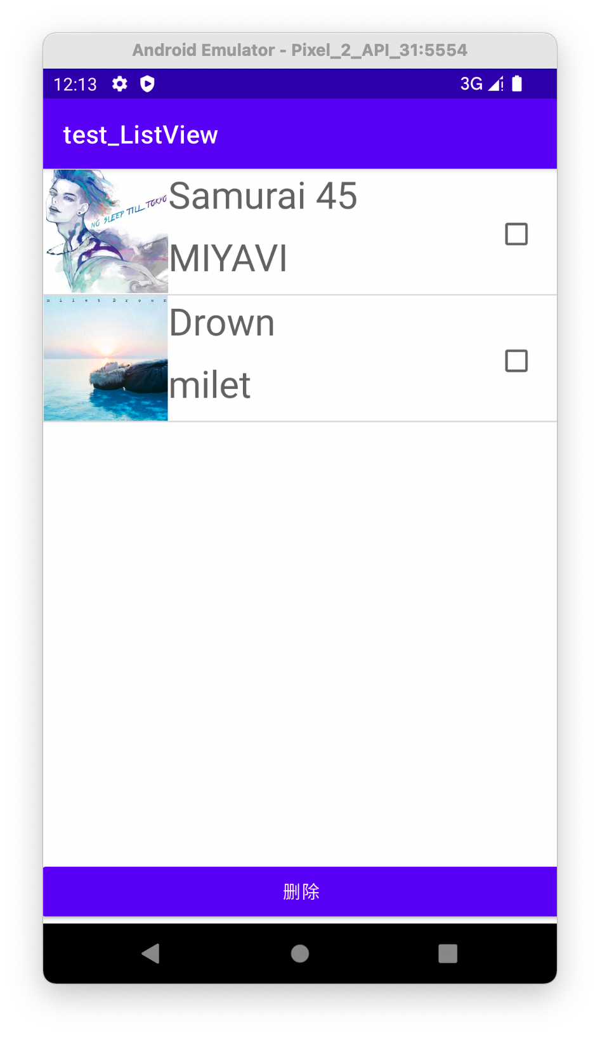
总结 | 通过这次的实验，我已经会使用自定义布局，自定义adapt，重写其中的方法，并且结合ListView，对其选项的Item进行布局，再添加image、text和checkbox，进行Item内容的填充，并修改focus的范围，能在界面对所有的可选项进行点击，通过监听器做出相应的处理。
附  录 | - MainActivity.java  package com.example.test_listview;  import androidx.appcompat.app.AlertDialog;  import androidx.appcompat.app.AppCompatActivity;  import android.content.DialogInterface;  import android.os.Bundle;  import android.view.View;  import android.widget.Adapter;  import android.widget.AdapterView;  import android.widget.ArrayAdapter;  import android.widget.Button;  import android.widget.CheckBox;  import android.widget.ListView;  import android.widget.TextView;  import java.util.ArrayList;  import java.util.List;  import java.util.Vector;  public class MainActivity extends AppCompatActivity {  // TextView textView;  ListView listView;  Button btn_delete;  List<MusicListArray> musics = new ArrayList<>();  @Override  protected void onCreate(Bundle savedInstanceState) {  super.onCreate(savedInstanceState);  setContentView(R.layout.activity_main);  //初始化  init_ListView();  }  private void init_ListView(){  //获取  // textView = (TextView) findViewById(R.id.music);  listView = (ListView) findViewById(R.id.musicView);  //添加数据  add_data();  //创建适配器--自定义适配器  MusicAdapt adapter = new MusicAdapt(this,R.layout.music_option,musics);  listView.setAdapter(adapter);  //删除按钮  btn_delete = (Button) findViewById(R.id.btn_delete);  //删除按钮的监视器  btn_delete.setOnClickListener(new View.OnClickListener() {  @Override  public void onClick(View view) {  //删除被选中的项  for(int i=musics.size()-1;i>=0;i--){  if(adapter.getItem(i).isCheck()){  adapter.remove(adapter.getItem(i));  adapter.notifyDataSetChanged();  }  }  }  });  //创建监听器  AdapterView.OnItemClickListener listViewListener = new AdapterView.OnItemClickListener() {  @Override  public void onItemClick(AdapterView<?> adapterView, View view, int i, long l) {  //显示AlertDialog提示  showNormalDialog(i);  // String msg = "父 View:" + adapterView.toString() + "\n" +  // "子 View:" + view.toString() + "\n" +  // "位置:" + String.valueOf(i) +  // ",ID:" + String.valueOf(l);  // textView.setText(msg);  }  };  listView.setOnItemClickListener(listViewListener);  // listView.setOnItemClickListener(new AdapterView.OnItemClickListener() {  // @Override  // public void onItemClick(AdapterView<?> adapterView, View view, int i, long l) {  ////  //// MusicListArray temp = adapter.getItem(i);  //// //选中  //// CheckBox checkBox = (CheckBox)view.getTag();  //// if(checkBox.isChecked()){  //// temp.setCheck(true);  //// }else {  //// temp.setCheck(false);  //// }  //  // //显示AlertDialog提示  // showNormalDialog(i);  // }  // });  }  public void add_data(){  MusicListArray one = new MusicListArray(R.drawable.spongeswap, "Rpongeswap","Nick Nitro");  musics.add(one);  MusicListArray two = new MusicListArray(R.drawable.doonderful, "Doonderful!","Namco Sound Team");  musics.add(two);  MusicListArray three = new MusicListArray(R.drawable.roundtable_rival, "Roundtable Rival","Lindsey Stirling");  musics.add(three);  MusicListArray four = new MusicListArray(R.drawable.samurai_45, "Samurai 45","MIYAVI");  musics.add(four);  MusicListArray five = new MusicListArray(R.drawable.drown, "Drown","milet");  musics.add(five);  }  private void showNormalDialog(int i){  //创建dialog构造器  AlertDialog.Builder normalDialog = new AlertDialog.Builder(this);  //设置title  normalDialog.setTitle(musics.get(i).getName());  // //设置icon  // normalDialog.setIcon();  //设置内容  normalDialog.setMessage("正在播放该歌曲");  //设置按钮  normalDialog.setPositiveButton("确定"  , new DialogInterface.OnClickListener() {  @Override  public void onClick(DialogInterface dialog, int which) {  dialog.dismiss();  }  });  //创建并显示  normalDialog.create().show();  }  }  - MusicAdapt.java  package com.example.test_listview;  import android.annotation.SuppressLint;  import android.content.Context;  import android.view.LayoutInflater;  import android.view.View;  import android.view.ViewGroup;  import android.widget.ArrayAdapter;  import android.widget.CheckBox;  import android.widget.ImageView;  import android.widget.LinearLayout;  import android.widget.TextView;  import androidx.recyclerview.widget.RecyclerView;  import java.util.List;  public class MusicAdapt extends ArrayAdapter<MusicListArray> {  private int resourceId;  private CheckBox checkBox;  public MusicAdapt(Context context, int resourceId, List<MusicListArray> musicListArrays) {  super(context, resourceId, musicListArrays);  this.resourceId = resourceId;  }  @SuppressLint("ViewHolder")  @Override  public View getView(int position, View convertView, ViewGroup parent){  MusicListArray musicList = getItem(position);  LinearLayout music_list_item = new LinearLayout(getContext());  String inflater = Context.LAYOUT_INFLATER_SERVICE;  LayoutInflater vi = (LayoutInflater)getContext().getSystemService(inflater);  convertView = vi.inflate(resourceId, music_list_item, true);  // RecyclerView.ViewHolder viewHolder;  // viewHolder = (RecyclerView.ViewHolder)convertView.getTag();  //  // ViewHolder viewHolder = new ViewHolder();  checkBox = (CheckBox) convertView.findViewById(R.id.checkbox);  // viewHolder.checkBox = (CheckBox) ;  checkBox.setOnClickListener(new View.OnClickListener() {  @Override  public void onClick(View view) {  if(musicList.isCheck()){  musicList.setCheck(false);  }else {  musicList.setCheck(true);  }  }  });  // this.checkBox = (CheckBox)convertView.findViewById(R.id.checkbox);  //填充数据  ImageView image = (ImageView) music_list_item.findViewById(R.id.music_image);  TextView name = (TextView) music_list_item.findViewById(R.id.music_name);  TextView info = (TextView) music_list_item.findViewById(R.id.music_info);  CheckBox check = (CheckBox) music_list_item.findViewById(R.id.checkbox);  image.setImageResource(musicList.getImageId());  name.setText(musicList.getName());  info.setText(musicList.getIfo());  check.setChecked(musicList.isCheck());  return music_list_item;  }  // private class ViewHolder{  // CheckBox checkBox;  // }  }  - MusicListArray.java  package com.example.test_listview;  public class MusicListArray {  private int imageId;  private String name;  private String info;  private boolean check = false;  public MusicListArray(int imageId, String name, String info) {  this.imageId = imageId;  this.name = name;  this.info = info;  }  public int getImageId() {  return imageId;  }  public void setImageId(int imageId) {  this.imageId = imageId;  }  public String getName() {  return name;  }  public void setName(String name) {  this.name = name;  }  public String getIfo() {  return info;  }  public void setIfo(String info) {  this.info = info;  }  public boolean isCheck() { return check; }  public void setCheck(boolean check) { this.check = check; }  }  - Activity_main.xml  <?xml version="1.0" encoding="utf-8"?>  <androidx.constraintlayout.widget.ConstraintLayout xmlns:android="http://schemas.android.com/apk/res/android"  xmlns:app="http://schemas.android.com/apk/res-auto"  xmlns:tools="http://schemas.android.com/tools"  android:layout_width="match_parent"  android:layout_height="match_parent"  tools:context=".MainActivity">  <ListView  android:id="@+id/musicView"  android:layout_width="wrap_content"  android:layout_height="0dp"  app:layout_constraintBottom_toBottomOf="parent"  app:layout_constraintEnd_toEndOf="parent"  app:layout_constraintHorizontal_bias="1.0"  app:layout_constraintStart_toStartOf="parent"  app:layout_constraintTop_toTopOf="parent"  app:layout_constraintVertical_bias="0.005">  </ListView>  <Button  android:id="@+id/btn_delete"  android:layout_width="417dp"  android:layout_height="51dp"  android:text="@string/delete"  app:layout_constraintBottom_toBottomOf="parent"  app:layout_constraintEnd_toEndOf="parent"  app:layout_constraintHorizontal_bias="0.498"  app:layout_constraintStart_toStartOf="parent"  app:layout_constraintTop_toTopOf="parent"  app:layout_constraintVertical_bias="1.0" />  <!-- <TextView-->  <!-- android:id="@+id/music"-->  <!-- android:layout_width="fill_parent"-->  <!-- android:layout_height="wrap_content"-->  <!-- android:text="@string/music"-->  <!-- android:textSize="24sp"-->  <!-- app:layout_constraintBottom_toBottomOf="parent"-->  <!-- app:layout_constraintEnd_toEndOf="parent"-->  <!-- app:layout_constraintHorizontal_bias="1.0"-->  <!-- app:layout_constraintStart_toStartOf="parent"-->  <!-- app:layout_constraintTop_toTopOf="parent"-->  <!-- app:layout_constraintVertical_bias="0.932" />-->  </androidx.constraintlayout.widget.ConstraintLayout>  - Music_option.xml  <?xml version="1.0" encoding="utf-8"?>  <RelativeLayout xmlns:android="http://schemas.android.com/apk/res/android"  android:orientation="horizontal"  android:descendantFocusability="beforeDescendants"  android:layout_width="match_parent"  android:layout_height="match_parent">  <ImageView  android:id="@+id/music_image"  android:layout_width="100dp"  android:layout_height="100dp" />  <TextView  android:id="@+id/music_name"  android:layout_width="wrap_content"  android:layout_height="50dp"  android:layout_alignParentTop="true"  android:layout_marginStart="0dp"  android:layout_marginTop="0dp"  android:layout_toEndOf="@+id/music_image"  android:textSize="30sp" />  <TextView  android:id="@+id/music_info"  android:layout_width="wrap_content"  android:layout_height="50dp"  android:layout_alignParentTop="true"  android:layout_marginStart="0dp"  android:layout_marginTop="50dp"  android:layout_toEndOf="@+id/music_image"  android:textSize="30sp" />  <CheckBox  android:id="@+id/checkbox"  android:layout_width="wrap_content"  android:layout_height="wrap_content"  android:focusable="false"  android:layout_alignBottom="@+id/music_image"  android:layout_alignParentTop="true"  android:layout_marginStart="263dp"  android:layout_marginTop="28dp"  android:layout_marginBottom="24dp"  android:layout_toEndOf="@+id/music_image" />  </RelativeLayout>

