青 岛 理 工 大 学
课程实验报告
课程名称 | Android开发技术 | 班级 | 软件201 | 实验日期 | 2021.10.21
姓名 | 刘如意 | 学号 | 201911010119 | 实验成绩
实验名称 | Android程序的生命周期实验
实验目的  及要求 | - 熟悉Android应用程序构建过程。  - 掌握Activity的生命周期规律。
实验环境 | Win10, Android Studio
实验内容 | - 建立一个Android Project, Activity名称为MainActivity, 设法观察全生命周期、可视生命周期和活动生命周的各个回调函数的回调时机和顺序；  - 添加SecondActivity，并在MainActivity中添加按钮，点击后打开SecondActivity，观察2个Activity切换时各回调函数的回调情况；  - 添加ThirdActivity，并在SecondActivity中添加按钮，点击后打开ThirdActivity，观察3个Activity切换时各回调函数的回调情况；  - 先后修改SecondActivity和ThirdActivity的风格为对话框模式，观察3个Activity切换时各回调函数的回调情况。
算法描述及实验步骤 | 使用安卓自身的Logcat日志输出TAG，以观察生命周期的调用过程  private static String TAG = "LIFECYCLE";  Log.i(TAG,"(1)onCreate(1)");  Intent intent = new Intent();  intent.setClass(MainActivity.this,SecondActivity.class);  startActivity(intent);  android:theme="@android:style/Theme.Dialog"
调试过程及实验结果 | 1.  全生命周期  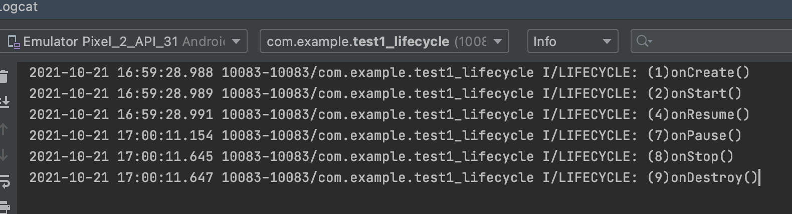  可视生命周期  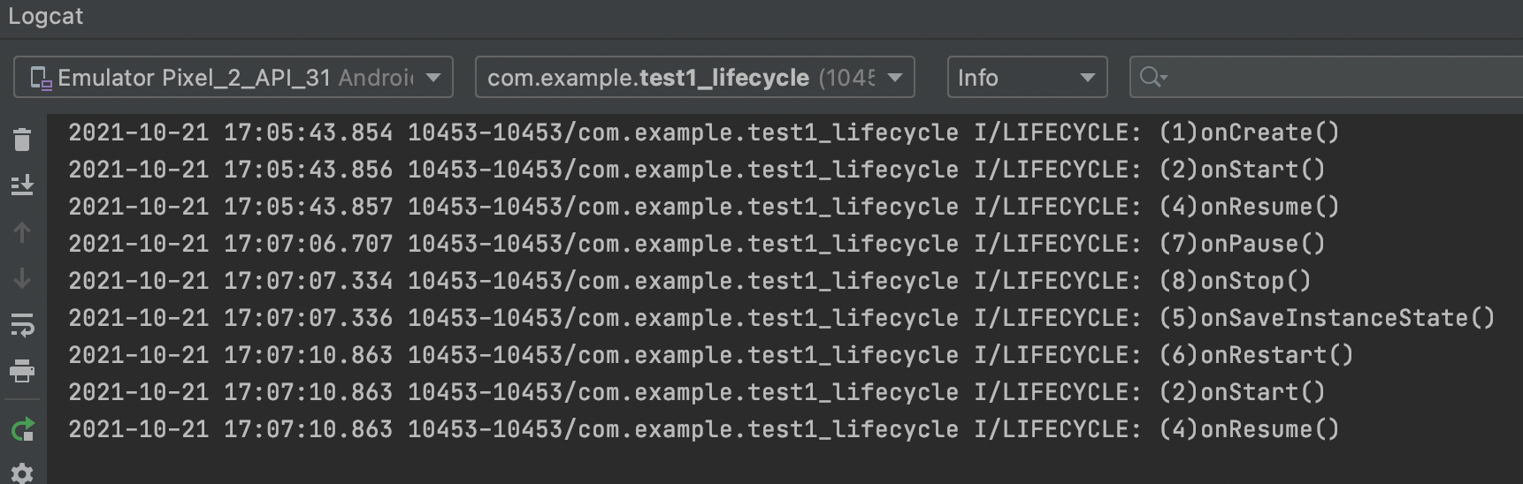  2.在两个Activity中切换  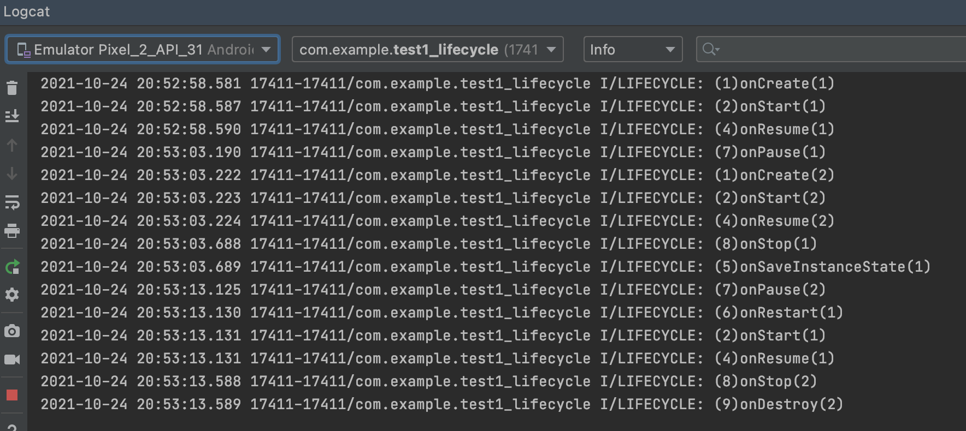  3.在三个Activity中切换  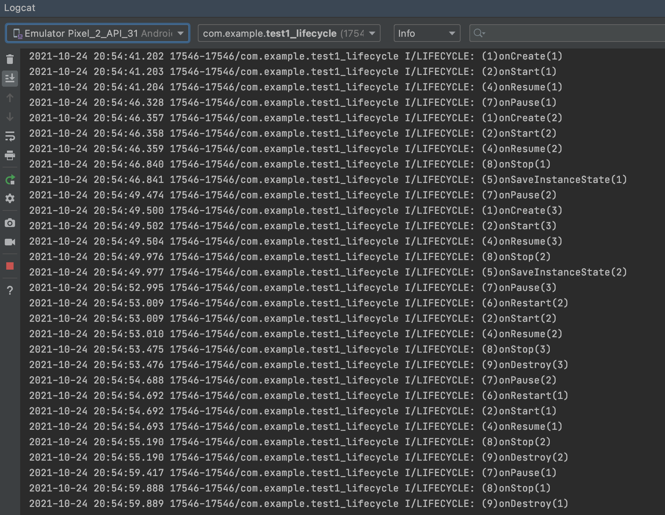  - 修改SecondActivity为对话框  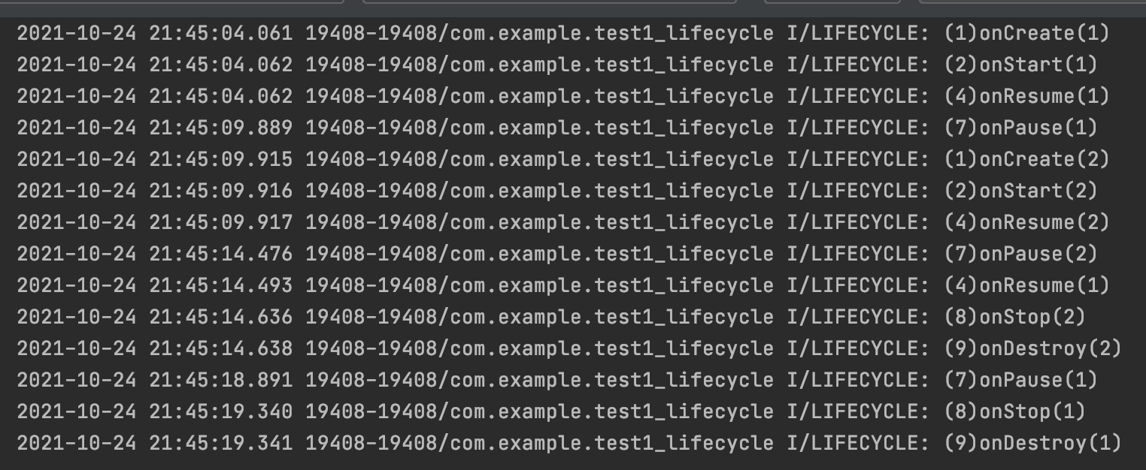  - 修改ThirdActivity为对话框  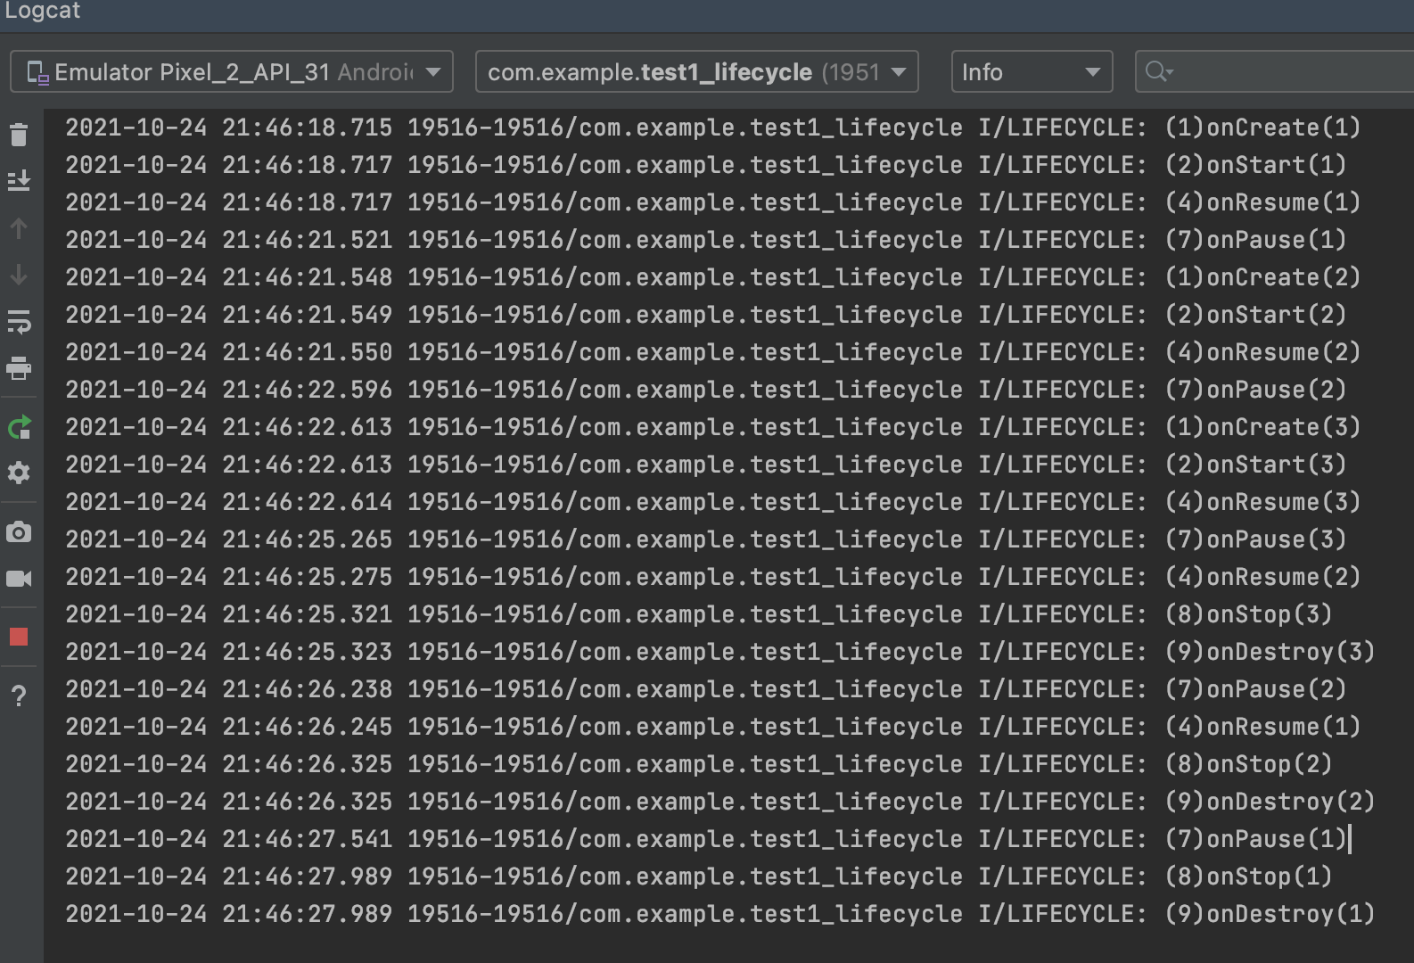  App截图  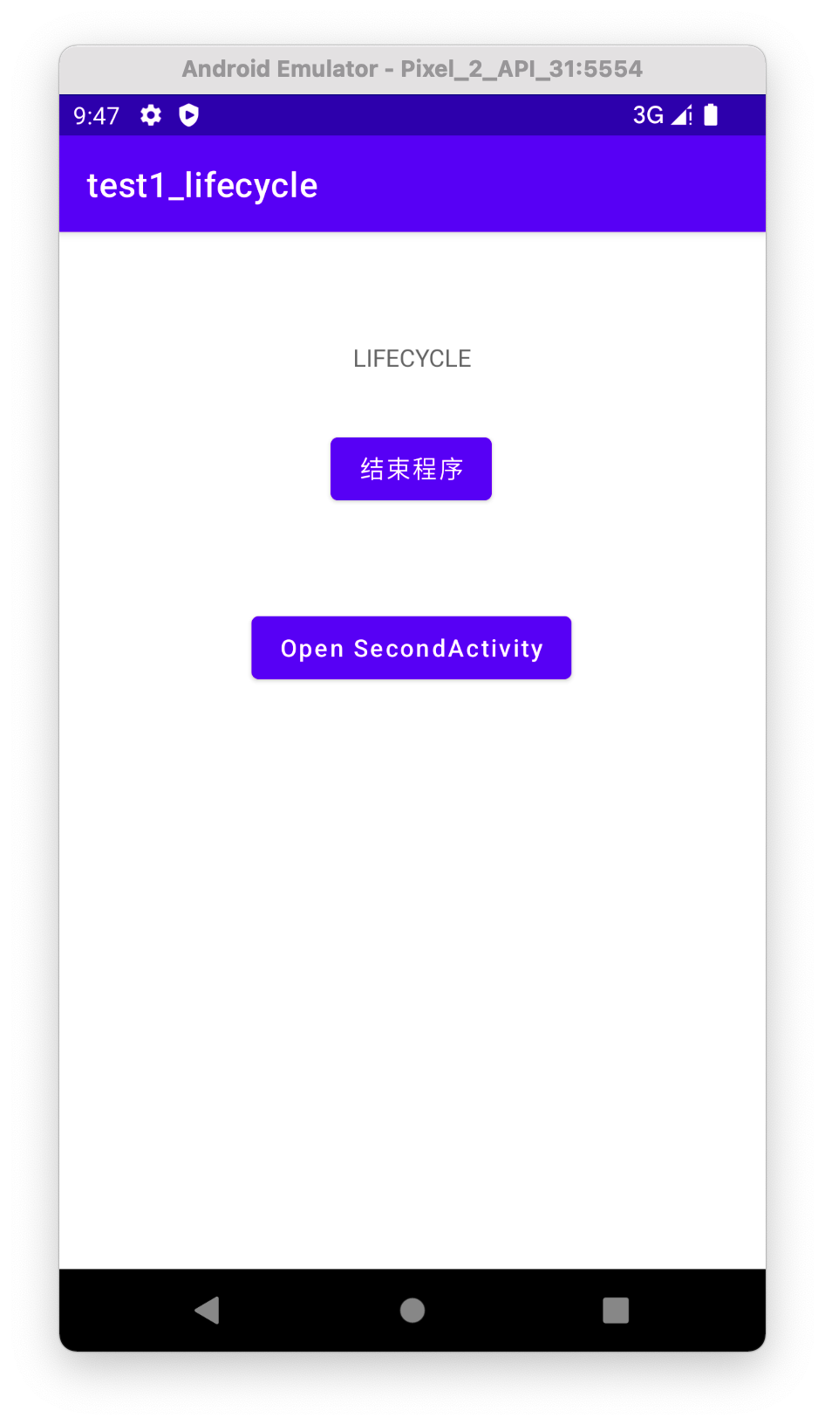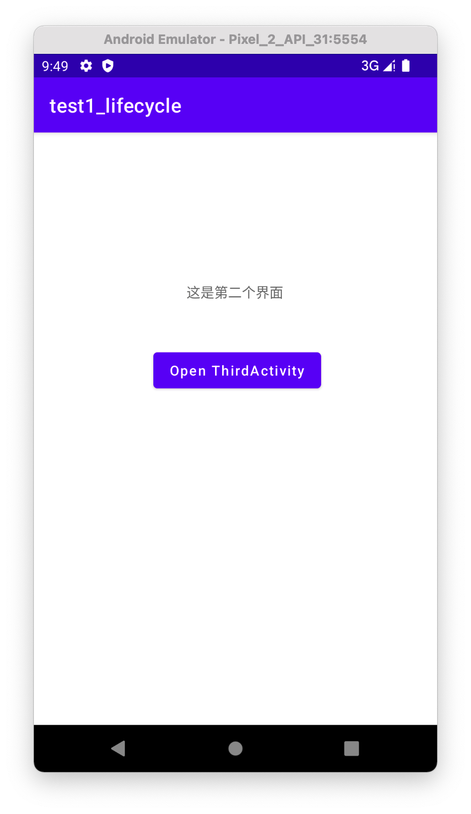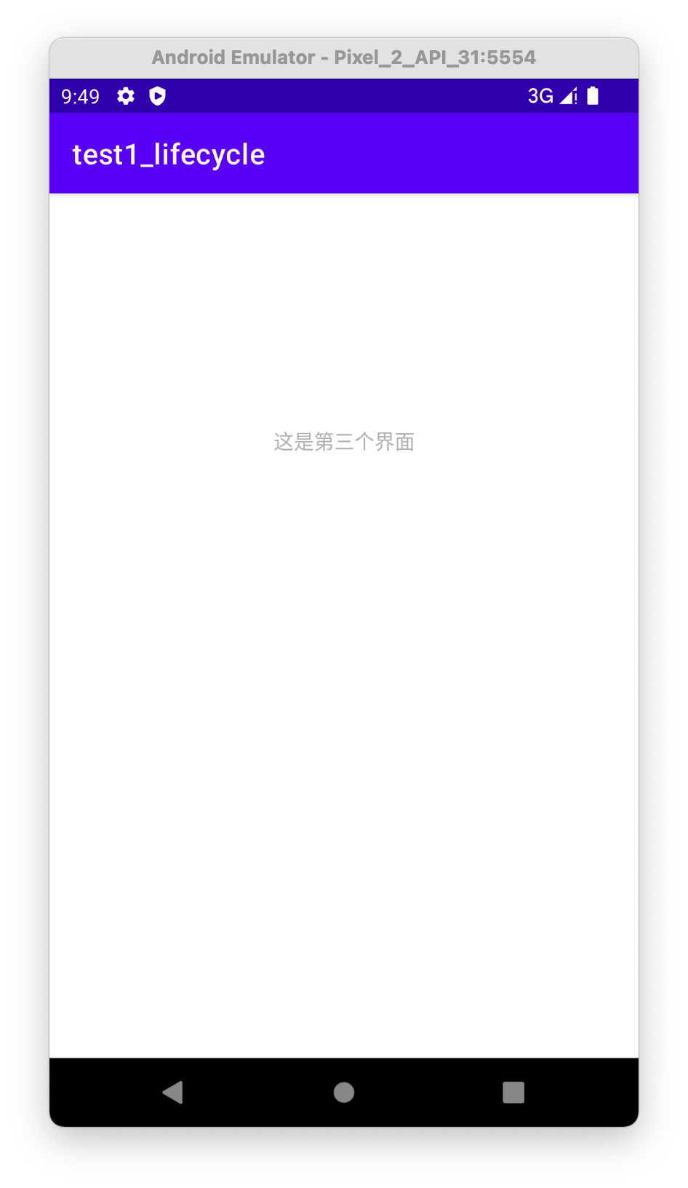  对话框模式  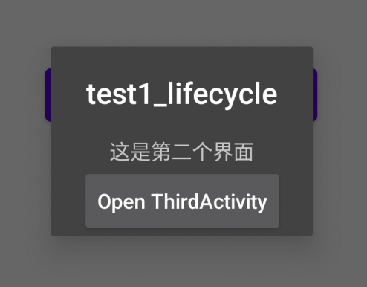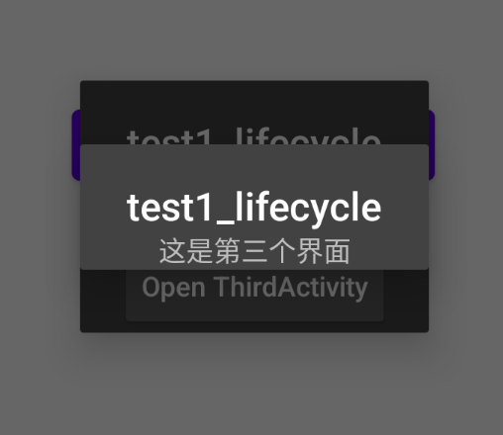
总结 | 通过这次的实验，我了解了应用程序的构建过程，也让我掌握了安卓的生命周期的基本规律。在此实验之前已经对安卓的构建和生命周期有了一定的理解，但并没有很透彻，经过这点的实验过程，更加进一步的学习了这方面的知识，会对以后的学习提供很大的帮助。
附  录 | - MainActivity.java  package com.example.test1_lifecycle;  import androidx.appcompat.app.AppCompatActivity;  import android.content.Intent;  import android.os.Bundle;  import android.util.Log;  import android.view.View;  import android.widget.Button;  public class MainActivity extends AppCompatActivity {  private static String TAG = "LIFECYCLE";  @Override  protected void onCreate(Bundle savedInstanceState) {  super.onCreate(savedInstanceState);  setContentView(R.layout.activity_main);  Log.i(TAG,"(1)onCreate(1)");  // 结束程序  Button button = (Button) findViewById(R.id.btn_finish);  button.setOnClickListener(new View.OnClickListener() {  @Override  public void onClick(View view) {  finish();  }  });  // 打开第二个界面  Button btn_second_activity = (Button) findViewById(R.id.btn_second_activity);  btn_second_activity.setOnClickListener(new View.OnClickListener() {  @Override  public void onClick(View view) {  Intent intent = new Intent();  intent.setClass(MainActivity.this,SecondActivity.class);  // Intent intent = new Intent(MainActivity.class, SecondActivity.class);  startActivity(intent);  }  });  }  @Override  public void onStart(){  super.onStart();  Log.i(TAG,"(2)onStart(1)");  }  @Override  public void onRestoreInstanceState(Bundle savedInstanceState){  super.onRestoreInstanceState(savedInstanceState);  Log.i(TAG,"(3)onRestoreInstanceState(1)");  }  @Override  public void onResume(){  super.onResume();  Log.i(TAG,"(4)onResume(1)");  }  @Override  public void onSaveInstanceState(Bundle savedInstanceState){  super.onSaveInstanceState(savedInstanceState);  Log.i(TAG,"(5)onSaveInstanceState(1)");  }  @Override  public void onRestart(){  super.onRestart();  Log.i(TAG,"(6)onRestart(1)");  }  @Override  public void onPause(){  super.onPause();  Log.i(TAG,"(7)onPause(1)");  }  @Override  public void onStop(){  super.onStop();  Log.i(TAG,"(8)onStop(1)");  }  @Override  public void onDestroy(){  super.onDestroy();  Log.i(TAG,"(9)onDestroy(1)");  }  }  - SecondActiity.java  package com.example.test1_lifecycle;  import androidx.appcompat.app.AppCompatActivity;  import android.content.Intent;  import android.os.Bundle;  import android.util.Log;  import android.view.View;  import android.widget.Button;  public class SecondActivity extends AppCompatActivity {  private static String TAG = "LIFECYCLE";  @Override  protected void onCreate(Bundle savedInstanceState) {  super.onCreate(savedInstanceState);  setContentView(R.layout.activity_second);  Log.i(TAG,"(1)onCreate(2)");  // 打开第三个界面  Button btn_third_activity = (Button) findViewById(R.id.open_third_activity);  btn_third_activity.setOnClickListener(new View.OnClickListener() {  @Override  public void onClick(View view) {  Intent intent = new Intent();  intent.setClass(SecondActivity.this,ThirdActivity.class);  startActivity(intent);  }  });  }  @Override  public void onStart(){  super.onStart();  Log.i(TAG,"(2)onStart(2)");  }  @Override  public void onRestoreInstanceState(Bundle savedInstanceState){  super.onRestoreInstanceState(savedInstanceState);  Log.i(TAG,"(3)onRestoreInstanceState(2)");  }  @Override  public void onResume(){  super.onResume();  Log.i(TAG,"(4)onResume(2)");  }  @Override  public void onSaveInstanceState(Bundle savedInstanceState){  super.onSaveInstanceState(savedInstanceState);  Log.i(TAG,"(5)onSaveInstanceState(2)");  }  @Override  public void onRestart(){  super.onRestart();  Log.i(TAG,"(6)onRestart(2)");  }  @Override  public void onPause(){  super.onPause();  Log.i(TAG,"(7)onPause(2)");  }  @Override  public void onStop(){  super.onStop();  Log.i(TAG,"(8)onStop(2)");  }  @Override  public void onDestroy(){  super.onDestroy();  Log.i(TAG,"(9)onDestroy(2)");  }  }  - ThirdActivity.java  package com.example.test1_lifecycle;  import androidx.appcompat.app.AppCompatActivity;  import android.os.Bundle;  import android.util.Log;  public class ThirdActivity extends AppCompatActivity {  private static String TAG = "LIFECYCLE";  @Override  protected void onCreate(Bundle savedInstanceState) {  super.onCreate(savedInstanceState);  setContentView(R.layout.activity_third);  Log.i(TAG,"(1)onCreate(3)");  }  @Override  public void onStart(){  super.onStart();  Log.i(TAG,"(2)onStart(3)");  }  @Override  public void onRestoreInstanceState(Bundle savedInstanceState){  super.onRestoreInstanceState(savedInstanceState);  Log.i(TAG,"(3)onRestoreInstanceState(3)");  }  @Override  public void onResume(){  super.onResume();  Log.i(TAG,"(4)onResume(3)");  }  @Override  public void onSaveInstanceState(Bundle savedInstanceState){  super.onSaveInstanceState(savedInstanceState);  Log.i(TAG,"(5)onSaveInstanceState(3)");  }  @Override  public void onRestart(){  super.onRestart();  Log.i(TAG,"(6)onRestart(3)");  }  @Override  public void onPause(){  super.onPause();  Log.i(TAG,"(7)onPause(3)");  }  @Override  public void onStop(){  super.onStop();  Log.i(TAG,"(8)onStop(3)");  }  @Override  public void onDestroy(){  super.onDestroy();  Log.i(TAG,"(9)onDestroy(3)");  }  }  - activity_main.xml  <?xml version="1.0" encoding="utf-8"?>  <androidx.constraintlayout.widget.ConstraintLayout xmlns:android="http://schemas.android.com/apk/res/android"  xmlns:app="http://schemas.android.com/apk/res-auto"  xmlns:tools="http://schemas.android.com/tools"  android:layout_width="match_parent"  android:layout_height="match_parent"  tools:context=".MainActivity">  <TextView  android:id="@+id/textView"  android:layout_width="wrap_content"  android:layout_height="wrap_content"  android:text="@string/lifecycle"  app:layout_constraintBottom_toBottomOf="parent"  app:layout_constraintLeft_toLeftOf="parent"  app:layout_constraintRight_toRightOf="parent"  app:layout_constraintTop_toTopOf="parent"  app:layout_constraintVertical_bias="0.108" />  <Button  android:id="@+id/btn_finish"  android:layout_width="wrap_content"  android:layout_height="wrap_content"  android:text="@string/btn_finish"  app:layout_constraintBottom_toBottomOf="parent"  app:layout_constraintEnd_toEndOf="parent"  app:layout_constraintHorizontal_bias="0.498"  app:layout_constraintStart_toStartOf="parent"  app:layout_constraintTop_toBottomOf="@+id/textView"  app:layout_constraintVertical_bias="0.066" />  <Button  android:id="@+id/btn_second_activity"  android:layout_width="wrap_content"  android:layout_height="wrap_content"  android:layout_marginTop="56dp"  android:text="@string/open_secondActivity"  android:textAllCaps="false"  app:layout_constraintBottom_toBottomOf="parent"  app:layout_constraintEnd_toEndOf="parent"  app:layout_constraintHorizontal_bias="0.498"  app:layout_constraintStart_toStartOf="parent"  app:layout_constraintTop_toBottomOf="@+id/btn_finish"  app:layout_constraintVertical_bias="0.0" />  </androidx.constraintlayout.widget.ConstraintLayout>  - activity_second.xml  <?xml version="1.0" encoding="utf-8"?>  <androidx.constraintlayout.widget.ConstraintLayout  xmlns:android="http://schemas.android.com/apk/res/android"  xmlns:app="http://schemas.android.com/apk/res-auto"  xmlns:tools="http://schemas.android.com/tools"  android:layout_width="match_parent"  android:layout_height="match_parent"  tools:context=".SecondActivity"  >  <TextView  android:id="@+id/textView2"  android:layout_width="wrap_content"  android:layout_height="wrap_content"  android:text="@string/second"  app:layout_constraintBottom_toBottomOf="parent"  app:layout_constraintEnd_toEndOf="parent"  app:layout_constraintHorizontal_bias="0.498"  app:layout_constraintStart_toStartOf="parent"  app:layout_constraintTop_toTopOf="parent"  app:layout_constraintVertical_bias="0.262" />  <Button  android:id="@+id/open_third_activity"  android:layout_width="wrap_content"  android:layout_height="wrap_content"  android:text="@string/open_thirdActivity"  android:textAllCaps="false"  app:layout_constraintBottom_toBottomOf="parent"  app:layout_constraintEnd_toEndOf="parent"  app:layout_constraintHorizontal_bias="0.507"  app:layout_constraintStart_toStartOf="parent"  app:layout_constraintTop_toBottomOf="@+id/textView2"  app:layout_constraintVertical_bias="0.119" />  </androidx.constraintlayout.widget.ConstraintLayout>  - activity_third.xml  <?xml version="1.0" encoding="utf-8"?>  <androidx.constraintlayout.widget.ConstraintLayout xmlns:android="http://schemas.android.com/apk/res/android"  xmlns:app="http://schemas.android.com/apk/res-auto"  xmlns:tools="http://schemas.android.com/tools"  android:layout_width="match_parent"  android:layout_height="match_parent"  tools:context=".ThirdActivity"  android:theme="@android:style/Theme.Dialog"  >  <TextView  android:id="@+id/textView3"  android:layout_width="wrap_content"  android:layout_height="wrap_content"  android:text="@string/third"  app:layout_constraintBottom_toBottomOf="parent"  app:layout_constraintEnd_toEndOf="parent"  app:layout_constraintStart_toStartOf="parent"  app:layout_constraintTop_toTopOf="parent"  app:layout_constraintVertical_bias="0.28" />  </androidx.constraintlayout.widget.ConstraintLayout>  - AndroidManifest.xml  <?xml version="1.0" encoding="utf-8"?>  <manifest xmlns:android="http://schemas.android.com/apk/res/android"  package="com.example.test1_lifecycle">  <application  android:allowBackup="true"  android:icon="@mipmap/ic_launcher"  android:label="@string/app_name"  android:roundIcon="@mipmap/ic_launcher_round"  android:supportsRtl="true"  android:theme="@style/Theme.Test1_lifecycle">  <activity  android:name=".ThirdActivity"  android:theme="@style/Theme.AppCompat.Dialog"  android:exported="true" />  <activity  android:name=".SecondActivity"  android:theme="@style/Theme.AppCompat.Dialog"  android:exported="true" />  <activity  android:name=".MainActivity"  android:exported="true">  <intent-filter>  <action android:name="android.intent.action.MAIN" />  <category android:name="android.intent.category.LAUNCHER" />  </intent-filter>  </activity>  </application>  </manifest>

