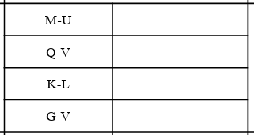

157.079889  
51.364517

69.675702

567.800319

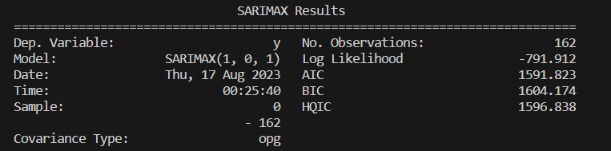

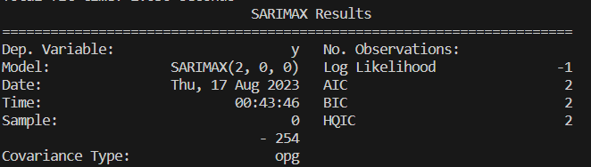

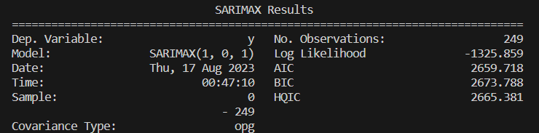

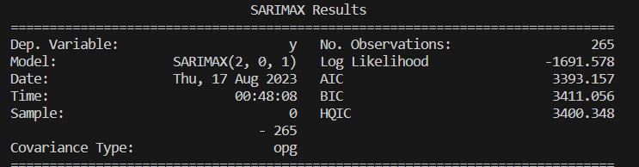

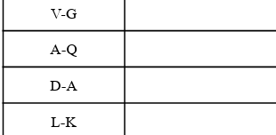

507.110854

128.326678

46.601084

251.410252

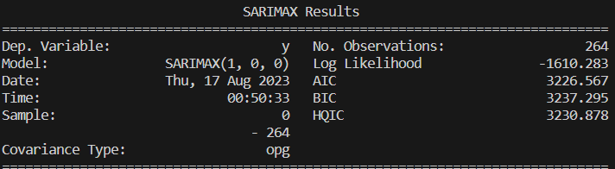

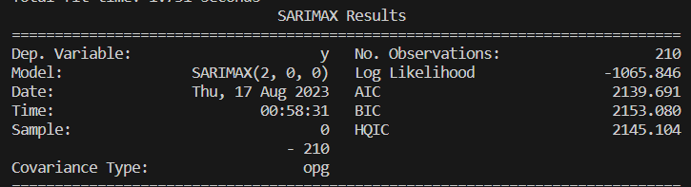

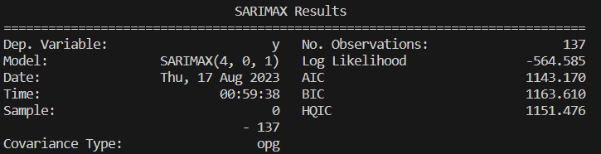

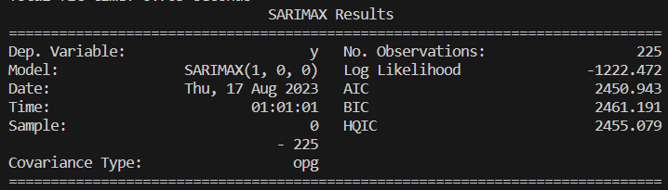

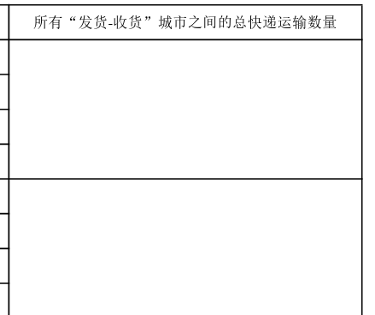

10353.591542

9829.155892