CMC Lab 01 — Cloud Virtualization
Lab Report | April 24, 2026

Part A: VM vs Container Resource Comparison

Virtual Machine (Ubuntu 22.04 — Hyper-V)
Memory & process usage inside the VM:

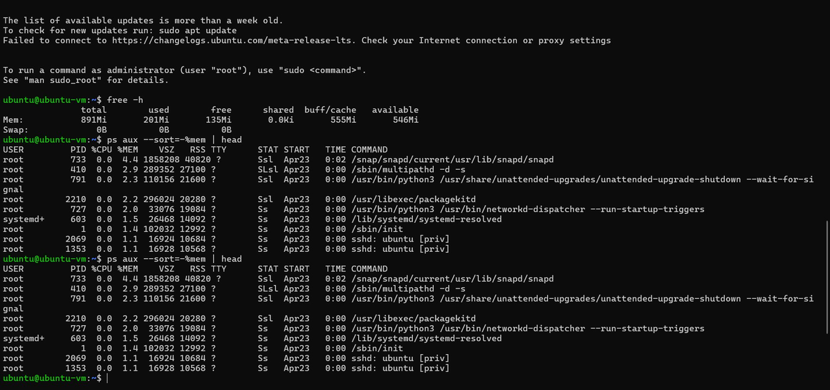

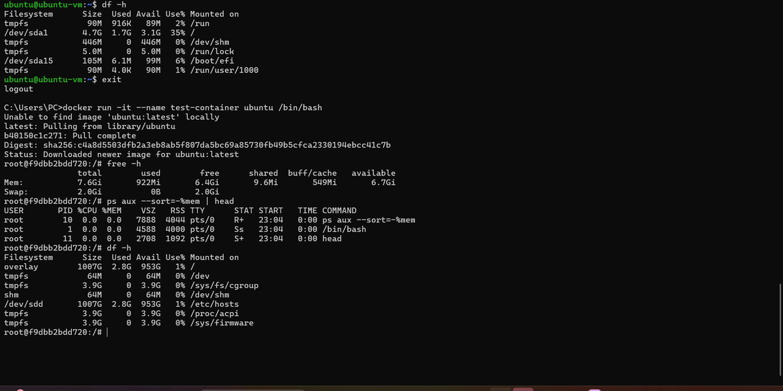

Docker Container (ubuntu:latest)
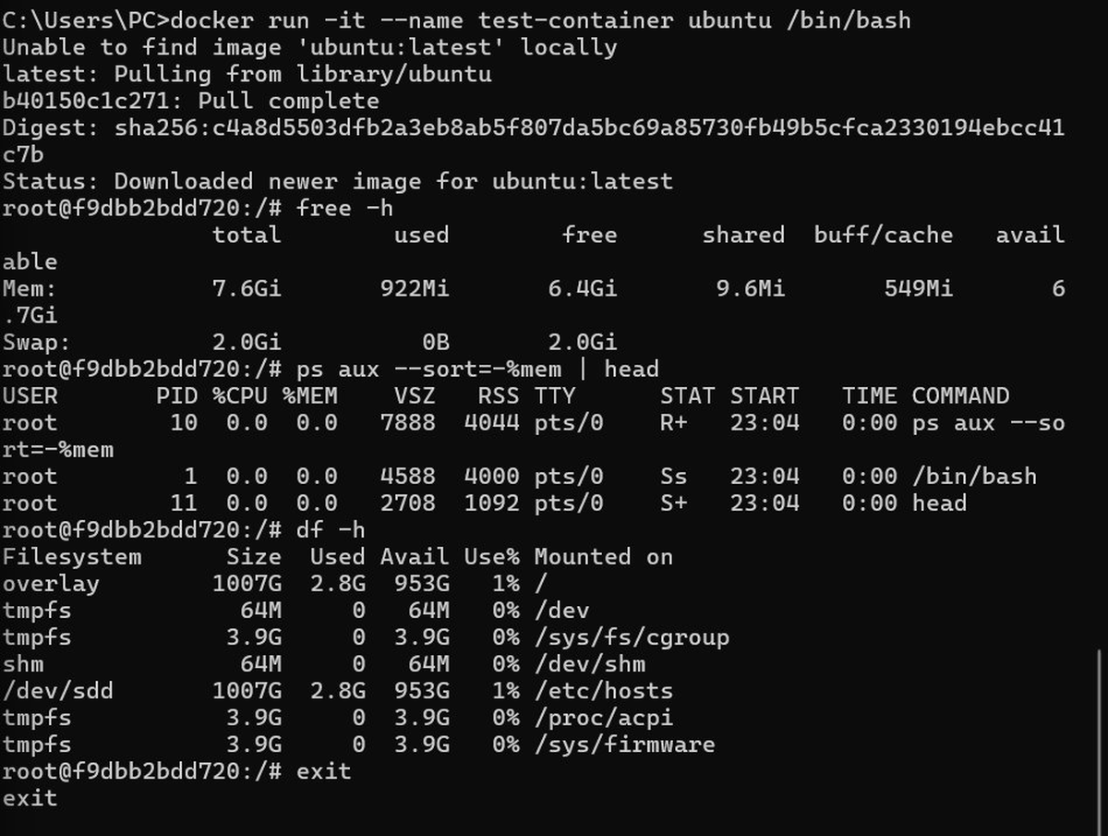

Comparison Table

Metric | Virtual Machine | Docker Container
Total RAM | 891 MB | 7.6 GB (shared host)
Used RAM | 201 MB | 922 MB
Active Processes | 10+ system processes | 3 processes only
Disk Size | 4.7 GB | 1007 GB (shared host)
Startup Time | Several seconds | Near instant
Isolation | Full OS isolation | Process-level isolation

Part B: Cloud Infrastructure Exploration

Hypervisor Detection (dmesg)
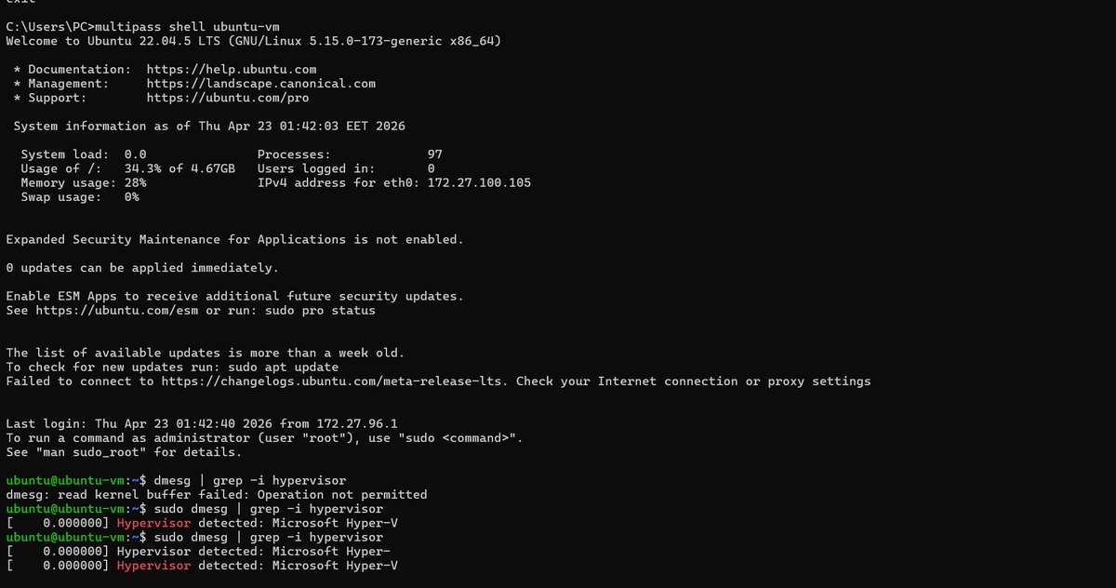

Result: Hypervisor detected: Microsoft Hyper-V — same role as AWS Nitro Hypervisor.

System Information (dmidecode)
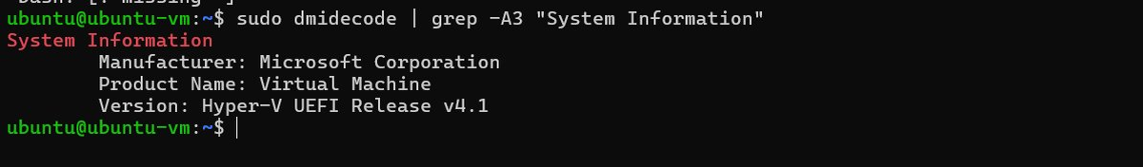

Manufacturer: Microsoft Corporation | Product: Virtual Machine | Version: Hyper-V UEFI Release v4.1

Process Monitoring — top
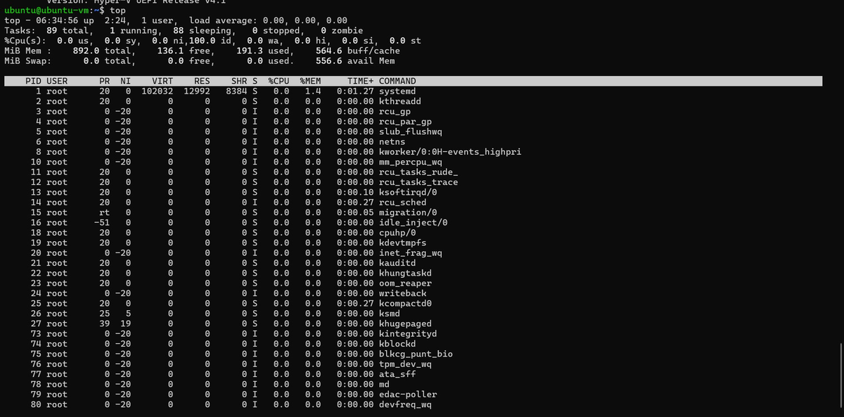

Process Monitoring — htop
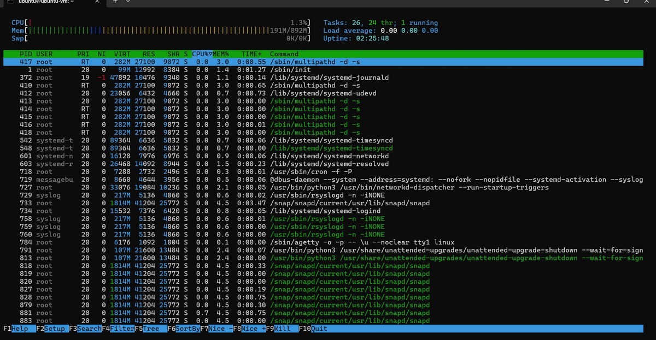

The VM shows 89 total tasks, 1 running, 88 sleeping. Memory: 892 MB total, 191 MB used.

Part C: Tail Latency Mini-Simulation

Flask App Response Times & Histogram
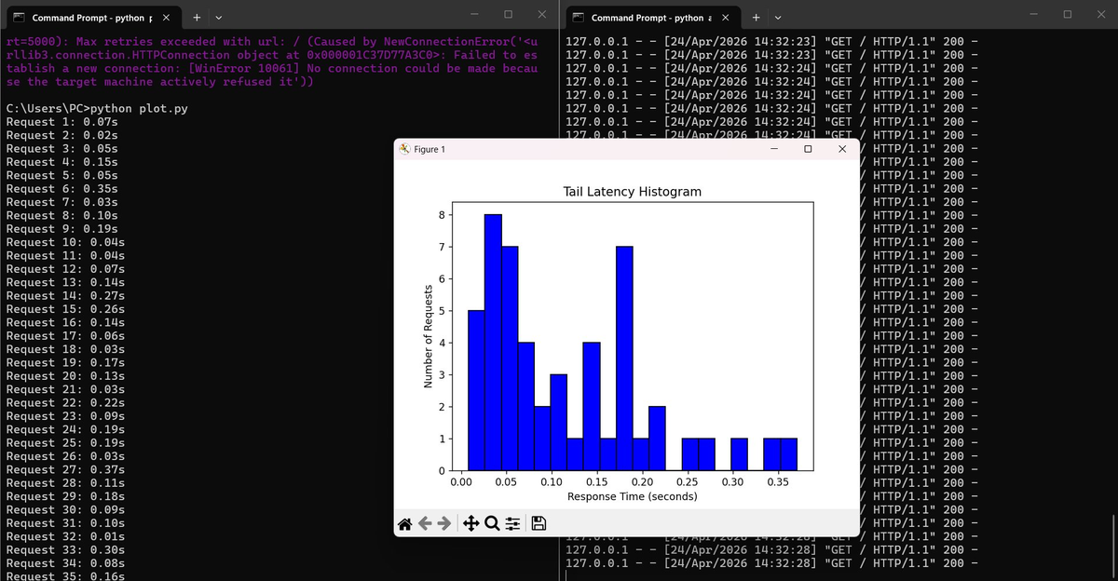

Most requests complete in 0.02–0.07s, but a small number take 0.25–0.35s — this is the tail latency.

Discussion: VM vs Container for Microservices
Containers are better for microservices because:

1. Resource Efficiency — Containers run with only 3 processes vs 10+ in a VM, using far less overhead.
2. Faster Startup — Containers start in milliseconds; VMs take seconds — critical for auto-scaling.
3. VMs are better when strong security isolation or a different OS kernel is required.
4. Tail latency matters most in microservices fan-out: one slow service slows the whole request.

Conclusion: Use containers (Docker/Kubernetes) for microservices. Use VMs for security-sensitive or legacy workloads.

Discussion Questions
Why does AWS split Nitro into hardware components?
To offload networking, storage and security to dedicated chips — freeing the CPU fully for the guest VM.

When would you use VMs over containers?
When strong isolation, different OS kernels, or compliance requirements make containers unsuitable.

How does tail latency change with parallel calls?
It worsens — with N services, the chance at least one is slow increases. Solutions: hedged requests, replication.

