CMC Lab 02
Distributed Consistency and Consensus
April 25, 2026

Task 1: Redis Replication and CAP Theorem
Objective: Demonstrate Redis master-replica replication and observe CAP theorem behavior during network partition.

Step 1: Docker Compose Configuration
The environment was set up using a docker-compose.yml file defining three services: redis-node1 (master), redis-node2 (replica), and etcd.
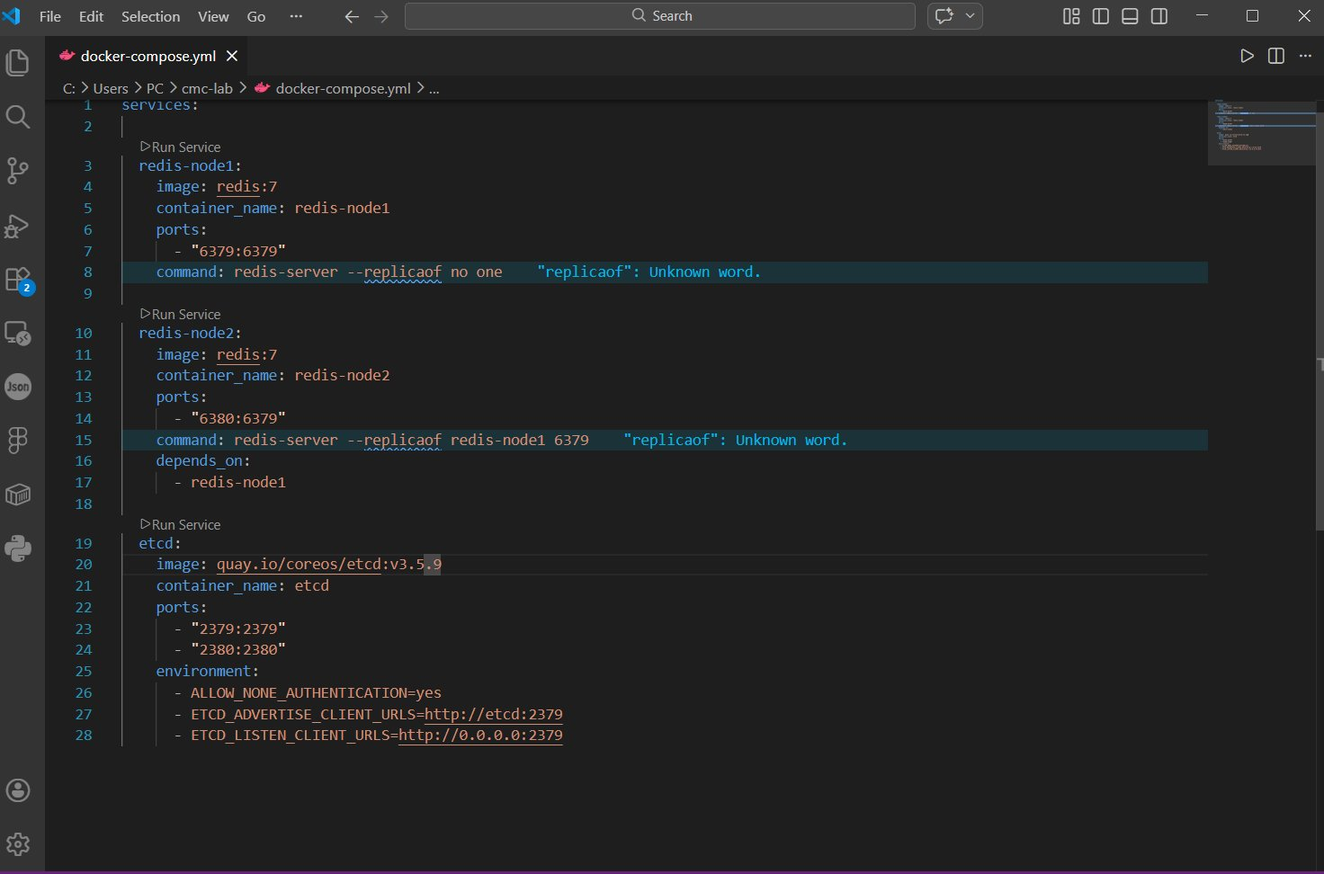
Figure 1: docker-compose.yml configuration in VS Code

Step 2: Pulling Docker Images
Running docker-compose up initiated the download of all required images: Redis 7 and etcd v3.5.9.
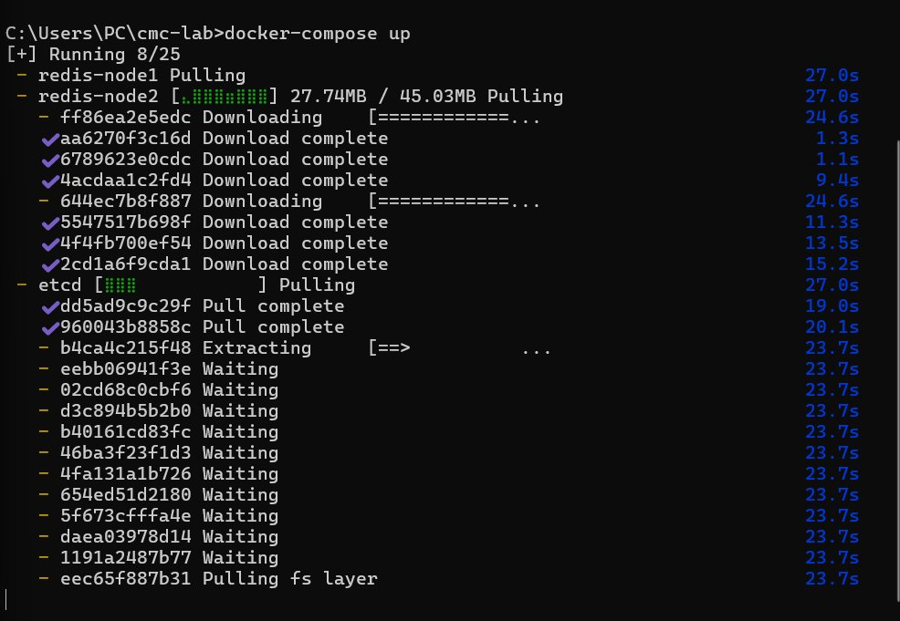
Figure 2: Docker pulling images for all services

Step 3: Redis Replication Test
A key was written to redis-node1 (master) and successfully read from redis-node2 (replica), confirming replication is working:
- SET mykey "hello" on redis-node1 → returned OK
- GET mykey on redis-node2 → returned "hello" ✓
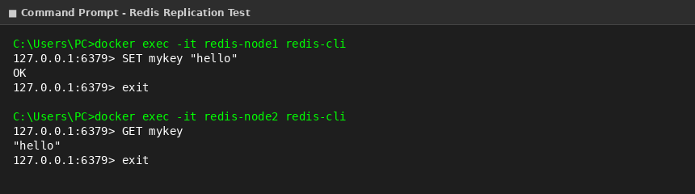
Figure 3: Writing to master (node1) and reading from replica (node2)

Step 4: Network Partition Simulation (CAP Theorem)
redis-node2 was stopped to simulate a network partition, then a new key was written to redis-node1:
- docker stop redis-node2 → partition simulated
- SET anotherkey "test" on redis-node1 → returned OK (master continued accepting writes)
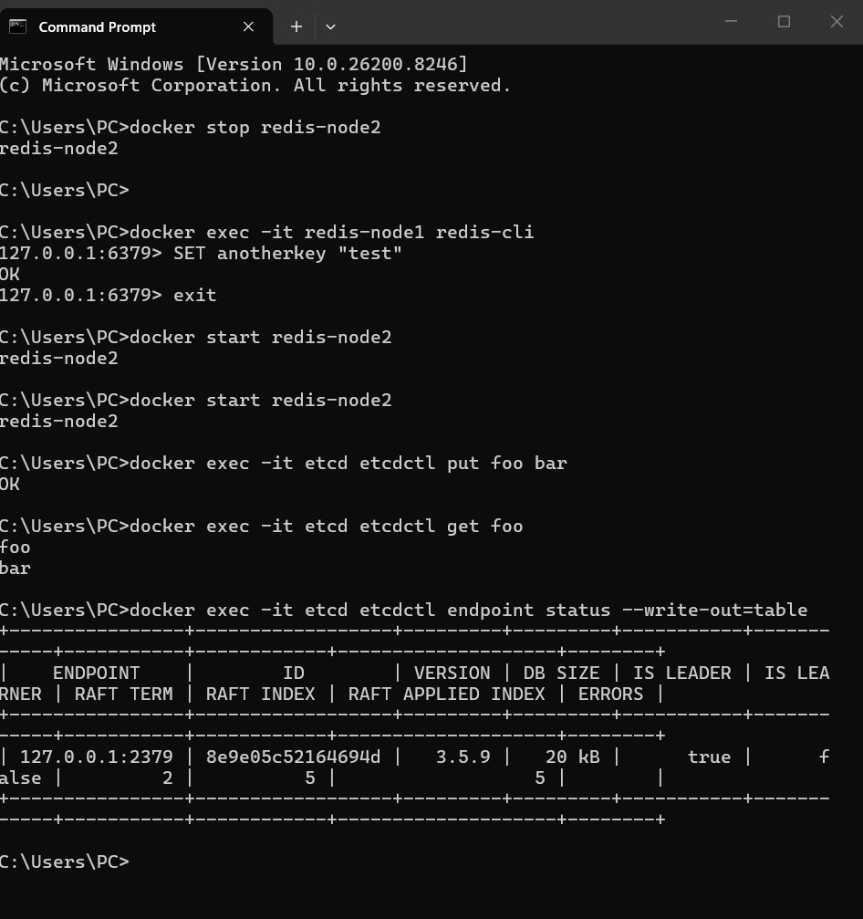
Figure 4: Network partition simulation and continued writes on master

Step 5: Redis Logs Verification
The Docker logs confirm the full replication lifecycle — initial full sync, partition, and re-synchronization after restart:
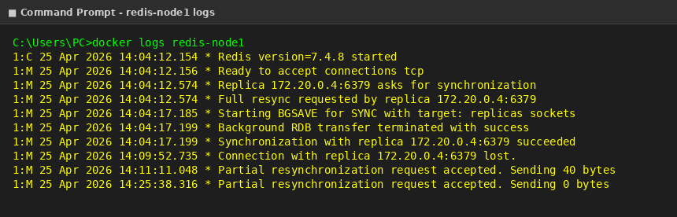
Figure 5: redis-node1 (master) logs showing replica sync and reconnections
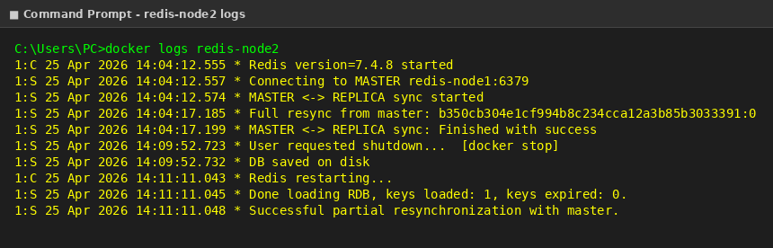
Figure 6: redis-node2 (replica) logs showing full sync, shutdown, and partial re-sync
Observation: Redis chose Availability over Consistency during the partition (AP system). The master continued accepting writes even when the replica was down. Upon restart, redis-node2 performed a partial resynchronization to catch up with the missed writes.

Task 2: Raft Consensus with etcd
Objective: Demonstrate the Raft consensus algorithm using etcd by observing leader election after a node restart.

Step 1: etcd Key-Value Operations & Leader Election
The following operations were performed on etcd:
- etcdctl put foo bar → returned OK
- etcdctl get foo → returned "bar" ✓
- endpoint status showed IS LEADER = true, RAFT TERM = 2, RAFT INDEX = 5
- etcd stopped then restarted → RAFT TERM changed to 3, RAFT INDEX = 7 (new election occurred)
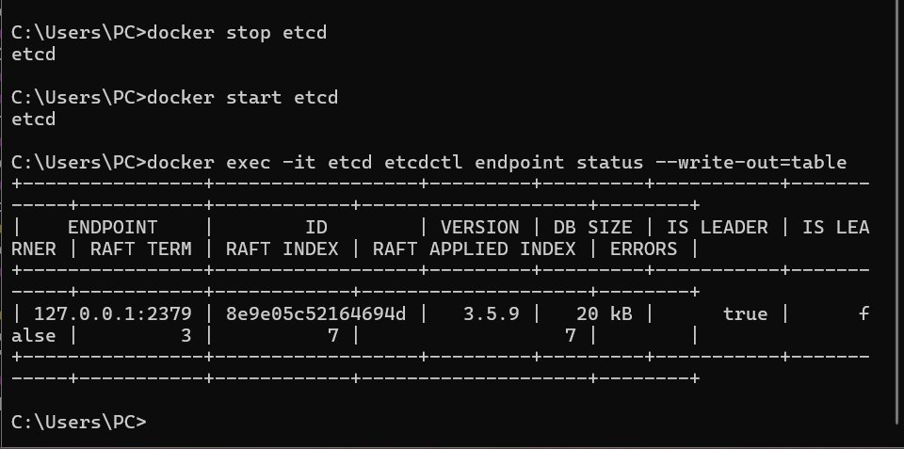
Figure 7: etcd Raft term increment after restart (Term 2 → Term 3)
Observation: The RAFT TERM incremented from 2 to 3 after the restart, confirming a new leader election took place. The RAFT INDEX also increased from 5 to 7. This demonstrates the Raft consensus algorithm ensuring the cluster always has a reliable leader.

Conclusion
This lab successfully demonstrated two core distributed systems concepts:
- CAP Theorem (Redis): Redis replication copies data from master to replica automatically. During a network partition, Redis prioritizes Availability (AP system), continuing to accept writes on the master. Upon reconnection, the replica re-synchronizes via partial resync.
- Raft Consensus (etcd): etcd uses the Raft algorithm to maintain consistency across the cluster. When a node restarts, a new election is triggered, incrementing the Raft term and ensuring the cluster always has a reliable, elected leader.

