CMC Lab 03 — Containers & Kubernetes
Namespaces, cgroups, Docker Images, and Kubernetes Deployments

Part A — Linux Namespaces & cgroups

Task A1 — Namespace Isolation
A Docker container was launched using the ubuntu:22.04 image. Inside the container, several commands were run to observe namespace isolation:
- hostname — showed a unique container ID (1e9e55b9a912), not the host name.
- ps -ef — only 2 processes visible (bash + ps), demonstrating PID namespace isolation.
- mount | head — showed overlay filesystem, not the host's real mounts.
- cat /proc/1/cgroup — confirmed the process is inside a Docker cgroup hierarchy.

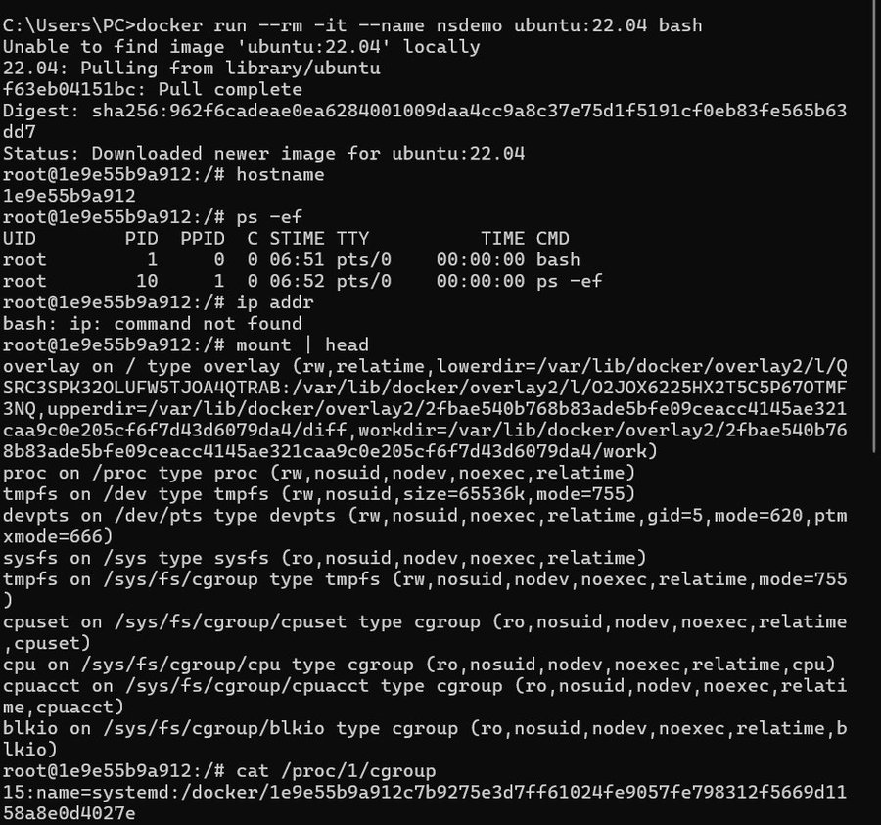

Task A2 — PID Namespace Comparison
From the host, docker inspect revealed the container's bash process has PID 2399 on the host, while inside the container the same process appears as PID 1. This demonstrates how PID namespaces provide process isolation — each container has its own PID 1.

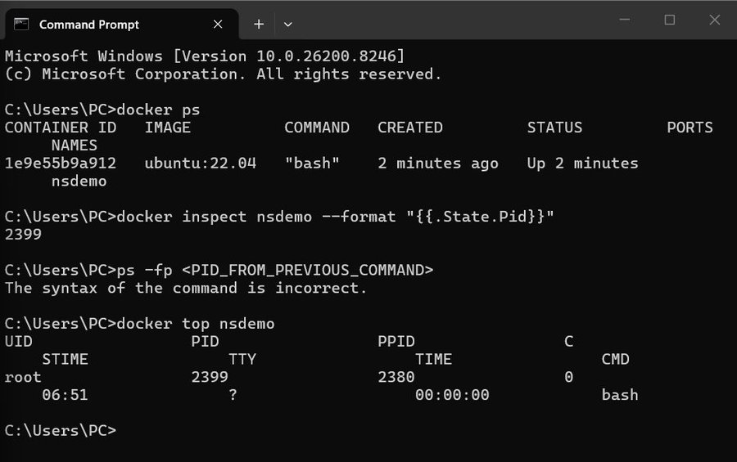

Task A3 — cgroup Resource Limits
A container was launched with --cpus=0.5 and --memory=256m limits. The stress tool was installed and run inside the container. docker stats confirmed the memory limit was enforced at exactly 256MiB, proving cgroups limit resource usage per container.

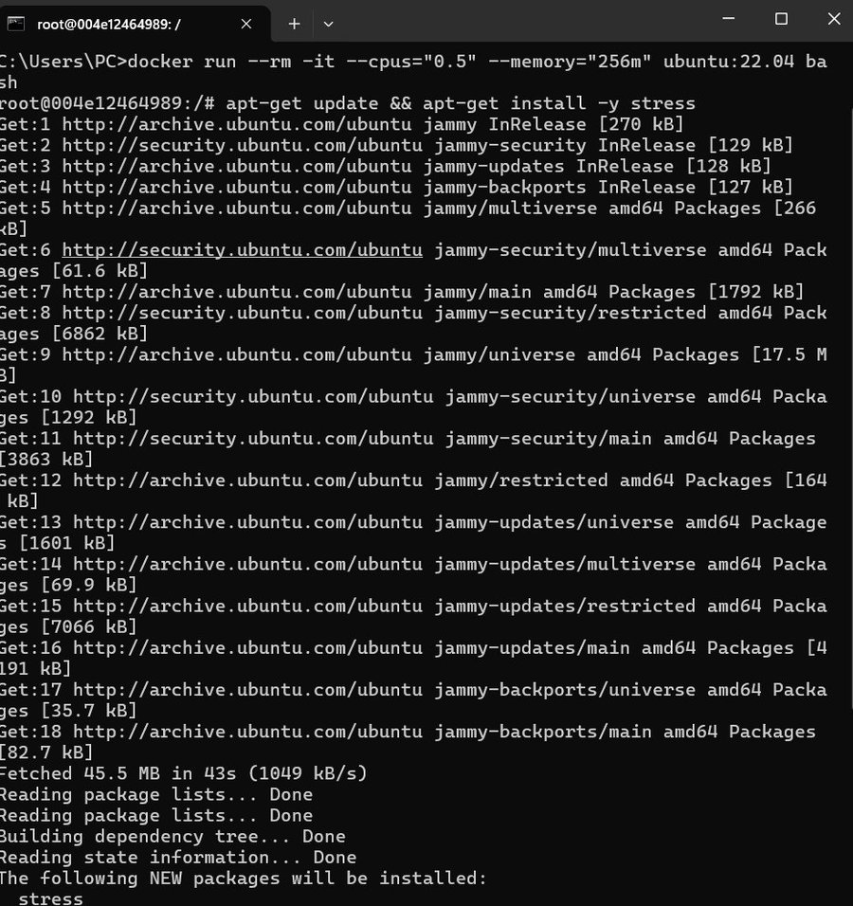
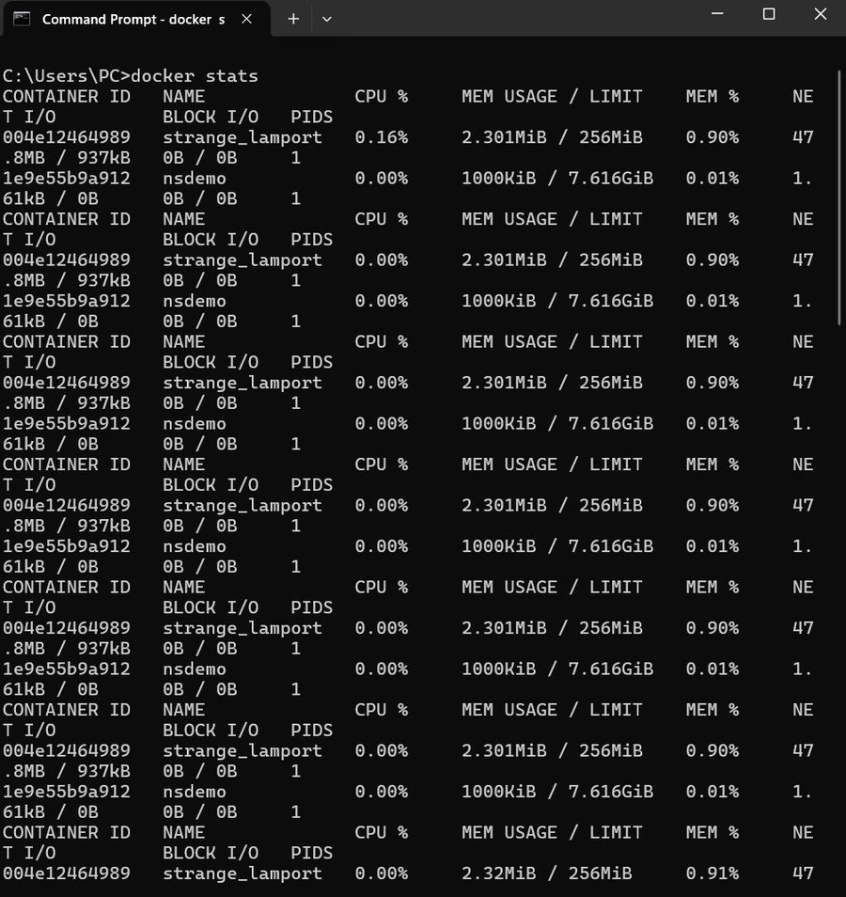

Part B — Docker Image Optimisation

Task B1 — Application Files
A simple Flask web application was created with two files: app.py (Flask app with / and /health endpoints) and requirements.txt (contains flask==3.0.0).

Task B2 — Basic Dockerfile (lab3-basic)
A single-stage Dockerfile (Dockerfile.basic) was built using python:3.12-slim as the base image.

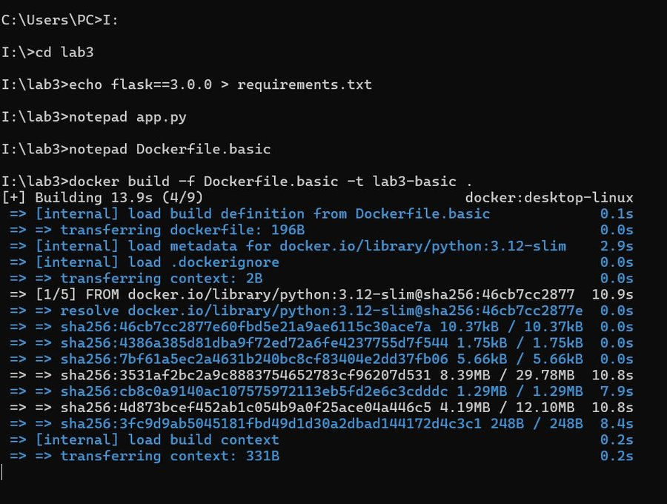
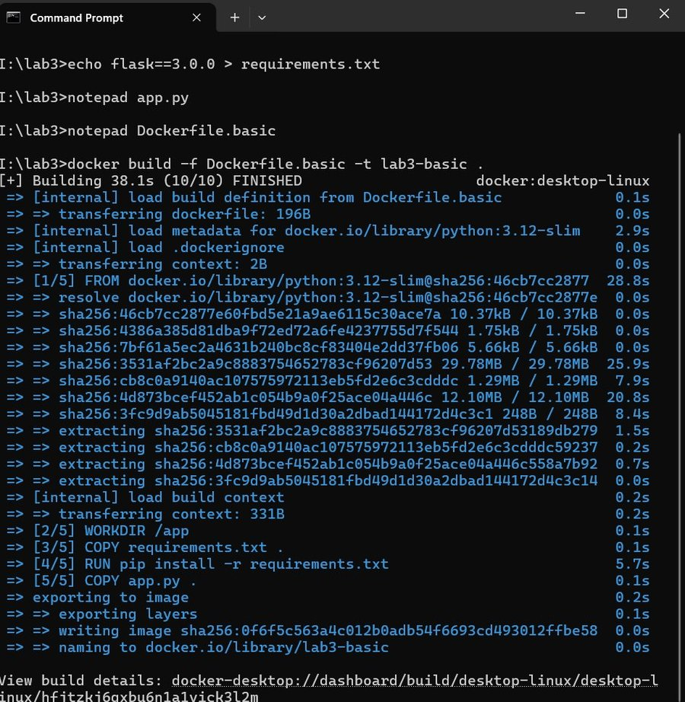
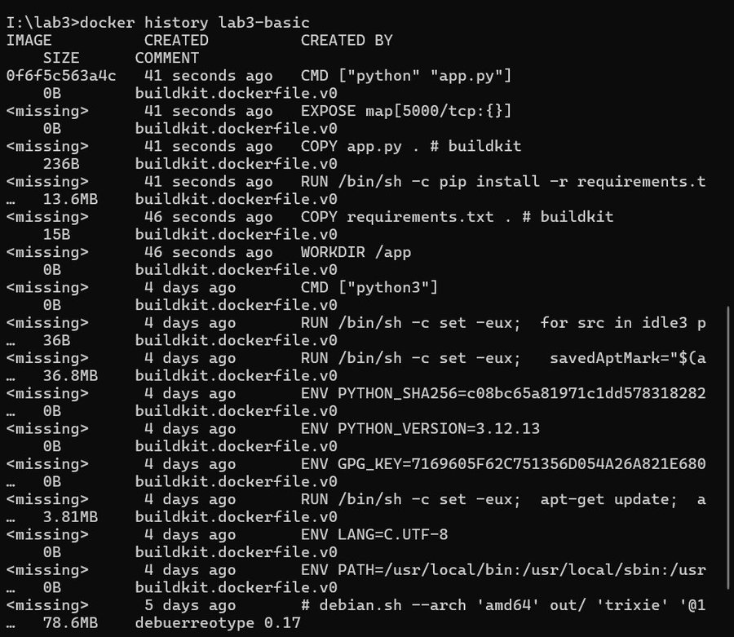
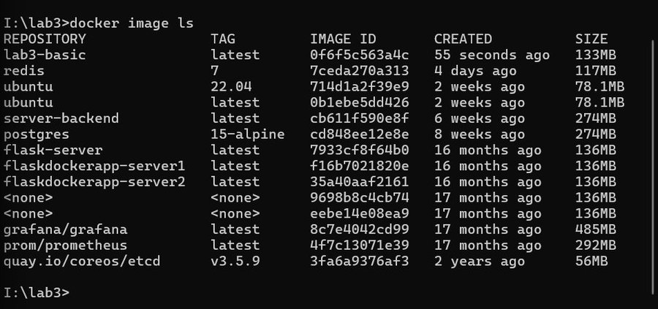

Task B3 — Multi-stage Dockerfile (lab3-multi)
A multi-stage Dockerfile (Dockerfile.multistage) was built. The builder stage installs dependencies into /install, and the final stage copies only the installed packages — excluding build tools and cache.

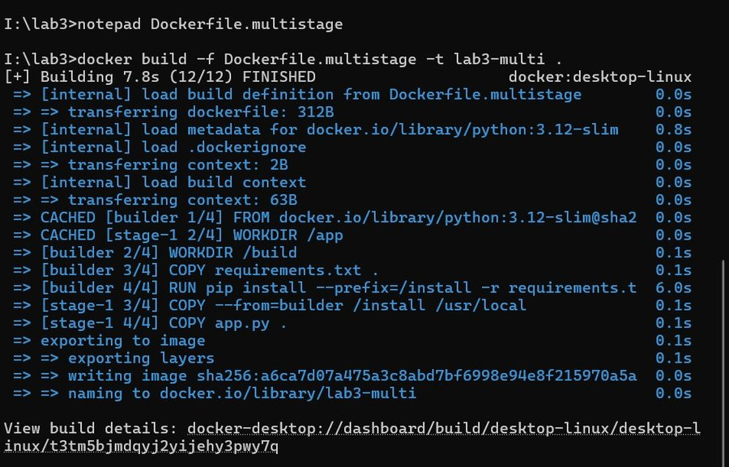
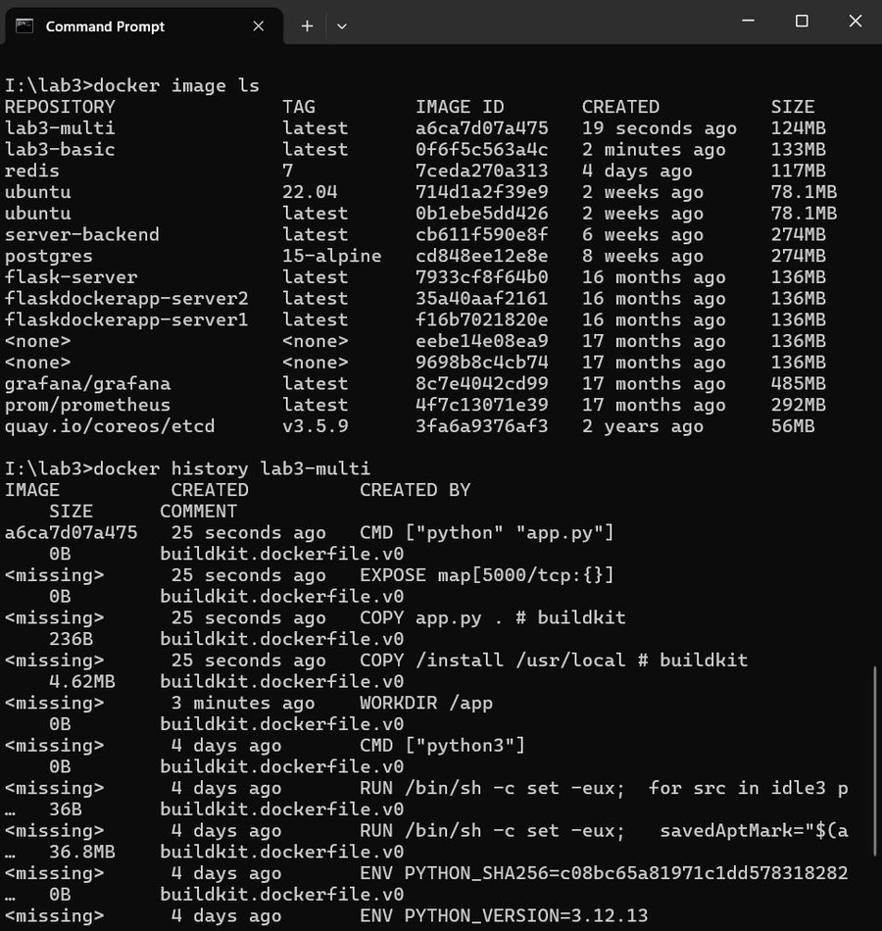

D2 — Image Size Comparison
The table below compares both images:

Image | Strategy | Size
lab3-basic | Single-stage | 133 MB
lab3-multi | Multi-stage | 124 MB

The multi-stage build is 9 MB smaller because build-time dependencies are discarded and only the final installed packages are copied into the runtime image.

Part C — Kubernetes Deployment

Task C1 — Cluster Setup
Kubernetes was enabled via Docker Desktop. After restart, the cluster was confirmed running with kubectl get nodes (docker-desktop Ready, v1.30.2) and kubectl cluster-info (control plane at https://kubernetes.docker.internal:6443).

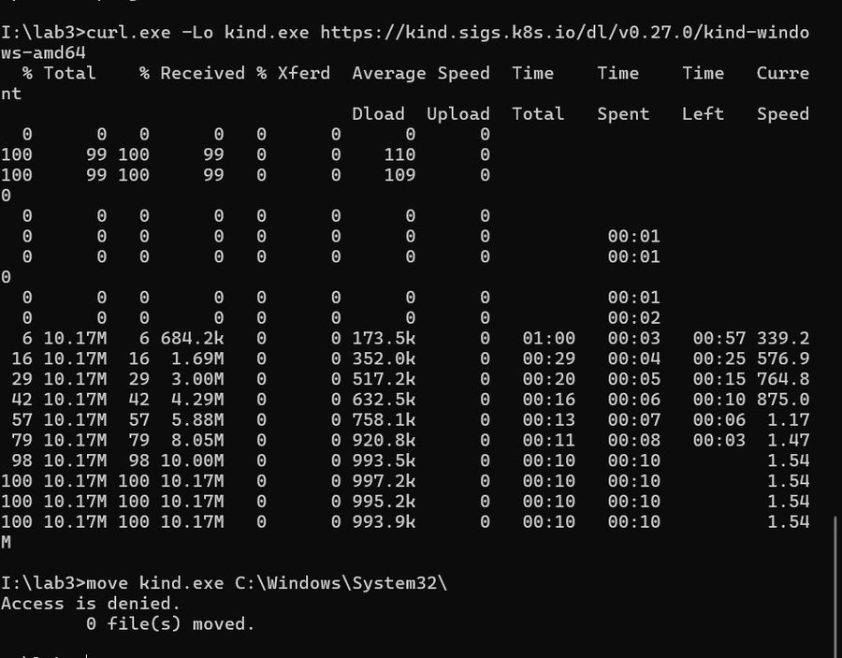
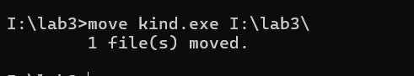
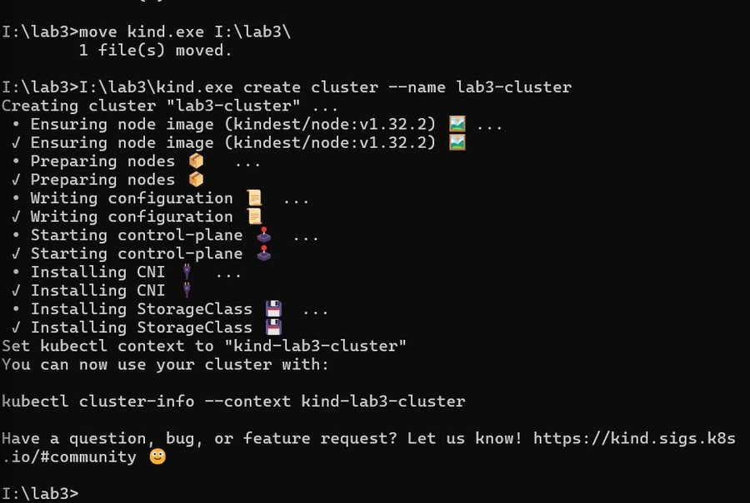
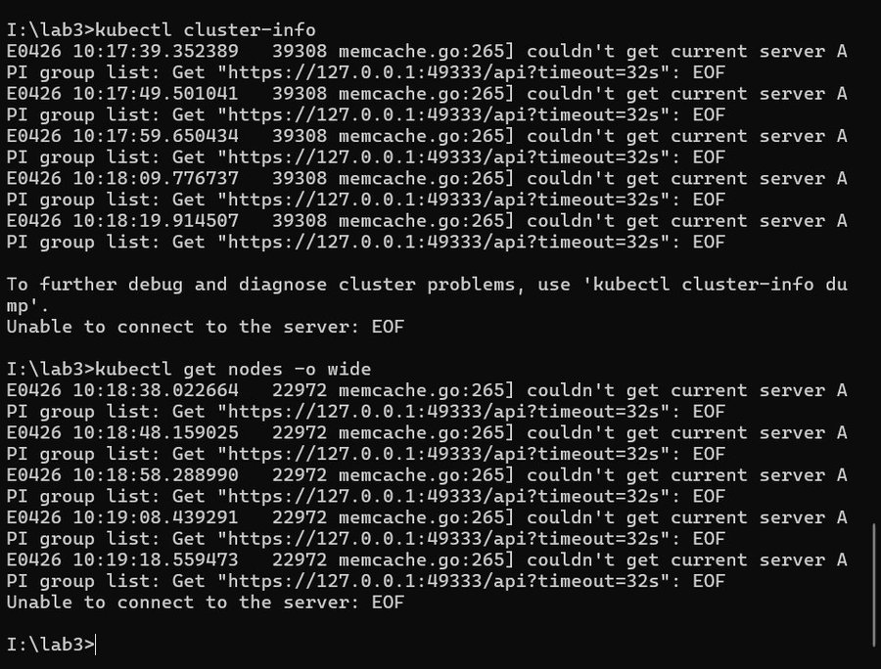

Task C2 — Deploy the Application
The deployment.yaml (3 replicas of lab3-multi) and service.yaml (ClusterIP on port 80) were applied successfully. All 3 pods reached Running state.

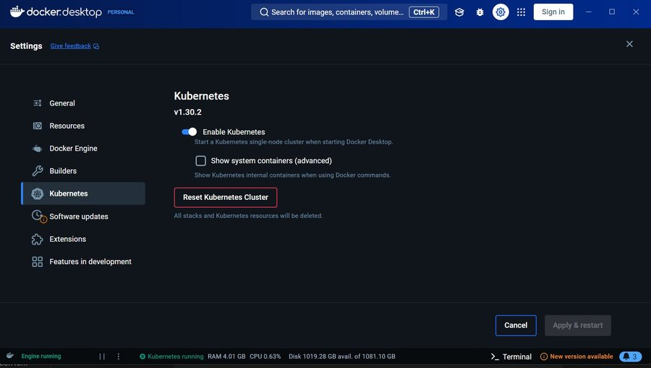
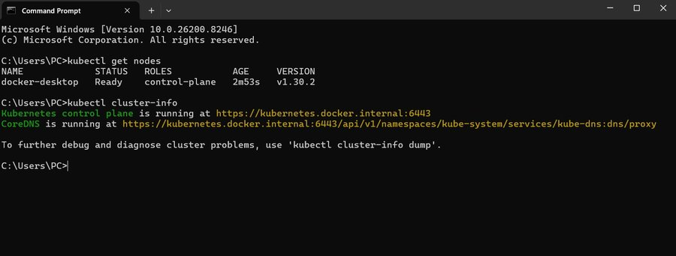
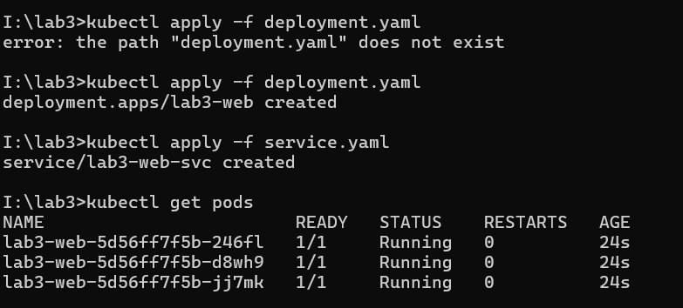
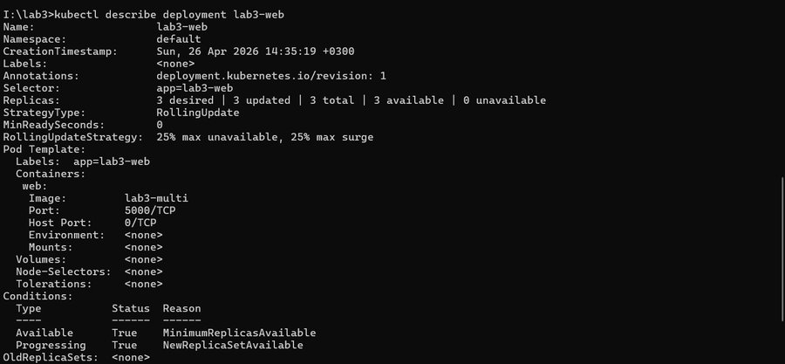

Task C3 — Self-Healing
One pod was manually deleted. Kubernetes immediately detected the missing replica and scheduled a new pod automatically. The desired replica count of 3 was restored within seconds.

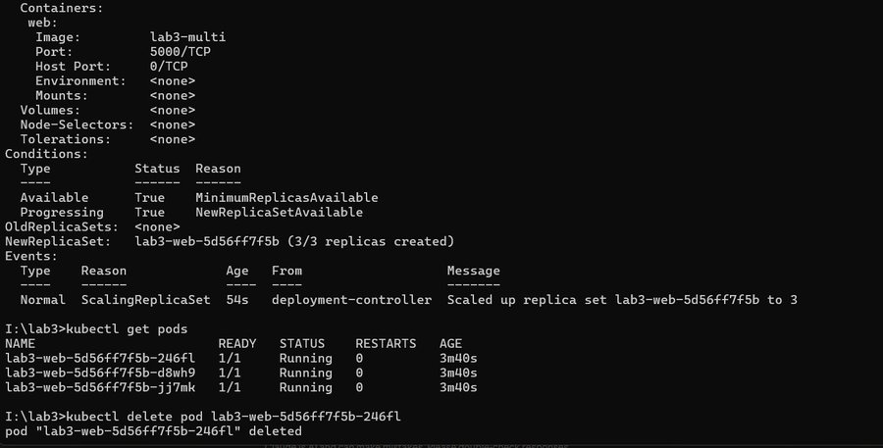
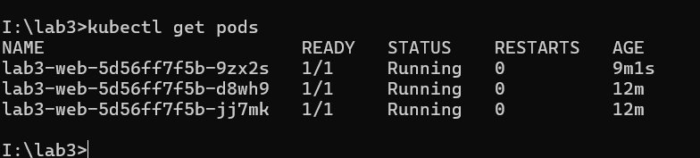

Task C4 — Scaling
The deployment was scaled up to 5 replicas and back down to 3 using kubectl scale. Kubernetes created/terminated pods automatically to match the desired state.

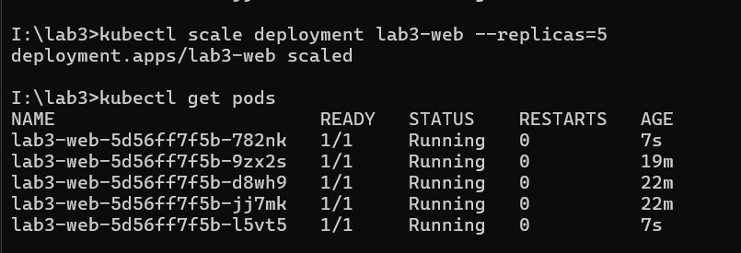
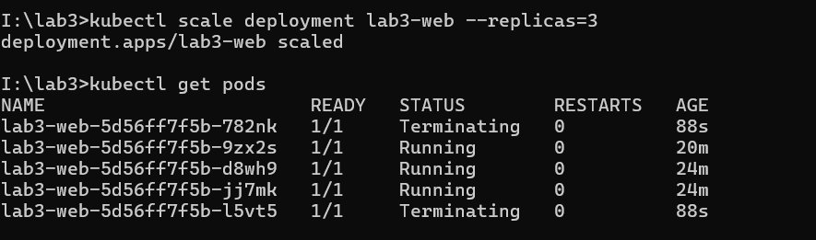
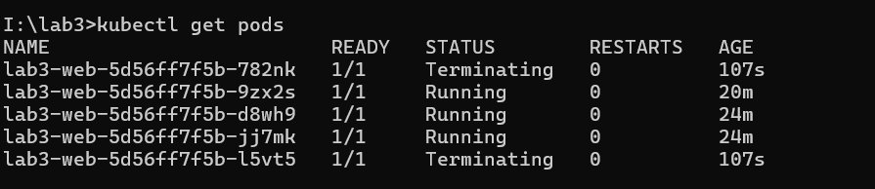

Task C5 — Health Probes
A second deployment (probe-deployment.yaml) was applied with both liveness and readiness probes on the /health endpoint. The pods initially showed 0/1 Ready, then became 1/1 once the readiness probe passed.

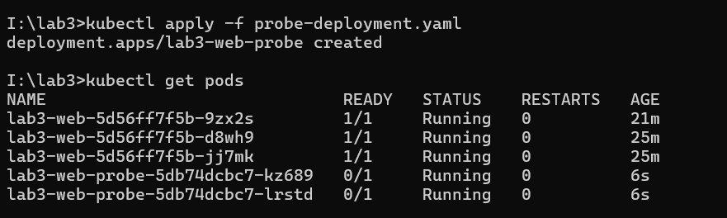
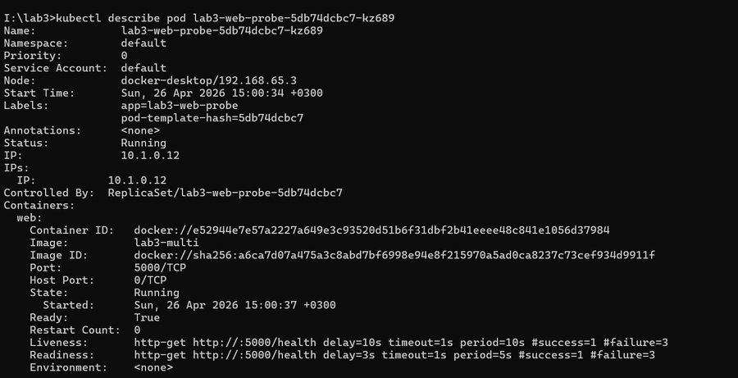

Part E — Deliverables & Reflection

D4 — Self-Healing Evidence
The kubectl get pods -w output captured the full self-healing sequence after a pod was deleted: Terminating → Pending → ContainerCreating → Running. The ReplicaSet controller continuously reconciles actual state with desired state (3 replicas), replacing failed pods without any manual intervention.

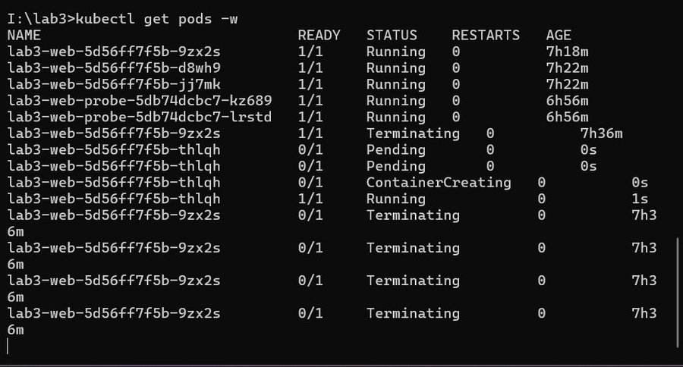

D5 — Reflection Questions
Q1: How do namespaces and cgroups together enable container isolation?
Namespaces provide logical isolation — each container gets its own view of the system (PID tree, network interfaces, filesystem mounts, hostname). cgroups provide resource isolation — they enforce hard limits on CPU, memory, and I/O per container. Together they ensure containers cannot see each other's processes and cannot starve the host of resources.

Q2: What is the advantage of multi-stage Docker builds?
Multi-stage builds separate the build environment from the runtime environment. Only the compiled artifacts or installed packages are copied into the final image — build tools, compilers, and pip cache are discarded. This produces smaller, more secure images with a reduced attack surface. In this lab, the multi-stage image was 9 MB smaller than the single-stage image (124 MB vs 133 MB).

Q3: How does Kubernetes self-healing work?
Kubernetes uses a reconciliation loop. The ReplicaSet controller constantly compares the actual number of running pods against the desired count in the spec. When a pod is deleted or crashes, the controller detects the deficit and immediately creates a new pod on an available node. No human intervention is needed — the system converges back to the desired state automatically.

Q4: What is the role of liveness vs readiness probes?
A readiness probe determines whether a pod is ready to receive traffic. Kubernetes will not send requests to a pod until its readiness probe passes. A liveness probe determines whether a container is still alive. If the liveness probe fails, Kubernetes restarts the container. Together they prevent traffic from reaching unhealthy pods and automatically recover stuck or crashed containers.

Q5: What is the difference between a Deployment and a ReplicaSet?
A ReplicaSet ensures a specified number of pod replicas are running at any time. A Deployment is a higher-level abstraction that manages ReplicaSets and adds rolling update and rollback capabilities. In practice, Deployments are always used instead of ReplicaSets directly, because they provide version history and zero-downtime update strategies.

