CMC Lab 04 — Microservices & Cloud-Native Design
Two-service e-commerce backend with Docker Compose, health checks, and failure simulation

Part A — Project Structure
A new folder week4-lab was created with two subfolders: product-service and order-service. Each service contains its own app.py, requirements.txt, and Dockerfile. A shared docker-compose.yml sits at the root.

Part B — product-service Implementation

product-service/app.py
The product service exposes two endpoints: /health (returns service status) and /products/<product_id> (returns product data from an in-memory dictionary). The service is stateless — it does not depend on any local mutable files.

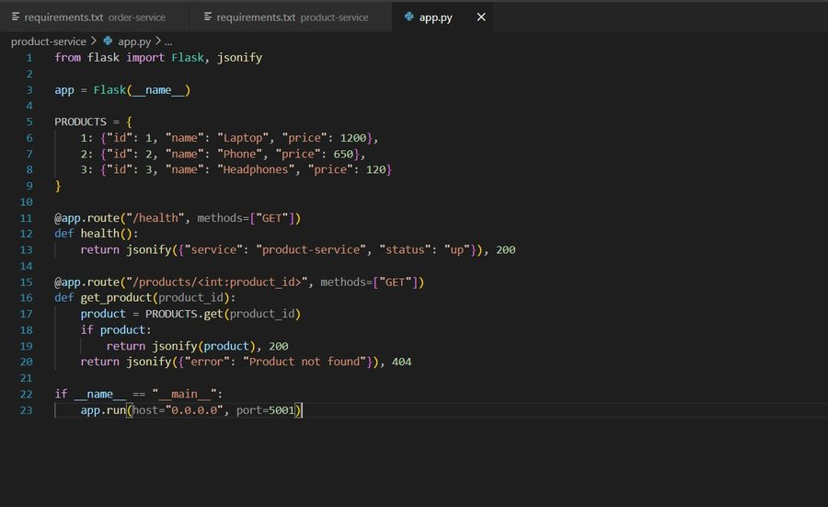

product-service/requirements.txt
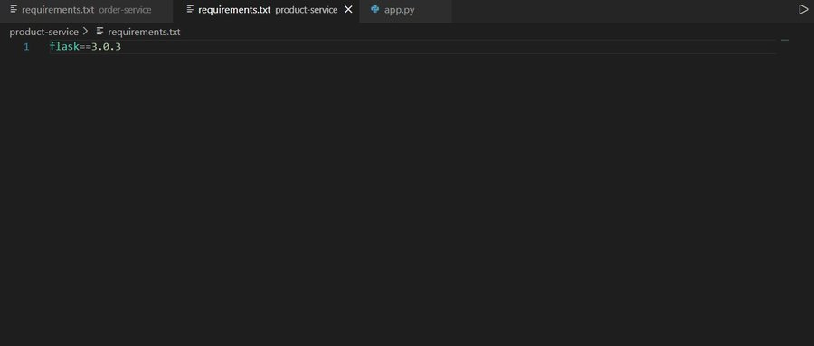

Part C — order-service Implementation

order-service/app.py
The order service accepts a POST /orders request, calls product-service synchronously, validates the product, and returns an order response. The product-service URL is read from an environment variable (PRODUCT_SERVICE_URL) rather than being hardcoded. The fetch_product() function implements a retry mechanism with timeout for resilience.

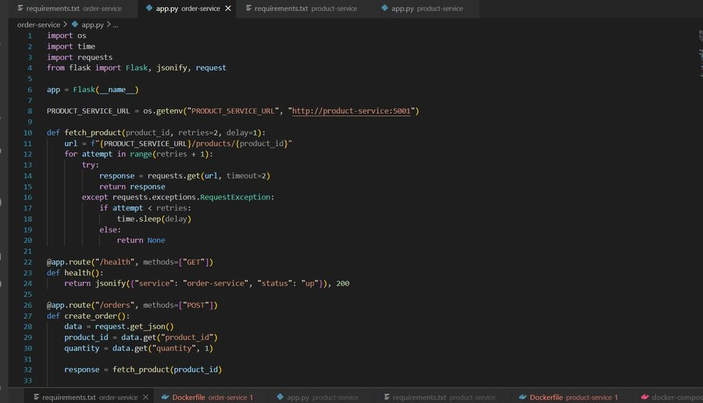
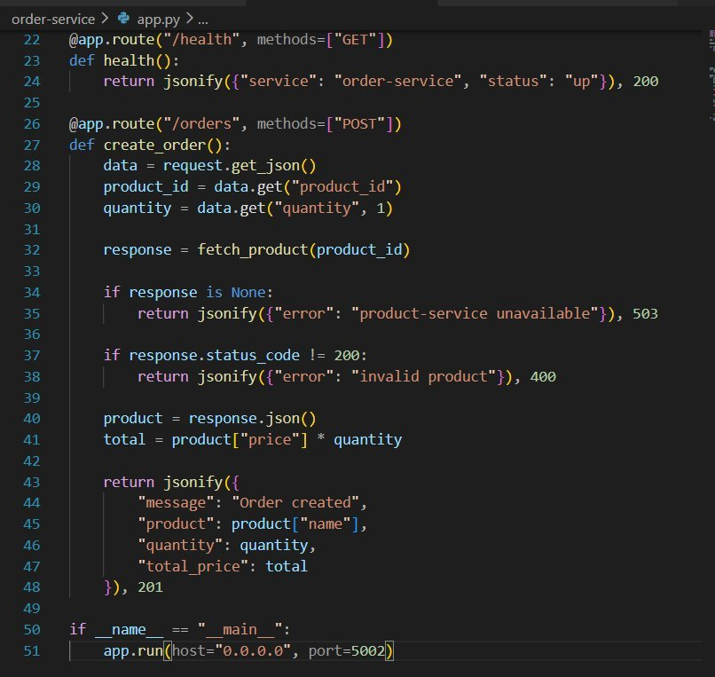

order-service/requirements.txt
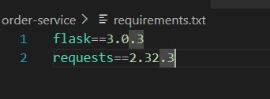

Part D — Dockerfiles

order-service/Dockerfile
Each service has its own Dockerfile based on python:3.12-slim. The requirements.txt is copied before app.py to optimize Docker layer caching.

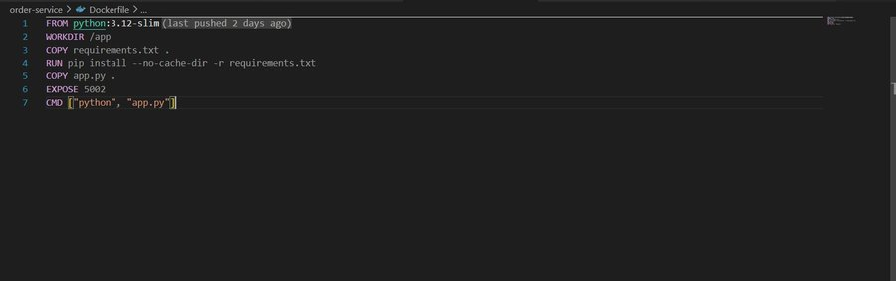

product-service/Dockerfile
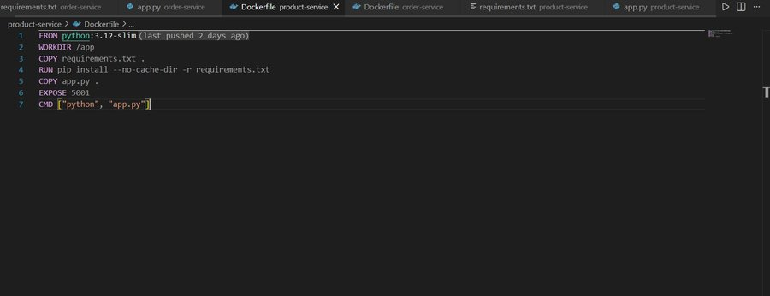

Part E — Docker Compose Orchestration

docker-compose.yml
The compose file defines both services with health checks, restart policies, and environment variables. The order-service depends_on product-service and receives the PRODUCT_SERVICE_URL via environment variable so no address is hardcoded.

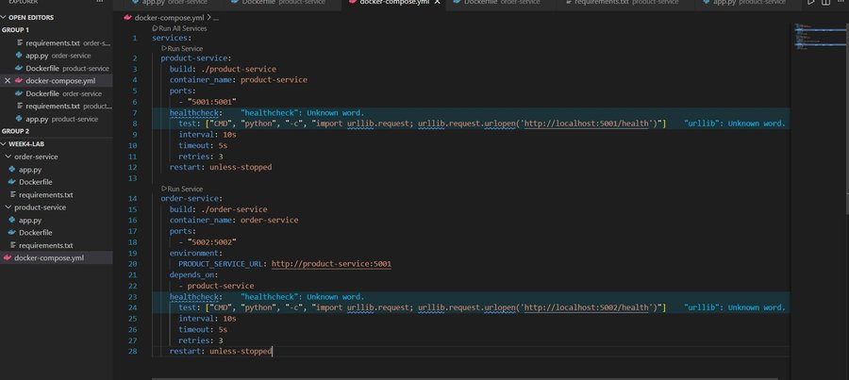

Part F — Build and Run
Both services were built and started using docker compose up --build -d. Both containers reached healthy status.

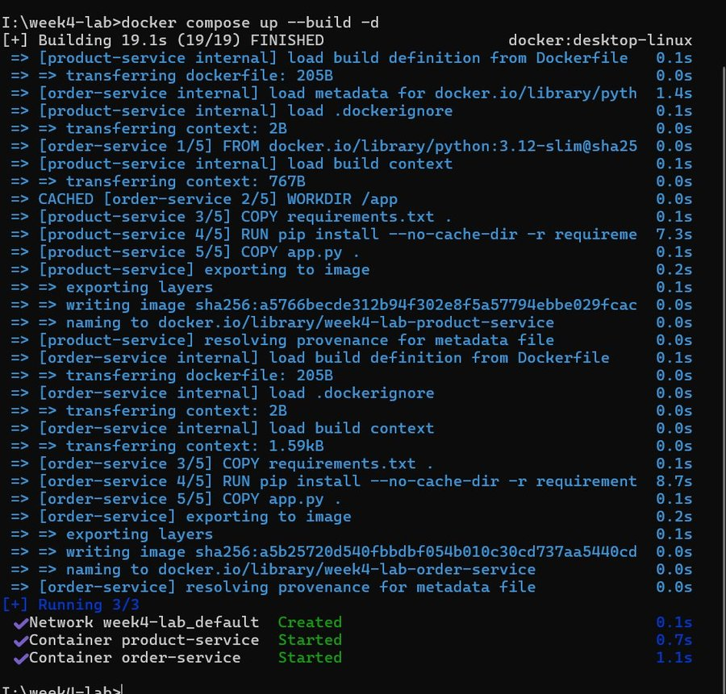

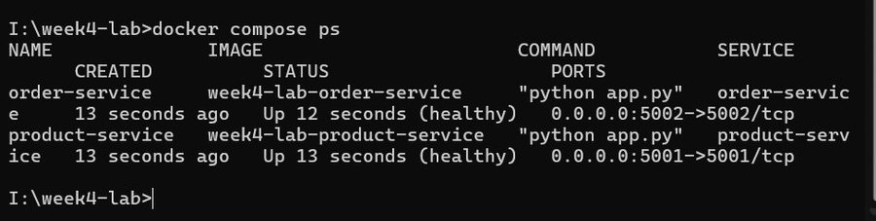

Part G — Functional Testing

product-service API Tests
Three curl requests were sent to product-service: a health check, a valid product lookup (product 1 = Laptop, price 1200), and an invalid product lookup (product 99 = 404 error).

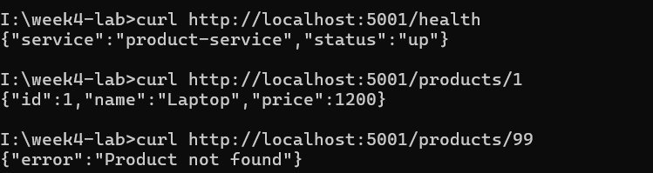

order-service API Test
A POST request was sent to order-service to create an order for 2 units of product 1 (Laptop). The response confirmed the order was created with a total_price of 2400.

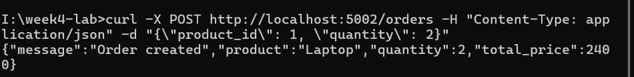

Part H — Failure Injection & Resilience
product-service was stopped using docker stop product-service. A new order request was then sent to order-service. The service attempted to contact product-service, the request timed out after retries, and the API returned HTTP 503 with the error message 'product-service unavailable'. The product-service was then restarted using docker start product-service and both containers returned to healthy status.

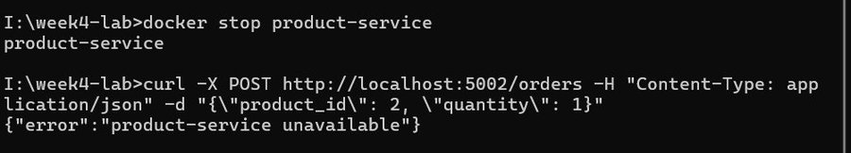
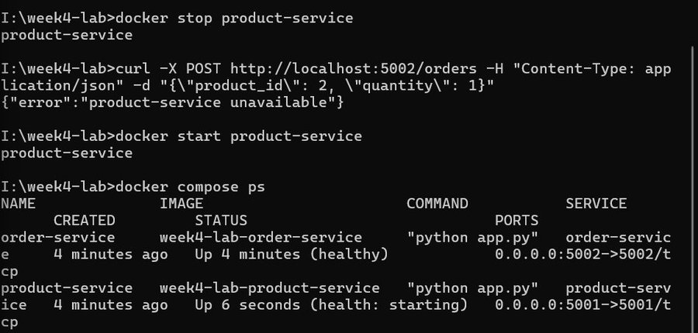

Part I — Architecture Reflection
Q1: Which parts of this lab show the benefits of microservices over a monolith?
Each service was developed, built, and deployed independently with its own Dockerfile and requirements. A bug or update in product-service does not require rebuilding order-service. The services can also be scaled independently — for example, deploying more replicas of product-service without affecting order-service. This matches the microservice principle of independent deployability.

Q2: Which new complexities were introduced by splitting the system into two services?
Network communication between services introduces latency and potential failure that would not exist in a monolith. The order-service must handle the case where product-service is unavailable (503 error). Service discovery is required — the address of product-service must be provided via an environment variable. Debugging becomes harder because a single request now spans two containers and two log streams.

Q3: What would break if network latency increased or one service became slow?
If product-service becomes slow, the fetch_product() timeout of 2 seconds would be exceeded on each retry attempt. With 2 retries the total wait time could reach 6 seconds before returning a 503 error to the client. High latency could cause order-service threads to block, reducing throughput. In production, a circuit breaker pattern would be needed to stop sending requests to a slow dependency and return a cached or fallback response immediately.

Q4: Which 12-factor app principles are visible in this implementation?

12-Factor Principle | How it appears in this lab
III. Config | PRODUCT_SERVICE_URL is injected via environment variable, not hardcoded.
IV. Backing services | product-service is treated as an attached resource accessed over HTTP.
VI. Processes | Both services are stateless — no local state, in-memory data only.
VII. Port binding | Each service binds to its own port (5001, 5002) and is self-contained.
IX. Disposability | restart: unless-stopped ensures containers restart quickly on failure.
XI. Logs | docker compose logs streams logs from each service independently.

