Claire Gatt

1BSc4

Assignment 1 Sit 1

Analyzing And Documenting Requirements

Software Engineering

Contents

Section 1: UML Use Case Diagram 2

Section 2: Scenario Documentation 3

Section 3: Use Case Documentation 5

Section 4: Requirements Engineering 7

Section 5: Structured and Meaningful Information 9

# Section 1: UML Use Case Diagram

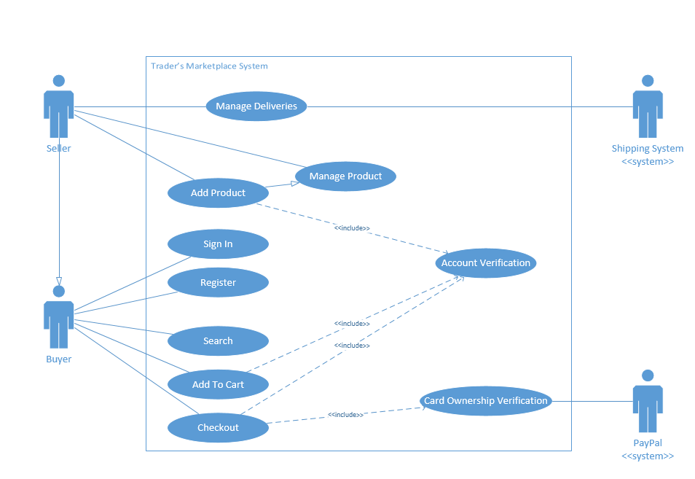

# Section 2: Scenario Documentation

|  |  |
| --- | --- |
| Scenario Name | Registering To The Trader’s Marketplace System as a Seller |
| Actors | Herman : Seller |
| Event Flow | 1. Herman, a local shop owner would like to start selling his stock online. After a research on the internet, he finds Trader’s Marketplace’s website and decides to register with this system. 2. He clicks on the “Register” link on the website, and a page is loaded where he is required to enter some details. Herman first choses the “Seller” option, because he wants to sell his products online. He is also required to enter his name and surname, the address from where the items will be picked up for delivery, an e-mail address, and his credit card information. Furthermore, he is required to enter a valid username (which has not been already used by another user) and a password. 3. Herman makes sure that all the details are correct and hits the “Complete Registration” button. 4. The system notifies Herman that his account was successfully created and can start using the system’s features immediately by sending him an email. |

|  |  |
| --- | --- |
| Scenario Name | Adding a product for sale to the System |
| Actors | Herman : Seller |
| Event Flow | 1. Herman would like to add some of his products that can be found in his shop outlet onto the website. 2. He starts off by Logging into the system with his newly registered account. 3. He enters his username and password. The system processes the login credentials and authenticates Herman’s account as a Seller. The system now redirects Herman to the “Manage Products” page. 4. Herman clicks on “Add new Product” link and is presented with a form where he is required to enter the product details. 5. Herman enters the product code, the product name, and a brief description of said product. He uploads a picture of the product, a category which best suits the product from a pre-defined list, and also chooses the brand from a pre-defined list. Herman finishes off by supplying the price per product, as well as the product quantity that he would like to set up for sale. 6. He makes sure that all of the product details are correct and hits the “Conform” button. 7. The Trader’s Marketplace system checks that the product code is not duplicated, and sends an email to Herman stating that his products are now for sale on the system. |

|  |  |
| --- | --- |
| Scenario Name | Adding a product to the Cart |
| Actors | John : Buyer |
| Event Flow | 1. John, a registered buyer with the Trader’s Marketplace system, wants to buy a specific product from the website. 2. He starts off by logging onto the system, by entering his username and password. The system processes the login credentials and authenticates John’s account as a Buyer. The system now redirects John to the “Browse Products” page. 3. John searches the products by typing in a name and choosing a category from a pre-defined list. 4. The system processes John’s request and displays all the products matching John’s input on the page. John browses through the products and selects the one that he would like to buy. 5. A page showing the details of the selected product is displayed. John selects the quantity that he would like to purchase and hits the “Buy” button. 6. The system submits John’s request and adds the product to his Cart. Meanwhile, John is redirected to his Cart page, where he can now see the product listed under his “Wish List”. |

# Section 3: Use Case Documentation

|  |  |
| --- | --- |
| Use Case Name | Registering to Trader’s Marketplace System as a Seller |
| Actors | Initiated by a user. |
| Event Flow | 1. The user selects the “Register” option from the main web page.  2. Trader’s Marketplace redirects the user to a new page.  3. The system loads a form where he user can input the registration details which consist of choosing whether the user is a Seller or Buyer, the user’s name, surname, address from where the items will be picked up for delivery, an e-mail address and the user’s credit card information. Additionally, the user enters a username and a password for his/her account.  4. The user enters all of the details.  5a. The user clicks the “Complete Registration” button.  5b. The user clicks on the “Cancel” button.  6a. If the users chooses “Complete Registration”, the system checks that all the information entered by the user is in the correct format and that the username is not duplicated. The system now sends an e-mail to the new user stating that the account was successfully created and that he / she can start using the system’s features.  6b. If the user chooses “Cancel”, the system redirects the user to the main page. |
| Precondition | The user is not already logged in.  The e-mail address is not already used.  The username is not already used. |
| Postcondition | The user presses “Confirm Registration” and the user is successfully registered to the system.  The user presses “Cancel” and the registration process is cancelled. |
| Quality Requirements | The newly registered user can log into the system within a few seconds upon registration.  Sending the email from the system to the user doesn’t take more than 1 minute. |
| Exceptions | 4. The user enters all of the details. In this case if the username and / or password provided are already taken by another account, an error message is shown next to said inputs. |

|  |  |
| --- | --- |
| Use Case Name | Adding a product for sale to the System |
| Actors | Initiated by a seller. |
| Event Flow | 1. The seller clicks on the “Add new Product” link.  2. The system checks that the seller is logged in and has a role of a Seller.  3. After confirming the role the role, the system redirects the seller to a new page.  4. The system loads a form on the page, where the user is required to enter the product details, which consist of the product code, the product name, a brief description of said product, a link to upload a picture which represents the product, a drop down list from which the user can choose a category which best suits the product, a drop down list containing all the possible brands for the products, a fixed price, and the product quantity.  5. The seller enters all the product details, and uploads a picture of said product.  6a. The seller clicks on the “Confirm” button.  6b. The seller clicks on the “Cancel” button.  7a. If the seller chooses “Confirm”, the system checks that all the information has been entered and that the product code doesn’t already exist. The system sends an email to the seller stating that the new product has been added successfully.  7b. If the seller chooses “Cancel”, the system redirects the user to the main page. |
| Precondition | The user is logged in.  The user has a Seller role.  The product code is not already used. |
| Postcondition | The seller presses “Confirm” and the product is added successfully.  The seller presses “Cancel” and the product is not added. |
| Quality Requirements | The product needs to be ready for sale within 1 minute.  Sending the email from the system to the user doesn’t take more than 1 minute. |
| Exceptions | 5. The seller enters all the details. In this case, the user will be shown an error message if the product code is already taken. |

|  |  |
| --- | --- |
| Use Case Name | Adding a product to Cart. |
| Actors | Initiated by a buyer. |
| Event Flow | 1. The buyer clicks on the “Browse Products” link.  2. The system redirects the user to a new page.  3. The system loads a list of products.  3. The user chooses to search for a product by typing its name in the provided Text Box.  3a. The user clicks on the “Search” button.  4. The system searches in the database for a product with the name provided by the user.  5. The system displays a list of products filtered by the name provided by the user.  6. The user clicks on one of the products.    7. The system redirects the user to another page containing all the information about the product.  8a. The user enters the quantity that he / she wants to buy and clicks on the “Buy” button.  8b. The user clicks on the “Cancel” button.  9a. If the user chooses “Buy”, the system adds the items chosen by the user to his / her Cart. The system also redirects the buyer to his Cart page.  9b. If the user chooses “Cancel”, the system redirects the buyer to the main page. |
| Precondition | The user is logged in.  The user has a Buyer role. |
| Postcondition | The buyer presses “Buy” and the products are added to the user’s Cart.  The buyer presses “Cancel” and the product which was selected is not added to the user’s Cart. |
| Quality Requirements | The product needs to be added to the user’s Cart within a few seconds.  The user is displayed with a list of products within a fraction of a second. |
| Exceptions | 4. The system searches in the database for a product with the name provided by the user. In this case, the system will not display any products if there are no products results returned from the user’s search request. |

# Section 4: Requirements Engineering

|  |  |
| --- | --- |
| User Story | Seller Registration |
| To Receive | the functionality to register with the system |
| As | seller |
| I Want | To choose between a buyer and a seller.  To enter my name, surname, an address from where my items will be picked up for delivery, and an e-mail address.  To enter my credit card information upon which the payments will be received.  To enter a username and password which I can use in order to log into the system.  The registration should also give me the option to choose another username and / or e-mail addresses if the ones provided are already in use.  The registration will also give me the option to confirm my registration details. |
|  |  |
| User Story Versions, Author and Dates | V1.0 Claire Gatt 8th November 2014 |
| Acceptance Criteria | The Registration must have appropriate fields where the user can enter his / her details.  The Registration functionality must show appropriate error messages when   * the username entered by the user is already found in the database * the e-mail address entered by the user is already found in the database |

|  |  |
| --- | --- |
| User Story | Add Product |
| To Receive | the functionality to add products for sale on the website |
| As | seller |
| I Want | To enter the product code, product name and a brief description of the product.  To upload an image of the product from my computer to the website.  To choose from a pre-defined dropdown list, the product’s category.  To choose from a pre-defined dropdown list, the product’s brand.  To enter a price for the product and the quantity that I have available for sale.  The system should also give me the option to choose another product code if the one provided is already in use.  The system will also give me the option to confirm my product details. |
|  |  |
| User Story Versions, Author and Dates | V1.0 Claire Gatt 8th November 2014 |
| Acceptance Criteria | The system must have appropriate fields where the user can enter the product’s details.  The system must also provide the user with a list of product categories and brand from which he / she can choose from.  The system must show appropriate error messages when the product code entered by the user is already in use. |

|  |  |
| --- | --- |
| User Story | Add Product to Cart |
| To Receive | the functionality to add products to my cart. |
| As | buyer |
| I Want | To select from a list of products, the product I want to buy.  To be provided with more product description when I click on the product.  To be able to enter the quantity that I wish to buy.  To be informed by an appropriate message on the website if the product is out of stock.  The system should give me the option to choose whether I want to add the product to my cart. |
|  |  |
| User Story Versions, Author and Dates | V1.0 Claire Gatt 8th November 2014 |
| Acceptance Criteria | The system must redirect the user to the product details page when he / she clicks on one product.  The system must provide the user with an appropriate field where he / she can enter the product quantity that he / she wishes to buy.  The system should alert the user with an appropriate message, displayed on the website itself if the product is out of stock.  The system must show an appropriate error message if the quantity amount entered is not a valid input. |

# Section 5: Structured and Meaningful Information

User Stories and Use Case Documentation are two different things, and both give different aspects of information for the same scenario. User Stories focus more on the benefits and the end result of the functionality being described, whereas Use Case Documentation generally describes how the system will act and interact with the users.

As can be seen in Section 3 above, the Use Case Documentation is basically describing set of actions between the user and the system. First, we have the “Use Case Name”, which presents a very short description of the functionality which is going to be documented. Then we have a list of actors which are going to be interacting with the system. The “Event Flow”, is the section which describes the interaction process. For example, in the “Registering to Trader’s Marketplace System as a Seller” Use Case Documentation which can be found in page 5 of this document, one can see the main interactions between the user, which wants to register as a Seller, and the system, which is receiving the user’s input and responding to said input accordingly. Following the “Event Flow”, we have the “Precondition” section, which basically describes a set of things that must have already happened in the system, prior to starting the functionality. For example, before registration, the system must check whether, the user trying to register, is already logged in or not. The “Postcondition” section describes what the system will do by the end of the functionality. The “Quality Requirements” section provides us with an overview of the quality features of the functionality in question, and the “Exceptions” describe some of the exceptions which can be found within the functionality, for example if the user is required to enter the username and e-mail address upon registration, the process will not be completed if the provided data already exists. (Courtney, 2012)

On the other hand, a User Story is basically a short description of what the users wants to do when using the system. As opposed to the Use Case Documentation, User Stories are written from the user’s point of view, in a narrative manner. Let’s consider the “Seller Registration” User Story, which can be found in Section 4 page 7 of this document. First we have the “User Story” section which basically describes what the Story will be about, in this case a user trying to register as a Seller. Following, we have the “To Receive” section, which describes what functionality the user would like to achieve from said User Story. The “As” section contains the user role to the system. The “I Want” section describes what the user wants from the functionality. “User Story Versions, Author and Dates” basically holds a record of all the changes made in the User Story by listing the version number, the name of the author and the date upon which the data was changed. Followed is the “Acceptance Criteria”, which contains what the user is expecting from the functionality, so that he / she can ultimately accept it. (Courtney, 2012)

Use Case Documentation are generally written in order to highlight the requirements prior of development. This doesn’t necessarily mean that all the requirements will be derived from the Use Case Documentations, but they often erect some hidden requirements. Furthermore, Use Case Documentation provides a transactional record between the user and the system, whereas a User Story highlights the values that the user wishes to receive from the system. Apart from having various difference in requirements presentation, both of the process in question are related to the requirements gathering process. Use Case Documentation lack in expressing usefulness and usability of the functionality. They also lack in providing interaction details between different functionalities, since they are functionality – specific.

User Stories are generally very useful for planning, and help to draw out any hidden assumptions. They also help to clarify any misunderstandings within the team’s understanding of the functionality. However, this doesn’t mean that they provide enough information for the developers to start and finish the development process, since they are generally quite vague. Their purpose is solely to present enough data so that a team of developers can estimate how difficult/easy and time-consuming the functionality is. Therefore, User Stories are a great help when a team needs to clarify and hidden assumptions or requirements. They are also very good to use so that the clients are not entirely left out of the development process. User Stories can be very costly and inefficient when the clients or other project stakeholders do not have the same interest as the development team. (Cohn, 2004)