Week 15 Challenge

Overview

This week I was tasked with reviewing the production details of the new MechaCar. Specifically, to determine which variables effect fuel efficiency (as MPG), collect statistics on the PSI of suspension coils, explore if manufacturing lots are different than the average population, and design a study to compare the performance of the MechaCar with competing vehicles.

MPG Contributing Factors



From the above results, the most significant factors that effect MPG of the MechaCar are vehicle length and ground clearance. According to the r-squared value, this model is only 71% accurate so there is room for improvement if we included more factors in the dataset

Summary Statistics on Suspension Coils



The overall variance is under 100 PSI, so it meets the specifications. Lot 3, however, has a variance well above the acceptable value (170>62)

T-Tests on Suspension Coils

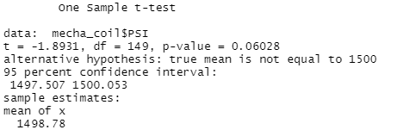

Reviewing the results of the suspension coil T-test across all lots, they are not statistically different from the population average.

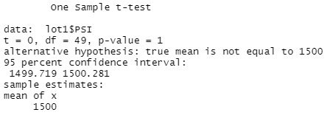

The results of the Lot 1 T-test show they are not statistically different from the population average

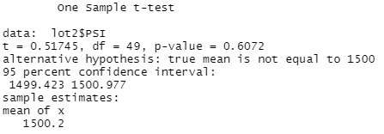

The results of the Lot 2 T-test show they are not statistically different from the population average

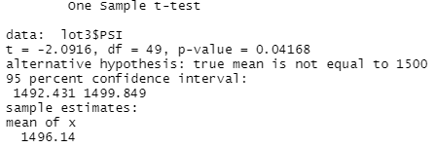

The results of the Lot 3 T-test are slightly statistically different from the population average

Study Design: MechaCar v. Competition

* Metric to Test: Driving range (fuel tank size x MPG)
* Null Hypothesis: There is no significant difference between a MechaCar’s driving range and the driving range of the competitions’ vehicles
* Statistical Test: 2 sample T-test
* Data Needed: Driving range values for multiple models of cars