Claire Golden

UCB Ext. Data Analysis and Visualization Bootcamp

Feb. 20, 2022

**VBA of Wall Street: Week 2 Challenge**

Overview & Purpose

This week I was tasked with reviewing data of several green stock options in order to recommend which stocks are doing well and are worth investing in. I looked at the daily values of 12 different green stocks over the years 2017 and 2018.

Results

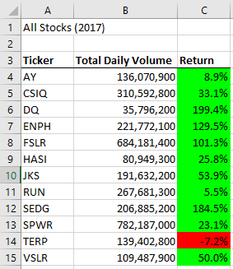

There were 2 stocks, ENPH and RUN, that had positive returns for both years I analyzed. ENPH has a lower rate of return in 2018 than in 2017, which doesn’t suggest a promising projection for future performance. RUN’s return increases from 2017 to 2018 which indicates a positive trend.

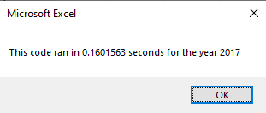 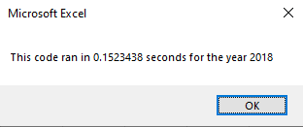

The code ran about 0.01 sec faster for 2018 than 2017. This makes sense to me since the stocks had higher return values in 2017, that would mean more digits to be run through the code.

Summary

The advantages of refactoring this code were increasing the speed at which the code runs and making the code easier to understand for the reader. I was also able to add in some extra format details to make the final output more visually pleasing. One big disadvantage was that the refactoring process can take a lot of time, but the silver lining is that you run into more possible issues that must be fixed so the code ends up better off for it.

The refactored version of this code takes up way less room spatially because it merged all the loops into one uniform formula that works for each loop. Additionally, the refactored code allows the addition or more worksheets containing data for these stocks for following years and this macro would be applicable to those worksheets without making any changes to the code.