*The National Quesstion and Jewish Heterogeneities in Victorian Britain: Theorising the Nation and the Jewish Subject in George Eliot’s Daniel Deronda and in Anglo-Jewish Writing*

The national question came to dominate much of the latter half of the 19th Century in both England and Continental Europe, and the question of Jewish nationhood became more and more of a concern following Jewish emancipation and the increasing assimilation and radicalisation of Jewish communities. Nationality as a concept increasingly took on significance as Empires continued to expand, and national movements emerged, producing cultural output that engaged directly with what it meant to be a nation. Where nationalism may have in many places been a progressive force, it was also accompanied by an increasing preoccupation with racial science which sought to separate peoples along pseudo-scientific conceptions of race popularised in practices like phrenology and eugenics which had implications not just for how peoples were perceived, but also in how they were depicted in literary works. Furthermore, writers sought to achieve what John Ruskin and Thomas Carlyle had identified as establishing a national consciousness through the medium of art. In this essay I will explore how Jewish identity and the questions of nationality, race, and Empire that surrounded it in the late 19th Century were engaged with by both George Eliot in *Daniel Deronda* (1876), and by Anglo-Jewish writers themselves, with particular reference to the work of Amy Levy and how it challenges many of Eliot’s narratives.

George Eliot is frequently lauded for her humanistic and sympathetic portrayal of Jews in Daniel Deronda, but there is a lot of complexity to that portrayal.[1] Whilst often identified as a philosemite, it is clear she did not always have charitable attitudes towards Jews, writing in a letter that ‘much of [the Jews’] early mythology and almost all their history is utterly revolting’ and ‘everything specifically Jewish is of a low grade’.[2] It is undeniable that over the course of this letter being written and Daniel Deronda’s publication in 1876, George Eliot’s attitudes towards Jews had shifted significantly. Gertrude Himmelfarb notes that on her travels to Frankfurt, Eliot specifically visited the Jewish quarter and took an interest in German Jewish cultural and intellectual life.[3] By the time she began writing *Daniel Deronda*, it is clear that she had come to regard Jewish scholarship and tradition as a vital part of understanding her own devout Christian faith.[4] *Daniel Deronda* is also one of very few works by Eliot to be set in the present, which differentiates it from her easlier writing and shows its deep preoccupation with contemporary political concerns.

With the question of politics and nationality comes the fraught question of race, given how tightly bound the two were in 19th Century political consciousness.[5] *Daniel Deronda* is indeed a deeply racialised novel and from the very beginning of the novel, Gwendolen finds herself fixated on the dark features of Daniel – features that mark him out as a racialised other. Lydia Glasher’s marginalisation is also tied to her status as a racialised other, and the characters who end up in that category have no way of escaping it. One interesting source of contemporary Jewish praise was from Joseph Jacobs in ‘Mordecai: A Protest Against the Critics by a Jew’ (1877). Jacobs was a eugenicist who worked with Francis Galton to create composite photos of racial “types” as part of their project of distinguishing racial categories.[6] To men like Jacobs, this was seen as a progressive endeavour – granting Jews legitimacy as a people through establishing them as a distinctive race.[7] Of course, the long term consequences of racial antisemitism would be horrific, but sciences like phrenology and eugenics did initially have progressive appeal, and radically changed how race and nationality would be perceived in the public consciousness.[8]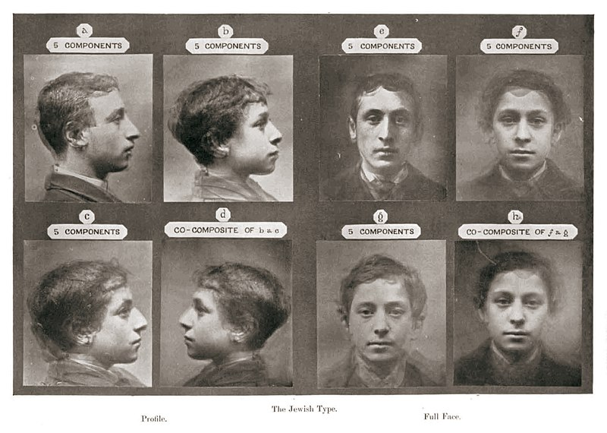Fig. 1. Composite photos of a “Jewish Type” created by Francis Galton and Joseph Jacobs to enable racial categorisation in 1883. Courtesy of Wikimedia Commons, accessed 20 April 2021. <https://commons.wikimedia.org/wiki/File:Jewish_Type_Galton.jpg>

Jacobs extends his ‘gratitude for the wonderful completeness and accuracy with which George Eliot has portrayed the Jewish nature’,[9] and argues that Daniel Deronda represents ‘a marvellously full and accurate way of all the many sides of our complex national character’.[10] His praise for her depicition of an inherent Jewish nature and his identification of a distinct national character shows his own personal appreciation for the racialised content of the novel, even though that content has grave implications. Daniel Novak traces the novel’s corporeal focus on the Jewish body and the racially encoded other to the eugenics of Galton, and sees Daniel Deronda as a series of racial re-embodiments in ‘Mordecai’s re-embodiment in Deronda, Deronda’s discovery of his Jewish origins, ant the “becoming body” of a Jewish national home’.[11] He also ties the focus on the body to the emergence of photography as a technology, and the distinct Victorian visual culture that accompanied it, seeing the novel’s bodily focus as ‘a literal reproduction of visual technology in the age of photography’.[12] *Daniel Deronda* depicts Jewishness as something encoded into the body, well displayed when Daniel meets his mother, Leonora Halm-Eberstein, and she specifically notes that it is as if their Jewishness is ‘tattooed under our clothes’.[13] Whilst Leonora represents an assimilationist model of being Jewish, even she cannot escape what she sees as a bodily encoded reality – that being Jewish cannot be hidden.

Daniel Deronda claims ‘it is the impulse of my feeling – to identify myself, as far as possible, with my hereditary people’.[14] Here race is given an affective affirmation, feeling is bound to blood, and consequently nationality and race become emotional issues. Mordecai’s guidance is what leads Daniel towards reclaiming his Judaism and discovering Zionism, and the pursuit of nationality is depicted as something felt in one’s soul; that nationality is not just a matter of ascribed belonging, but of affect and feeling through kinship. In *Daniel Deronda* being Jewish is about identifying himself with the bonds of blood and inherited racial categories. If nations are naturally formed along the lines of race – an idea that dominated the 19th Century – then outsiders who do not fit into that hegemonic racial category disrupt and complicate the idea of the nation itself.[15] Eliot’s solution to this is to imagine a separate nation for the Jews, and the presumption of the novel is that the desire to build one’s own nation along the lines of race is a natural thing. Here, the universalist values of the period following the French Revolution and the Napoleonic era which led to Jewish emancipation are challenged in favour of a new separatism enabled by nationalism.[16]

Mordecai’s anti-assimilationist views futher elucidate this nationalism, and he argues that ‘the partition of mankind into races and nations, resulting in various points of view or varieties of national genius’ has enriched the human character and soul in a way cosmopolitanism never could.[17] Richa Dwor also argues that this rejection of cosmopolitanism allows for ‘maintaining seperateness’ in a way that ‘facilitates identification with nationality’.[18] This clearly reflects Eliot’s idea that nationhood and national belonging are inevitable and are part of an inherent human spiritual need, and this is further seen in how travel is used as a device to find oneself – the “wandering Jew” must be doomed to always exist between countries until they establish their own, and Klesmer specifically references this trope, exclaiming ‘no, my name is Elijah, I am the wandering Jew’, when joking with Miss Arrowpoint.[19] Given Eliot’s rejection of Klesmer’s cosmopolitanism when he says he ‘feels still more of a cosmopolitan than a Jew’,[20] she is clearly seeking to reject that trope of rootlessness, and re-establish Jewish subjectivity in a national project. Eliot is also keen to elevate affective Jewish identity over actual religious practice. Deronda says, ‘I shall call myself a Jew… But I will not say that I shall profess to believe exactly as my fathers have believed’,[21] which shows him embracing a hereditary identity rather than practicing traditional Judaism. The symbolic affirmiation of oneself as a Jew is prioritised over Judaism itself, and as such Deronda identifies with the Jews as a perceived nation rather than a religious community.

Before Daniel discovers that he is Jewish, he is initially very dismissive of Jews, and is only willing to accept them if they forgo their religious customs and traditions. Eliot writes that:

His interest had never been practically drawn towards existing Jews, and the facts he knew about them, whether they walked conspicuous in fine apparel or lurked in by-streets, were chiefly of a sort most repugnant to him.[22]

The fact that he only changes his views towards Jews when he realises he is Jewish reflects a certain acceptance that antisemitism is inevitable amongst gentiles, and that tension between Jews and gentiles can only be resolved through Zionism. It also illustrates just how arbitrary the designation of who is a Jew can be, and a liminality between what it means to be a Jew and a gentile is displayed. Deronda does not have to even reveal himself to be a Jewish man – he could live life whilst pretending to be a gentile as many of his Sephardic *converso* ancestors likely would have – but he chooses to embrace being Jewish. To Eliot, it seems that embracing one’s national and racial heritage is an inherent part of living a fulfilled life and of being true to oneself. Bernard Semmel further argues that Eliot emphasised ‘the central importance of nation or race, and the national inheritance one was obligated not to reject but to take up and fulfil’. [23] Semmel further argues that in writing Daniel Deronda, Eliot had become convinced that the ‘values of individualism and cosmopolitanism that prevailed in British liberal circles would impair both family affection and social cohesion’.[24] The resolution of the novel with a nationalist realisation and the rejection of cosmopolitanism of characters like Klesmer, who ‘looked forward to a fusion of the races’,[25] in favour of a Zionist framework shows Eliot locating nationalism as a natural extension of family life, as was so common in contemporary nationalist narratives.[26] Ultimately, the Zionist resolution of the novel allows Daniel and Mirah to escape the problematic aspects of the Jewish London they were only ever tourists in, at a time when Jews were becoming more and more numerous in the East End.[27]

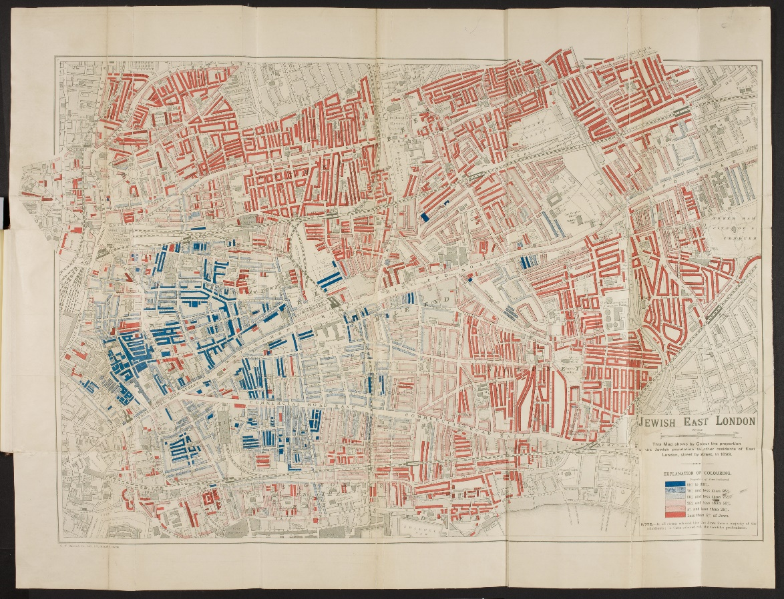

Fig. 2. A map of the Jewish East End drawn by George Arkell in 1900, darker blue areas have the highest concentration of Jews, and darker red areas the lowest. Courtesy of the British Library, accessed 21 April 2021. < https://www.bl.uk/collection-items/jewish-east-london>

The question of imperialism must also be remembered when critically assessing Daniel Deronda. It is perhaps prescient that George Eliot was writing at a time when Palestine was an Ottoman territory, and therefore establishing a Jewish state there would not challenge the hegemony of the British Empire. Palestine would become a British Mandate in 1920, and it is worth asking if Eliot would have felt as sympathetic if she had been writing when it was a British territory. Certainly, the arrival of an English gentleman to Palestine could be seen as a civilising, imperialist mission while it remained Ottoman rather than British. Edward Said explicitly identified *Daniel Deronda* as an imperialist novel in *The Question of Palestine* (1979), arguing that Eliot’s utopian Zionism is callously indifferent to the native Palestinian population.[28] Using Said’s critical lens, we can interpret Eliot’s Zionism as a way of solving the “Jewish Question” by transplanting an English Jew, and the European Jews he sought to convert to Zionism with Mirah, to the Middle East. It also forgets the complexity of the region in favour of idealistic narratives, such as Mordecai’s contention that:

What is needed is the leaven – what is needed is the seed of fire. The heritage of Israel is beating in the pulses of millions; it lives on in their veins as a power without understanding [...] Let the reason of Israel disclose itself in a great outward deed, and let there be another great migration, another choosing of Israel to be a nationality whose members may still stretch to the ends of the earth, even as the sons of England and Germany, whom enterprise carries afar, but who will still have a national hearth and a tribunal of national opinion.[29]

Here Mordecai sees Israel as a national project necessitating the spark of agitation from diaspora Jews, and the action of mass migration. He does not necessarily reject the idea of Jews simultaneously still living as emancipated, integrated citizens of Europe, but sees the migration to the Holy Land as a matter of historical inevitability, and as something spiritually and historically mandated. However England and Germany’s relatively well assimilated Jews is ignorant to how many desperately poor Jews in Eastern Europe did not have this opportunity for migration, and how many Jews lived in Muslim countries already and who would be later forced to flee due to backlash towards the Zionist project.[30] For all the nuance and spiritual complexity of Mordecai’s understanding of Judaism, his perspective on being Jewish remains resolutely eurocentric and orientalist.

The ending of *Daniel Deronda* opens up many notorious ambiguities. Eliot’s construction of the idealised Jew takes a somewhat darker turn in the death of Mordecai, whose consumptive death as a narrative device to end the novel reflects the typical Victorian novel’s cliché of a morally pure consumptive dying as a resolution. In this death, Eliot’s construction of Jewish masculinities emasculates Mordechai, the Jewish man who had lived a fully realised Jewish life, and the idealised Jewish masculinity of Daniel Deronda triumphs – an English Gentlemen rendered Jewish through self-realisation rather than upbringing, social designation, and subjugation. This is particularly interesting given the proto-Zionist nature of the novel, and the preoccupation of later Zionists of creating a “New Jew” who would be free from the humiliation and emasculation of diaspora life. [31] The construction of a new Israeli masculinity was a huge part of the ideological underpinnings of the modern state of Israel, which sought to empower a new Jewish subject who would never again be defenceless and humiliated. [32] Mirah’s marriage to Daniel also shows her achieving a religious pinnacle of religious Jewish femininity, and marriage is a typically Victorian resolution. Eliot may have been basing this on what she perceived as a celebratory achievement for what she understood of religious Jews, but marriage does not necessarily mean the elevation of Jewish womanhood. If their relationship didn’t work out, would Mirah have no difficulty obtaining a *get*? Would married life genuinely be happy one for them? It is particularly interesting to introduce the work of Amy Levy in this context, her experiences as a queer Jewish woman, and particularly the novel *Reuben Sachs* (1888) – her complicated portrait of Jewish family life. *Reuben Sachs* is extremely critical of traditional religious Jewish family norms and the subordination of women within that traditional structure of Judaism, and directly challenges Jewish tradition in a way *Daniel Deronda* is never willing to do.

Brian Cheyette identifies *Reuben Sachs* as a ‘novel of revolt’ which emerged in response to the seismic changes affecting Anglo-Jewry in the later 19th Century.[33] As huge waves of immigrants from pogroms in Eastern Europe settled in the UK and British people themselves became more preoccupied with the “Jewish question”, post-emancipation assimilationist narratives began to weaken and new critiques of ‘propaganda fiction’ which attempted to idealise Anglo-Jewish life emerged amongst British Jewish writers.[34] Earlier Victorian Jewish writers like Grace Aguilar and Benjamin Disraeli were keen to stress the similarities between gentiles and Jews in Britain, with Aguilar writing that ‘Only in some private and personal characteristics, and in religious belief, does the Jew differ from his neighbours’.[35] But as the century went on and conditions for Jews in Britain changed, a new desire emerged to critique the painful and problematic aspects of Jewish life beyond liberal idealism. [36] Linda Gertner Zatlin argues that later Victorian Jewish novels sought to differentiate themselves from earlier ‘novelists who stressed the ‘Englishness’ of the Jew, presenting him generally as a product of the middle class, in manners if not in wealth’.[37]. Even the name itself, *Reuben Sachs*, seems to be a parody of *Daniel Deronda*, and the content of the novel fiercely critiques its idealism and naiveté. Furthermore, Susan David Bernstein argues that the framing of the story through the narrator’s gaze specifically mocks the eugenicist attempts to classify a physical Jewish “type”.[38] This rejection of reductionist racial categories and imagined national projects offers a more ambivalent and multi-faceted take on the Anglo-Jewish experience.

In her journalistic ouput, Levy also specifically engaged with the issue of Jewish depictions in literature, and with *Daniel Deronda* itself. Her article ‘The Jew in Fiction’ (1886) published in *The Jewish Chronicle* specifically noted that ‘there has been no serious attempt at serious treatment of the subject; at grappling in its entirety with the complex problem of Jewish life and Jewish character’, and that the richness of Jewish life and of Jewish humanity itself ‘has been found worth of none but the most superficial observation’.[39] Given the one-dimensionality that can be interpreted of Daniel in particular, where he can only be depicted in terms of almost idealised Christian virtue and morality despite his eventual Jewish formation of self, Levy’s critique is potent. Levy desired to see ordinary Jews depicted with all their ‘surprising virtues and no less surprising vices’,[40] but Daniel is not given the moral ambiguity and complexity of a character like Gwendolen, and his heroic idealisation to the point of caricature does make him seem more of a device for a moralistic literary lesson than a believable, well-rounded human being. Levy rejects both the idealised Jewish subject of Daniel Deronda and the vulgar villain of Fagin in Charles Dickens’ *Oliver Twist* (1838) as being the only popular literary models of British Jews and rejects this hero/villain dichotomy as demeaning to the humanity of ordinary Jews. *Reuben Sachs* further challenges this dichotomy by creating Jewish characters that are deeply ambiguous and complicated, both in their characterisation, and their relationships with the very essence of being Jewish. Levy further railed against the subordination of Jewish women in religious communities, writing in ‘The Middle-Class Jewish Women of Today’ (1886) that life for an ordinary middle-class Jewish woman was ‘carefully excluded, with almost Eastern jealousy from every-day intercourse with men and youths of her own age’, where she is ‘taught to look upon marriage as the only satisfactory termination to her career’, and where ultimately ‘her lot is a desperately unenviable one’.[41] This gives pause for serious reflection on Mirah’s depiction in Daniel Deronda, and Levy attacks the idea of marriage necessarily being a happy ending for a Jewish woman.

*Reuben Sachs* categorically rejects the Zionist conclusions of *Daniel Deronda*, and mocks Eliot’s perceived attempt to act as a gentile emissary for Jews. Take for instance, the following passage:

“I wonder”, cried Rose, throwing herself into the breach, “what Mr. Lee- Harrison thought of it all.”  
“I think,” said Leo, “that he was shocked at finding us so little like the people in Daniel Deronda.”  
“Did he expect,” cried Esther, “to see our boxes in the hall, ready packed and labelled Palestine?”  
“I have always been touched,” said Leo, “at the immense good faith with which George Eliot carried out that elaborate misconception of hers.”[42]

Here Levy shows an immense skepticism towards both *Daniel Deronda* as a novel, and towards Zionism as a national movement. She attacks the naivete of George Eliot trying to act as a friend to the Jews without realising the complexity and heterogeneity of Jewish intellectual and cultural life, even if she did mean well. Levy clearly realises that it is unfair for a gentile to try and act as a spokesperson for Jews. The character of Bertie Lee-Harrison is a particulary interesting foil to the character of *Daniel Deronda*. He is a wealthy gentile whose philosemitism leads him to convert to Judaism, but only to adopt an exaggerated caricature of what it means to be Jewish which he has picked up from his own bigoted assumptions about Jews. His philosemitism is therefore revealed to really be antisemitic as he acts as an imperialist seeking to absorb what he sees as the supposed authenticity of an “exotic” people, picking and choosing their customs and fetishizing them as a racialised other. This parody of Daniel Deronda reveal’s Eliot’s Jewish interests to be superficial and inauthentic, with no real relation to the lives of ordinary Jews.

Semmel argues that Eliot’s portrait of Jewish life is coloured by her use of Jews as a metaphor, and they are merely used as a device to explore the national question in a way that is fundamentally antisemitic.[43] Amanda Anderson further develops this point, noting that in the Hegelian tradition, the Jewish people create a problem for modernity, and by implication nationalism, through their resistance to modernity and their separate character.[44] *Daniel* *Deronda*’s narrative arc is ultimately about rediscovering the bonds of family, and the bonds of nationhood and race – both of which had been challenged by modernity and which to Eliot were inevitably linked together. Levy on the other hand is scathing of the traditional Jewish fixation on family bonds at the expense of human happiness, and rejects the idea of a racialised Jew, offering a much more nuanced portrait of what it means to be Jewish. Where Eliot tries to homogenise Jews into a single racial category despite the great diversity of Jewish peoples and experiences, Levy provides a far more realistic portrait of Jewish heterogeneity and complexity. The national questions of both Britain and the Jewish people are not satisfactorily resolved in *Daniel Deronda*, and the novel raises more questions than it answers. The complexity of Victorian Jewish intellectual life is further entrenched by the emergence of radical publications amongst Yiddish-speaking immigrants in the Jewish East End, such as *Der Arbeiter Fraint* and *Das Fraye Vort*, which were often explicitly anarchist or communist, and rejected the idealist Zionism of *Daniel Deronda* outright.[45] *Daniel Deronda* is certainly a break from the anti-Semitic defamation of novels like *Oliver Twist*, but it does not have any appreciation for just how rich and heterogenous Victorian Jewish lives and perspectives were. As Anderson explains, ‘the Jewish Question interrogates the limits of modernity’,[46] and the engagement of both Eliot and Levy with what it meant to be Jewish sought to address not just Jewish life, but also modernity aand the nation itself, but in the case of Eliot this interrogation ultimately fails due to her oversimplifications and one-dimensionality.

*Bibliography*

Aguilar, Grace, ‘Social Arrangements of the English Jews’, in *Grace Aguilar: Selected Writings*, ed. By Michael Galchinsky (Peterborough: Broadview Press, 2003)

Anderson, Amanda, ‘George Eliot and the Jewish Question’, *The Yale Journal of Criticism*, 10.1 (1997), 39-41

Arkell, George. 1900. Map of Jewish East London. Map on canvas. Accessed 21 April 2021. https://www.bl.uk/collection-items/jewish-east-london

Cheyette, Brian, ‘From Apology to Revolut: Benjamin Farjeon, Amy Levy and the Post-Emancipation Anglo-Jewish Novel, 1880-1900’, *Jewish Historical Studies*, 29.1 (1982), 253-265

Dwor, Richa, *Jewish Feeling: Difference and Affect in Nineteenth-Century Jewish Women’s Writing* (London: Bloomsbury, 2015)

Eliot, George, *Daniel Deronda (*Oxford: Oxford World’s Classics, 2014)

Eliot, George, *The George Eliot Letters*, ed. by Gordon S. Haight (New Haven: Yale University Press, 1954)

Galton, Francis and Joseph Jacobs. 1883. Jewish Racial Composite. Composite photograph. Accessed 20 April 2021. <https://commons.wikimedia.org/wiki/File:Jewish_Type_Galton.jpg>

Gertner Zatlin, Linda, *The Nineteeenth-Century Anglo-Jewish Novel* (New York: 1981), p. 51.

Van Ginderachter, Maarten and Marnix Beyen, *Nationhood from Below: Europe in the Long Nineteenth Century* (London: Palgrave, 2012)

Himmelfarb, Gertrude, *The Jewish Odyssey of George Eliot* (New York: Encounter Books, 2009)

Jacobs, Joseph, ‘Mordecai: A Protest Against the Critics’, *Macmillan’s Magazine*, June 1877, 101-111

Laqueur, Walter, *A History of Zionism: From the French Revolution to the Establishment of the Stae of Israel* (New York: Doubleday, 2009)

Levy, Amy, *Reuben Sachs*, ed. By Susan David Bernstein (Peterborough: Broadview Press, 2006)

Meyer, Susan, ‘”Safely to Their Own Borders”: Proto-Zionism, Feminism, and Nationalism in Daniel Deronda’, *ELH*, 60.3(1993), 733-758

Novak, Daniel, ‘A Model Jew: “Literary Photographs” and the Jewish Body in Daniel Deronda’, Representations, 85.1 (2004), 58-97

Said, Edward, *The Question of Palestine* (New York: Knopf Doubleday Publishing Group, 2015)

Semmel, Bernard, *George Eliot and the Politics of National Inheritance* (Oxford: Oxford University Press, 1994)

Tucker, Irene, ‘Historicizing The Theorization of Race: A Nineteenth-Century Story’, *Criticism*, 61.4 (2019), 527-549

1. Susan Meyer, ‘”Safely to Their Own Borders”: Proto-Zionism, Feminism, and Nationalism in Daniel Deronda’, *ELH*, 60.3(1993), 733-758 (pp. 733-734).
2. George Eliot, *The George Eliot Letters*, ed. by Gordon S. Haight (New Haven: Yale University Press, 1954), !, p. 246.
3. Gertrude Himmelfarb, *The Jewish Odyssey of George Eliot* (New York: Encounter Books, 2009), p. 57-58.
4. Himmelfarb, p. 70.
5. Irene Tucker, ‘Historicizing The Theorization of Race: A Nineteenth-Century Story’, *Criticism*, 61.4 (2019), 527-549 (pp. 530-532).
6. Daniel Novak ‘A Model Jew: “Literary Photographs” and the Jewish Body in Daniel Deronda’, Representations, 85.1 (2004), 58-97 (pp. 58-60).
7. Novak, p. 61.
8. Novak, p. 64.
9. Joseph Jacobs, ‘Mordecai: A Protest Against the Critics’, *Macmillan’s Magazine*, June 1877, 101-111 (p. 101).
10. Jacobs, p. 102.
11. Novak, p. 60.
12. Novak, p. 60.
13. George Eliot, *Daniel Deronda (*Oxford: Oxford World’s Classics, 2014), p. 470.
14. Eliot, *Daniel Deronda*, p. 566
15. Tucker, p. 535.
16. Maarten Van Ginderachter and Marnix Beyen, *Nationhood from Below: Europe in the Long Nineteenth Century* (London: Palgrave, 2012), p. 156.
17. Eliot, *Daniel Deronda*, p. 421.
18. Richa Dwor, *Jewish Feeling: Difference and Affect in Nineteenth-Century Jewish Women’s Writing* (London: Bloomsbury, 2015), p. 110.
19. Eliot, *Daniel Deronda*, p. 182..
20. Eliot, *Daniel Deronda*, p. 183.
21. Eliot, *Daniel Deronda*, p. 620.
22. Eliot, *Daniel Deronda*, p. 158.
23. Bernard Semmel, *George Eliot and the Politics of National Inheritance* (Oxford: Oxford University Press, 1994), p. 11.
24. Semmel, p. 7.
25. Eliot, *Daniel Deronda*, p. 184.
26. Van Ginderachter and Beyen, p. 134.
27. Meyer, p. 743.
28. Edward Said, *The Question of Palestine* (New York: Knopf Doubleday Publishing Group, 2015), p. 69.
29. Eliot, *Daniel Deronda*, p. 398.
30. Walter Laqueur, *A History of Zionism: From the French Revolution to the Establishment of the Stae of Israel* (New York: Doubleday, 2009), p. 266.
31. Laqueur, p. 111.
32. Laqueur, p. 192.
33. Brian Cheyette, ‘From Apology to Revolut: Benjamin Farjeon, Amy Levy and the Post-Emancipation Anglo-Jewish Novel, 1880-1900’, *Jewish Historical Studies*, 29.1 (1982), 253-265 (pp.253-254).
34. Cheyette, p. 254.
35. Grace Aguilar, ‘Social Arrangements of the English Jews’, in *Grace Aguilar: Selected Writings*, ed. By Michael Galchinsky (Peterborough: Broadview Press, 2003), p. 333.
36. Meyer, p. 740.
37. Linda Gertner Zatlin, *The Nineteeenth-Century Anglo-Jewish Novel* (New York: 1981), p. 51.
38. Susan David Bernstein, ‘Introduction’, in Amy Levy, *Reuben Sachs*, ed. By Susan David Bernstein (Peterborough: Broadview Press, 2006), p. 16.
39. Amy Levy ‘The Jew in Fiction’, *The Jewish Chronicle*, 15 July 1886.
40. Amy Levy, ‘The Jew in Fiction’.
41. Amy Levy ‘The Middle-Class Jewish Women of Today’, *The Jewish Chronicle*, 17 September 1886.
42. Levy, *Reuben Sachs*, p. 100.
43. Semmel, p. 14.
44. Amanda Anderson, ‘George Eliot and the Jewish Question’, *The Yale Journal of Criticism*, 10.1 (1997), 39-41 (p. 42).
45. Jonathan Rose, *The Intellectual Life of the British Working Classes* (New Haven: Yale University Press, 2010), p. 55.
46. Anderson, p. 39.