**INSTRUCTIONS FOR RUNNING AUTOMATED IMAGE ALIGNMENT**

First time? Start at STEP 1. Otherwise, repeat STEP 4, STEP 6, and STEP 7.

STEP 1 : Download the Python File

Download Automated_Alignment.py from GitHub page.

STEP 2 : Install python

1. Check whether Python is installed (instructions here: <https://www.datacamp.com/blog/how-to-install-python>)
2. If Python is not installed, install it from the **Python website** (instructions here: <https://www.datacamp.com/blog/how-to-install-python>)

STEP 3 : Set Up Virtual Environment

*The virtual environment will allow you to install Python libraries without risking conflict with other projects.*

1. Open File Explorer or Finder and create a new folder for your project (I named mine Alignment_Project)
2. Open Command Line or Terminal (from start, type Command Line for Windows or Terminal for Mac and open the first result)
3. Type the following using the name of the folder you just created (e.g., replace Project_Folder_Name with Alignment_Project)

|  |  |
| --- | --- |
| Windows: | py -m venv Project_Folder_Name |
| Mac: | python3 -m venv Project_Folder_Name |

STEP 4 : Activate the Virtual Environment

1. Open Command Line or Terminal (from start, type Command Line for Windows or Terminal for Mac and open the first result)
2. Type the following using the name of your project folder

|  |  |
| --- | --- |
| Windows: | Project_Folder_Name\Scripts\activate |
| Mac: | source Project_Folder_Name/bin/activate |

Your command prompt should now have the name of your project folder in brackets before the cursor.

STEP 5 : Install Dependencies

1. Upgrade pip (type the following in command line)

|  |  |
| --- | --- |
| Windows: | py -m pip install --upgrade pip |
| Mac: | Python3 -m pip install --upgrade pip |

1. Install NumPy

|  |  |
| --- | --- |
| Windows: | py -m pip install numpy |
| Mac: | Python3 -m pip install numpy |

1. Install OpenCV

|  |  |
| --- | --- |
| Windows: | py -m pip install opencv-python |
| Mac: | Python3 -m pip install opencv-python |

1. Install Tkinter

|  |  |
| --- | --- |
| Windows: | py -m pip install tk |
| Mac: | Python3 -m pip install tk |

STEP 6 : Run the Script

**MAKE SURE YOUR ENVIRONMENT IS ACTIVE BEFORE DOING THIS, IF NOT, RETURN TO STEP 4.

1. In the command line, navigate to the directory where you stored auto_align.py (I advise putting it in your project folder so that everything is kept in one place) *notice the different slashes on Windows vs Mac

|  |  |
| --- | --- |
| Windows: | cd C:\Folder\Folder |
| Mac: | cd /Folder/Folder |

* 1. To find the path on Windows, navigate to the file in File Explore, right click, choose properties, and check the File location under details

* 1. To find the path on Mac, navigate to the file in Finder, right click, choose Get Info, and check Where

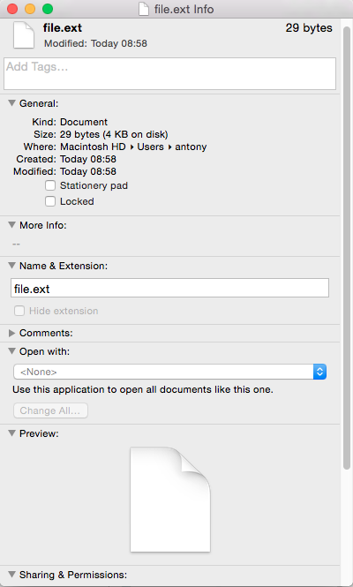

You should end up here:

1. Run the script

|  |  |
| --- | --- |
| Windows: | py auto_align.py |
| Mac: | Python3 auto_align.py |

1. A window will pop up: Navigate to the repeat image
2. A second window will pop up: Navigate to the historical image
3. WAIT (I did not make a loading symbol, should be less than 1 minute for small images, wait up to 5 minutes for full size image)
4. A window will pop up: Type the name for saving the aligned image