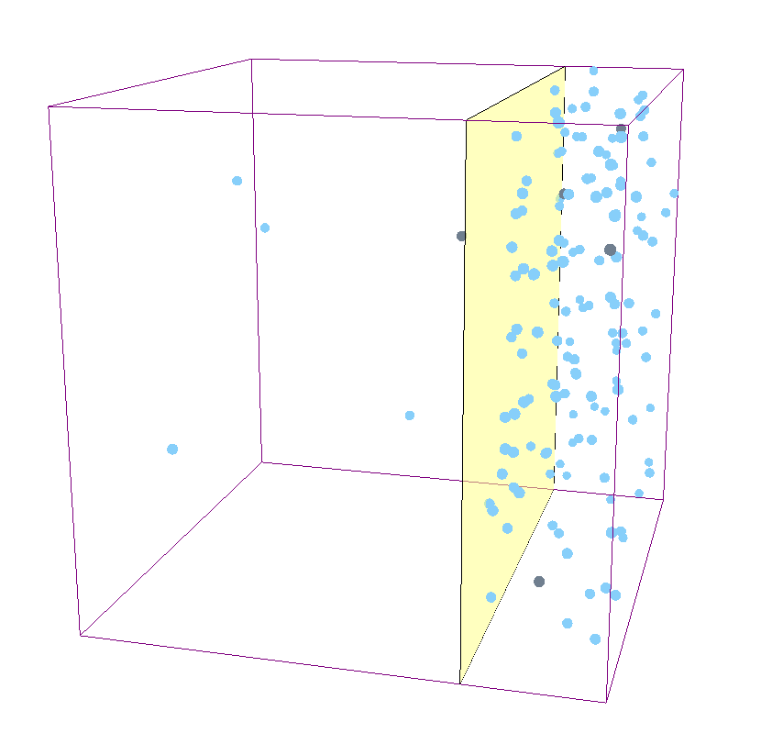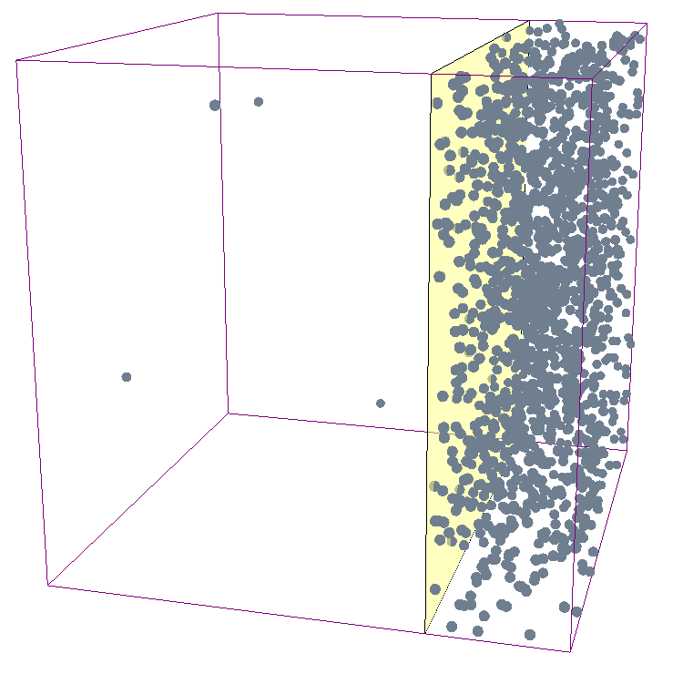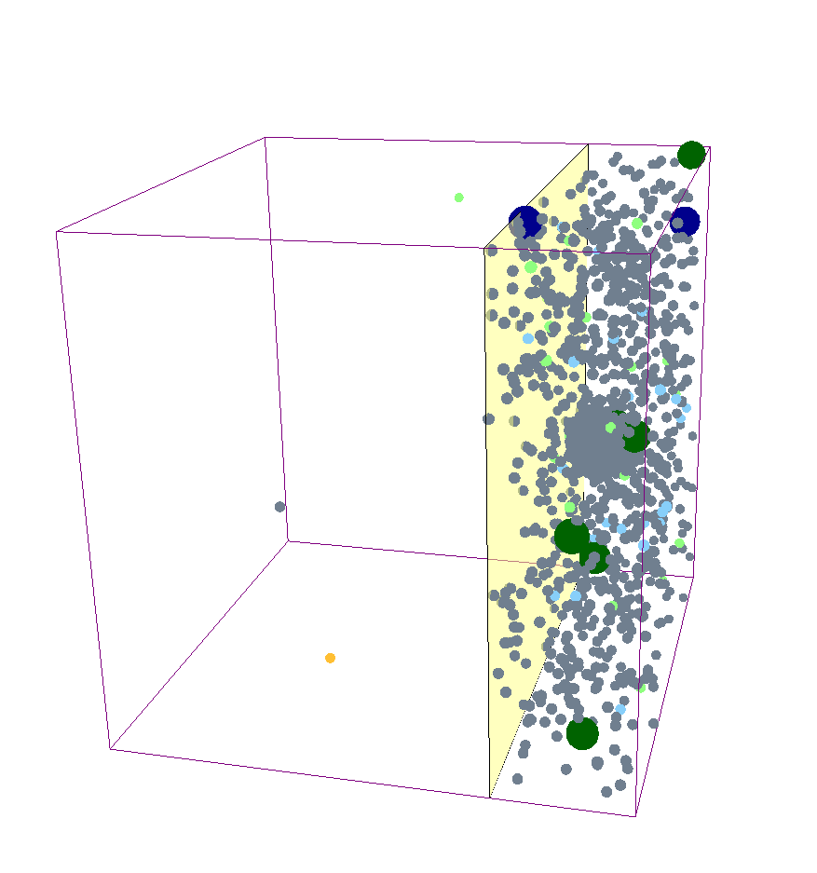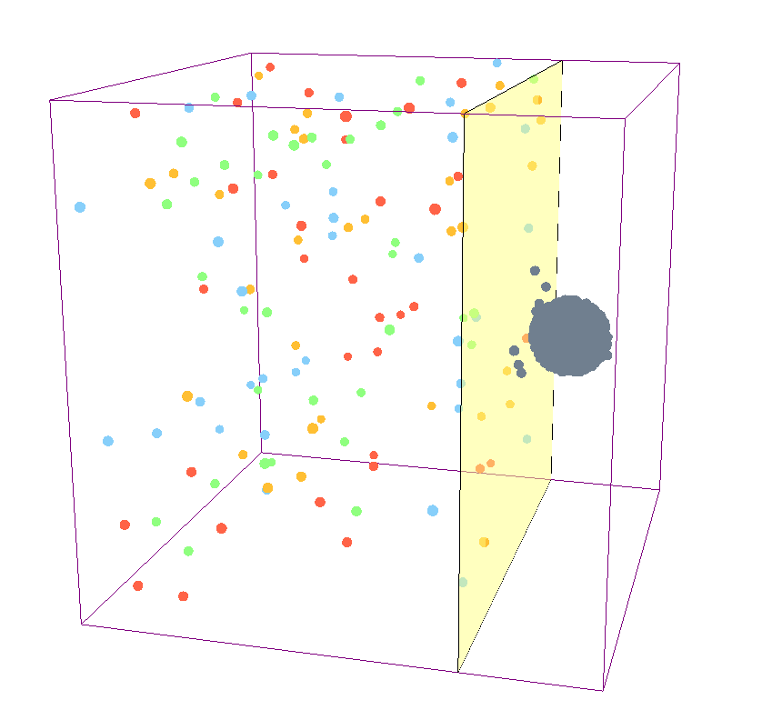

**Day 0**

**Day 33**

**Day 140**

**Day 140**

**Blood**

**Bone**

**Marrow**



CD19+ Tumour Cell

Naïve CAR-T Cell

Central Memory CAR-T Cell

Effector Memory CAR-T Cell

Effector CAR-T Cell

Naïve-Tumour Complex

Central Memory-Tumour Complex

Effector Memory-Tumour Complex

Effector-Tumour Complex