**Procedure**

1. Get the long format dataset for one household (regarded session_id as new id)
2. Transform long format into wide format. (web_id/category)
3. PCA (normalization)
4. K-means & silhouette method

**Two-people Household**

**Website**

Raw dataset (201×3)

|  |  |  |
| --- | --- | --- |
| session_id | web_id | count |

Train dataset (72×42)

|  |  |  |  |  |
| --- | --- | --- | --- | --- |
| session_id | web_id1 | web_id2 | … | web_idn |

Y (72×41)

|  |  |  |  |
| --- | --- | --- | --- |
| web_id1 | web_id2 | … | web_idn |

**1.**

Do not normalize data

Variance of first principal component is large.

Select the first four principal components as features to do K-means clustering

K-means clustering doesn’t perform well

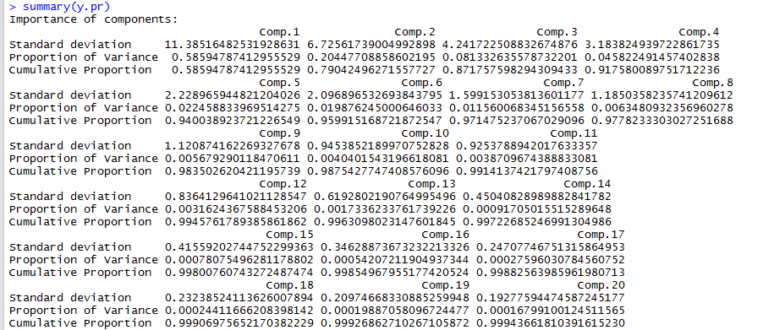

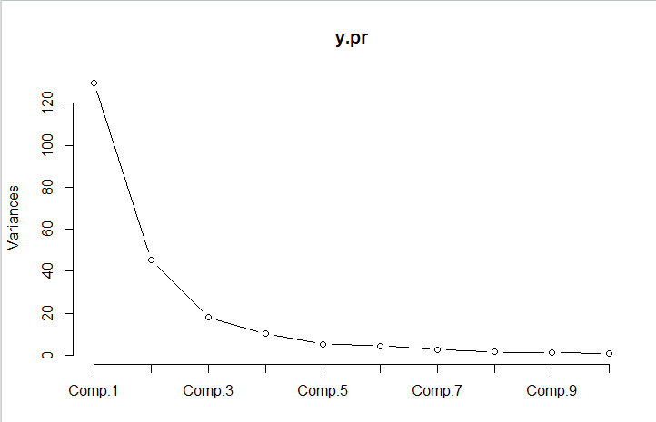

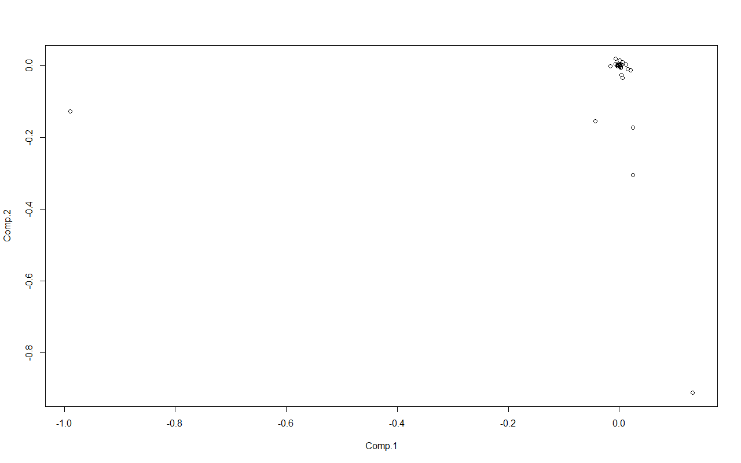

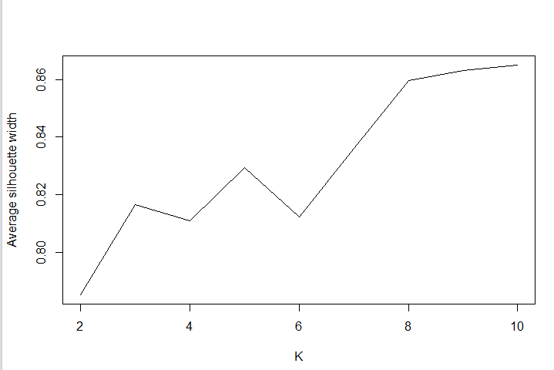

First four principal components

**2.**

normalize data by column (count/sum(count))

the proportion of variance is small.

Select the first four principal components as features to do K-means clustering, and k = 5

Select the first ten principal components as features, and k = 9

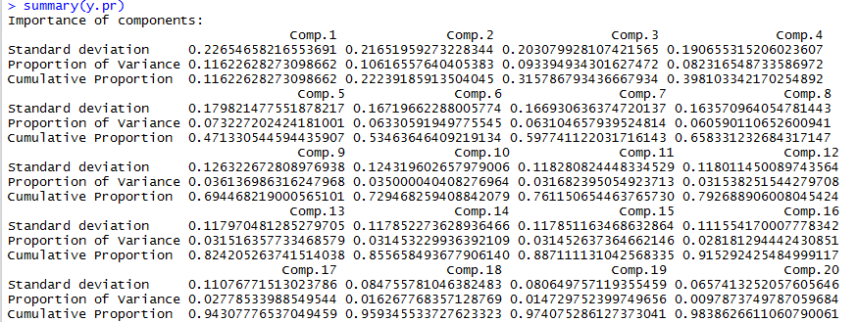

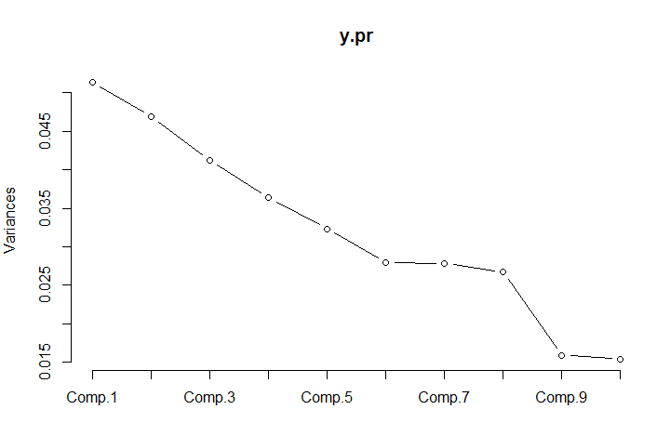

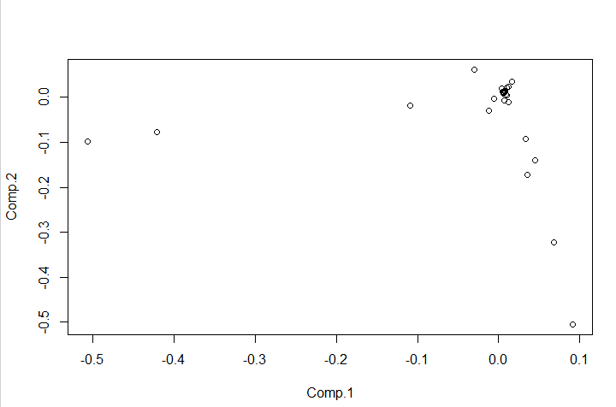

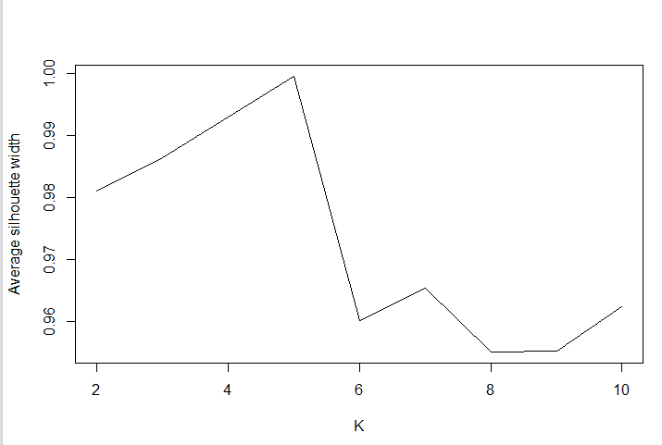

First four principal components

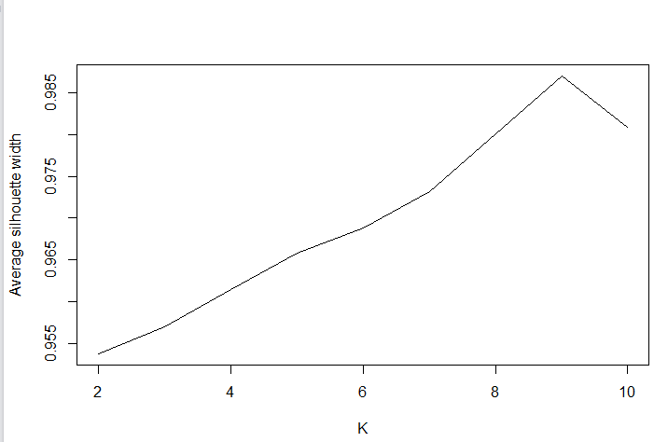

First ten principal components

**3.**

normalize data by rows (count/sum(count))

Select the first four principal components as features to do K-means clustering, and it sometimes works.

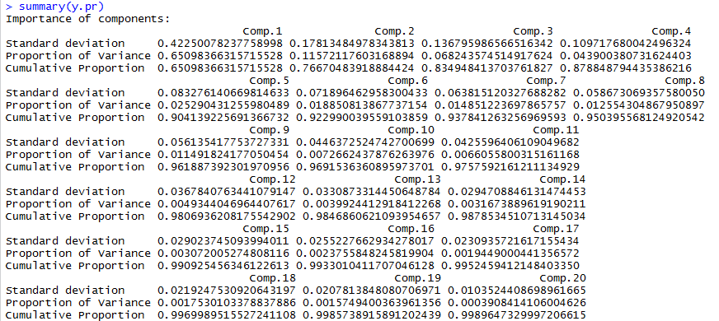

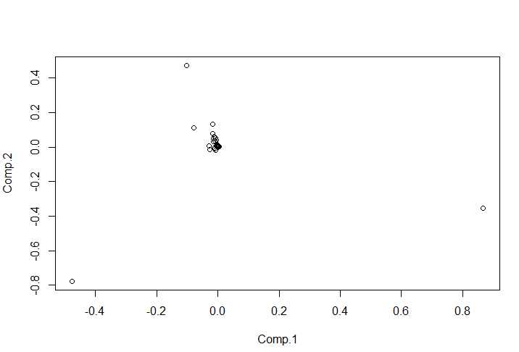

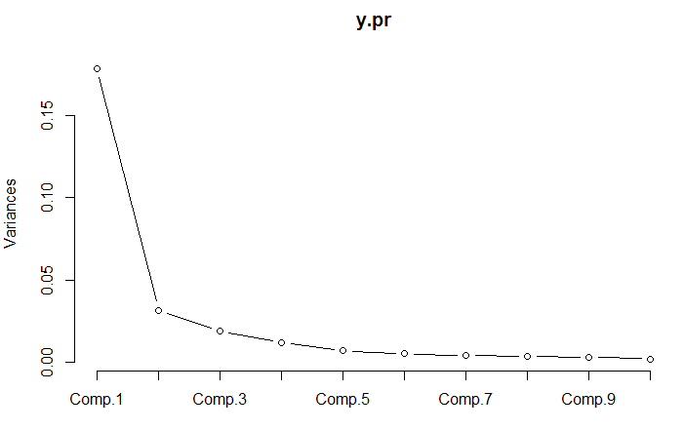

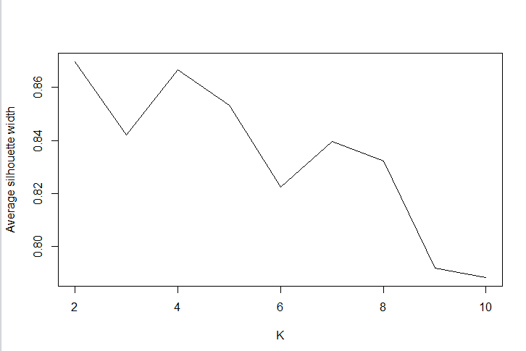

First four principal components

Try it on the other household, which household size = 5

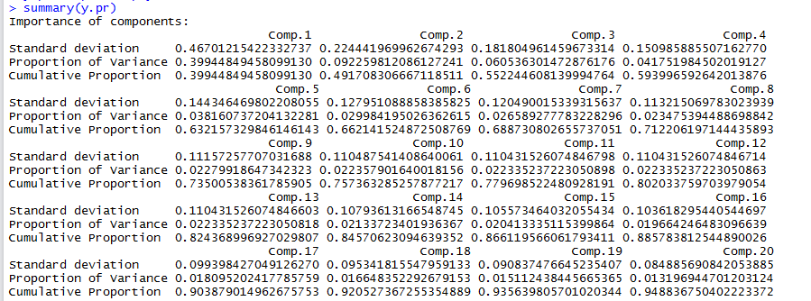

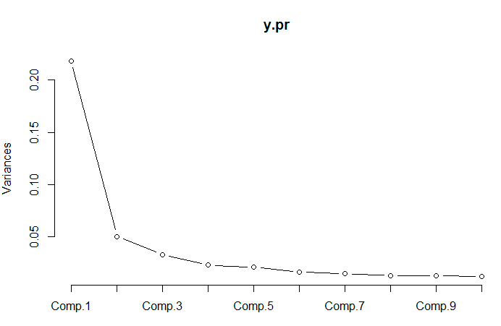

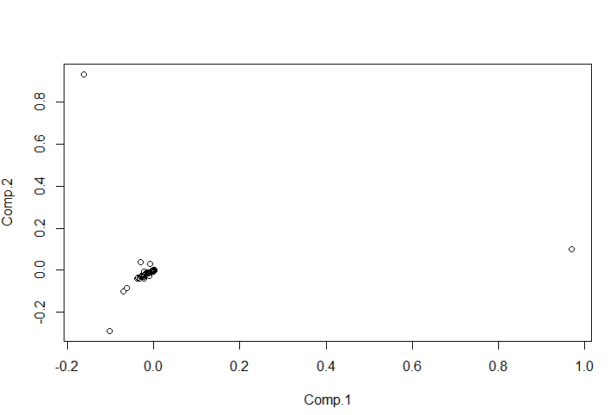

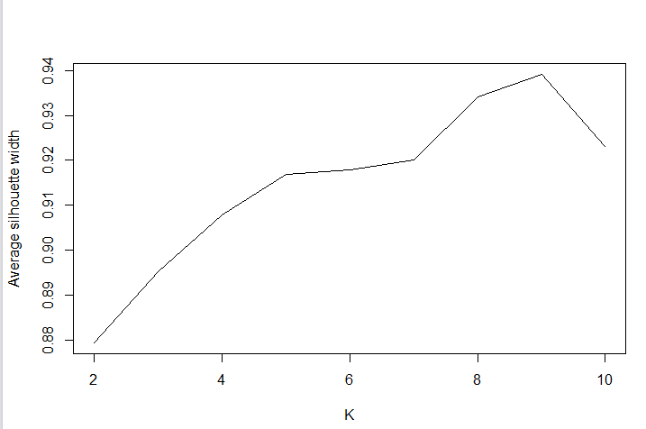

First four principal components

**Category**

Raw dataset (66×3)

|  |  |  |
| --- | --- | --- |
| session_id | category | count |

Train dataset (37×15)

|  |  |  |  |  |
| --- | --- | --- | --- | --- |
| session_id | Category1 | Category2 | … | categoryn |

Y (37×14)

|  |  |  |  |
| --- | --- | --- | --- |
| Category1 | Category2 | … | categoryn |

**1.**

Do not normalize data

Variance of first principal component is large.

Select the first four principal components as features to do K-means clustering

K-means clustering doesn’t perform well, and K=7

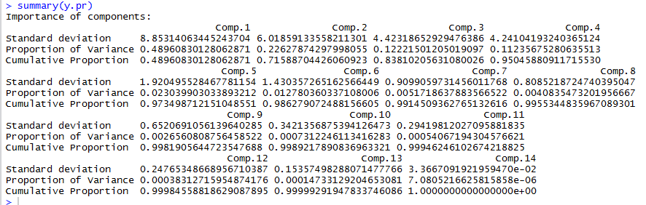

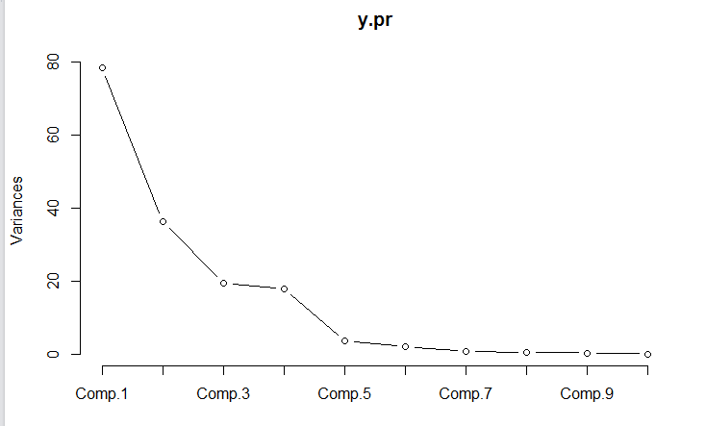

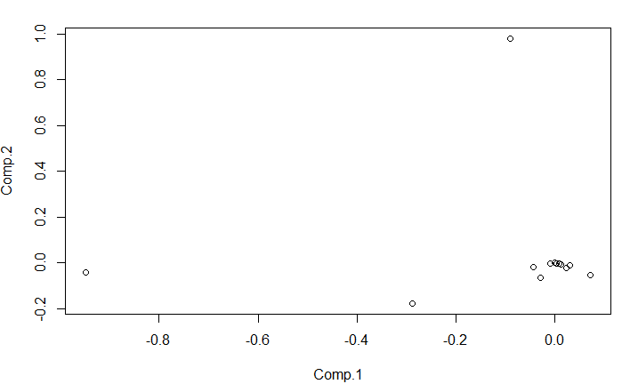

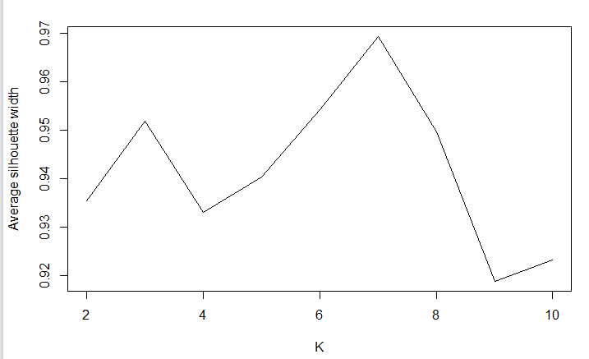

First four principal components.

**2.**

normalize data by column (count/sum(count))

the proportion of variance is small.

Select the first four principal components as features to do K-means clustering, and k = 6

Select the first ten principal components as features, and k = 6

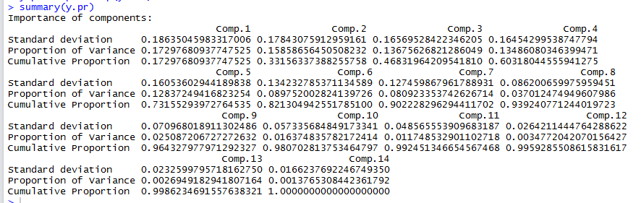

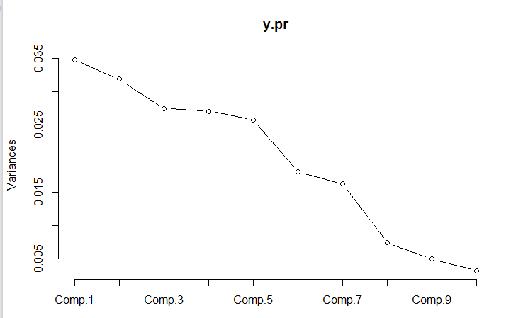

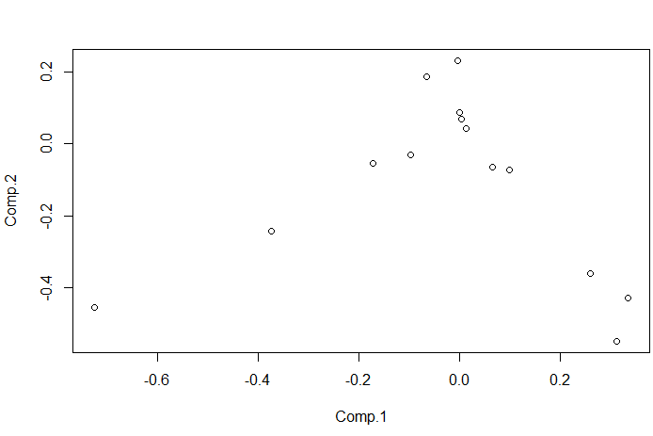

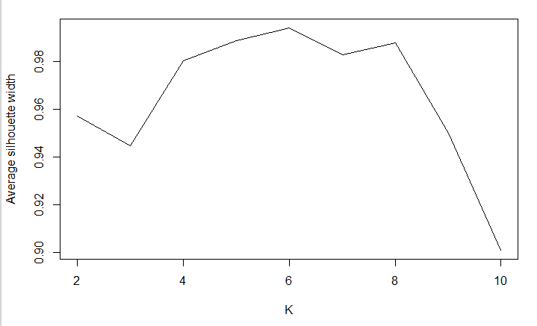

First four principal components

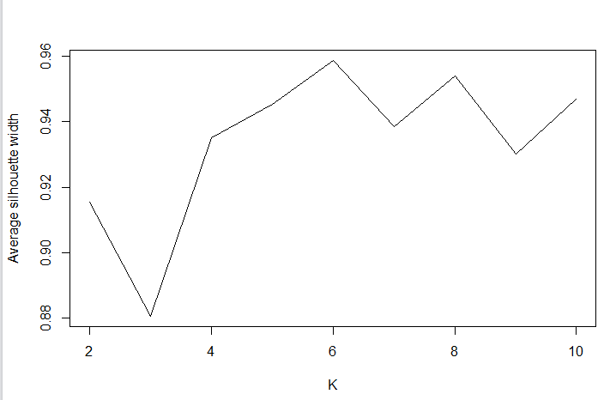

First ten principal components

**3.**

normalize data by rows (count/sum(count))

Select the first four principal components as features to do K-means clustering, and it doesn’t perform well.

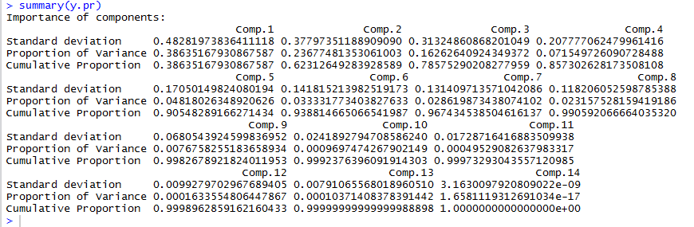

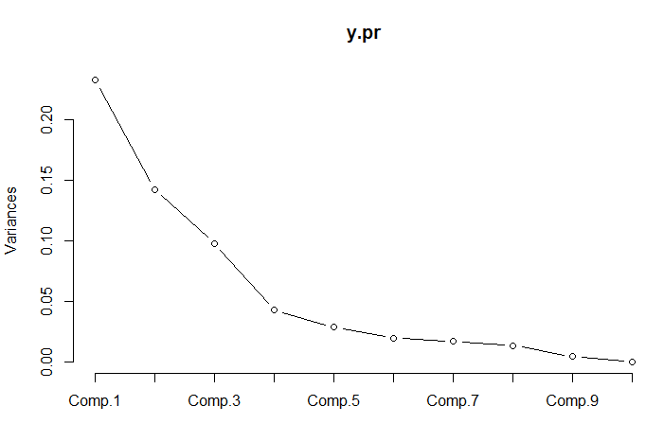

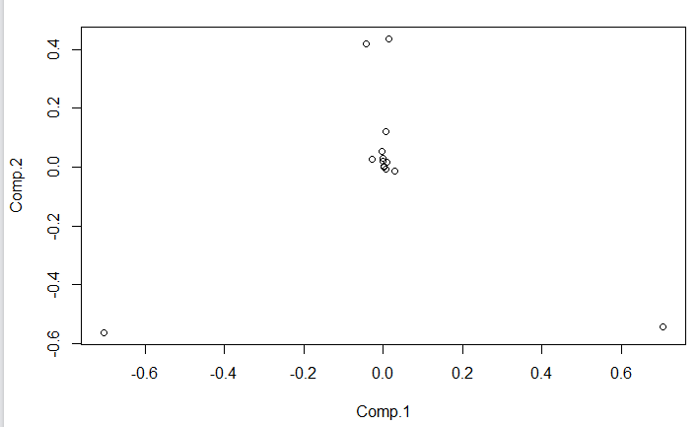

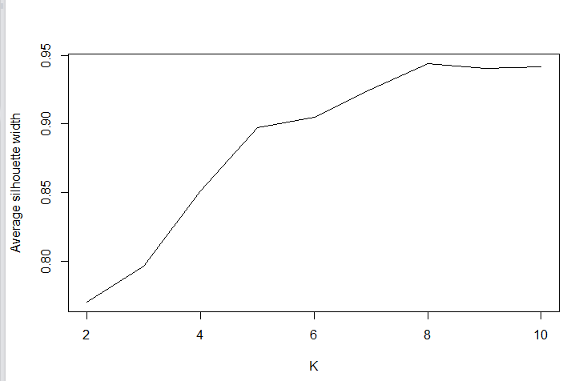

First four principal components

**Improvement**

1. Increase sample size. Used several months’ data rather than one.
2. Try other feature selection methods. Because if we want to compute n PCs, we need n2 observations.
3. Get some new features, such as the time one session last.
4. Delete outliers, such as count = 1.