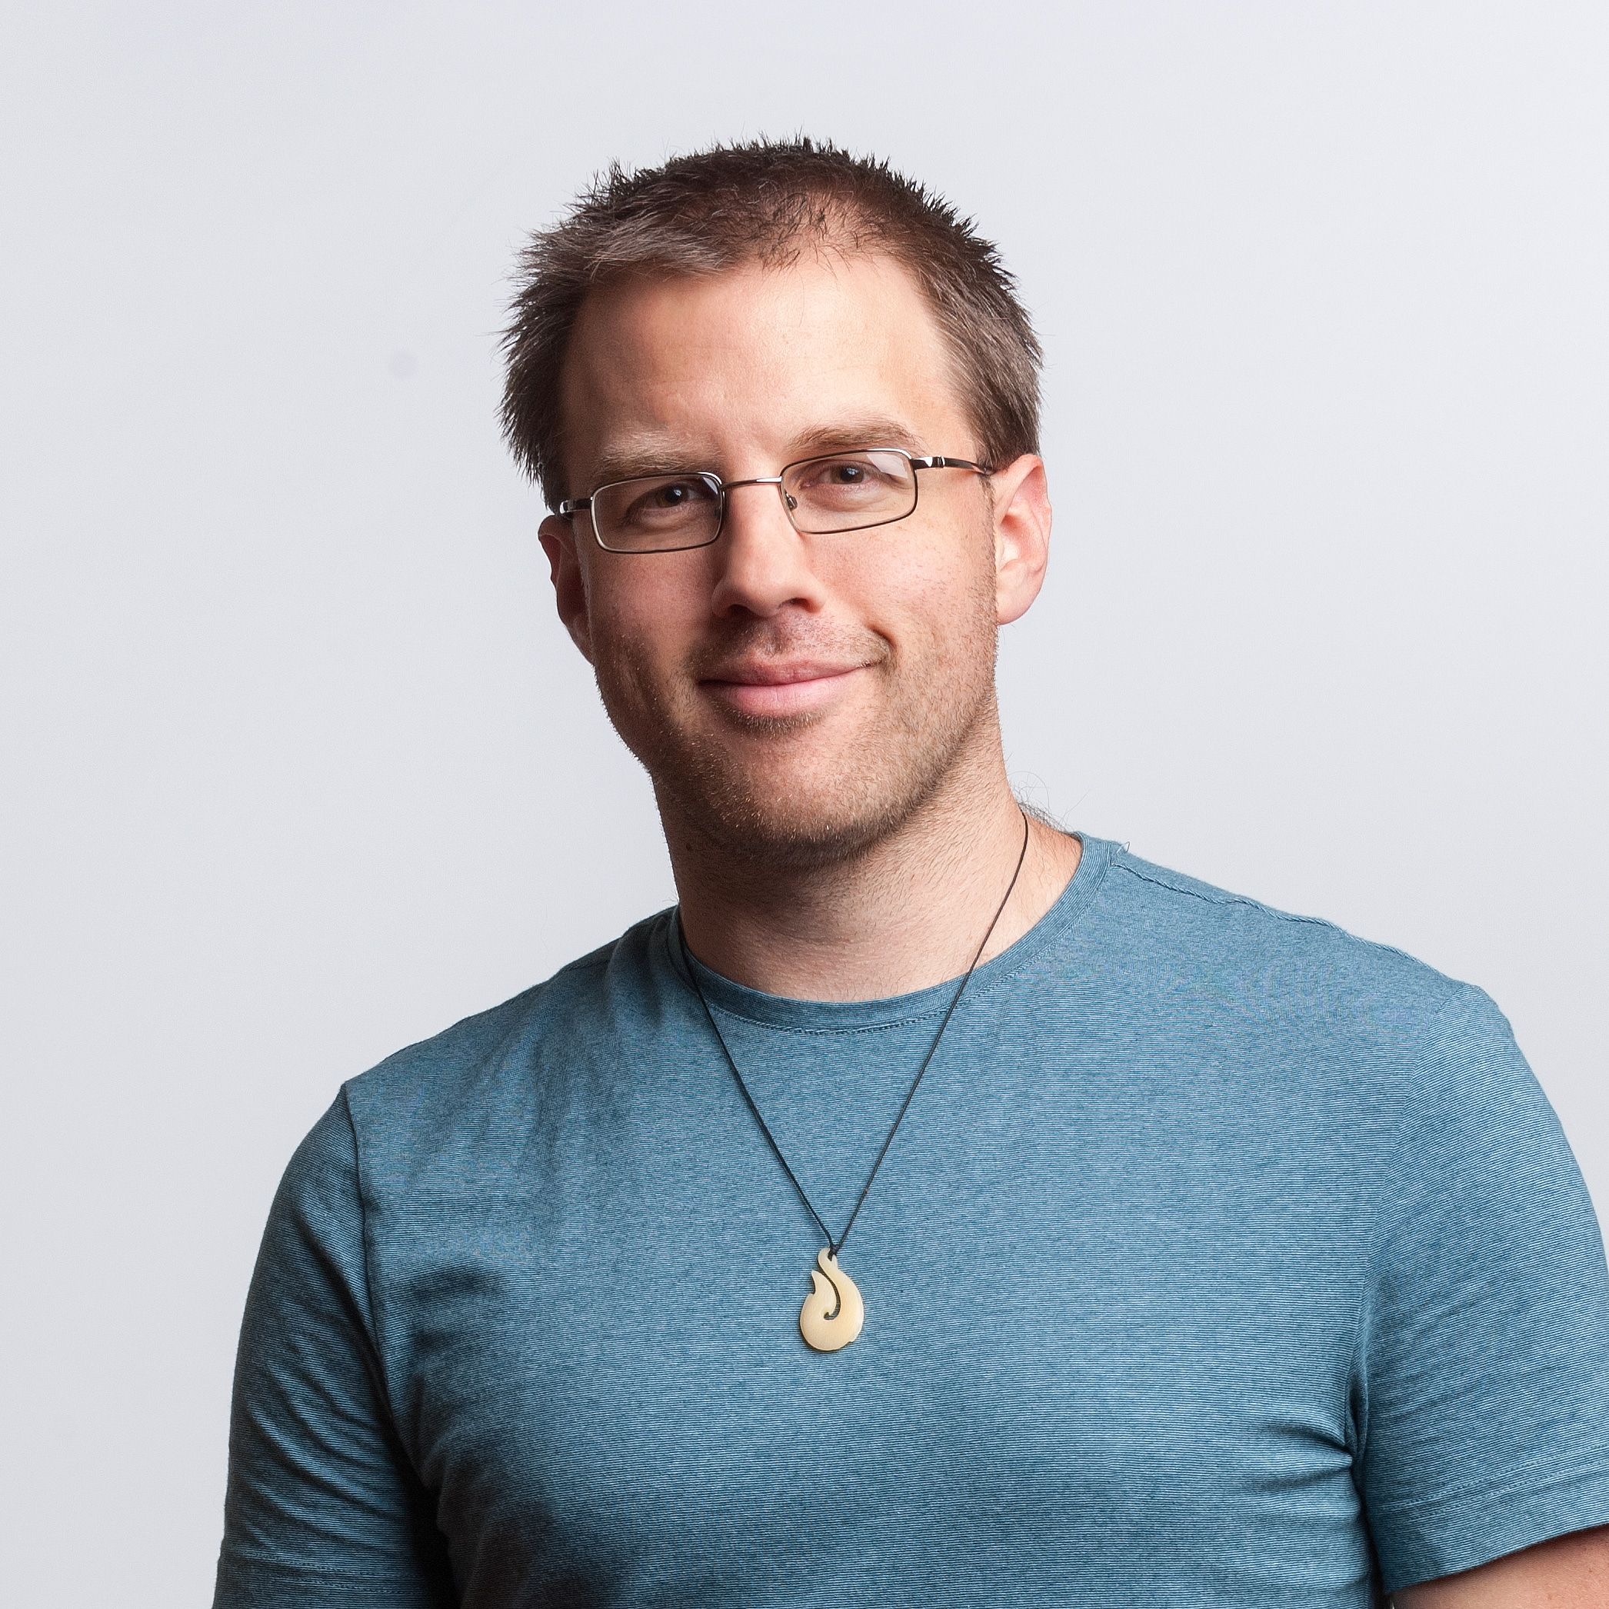

**Adon Moskal**

Senior Lecturer

Adon.Moskal@op.ac.nz

Hello my name is Adon, I like sunny days and long walks on the beach. I am a senior lecturer at Otago Polytechnic. When I am not teaching at the Polytechnic I am at home practicing my amateur pottery skills. My presence is integral to the functioning of the polytechnic and without me the polytechnic is nothing.

**David Rozado**

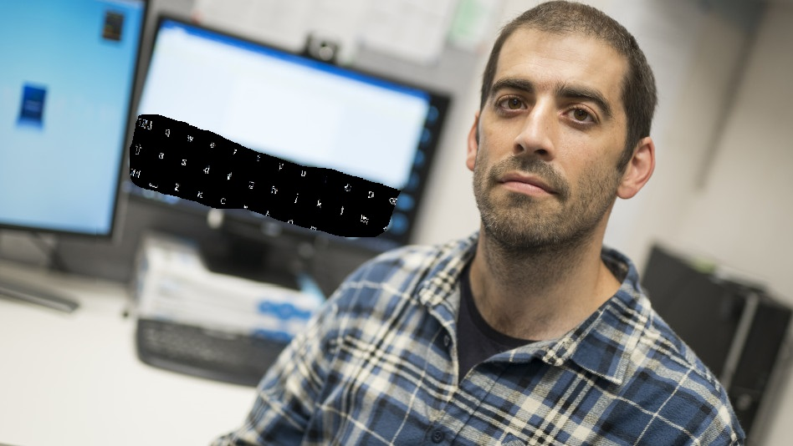

Principal Lecturer

David.Rozado@op.ac.nz

David Rozado holds a B.Sc. in Information Systems from Boston University, a M.Sc. in Bioinformatics from the Free University of Berlin and a Ph.D in Computer Science from the Autonomous University of Madrid. David joined Otago Polytechnic early in 2015. His main areas of research are Machine Learning and Accessibility software for users with motor impairment. He currently teaches Data Science &amp; Machine Intelligence, Algorithms &amp; Data Structures, and final year Project.

**Krissi Wood**

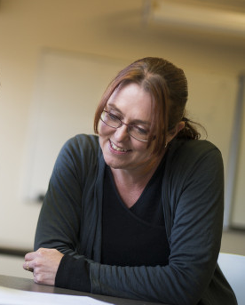

Lecturer

Krissi.Wood@op.ac.nz

Krissi is a BIT graduate from 2005, who has returned to the Polytechnic after a number of years in Industry. She is a lecturer in the School of Information Technology, where she teaches Programming, PC Maintenance and Web programming in first year and Databases in second year. Her main area of research is in Computing Education; and the focus for 2012 was pair programming and version control software.

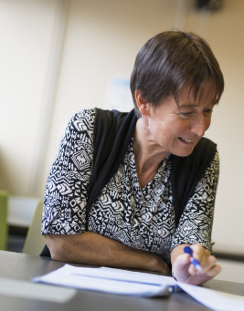**Dale Parsons**

Principal Lecturer

Dale.Parsons@op.ac.nz

Dale is a Principal Lecturer in the School of Information Technology. She teaches programming in the Bachelor of Information Technology. Her main area of research is in Computing Education.